ASSIGNMENT 1:

Name: Om Prasanna Kulkarni

PRN: 22510034

Batch: S3

Branch: CSE

Topic: Implementing Logic Gates Using PROTEUS Software

1. AND GATE

TRUTH TABLE:

|  |  |  |
| --- | --- | --- |
| A | B | Y |
| 0 | 0 | 0 |
| 0 | 1 | 0 |
| 1 | 0 | 0 |
| 1 | 1 | 1 |

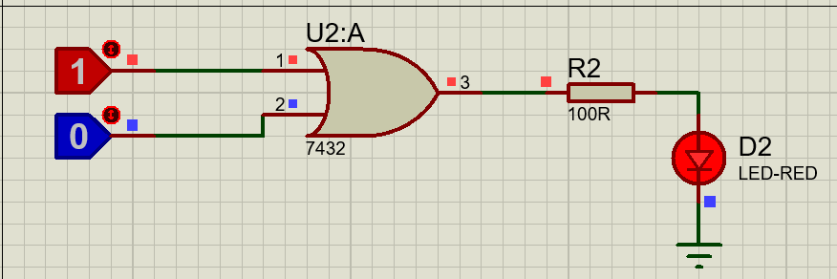

1. OR GATE

TRUTH TABLE:

|  |  |  |
| --- | --- | --- |
| A | B | Y |
| 0 | 0 | 0 |
| 0 | 1 | 1 |
| 1 | 0 | 1 |
| 1 | 1 | 1 |

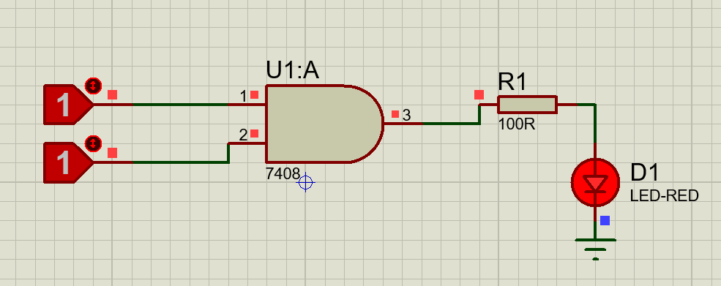

1. NOT GATE

TRUTH TABLE:

|  |  |
| --- | --- |
| A | Y |
| 1 | 0 |
| 0 | 1 |

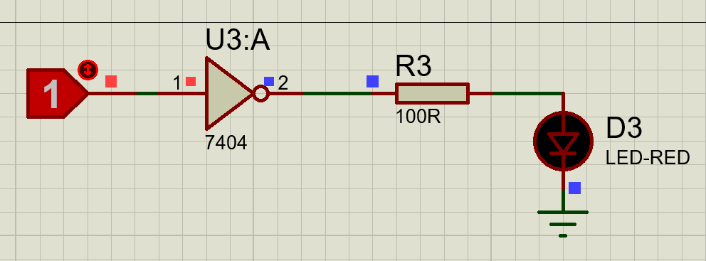

1. NAND GATE

TRUTH TABLE:

|  |  |  |
| --- | --- | --- |
| A | B | Y |
| 0 | 0 | 1 |
| 0 | 1 | 1 |
| 1 | 0 | 1 |
| 1 | 1 | 0 |

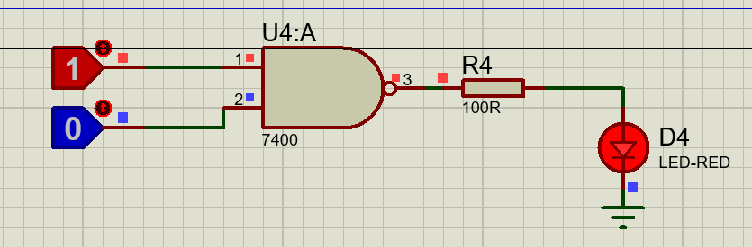

1. NOR GATE

TRUTH TABLE:

|  |  |  |
| --- | --- | --- |
| A | B | Y |
| 0 | 0 | 1 |
| 0 | 1 | 0 |
| 1 | 0 | 0 |
| 1 | 1 | 0 |

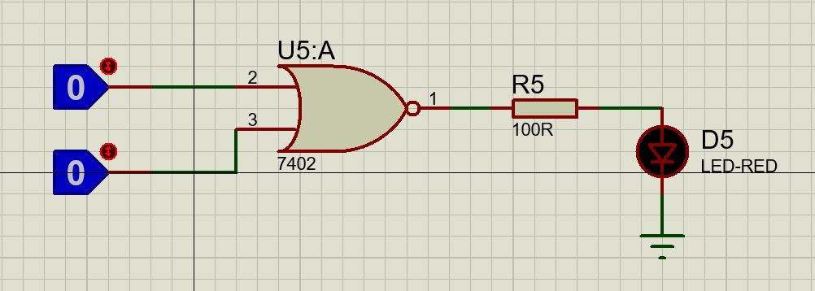

1. Ex-OR GATE

TRUTH TABLE:

|  |  |  |
| --- | --- | --- |
| A | B | Y |
| 0 | 0 | 0 |
| 0 | 1 | 1 |
| 1 | 0 | 1 |
| 1 | 1 | 0 |

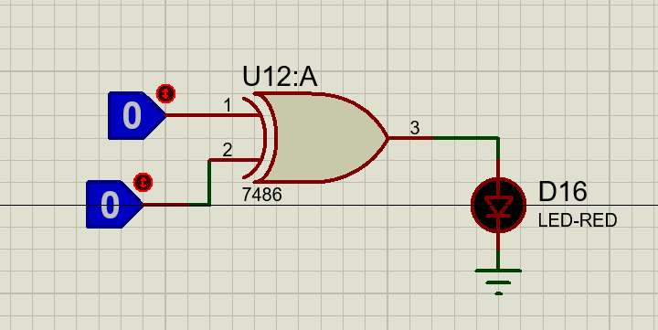.

1. Ex-NOR GATE

TRUTH TABLE

|  |  |  |
| --- | --- | --- |
| A | B | Y |
| 0 | 0 | 1 |
| 0 | 1 | 0 |
| 1 | 0 | 0 |
| 1 | 1 | 1 |

