ASSIGNMENT 10:

## TITLE: Addition on 8086

PRN: 22510034 Date:20-11-23

Aim:

a.       Perform subtraction of any two 8-bit numbers on 8086 emulator.

b.       Perform subtraction of any two 16-bit numbers on 8086 emulator.

Procedure:

-Install and open the emu 8086 Simulator on the computer device, Create and Open the new project and name it as Subtraction of two numbers.

Results:

8-bit Subtraction:

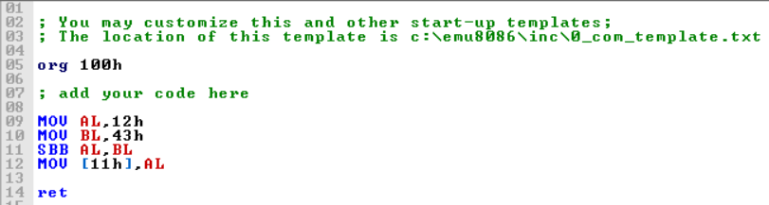

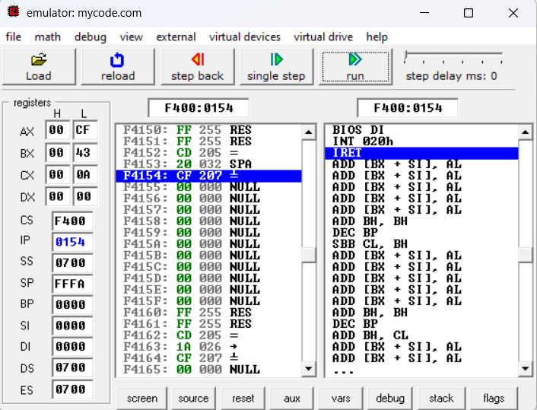

16-Bit Subtraction:  
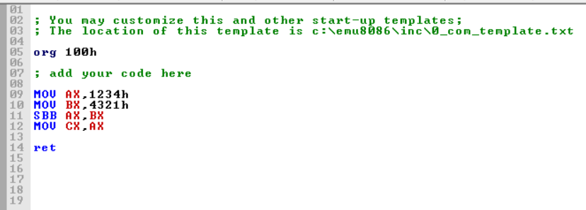

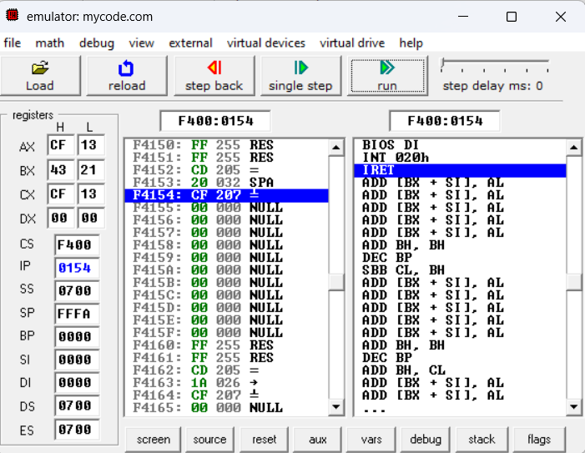

Conclusion:

By using emu8086 I understood the basic functionality of Subtraction in 8086 microprocessor