ASSIGNMENT 2:

Title: Study of the design of combinational and sequential circuit using Proteus

PRN: 22510034 Date:09-09-23

Aim:  
Study of the design of combinational and sequential circuit using Proteus.

a.       Implement half adder and full adder circuit. Verify the truth table.

b.       Implement circuit using basic gates for following flip flops: SR, JK, D, T. Verify the truth table.

c.       Implement 2x1 and 4x2 multiplexer using basic gates. Derive output equation using K Map. Verify the truth table.

Hardware Used: None  
Software Used: Proteus 8 Professional

Procedure:

I first of all implemented all the circuits on the proteus software then side by side prepared their logic equations and truth tables as well.

Results:

a)Adders:

Half Adder:

Boolean Expression:  
S= A Ex-Or B

C=A.B

TRUTH TABLE:

|  |  |  |  |
| --- | --- | --- | --- |
| INPUTS | | OUTPUTS | |
| A | B | S | C |
| 0 | 0 | 0 | 0 |
| 0 | 1 | 1 | 0 |
| 1 | 0 | 1 | 0 |
| 1 | 1 | 0 | 1 |

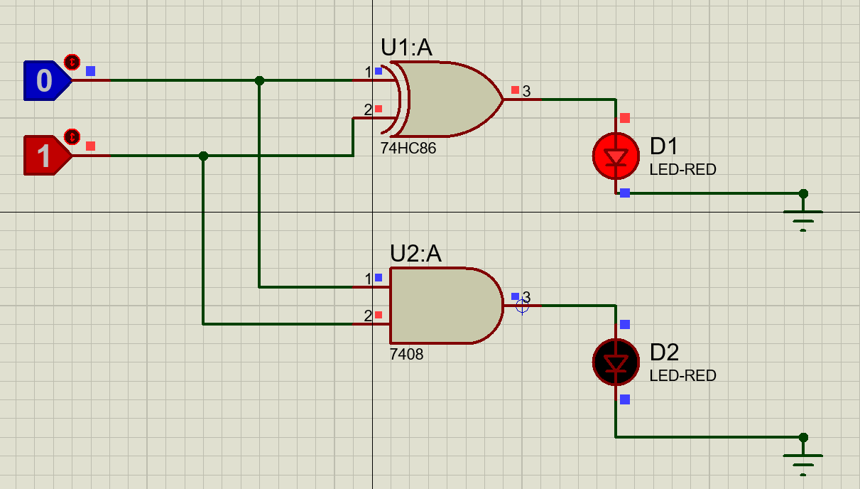

Full Adder:

Boolean Expression:

S=A Ex-Or B Ex-Or C

C=A.B+B.Cin+A.Cin

TRUTH TABLE:

|  |  |  |  |  |
| --- | --- | --- | --- | --- |
| INPUTS | | | OUTPUT | |
| A | B | Cin | S | C |
| 0 | 0 | 0 | 0 | 0 |
| 0 | 0 | 1 | 1 | 0 |
| 0 | 1 | 0 | 1 | 0 |
| 0 | 1 | 1 | 0 | 1 |
| 1 | 0 | 0 | 1 | 0 |
| 1 | 0 | 1 | 0 | 1 |
| 1 | 1 | 0 | 0 | 1 |
| 1 | 1 | 1 | 1 | 1 |

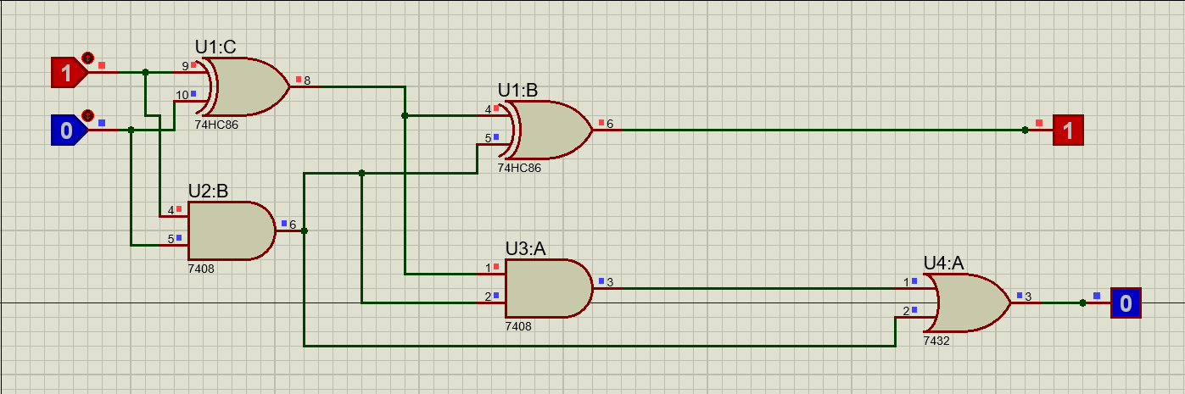

b) SR-FLIP FLOP:

TRUTH TABLE:

|  |  |  |
| --- | --- | --- |
| S | R | Qn+1 |
| 0 | 0 | Invalid |
| 0 | 1 | 1 |
| 1 | 0 | 01 |
| 1 | 1 | Hold |

Logic Diagram:

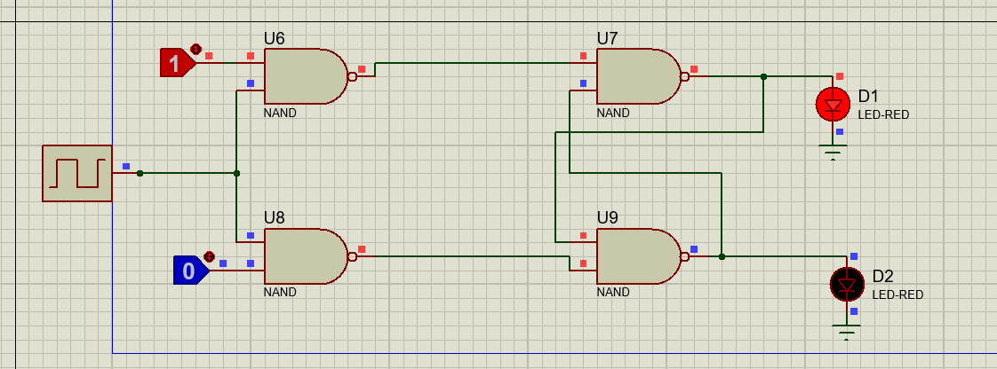

D-Flip Flop

TRUTH TABLE:

|  |  |  |
| --- | --- | --- |
| Qn | Qn+1 | D |
| 0 | 0 | 0 |
| 0 | 1 | 1 |
| 1 | 0 | 0 |
| 1 | 1 | 1 |

Logic Diagram:  
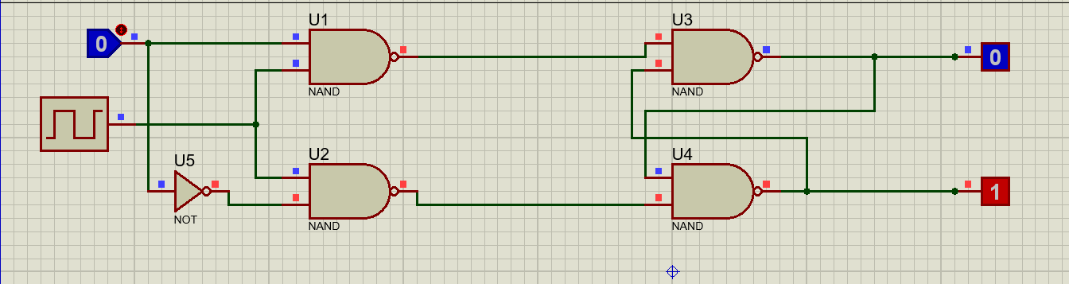

J-K FLIP FLOP:

TRUTH TABLE:

|  |  |  |
| --- | --- | --- |
| J | K | Qn+! |
| 0 | 0 | Hold |
| 0 | 1 | 0 |
| 1 | 0 | 1 |
| 1 | 1 | Invalid |

Logic Diagram:

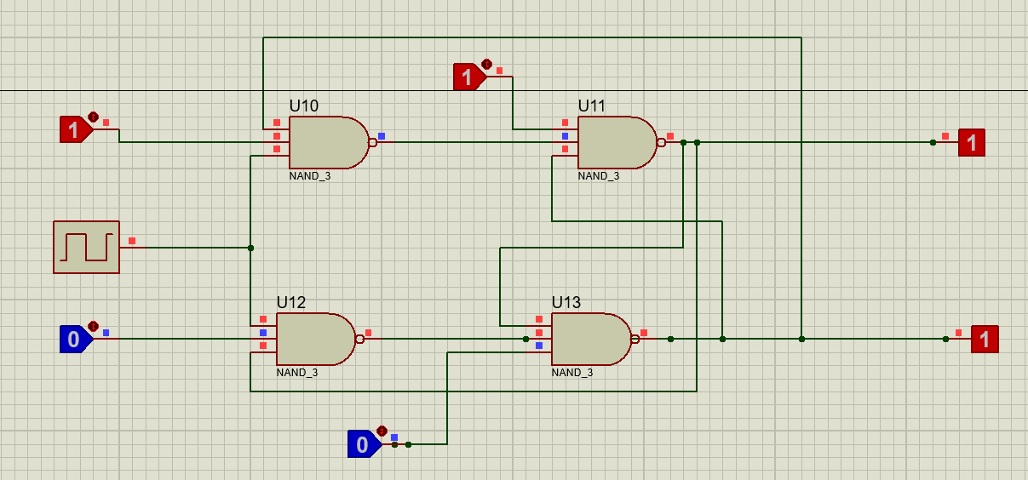

T Flip Flop:

Truth Table:

|  |  |  |
| --- | --- | --- |
| T | $$Q_{n}$$ | $$Q_{n+1}$$ |
| 0 | 0 | 0 |
| 0 | 1 | 1 |
| 1 | 0 | 1 |
| 1 | 1 | 0 |

Logic Diagram:

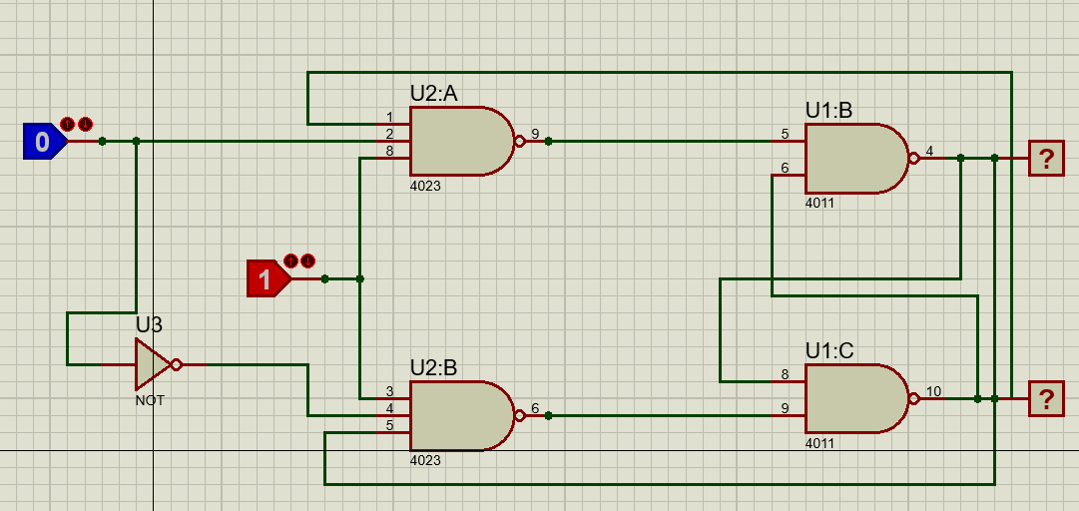

c)Multiplexers

2X1:

Prototype:

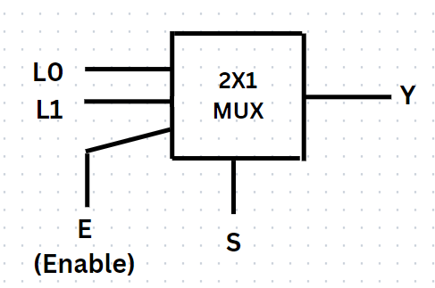

TRUTH TABLE:

|  |  |  |
| --- | --- | --- |
| E | S | Y |
| 0 | - | 0 |
| 1 | 0 | L0 |
| 1 | 1 | L1 |

LOGIC EQUATION:

Y=E $\overline{S}$ L0+ESL1=E($\overline{S}$ L0+SL1)

CIRCUIT:

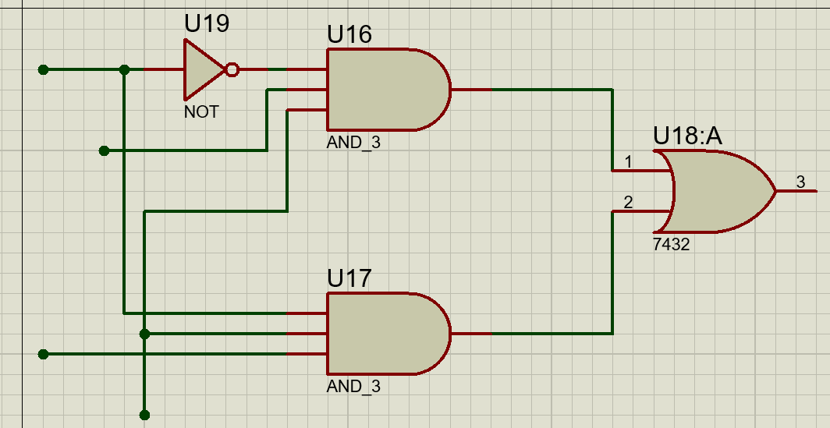

4x1:  
  
Prototype:  
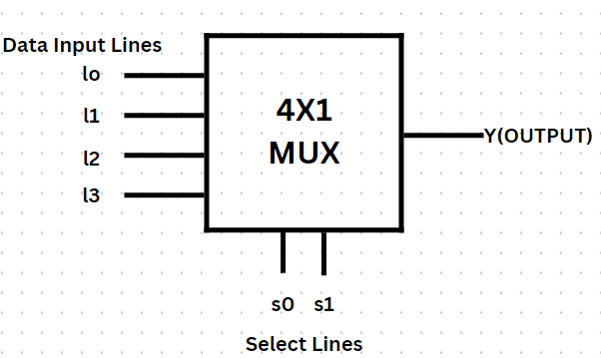

TRUTH TABLE:

|  |  |  |
| --- | --- | --- |
| S1 | S0 | Y |
|  |  |  |
| 0 | 0 | L0 |
| 0 | 1 | L1 |
| 1 | 0 | L2 |
| 1 | 1 | L3 |

LOGIC EQUATION:

Y= $\overline{S1}\overline{S0}$ L0+ $\overline{S1}$ S0L1+S1 $\overline{S0}$ L2+S1S0L3

Circuit:  
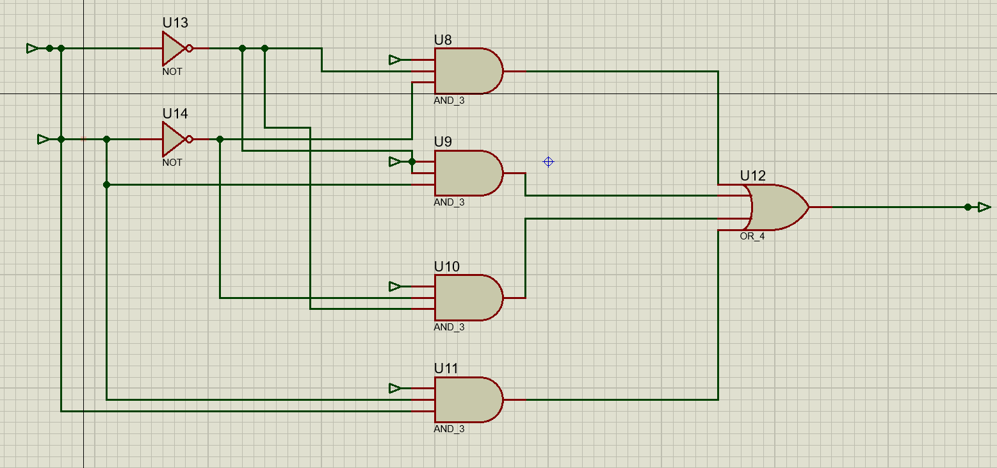

Conclusion:  
  
This assignment helped me to understand the multiplexer circuit in details and also understood to implement half and full adder circuits as well as basic flip flops using gates.