ASSIGNMENT 3:

Name: Om Prasanna Kulkarni

PRN: 22510034

Batch: S3

Branch: CSE

Topic: Implementing Multiplexer logic circuit using PROTEUS Software

4X1 MUX:

TRUTH TABLE:

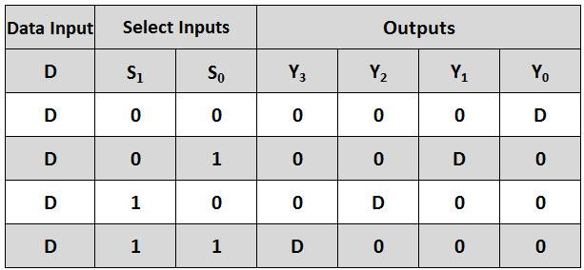

INSIDE CIRCUIT

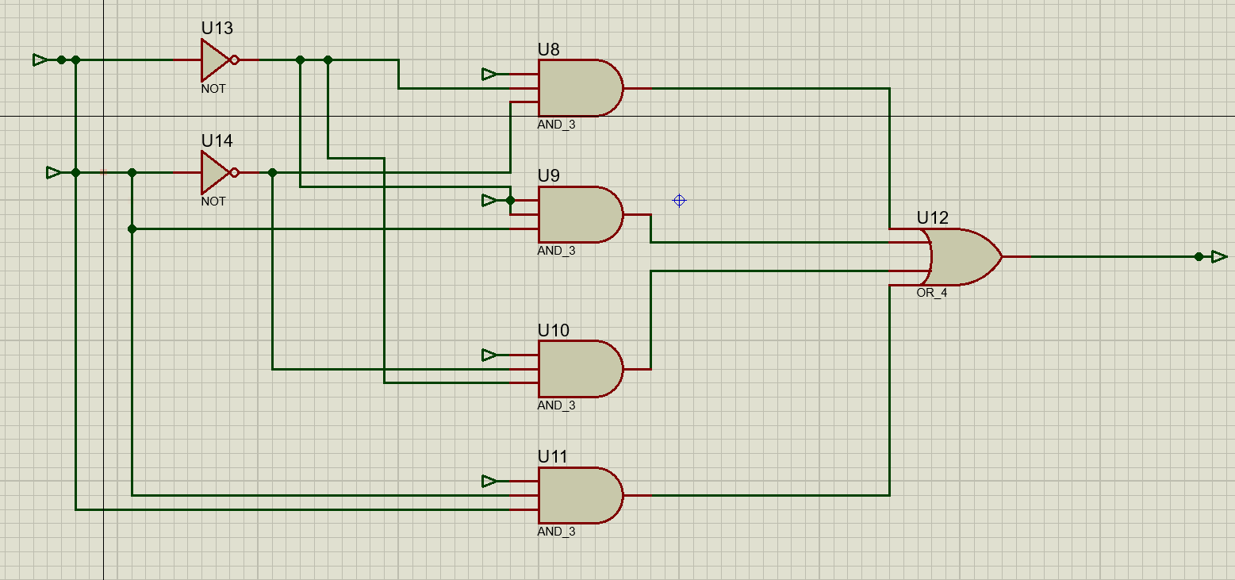

OUTER CIRCUIT:

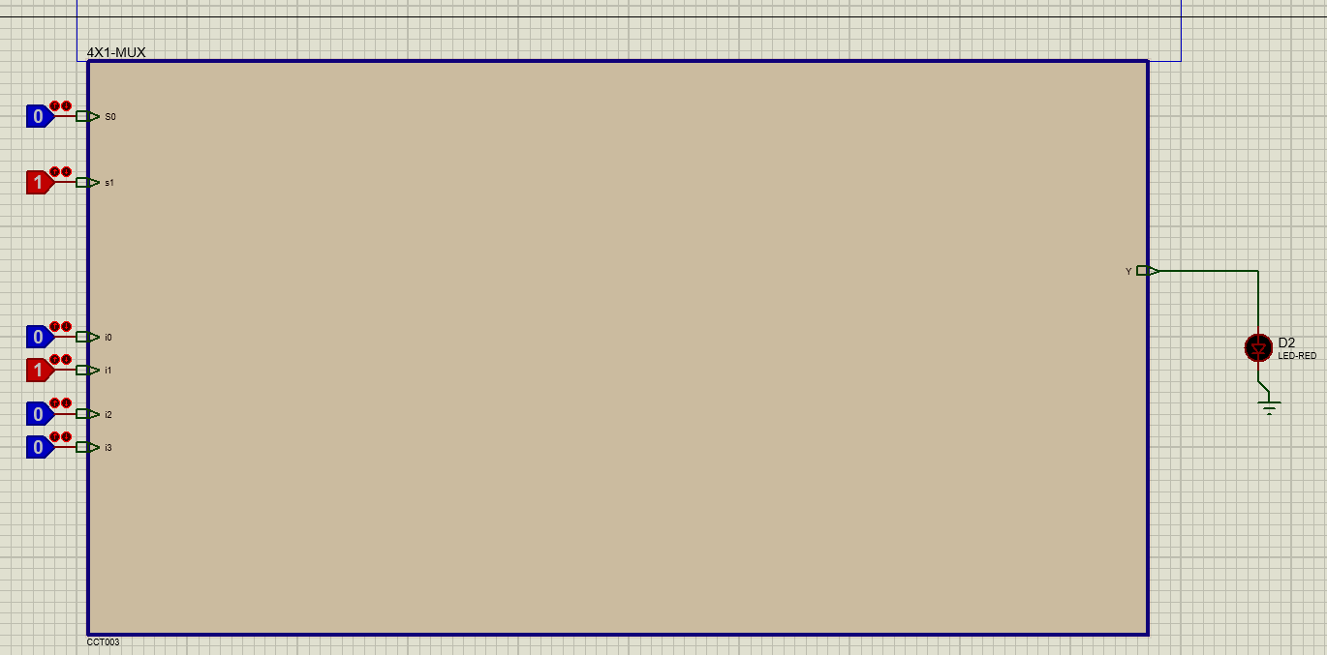

2X1:

TRUTH TABLE:

|  |  |  |  |
| --- | --- | --- | --- |
| S | A | B | Y |
| 0 | 0 | 0 | 0 |
| 0 | 0 | 1 | 0 |
| 0 | 1 | 0 | 1 |
| 0 | 1 | 1 | 1 |
| 1 | 0 | 0 | 0 |
| 1 | 0 | 1 | 1 |
| 1 | 1 | 0 | 0 |
| 1 | 1 | 1 | 1 |

