ASSIGNMENT 5:

## TITLE: Memory Management

PRN: 22510034 Date:26-10-23

Aim:

a)To write an assembly language code to transfer a data block of 5 size to a new destination address on GNU8085 simulator.

b)To write an assembly language code to transfer a data block of 5 size to a new destination address on DYNA 8085 kit.

Hardware Used: DYNA 8085 Kit

Software Used: GNU 8085 Simulator

Procedure:

-Install and open the GNU 8085 Simulator on the computer device, Create and Open the new project and name it as Memory Management.

-Write the assembly language program according to the question and Assemble and Run it.

-Perform the similar operations on DYNA 8085 kit.

Result:

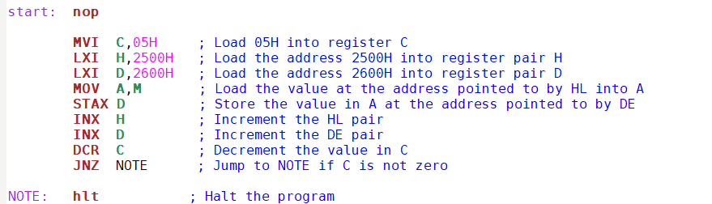

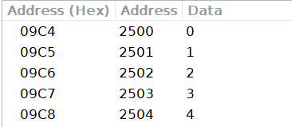

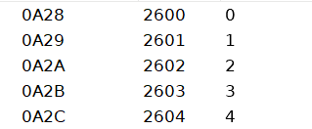

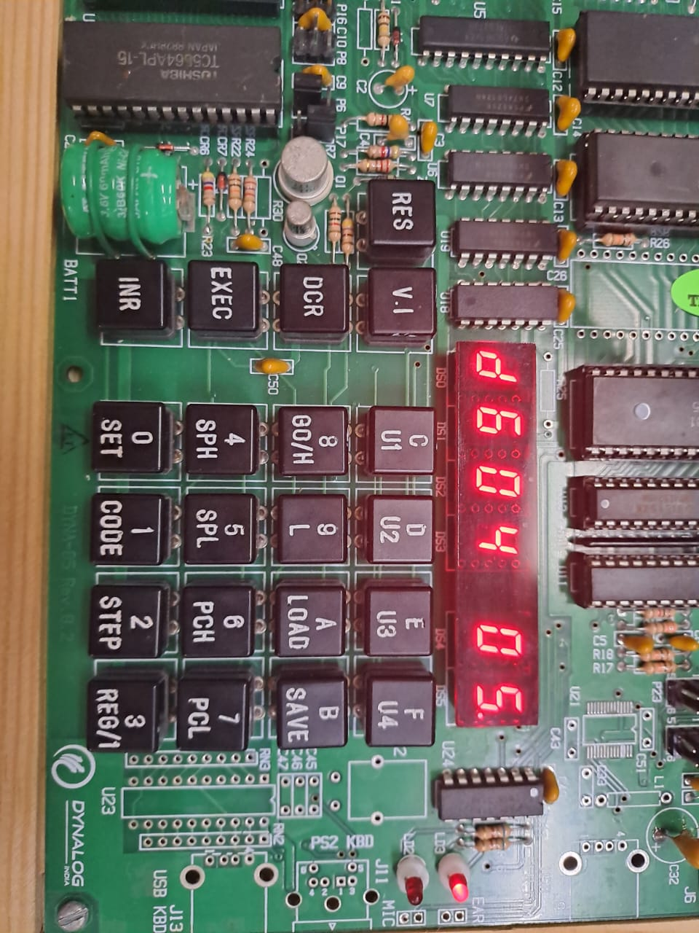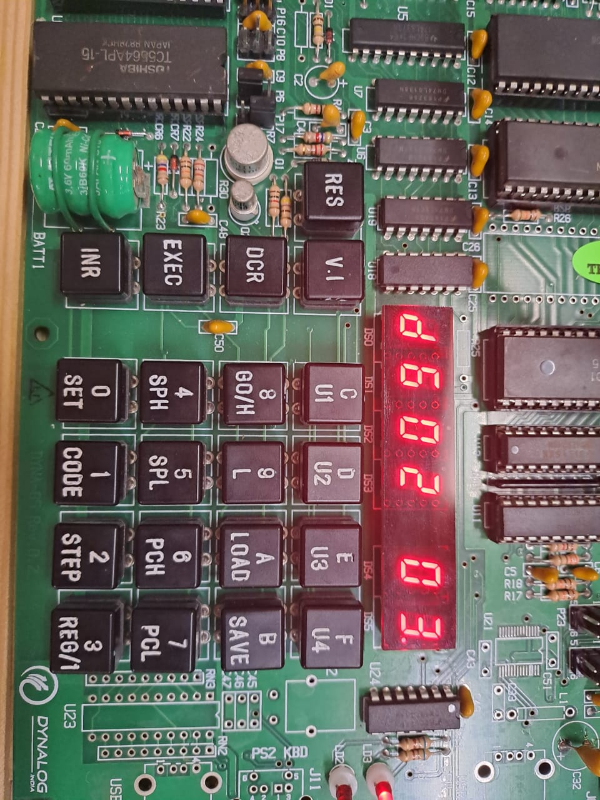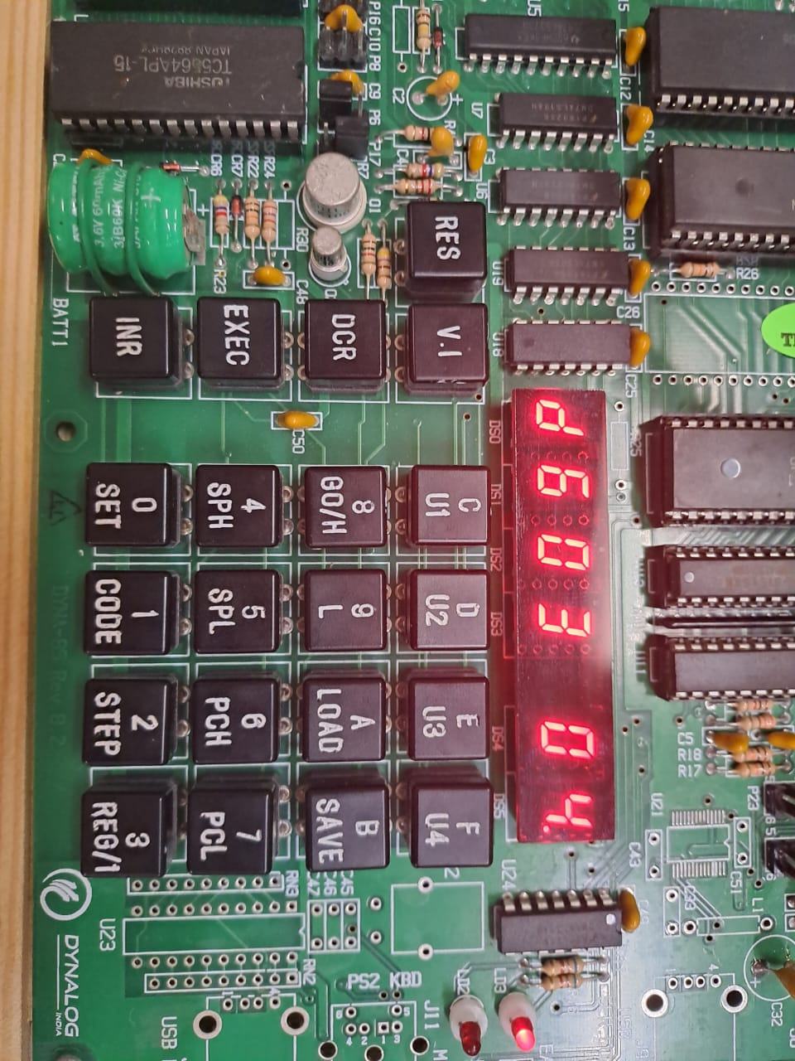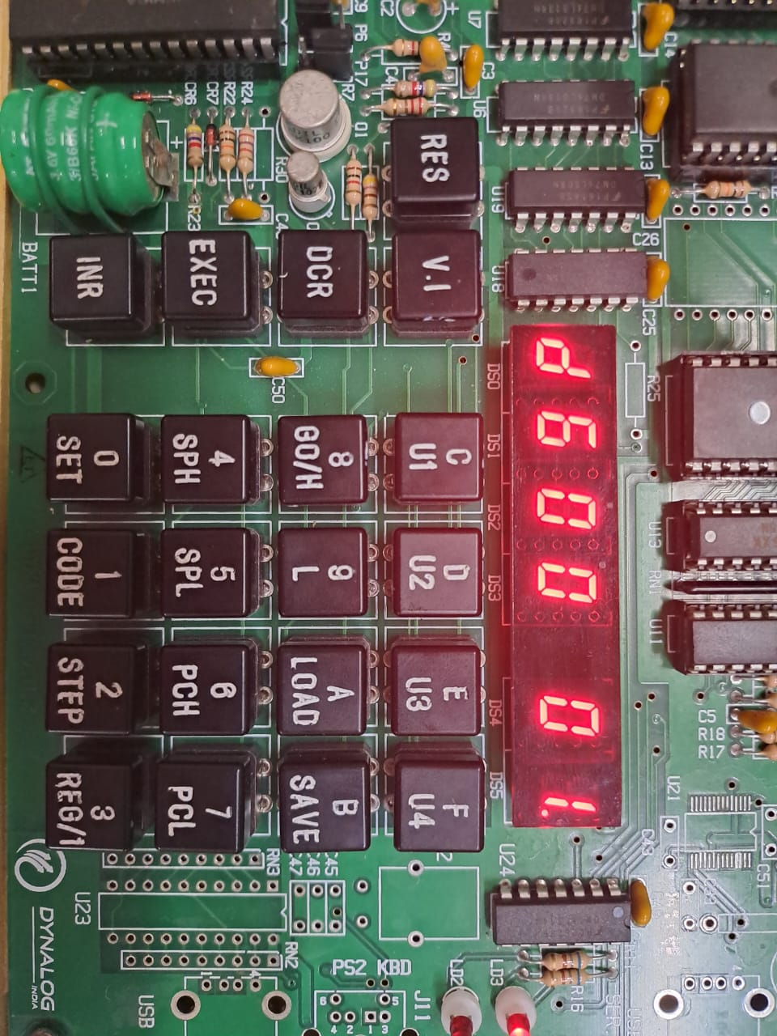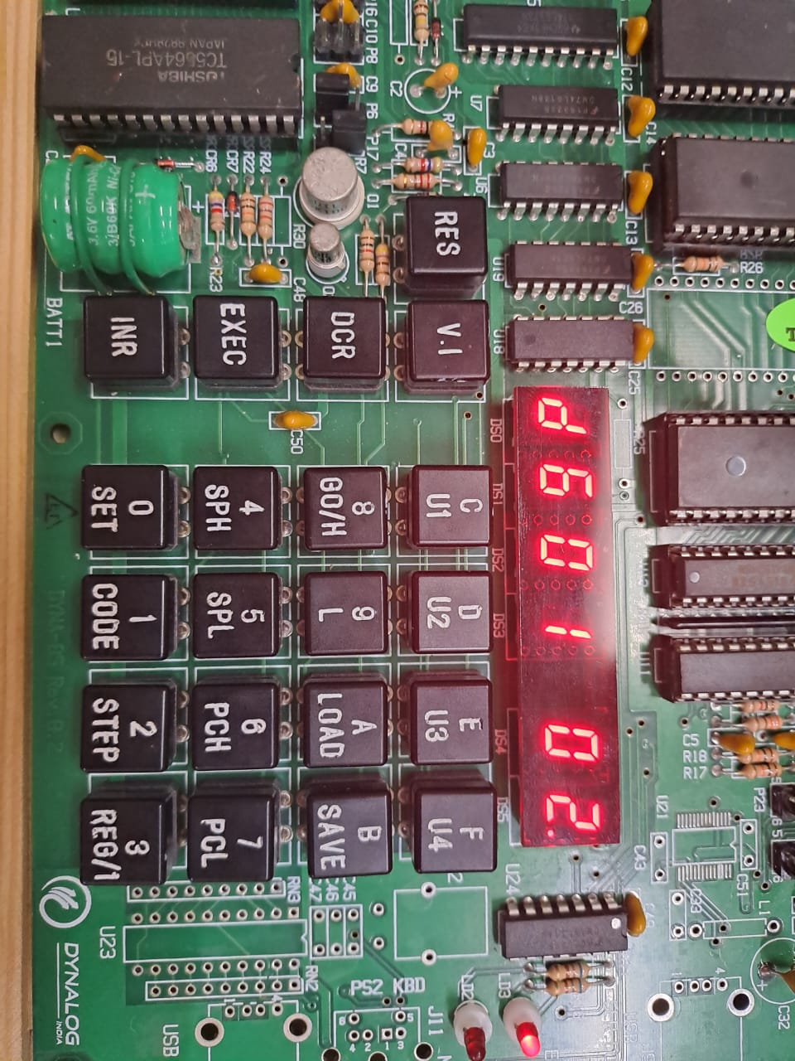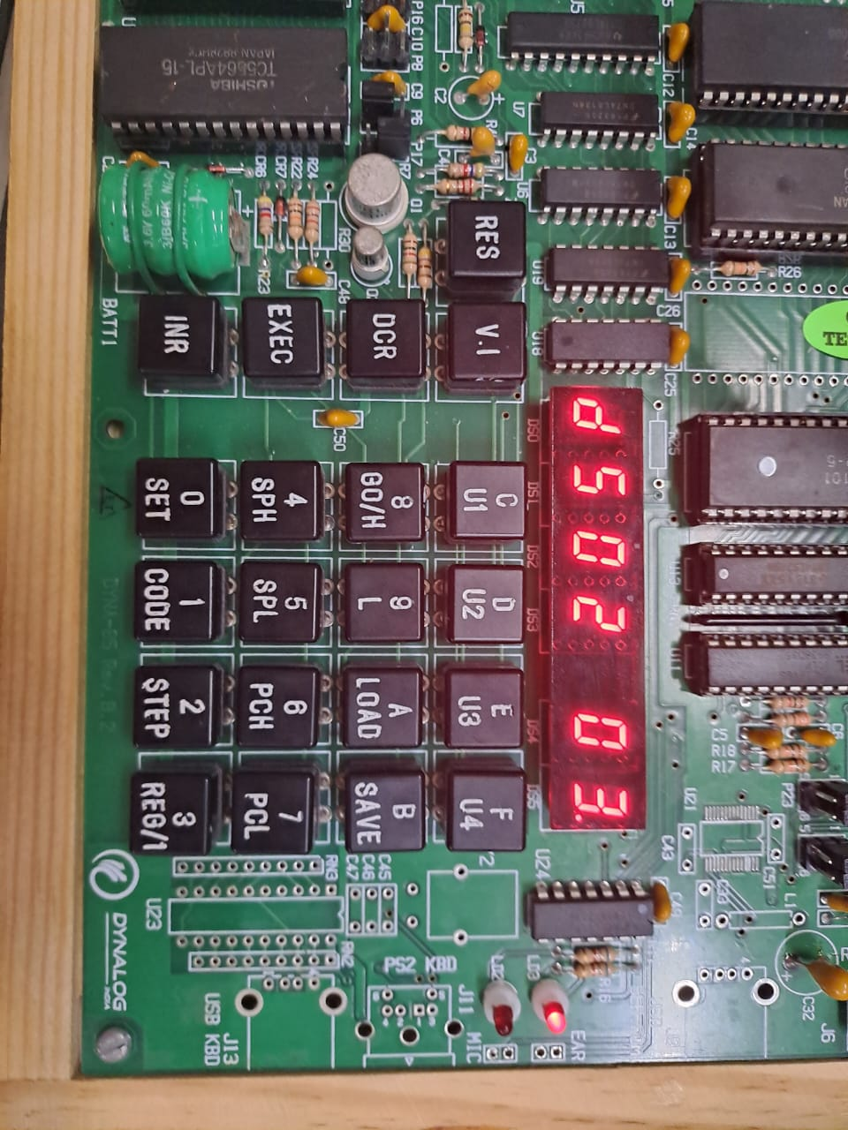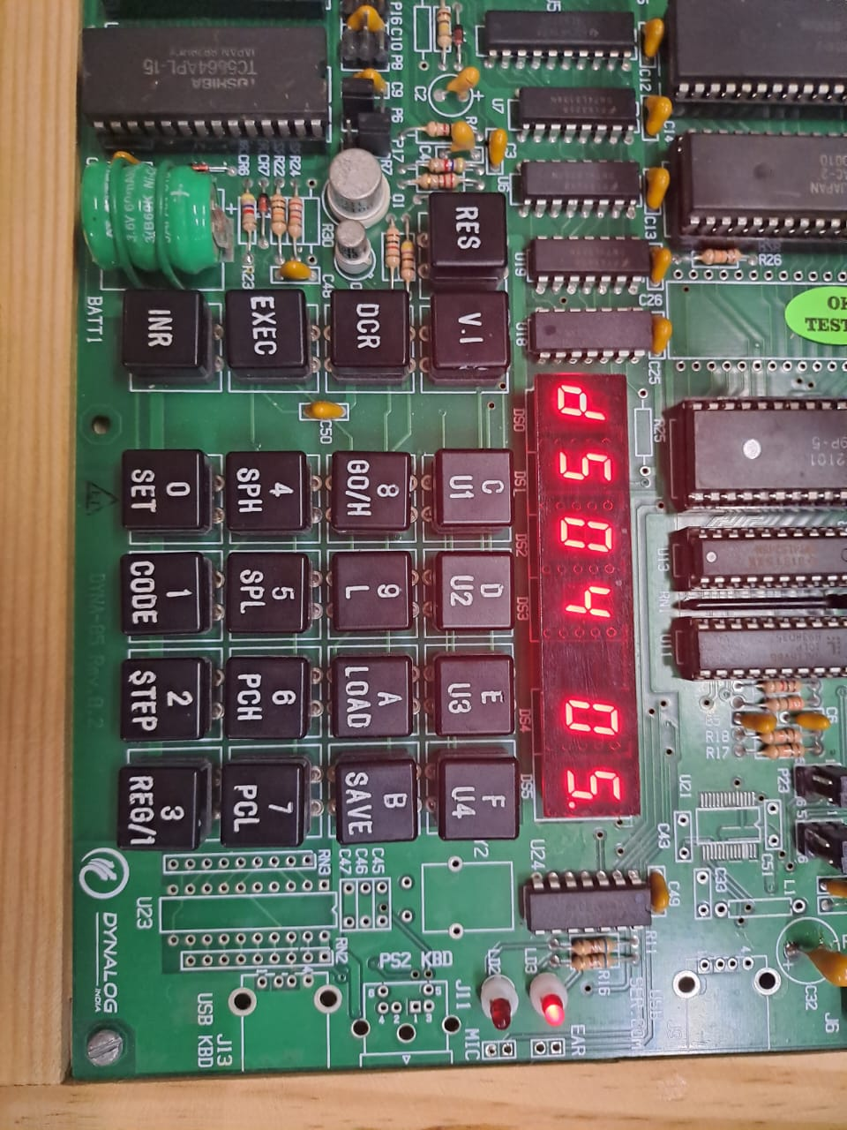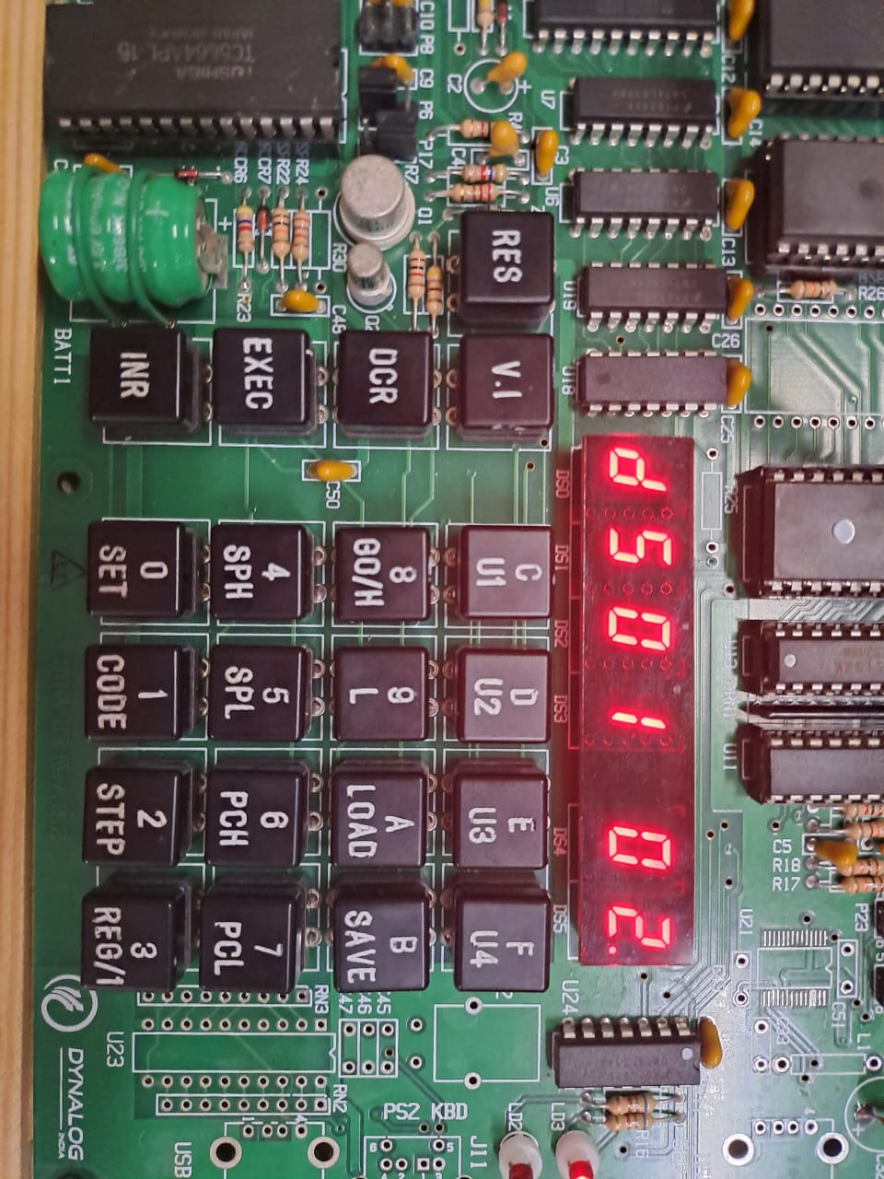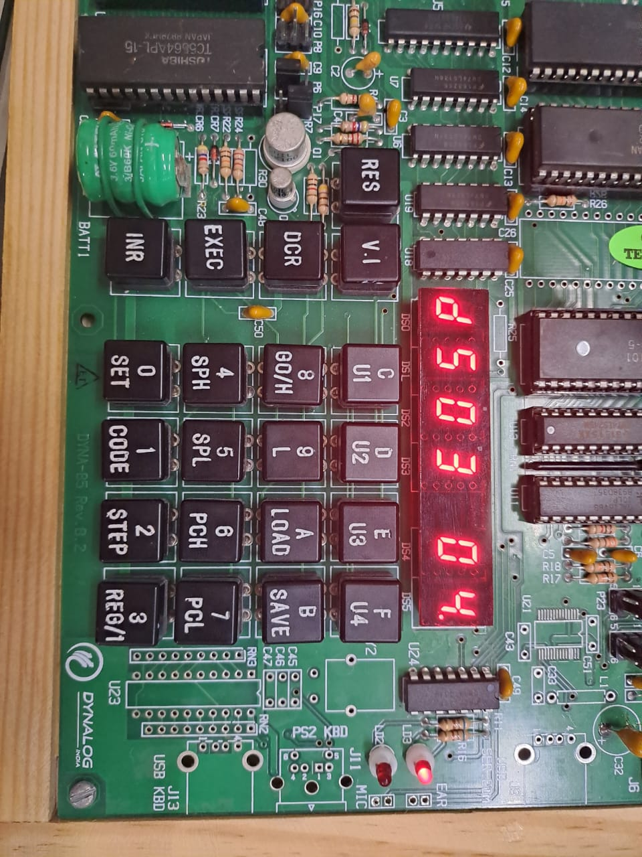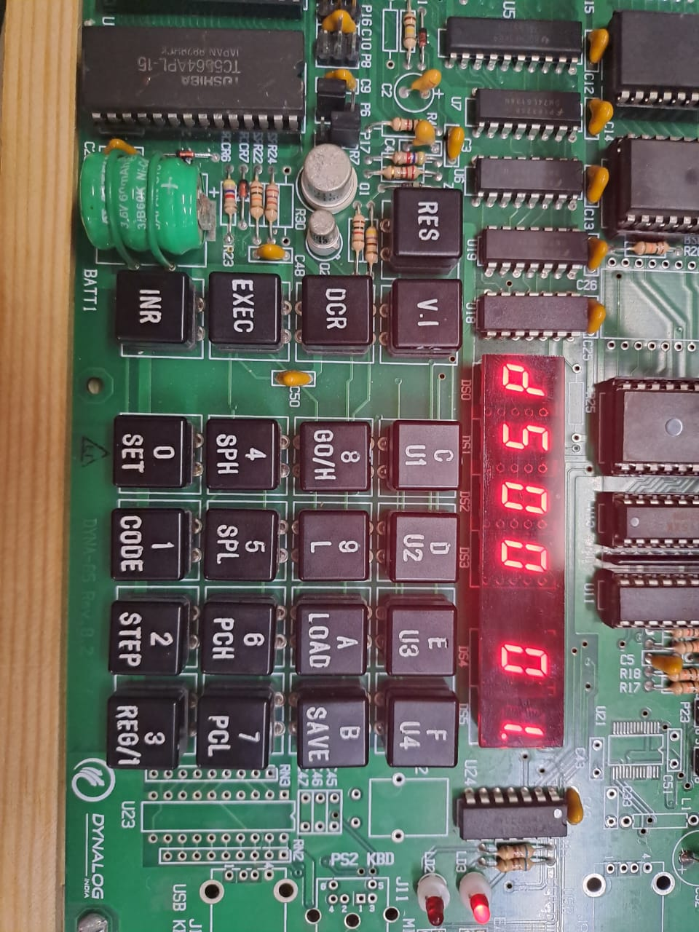

Conclusion:  
Block of 5 memory locations is transferred to another memory location by using GNU 8085 simulator and DYNA 8085 kit.