ASSIGNMENT 6:

## TITLE: Finding a number in an array

PRN: 22510034 Date:29-10-23

Aim:

1. Write an assembly language code to find a largest and smallest number from an array (data block) of 5 size to a new destination address. Perform the same on Dyna85 kit.

Procedure:

-Install and open the GNU 8085 Simulator on the computer device, Create and Open the new project and name it as Memory Management.

-Write the assembly language program according to the question and Assemble and Run it.

-Perform the similar operations on DYNA 8085 kit.

Result:

Largest:  
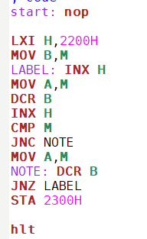

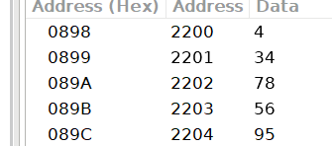 

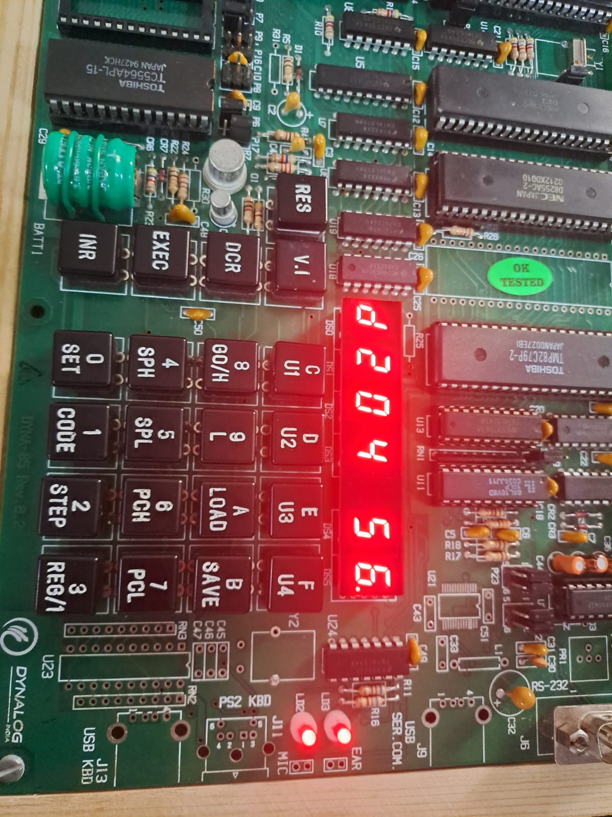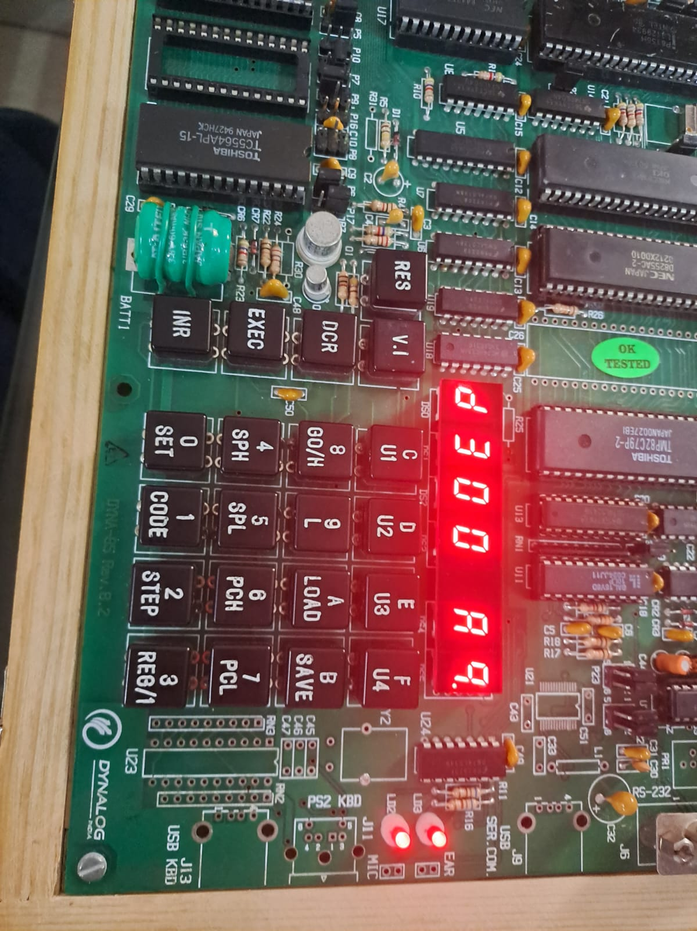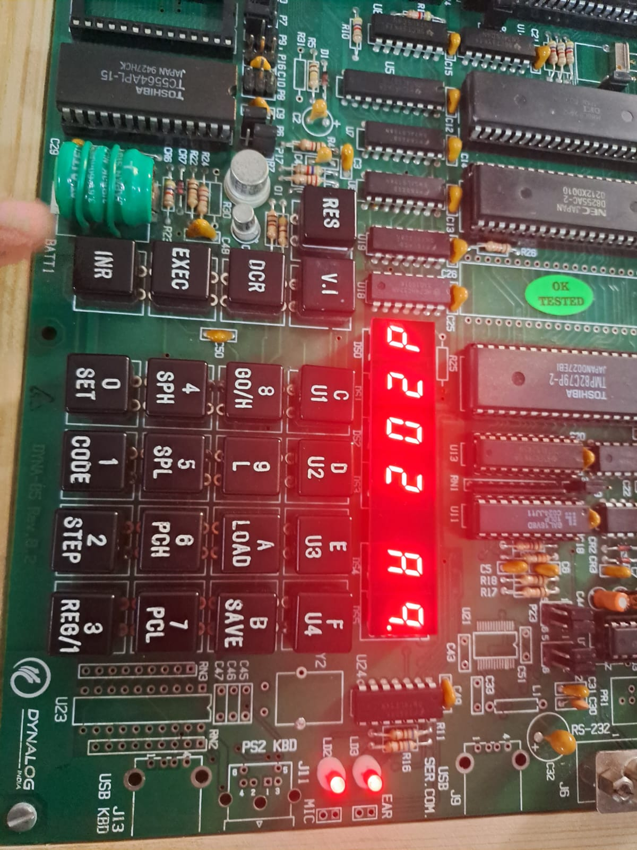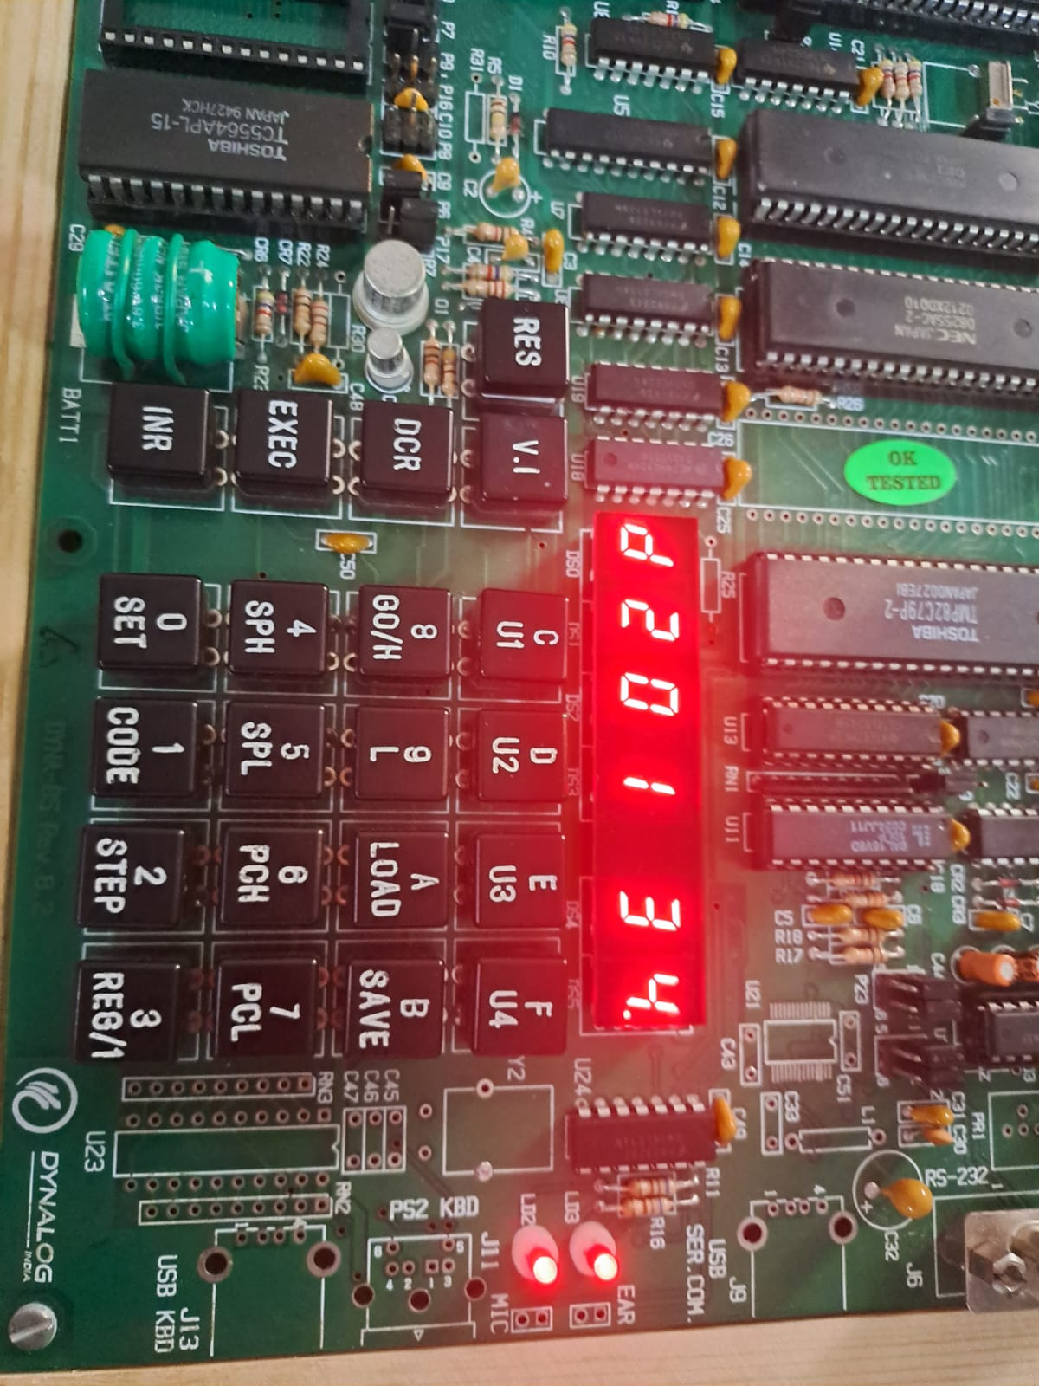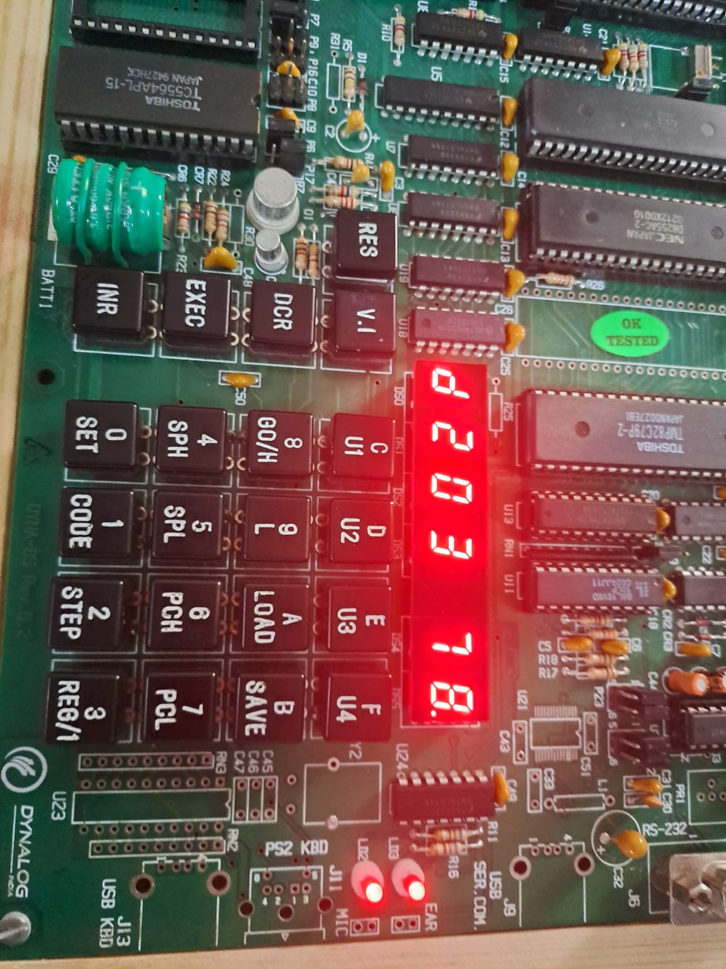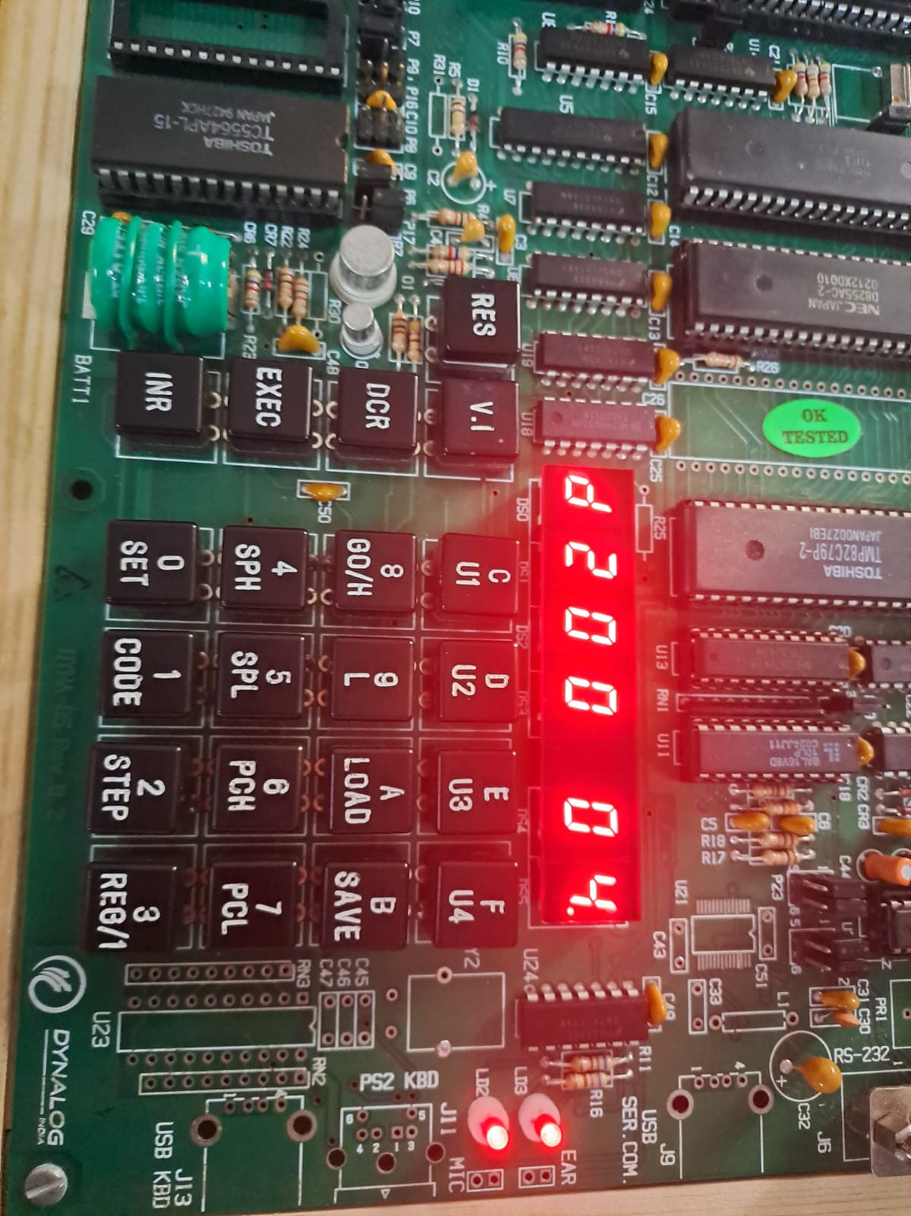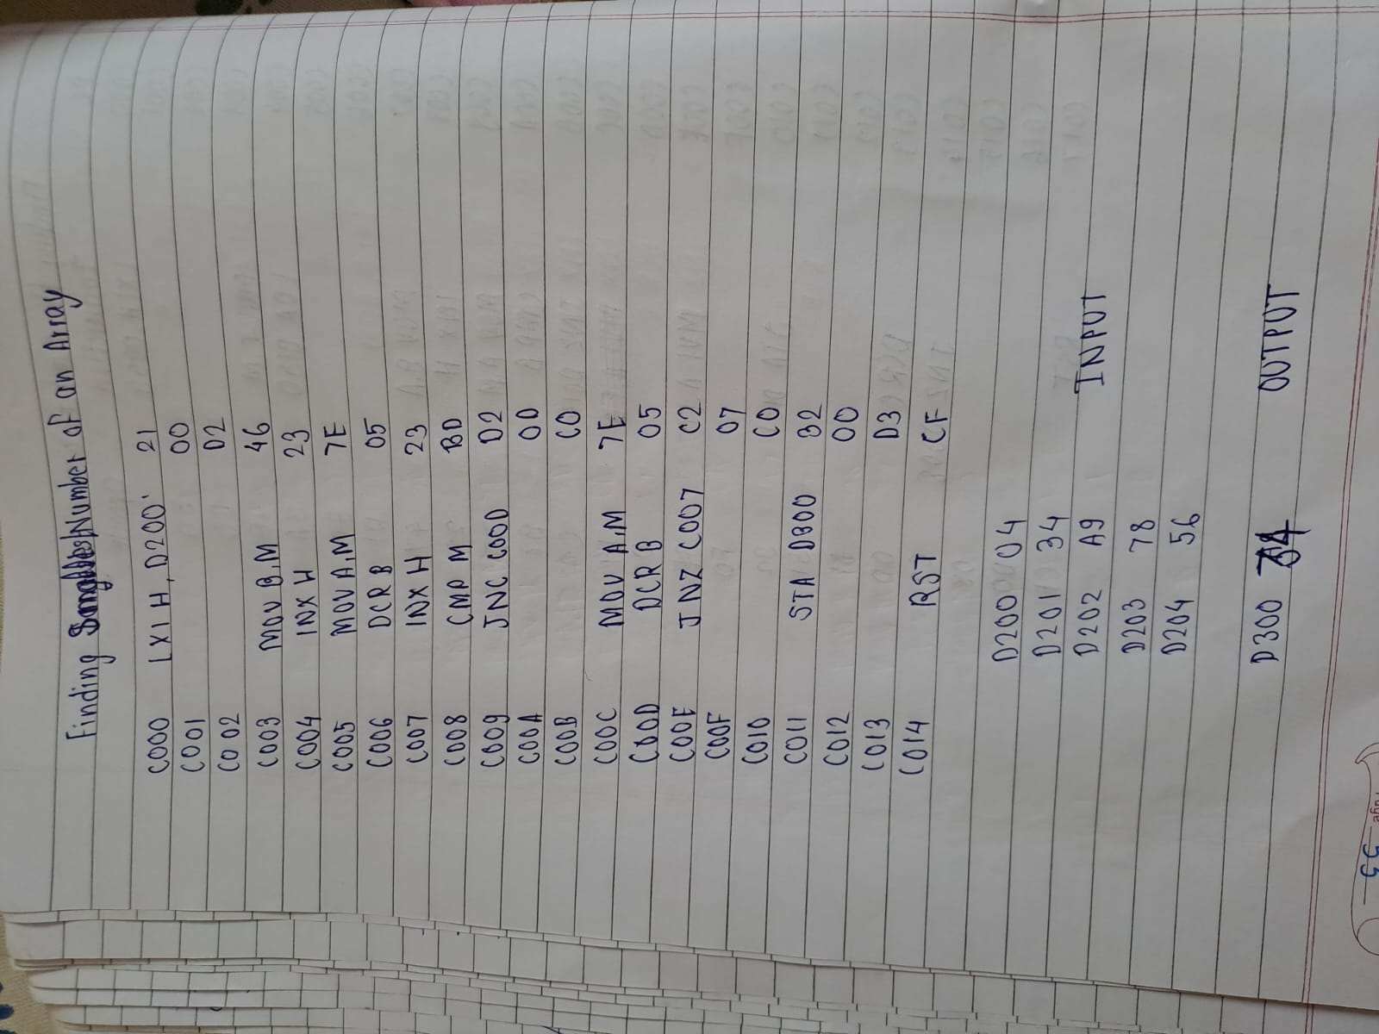

Smallest:

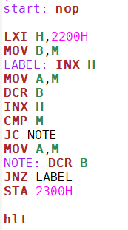 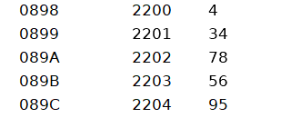 

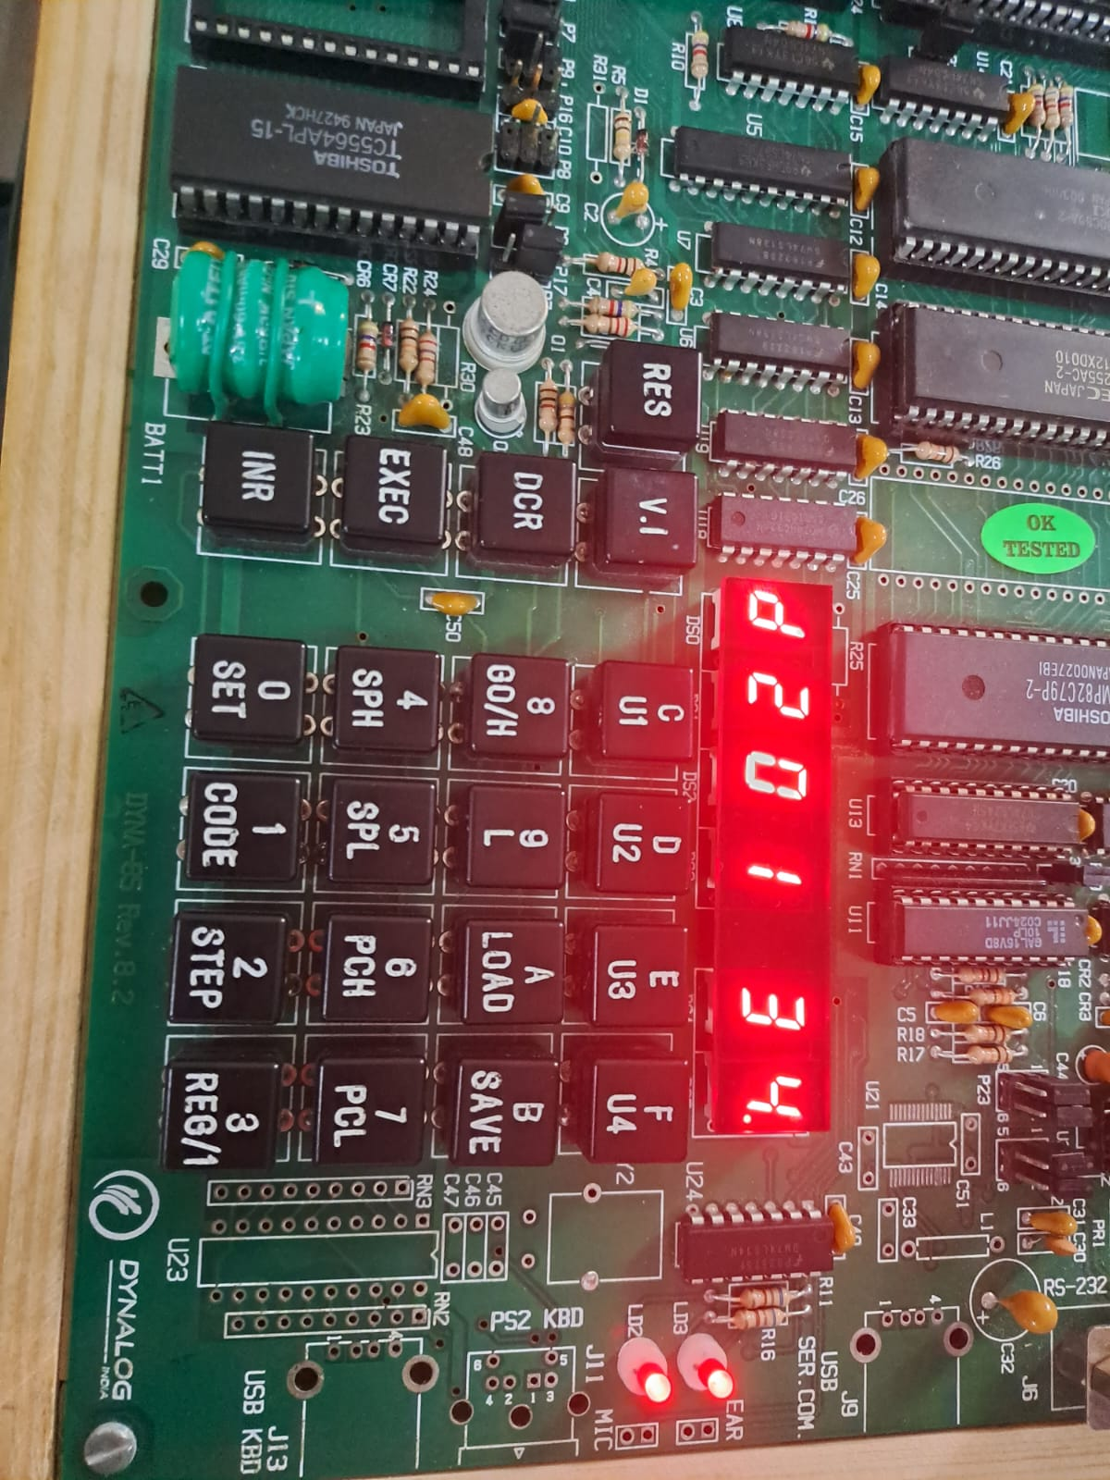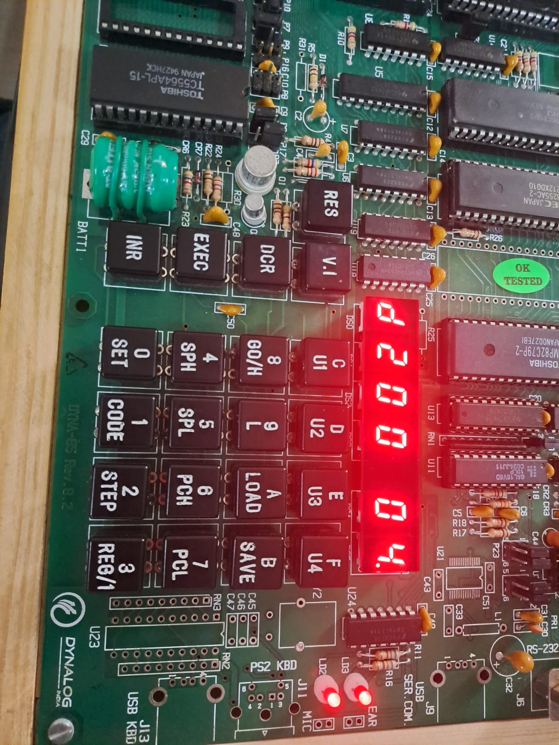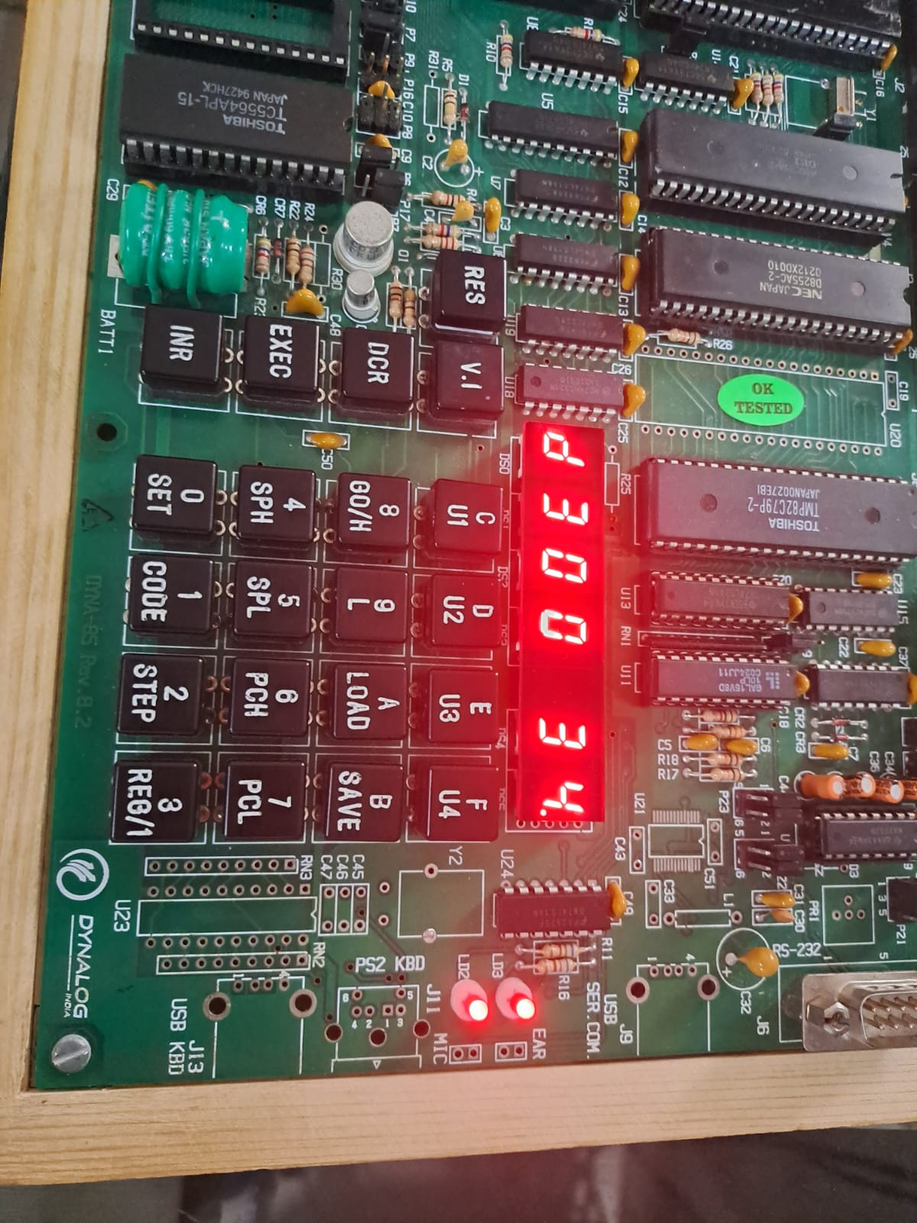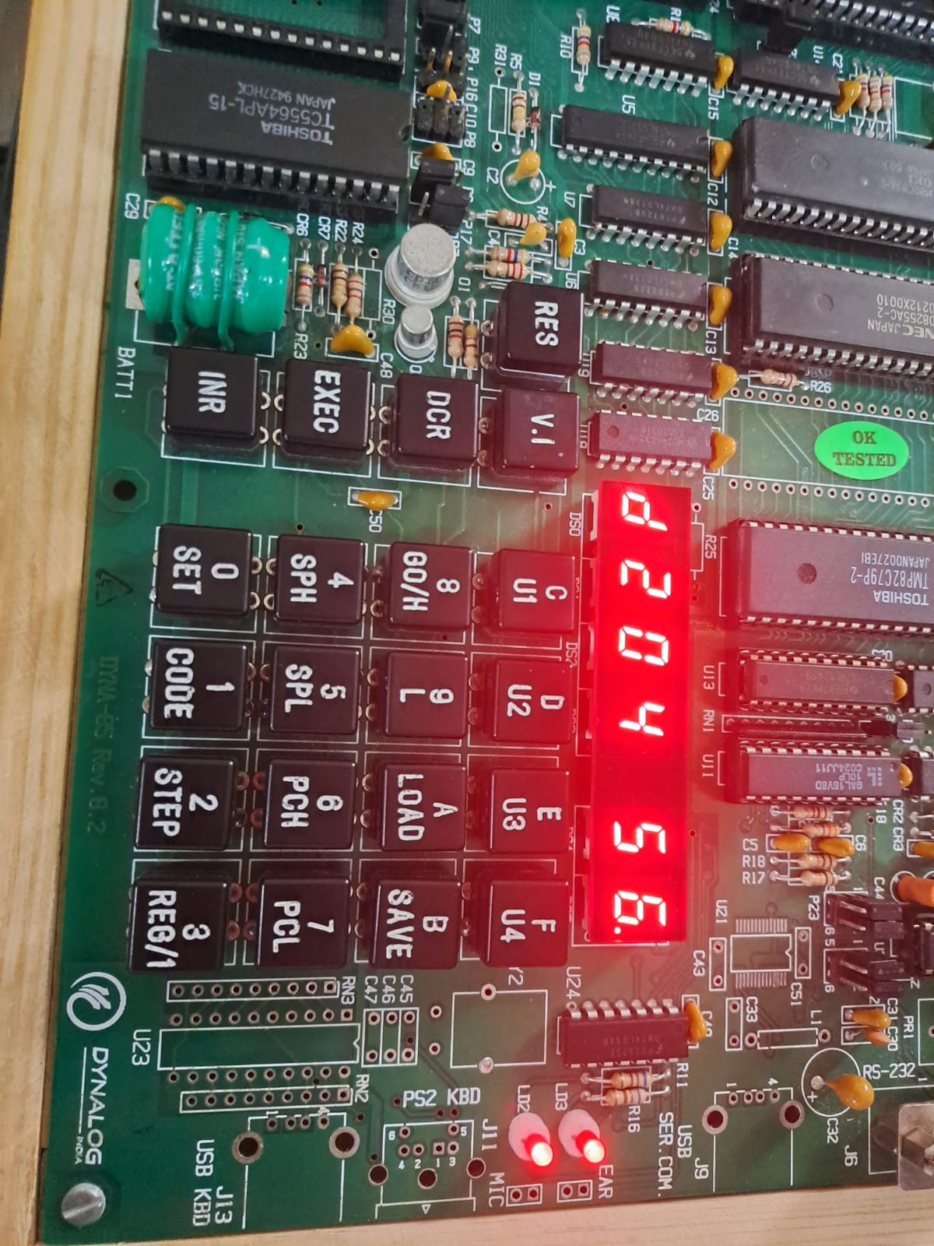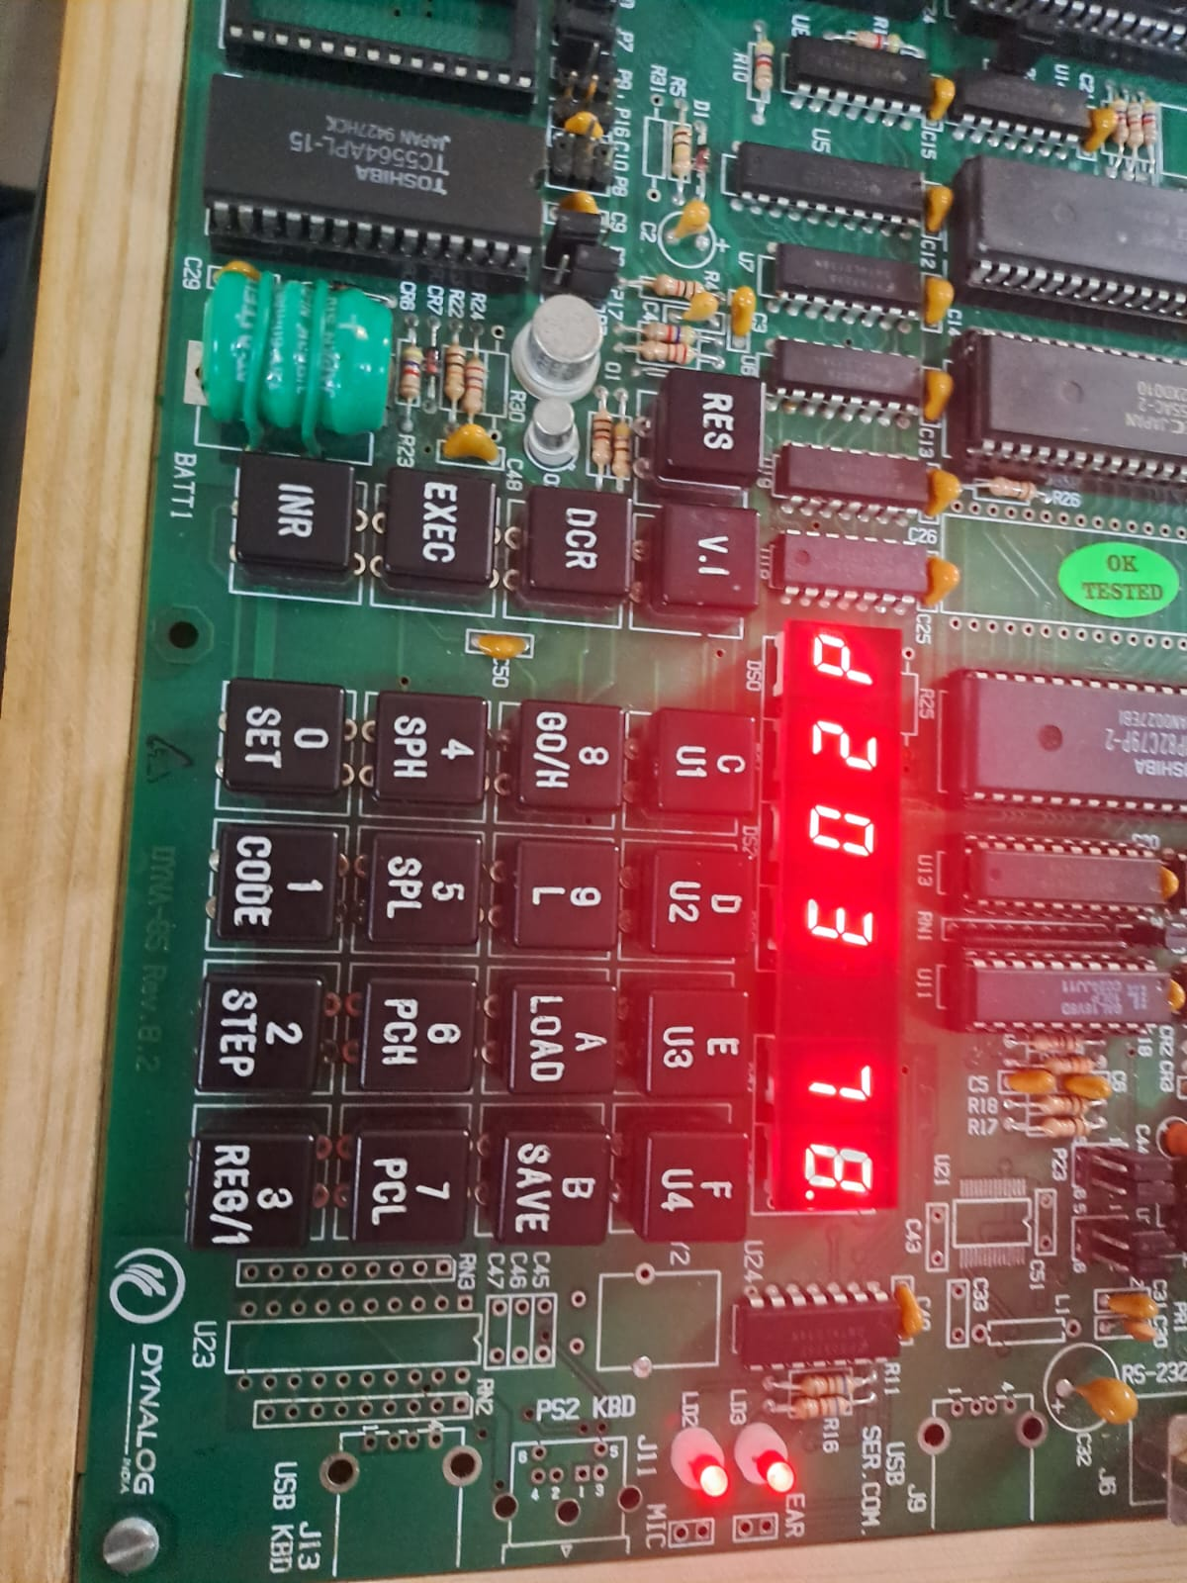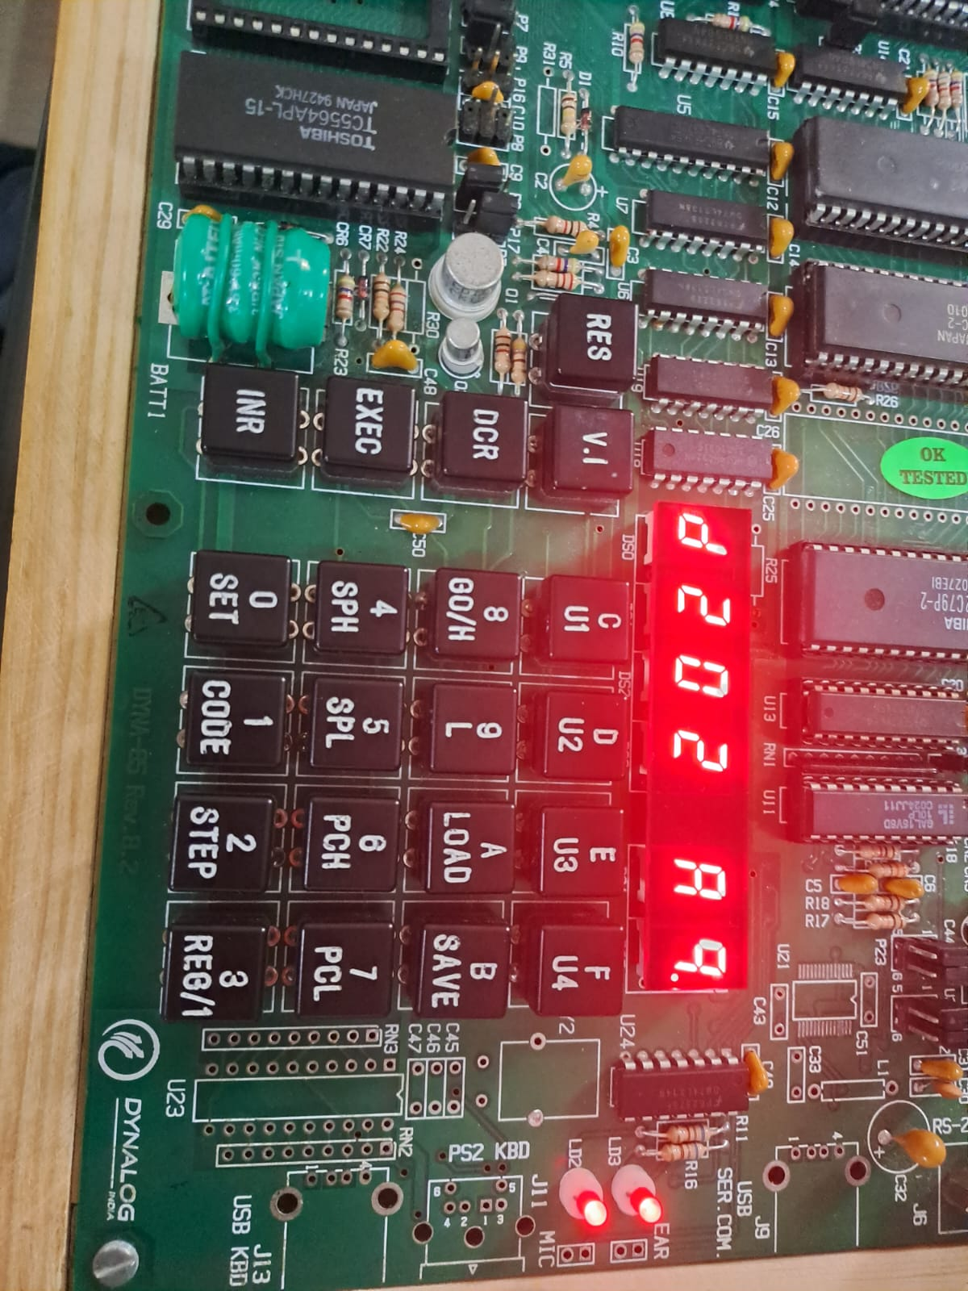

Conclusion:  
Successfully found the largest and the smallest number of an array with the help of both software and Hardware.