ASSIGNMENT 7:

## TITLE: Sorting an array

PRN: 22510034 Date:29-10-23

Aim:

Write an assembly language code to sort an array in ascending and descending order. Choose suitable value for m. Perform the same on Dyna85 kit.

Procedure:

-Install and open the GNU 8085 Simulator on the computer device, Create and Open the new project and name it as Memory Management.

-Write the assembly language program according to the question and Assemble and Run it.

-Perform the similar operations on DYNA 8085 kit.

Result:

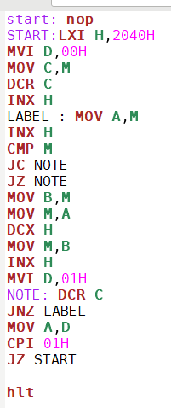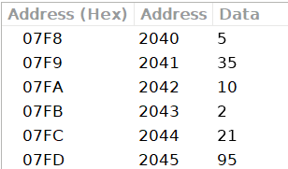

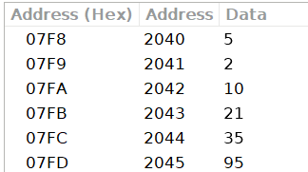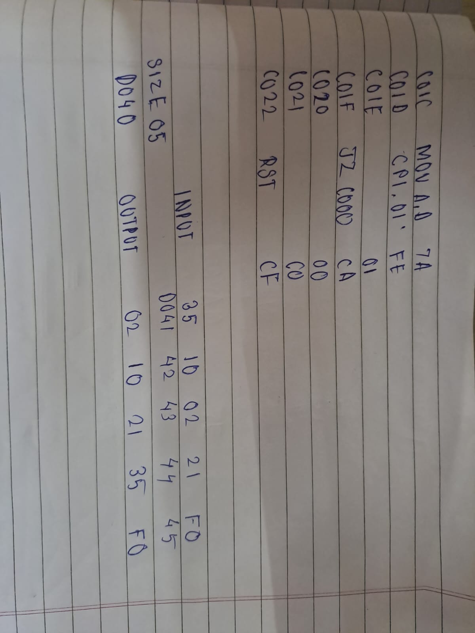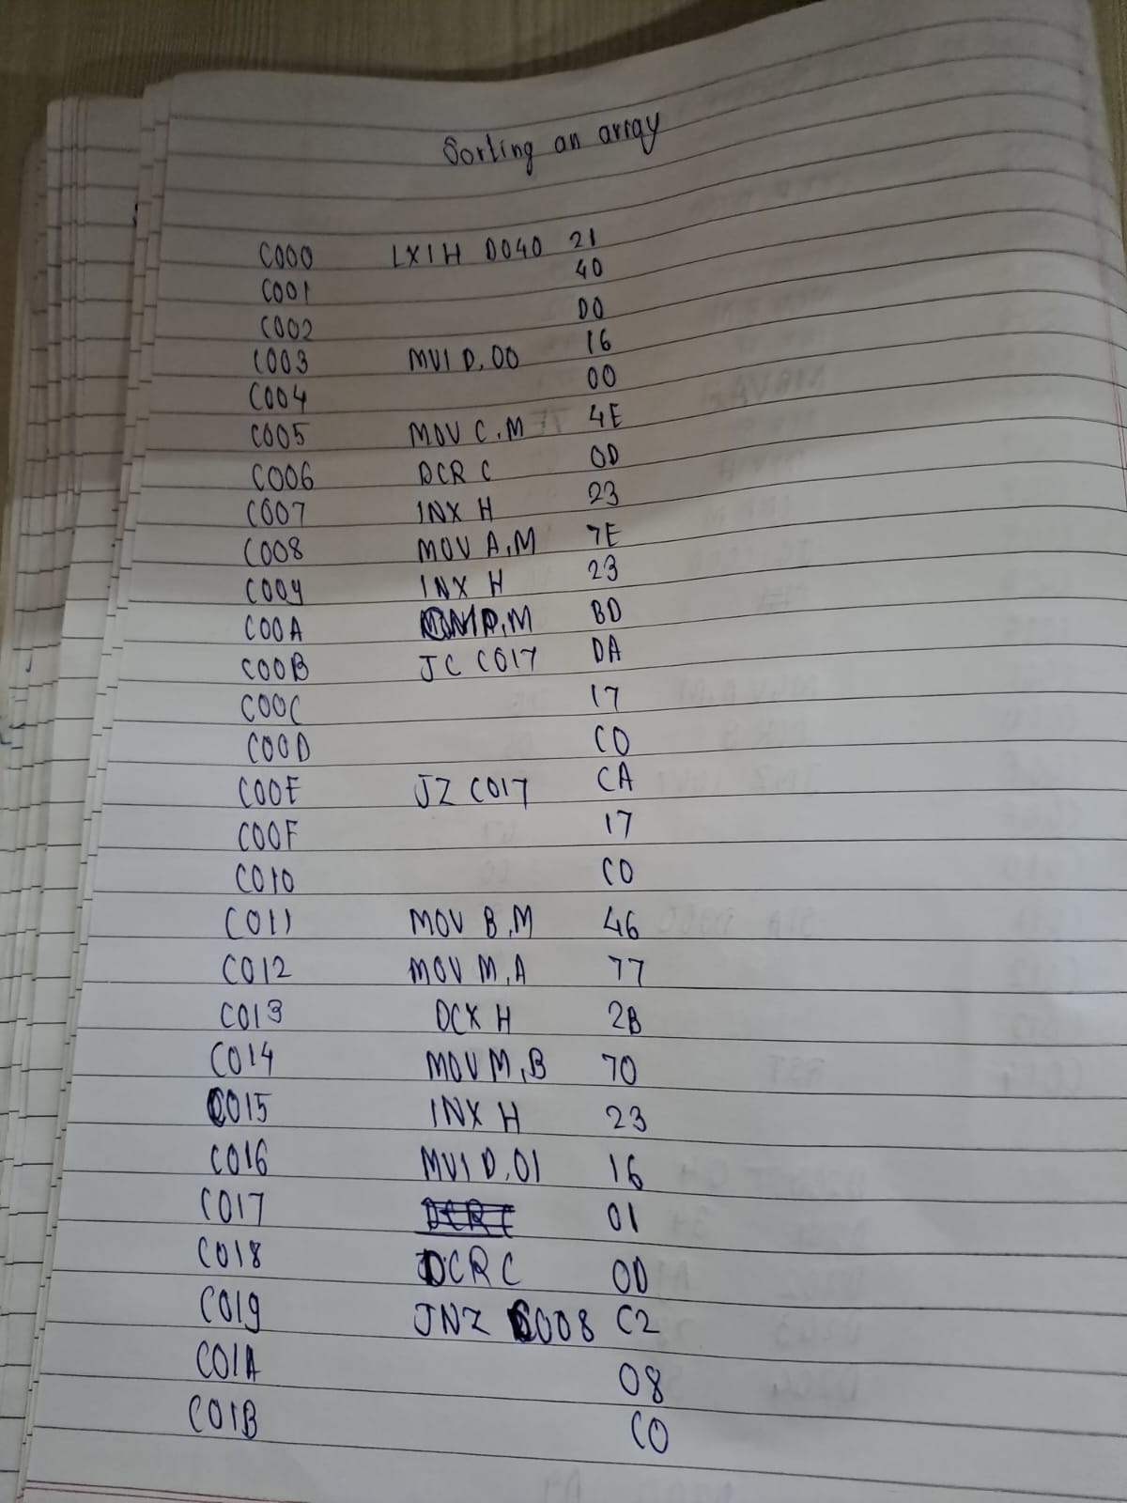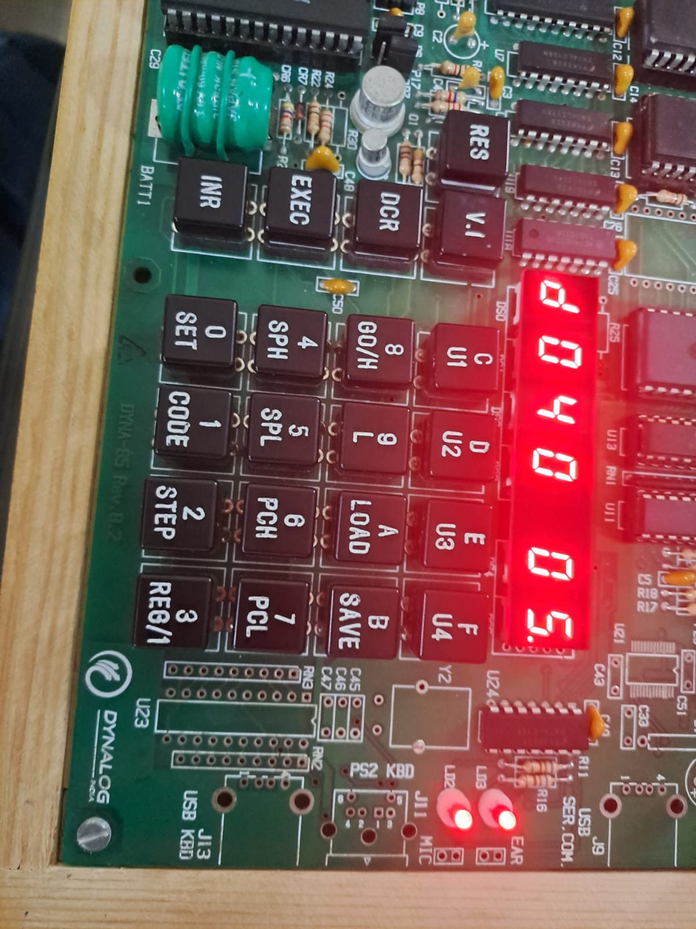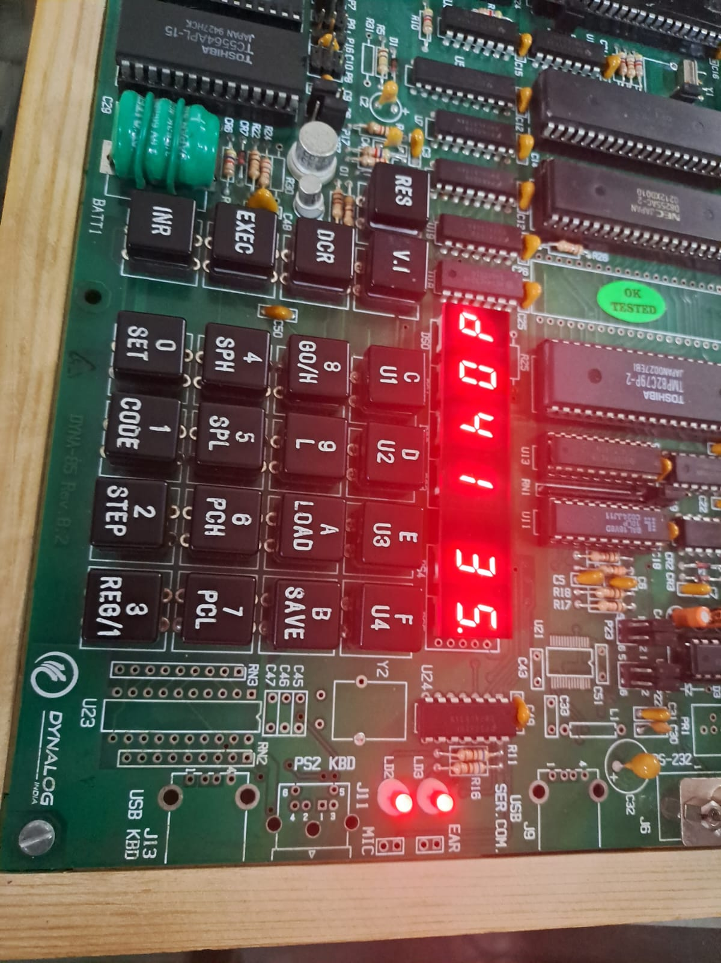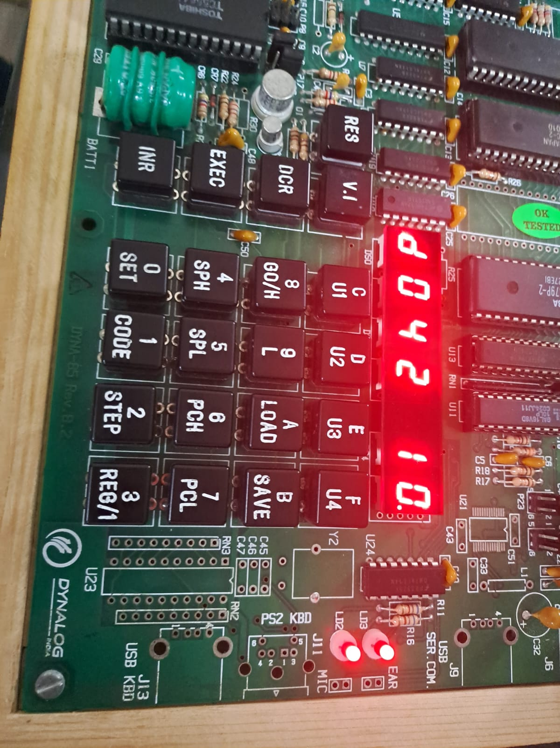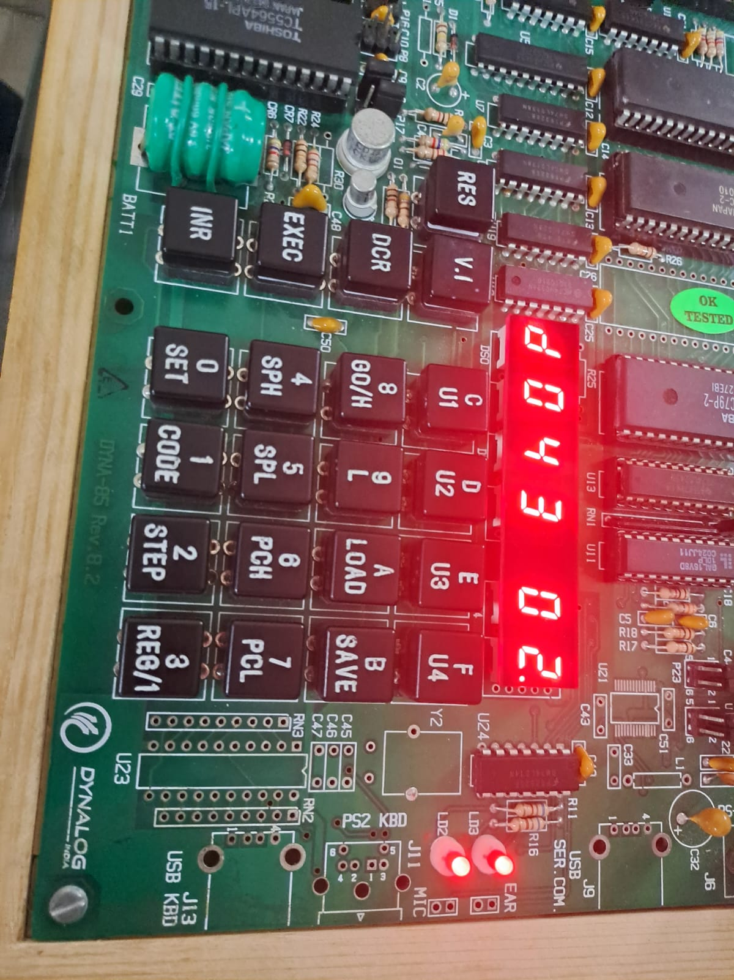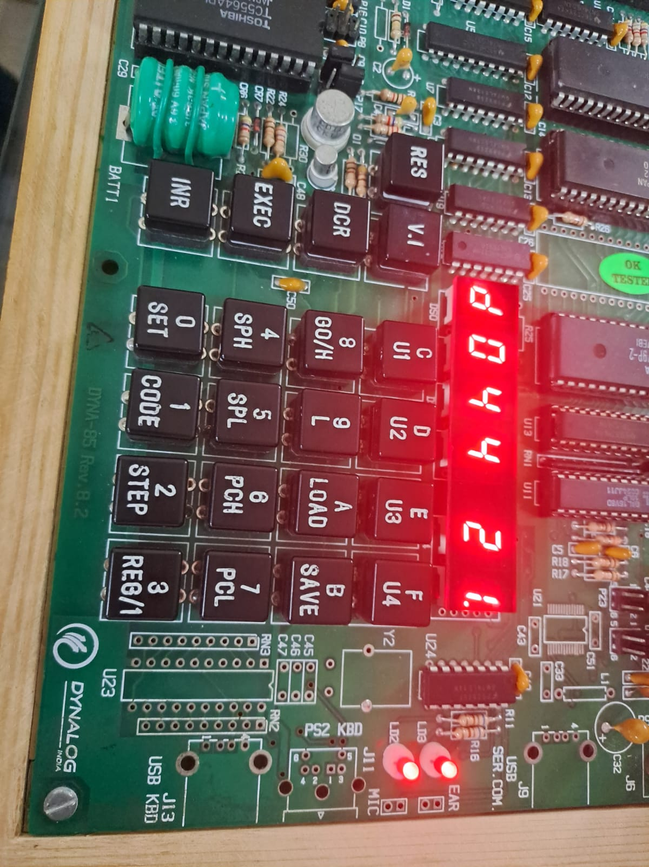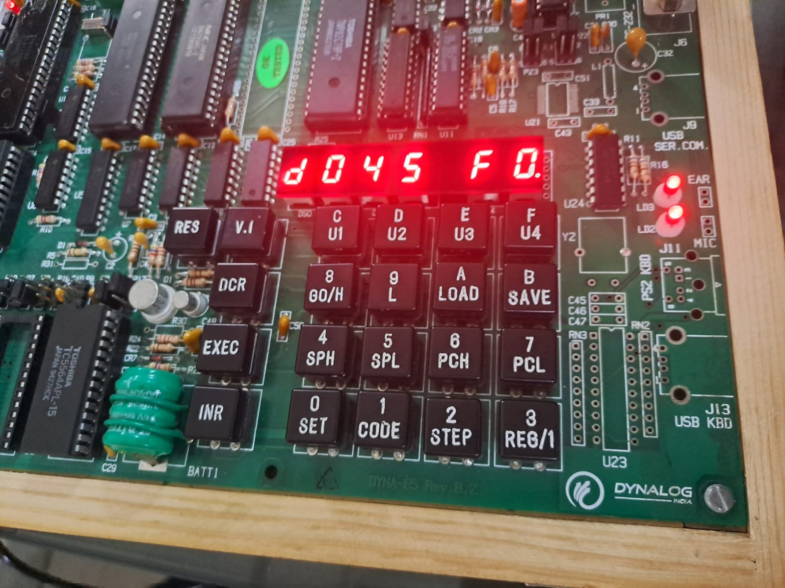

Conclusion:  
Successfully sorted an array on GNU 8085 simulator but not on the DYNA 8085 kit.