ASSIGNMENT 9:

## TITLE: Addition on 8086

PRN: 22510034 Date:20-11-23

Aim:

a.       Perform addition of any two 8-bit numbers on 8086 emulator

b.       Perform addition of any two 16-bit numbers on 8086 emulator

Software Used: emu 8086 Simulator.

Procedure:

-Install and open the emu 8086 Simulator on the computer device, Create and Open the new project and name it as Addition of two numbers.

Results:

8-Bit Addition:

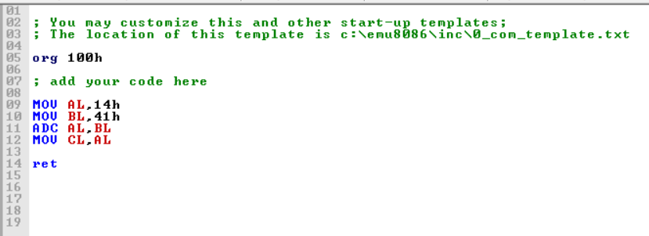

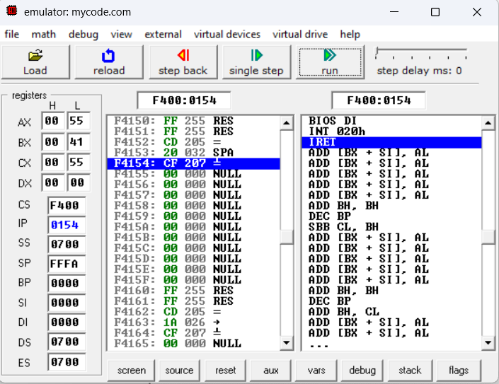

16-Bit Addition:

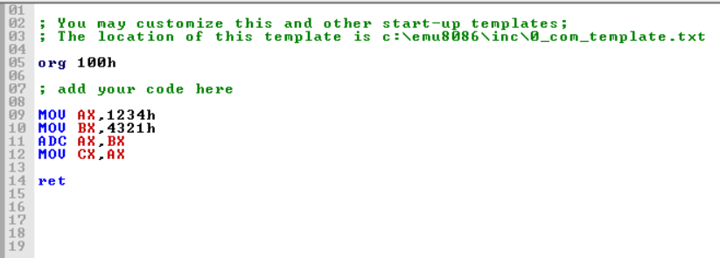

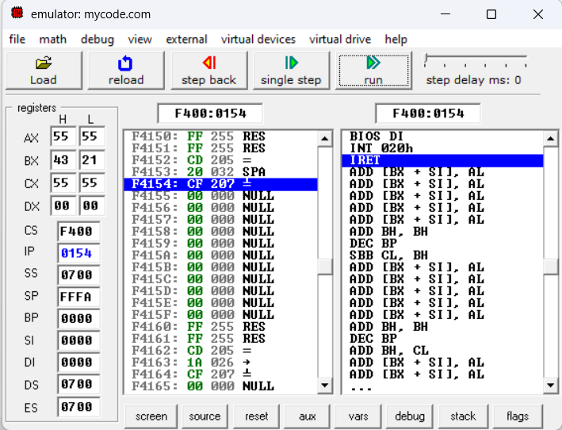

Conclusion: By using emu8086 software I understood the basic functioning of it with the help of arithmetic operations.