Walchand College of Engineering, Sangli

Computer Science & Engineering

Third Year

Course: Design and analysis of algorithm Lab

Lab course coordinator:

Mrs A M Chimanna- Batch: - T1, T2,T3,T4

**Week 2 Assignment**

**Searching Algorithm**

Q.1You are an IT company's manager. Based on their performance over the last N working days, you must rate your employee. You are given an array of N integers called workload, where workload[i] represents the number of hours an employee worked on an ith day. The employee must be evaluated using the following criteria:

* Rating = the maximum number of consecutive working days when the employee has worked more than 6 hours.

You are given an integer *N*where *N* represents the number of working days. You are given an integer array *workload*where *workload[i]* represents the number of hours an employee worked on an ith day.

**Task**

Determine the employee rating.

Q.2 You have N boxes numbered 1 through N and K candies numbered 1 through K. You put the candies in the boxes in the following order:

* first candy in the first box,
* second candy in the second box,
* .......
* ........
* so up to N-th candy in the Nth box,
* the next candy in (N - 1)-th box,
* the next candy in (N - 2)-th box
* ........
* .......
* and so on up to the first box,
* then the next candy in the second box
* ......    and so on until there is no candy left.

So you put the candies in the boxes in the following order:

Find the index of the box where you put the K-th candy.

Q.3 Implement and Explain Tower of Hanoi algorithm.

Q.4 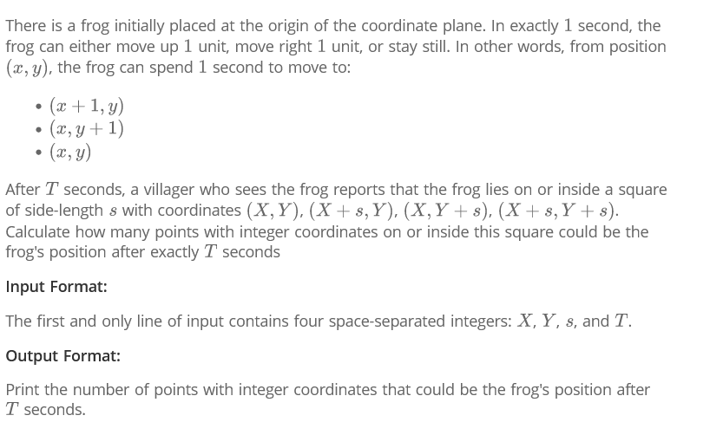

Q.5 Implement linear search Algorithm.

Q.6 Implement Binary Search algorithm.