**Assignment – 3**

Name : Om Kulkarni Date : 02/02/25

Class : TY CSE

PRN : 22510034 Batch : T-3

**(Building, Running and Debugging an app)**

1. Perform building, running and debugging of an ios application. (Refer page no 81 to 88).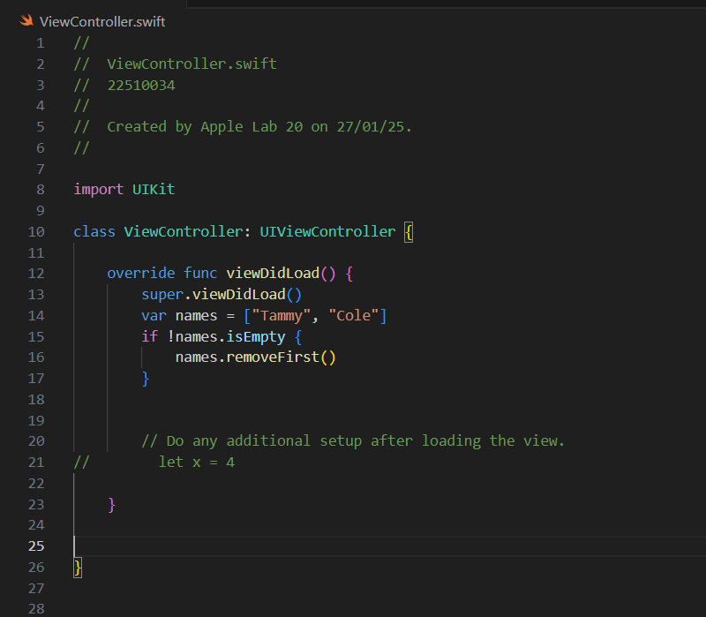
2. Implement Apple Light project (Use guided project reference given on page no 119).

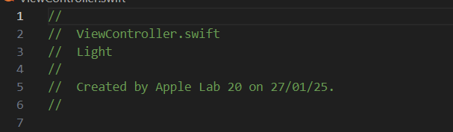

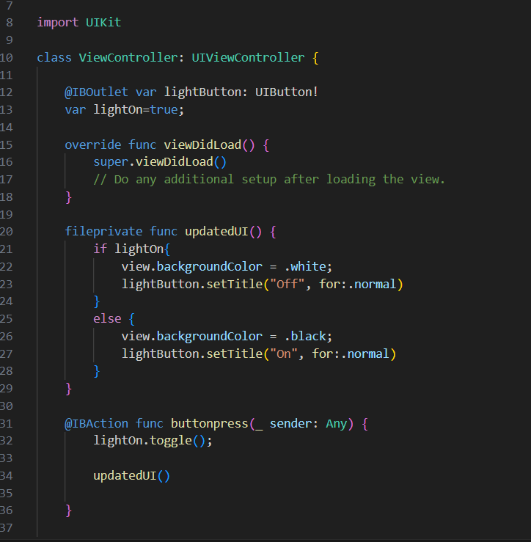

Output for 2nd question :   
