Programming Lab-2 ESE
PRN: 22510034 Course Code: 6CS271
Name: Om Prasanna Kulkarni
Date: 29/04/24

Q.1) Create calculator application such that client sends input and server implements required arithmetic operation and reply with result to client.

Ans :
Server side code
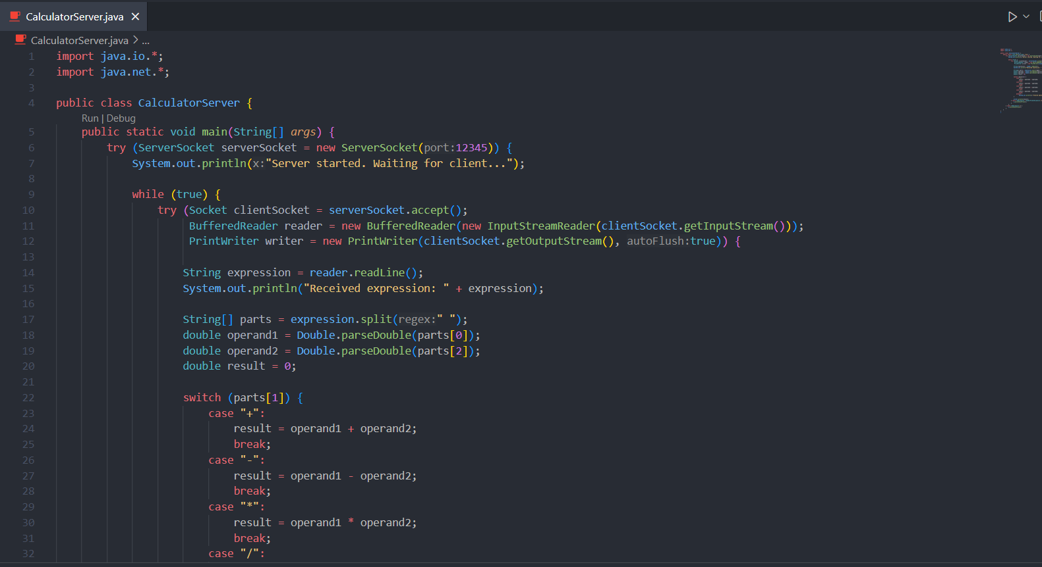
Client side code
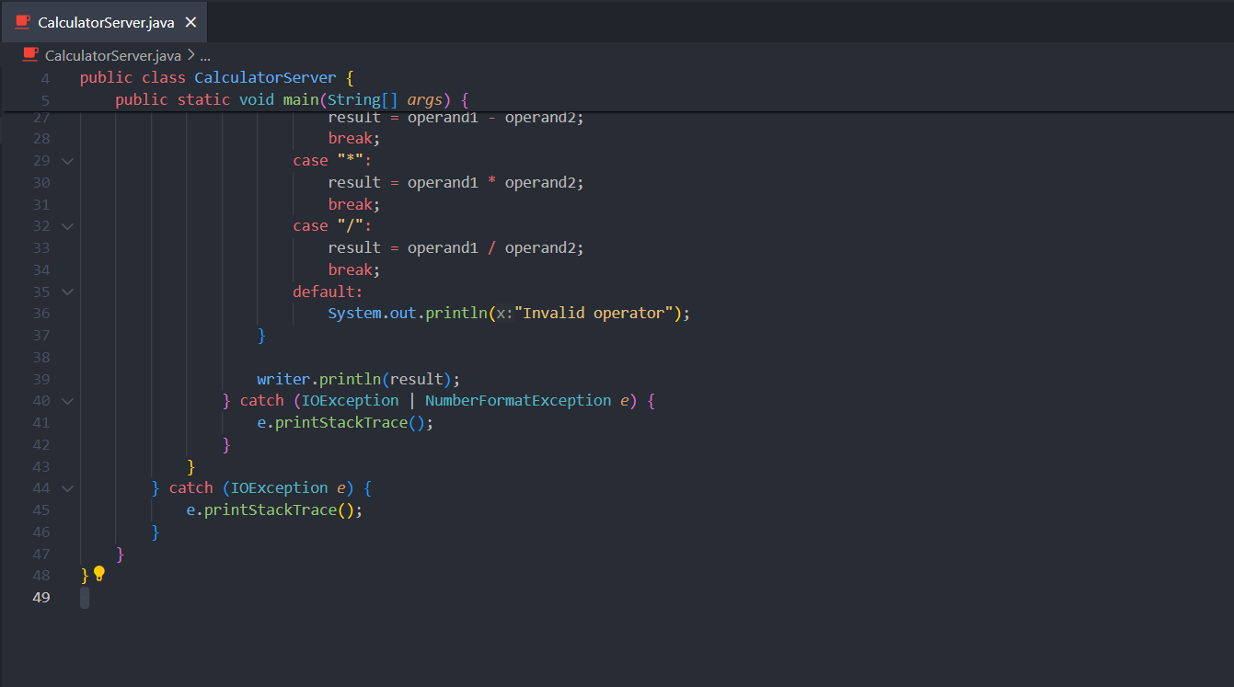
OUTPUT :
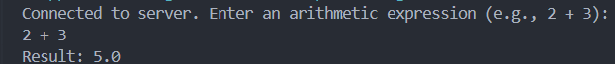

Q.2) Write a java program to read content from a file and write a content to file. suppose you are provided with buffer of size 30 bytes then how many read and write operation with given buffers are required.
Ans :
Output File before execution
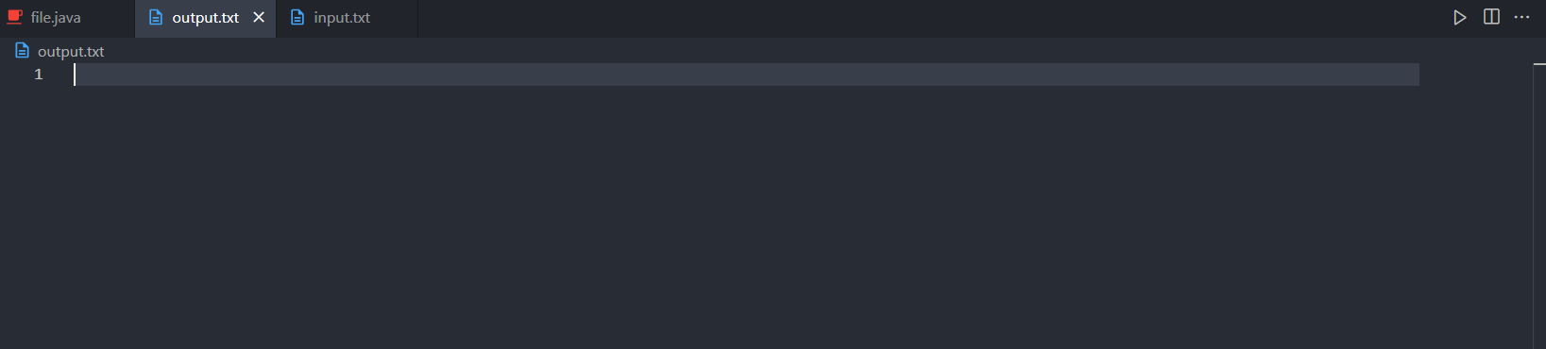
OUTPUT
Terminal :
Input.txt
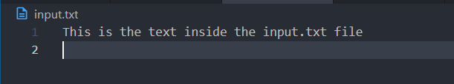
Output.txt
