ASSIGNMENT -1
PRN : 22510034 DATE : 12/01/24
Batch : S2
Subject : Programming Lab 2(6CS271)
Topic : Basic Installation and Programs

Q.1)Write steps for Installation of jdk package. Write procedure to set environment variable PATH.
Solution :

Step-1 :Go to official Jdk website
Install java for windows by downloading the installer executable file (.exe).

Step-2 :Run Installer
Double-click the downloaded installer executable file to start the installation.

Step-3 : Follow Installation Wizard
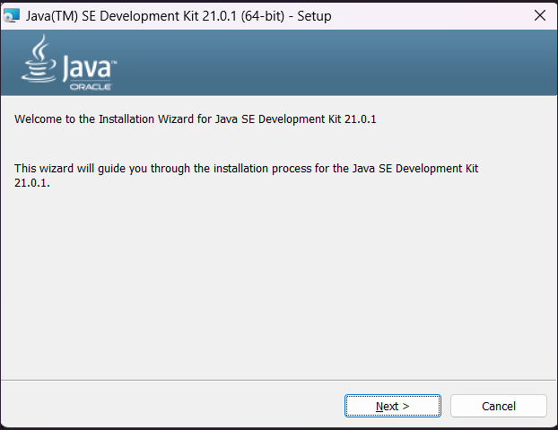
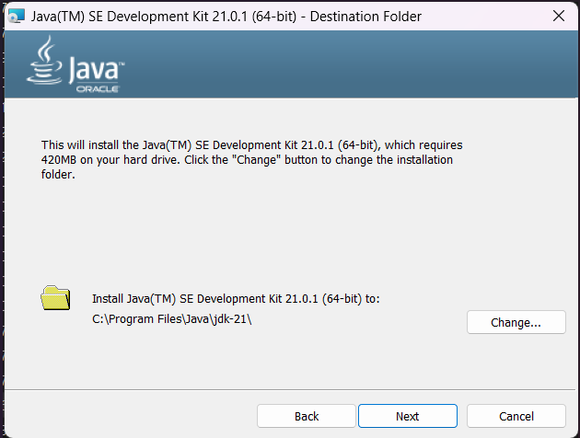
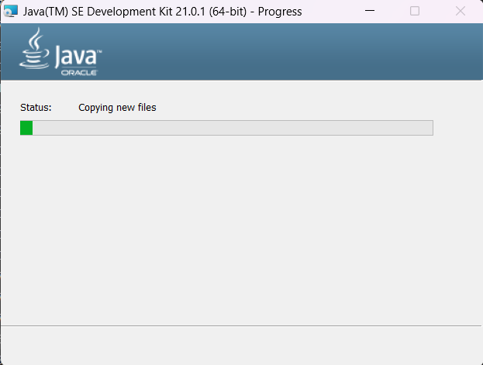

Now For the PATH Setup :

1. Find JDK Installation Directory:
- Locate the directory where JDK is installed. This is usually something like C:\Program Files\Java\jdk-<version>.
2. Copy JDK Path:
- Copy the path to the JDK installation directory. You will need this to set the PATH variable.
3. Open System Properties:
- Right-click on the Start button and select "System".
- Click on "Advanced system settings" on the left.
4. Open Environment Variables:
- In the System Properties window, click the "Environment Variables" button.
5. Edit User or System Variables:
- In the Environment Variables window, under either "User variables" or "System variables" (depending on whether you want to set the variable for your user or all users), find and select the "Path" variable in the list.
- Click on the "Edit" button.
6. Add JDK to Path:
- Click "New" and paste the path to the JDK's "bin" directory (e.g., C:\Program Files\Java\jdk-<version>\bin).
- Click "OK" to close each of the windows.
7. Verify Installation:
- Open a new Command Prompt (CMD) window and type java -version and javac -version to verify that the installation was successful.

Q.2)Describe JDK, JRE, JVM.
Solution:
JDK (Java Development Kit):

Purpose: Comprehensive toolkit for Java development.
Includes: Java Compiler (javac), Java Virtual Machine (JVM), development tools.
Usage: Developers use it to build, compile, and run Java applications.
JRE (Java Runtime Environment):

Purpose: Runtime environment for executing Java applications.
Includes: Java Virtual Machine (JVM), core libraries, necessary for running Java applications.
Usage: End-users who only need to run Java applications.
JVM (Java Virtual Machine):

Purpose: Virtual machine that executes Java bytecode.
Functionality: Interprets or compiles Java bytecode, abstracts hardware details.
Usage: Provides a runtime environment for Java applications, ensuring platform independence. Used by both JDK and JRE.

Q.3) Differentiate between C, C++, JAVA.
Solution:
C:
1. Procedural Language:
- C is a procedural programming language.
- It follows a top-down approach and is based on functions or procedures.

2. Low-Level Programming:
- Closer to the hardware, allowing manual memory management.
- Supports pointers and direct memory manipulation.

3. No Classes or Objects:
- Lacks features of object-oriented programming.
- Does not support classes or objects.

4. Limited Standard Library:
- Standard Library is smaller compared to C++ or Java.
- Requires additional libraries for various functionalities.

C++:

1. Object-Oriented Programming:
- C++ is an extension of C with added object-oriented features.
- Supports classes and objects for better code organization.

2. Operator Overloading:
- Allows overloading of operators for user-defined types.
- Provides a concise and expressive way to work with custom data types.

3. Standard Template Library (STL):
- Extensive Standard Template Library for data structures and algorithms.
- Provides generic classes and functions for common programming tasks.

4. Memory Management:
- Supports manual memory management similar to C.
- Introduces features like constructors and destructors for better resource management.

5. Exception Handling:
- Incorporates exception handling for better error management.
- Enables robust error recovery mechanisms.

Java:

1. Platform-Independent:
- Java code is compiled into bytecode, which runs on the Java Virtual Machine (JVM).
- Achieves platform independence, allowing "write once, run anywhere" (WORA).

2. Object-Oriented Programming:
- Strictly follows object-oriented principles.
- Everything in Java is an object, except primitive data types.

3. Automatic Memory Management:
- Uses automatic garbage collection for memory management.
- Developers don't need to explicitly free memory.

4. Rich Standard Library:
- Provides a comprehensive standard library with built-in packages.
- Includes libraries for networking, graphical user interfaces (GUI), and more.

5. No Pointers:
- Java omits explicit pointer manipulation.
- Uses references, but they are not as low-level as pointers in C or C++.

6. Multithreading Support:
- Built-in support for multithreading.
- Enables concurrent execution of multiple threads.

Q.4)Explain simple Hello World Program in Java. Explain compilation and Execution of java program.
Solution:

Source Code:
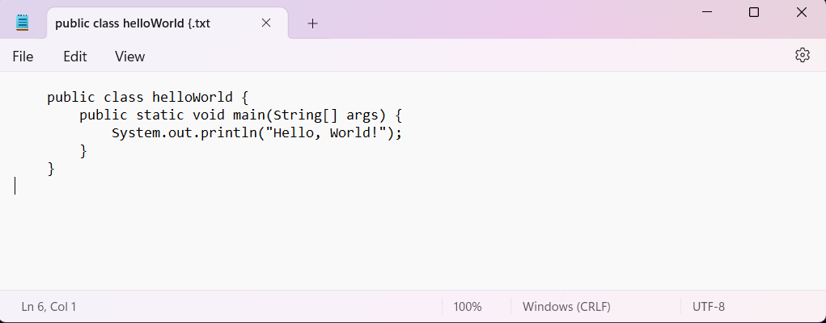

public class HelloWorld: This line declares a class named HelloWorld. In Java, every application must have at least one class, and the name of the class should match the filename (in this case, it should be saved as HelloWorld.java).

public static void main(String[] args): This line declares the main method, which is the entry point of the Java program. Execution of the program starts from the main method.

System.out.println("Hello, World!");: This line prints the string "Hello, World!" to the console. The System.out.println is used to display output.

Compilation:

Save the above code in a file named HelloWorld.java.
Open a command prompt or terminal.
Navigate to the directory where HelloWorld.java is located.
To compile the program, use the javac command:
javac HelloWorld.java

Execution:

After successful compilation, you can run the program using the java command:
java HelloWorld

This command runs the Java Virtual Machine (JVM) and tells it to execute the main method of the HelloWorld class :
OUTPUT :
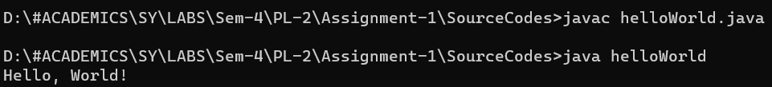

Q.5)Write a java program for reading input of various data types from user using scanner class.

Solution:
Source Code:
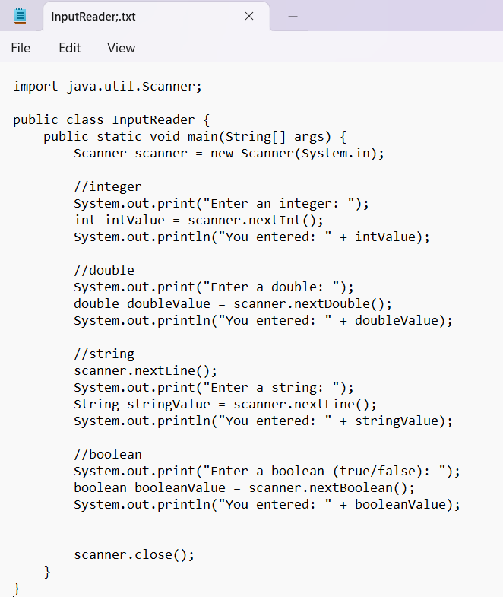
OUTPUT:
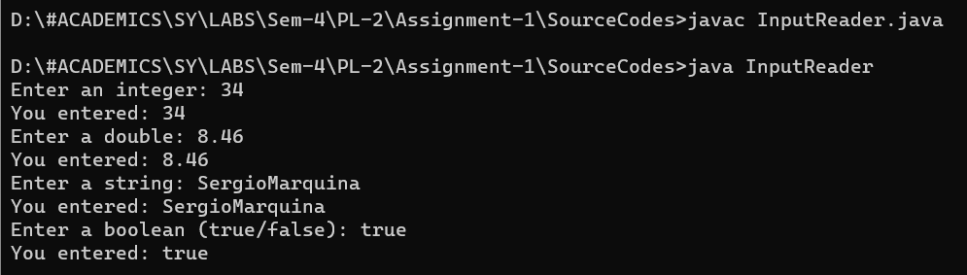

Q.6)Write a java program to convert seconds to hour, minute and seconds.
Solution:
Source Code:
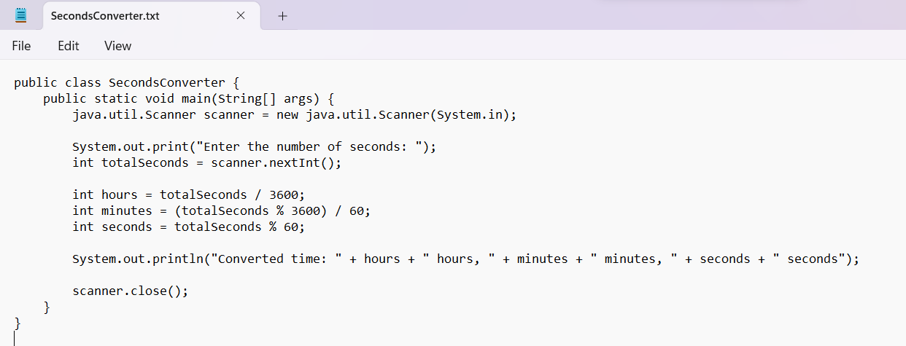

OUTPUT:
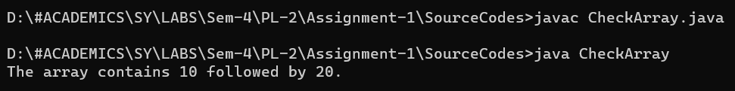

Q.7)Write a Java program to check if there is a 10 in a given array of integers with a 20 somewhere later in the array.
Solution:
Source Code:
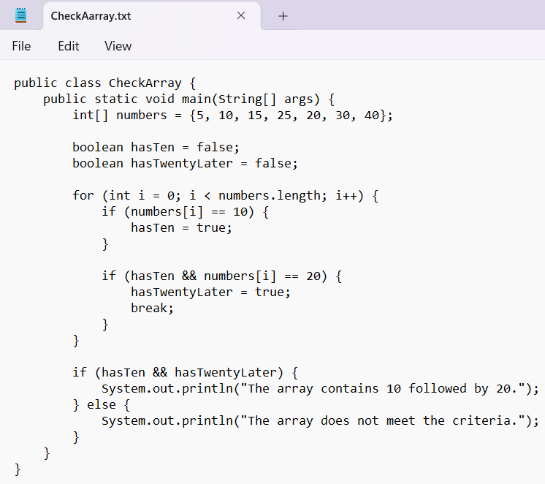

OUTPUT:


Q.8)Write a program to calculate the factorial of a number.( The number is passed as the command-line argument whose factorial we need to calculate.

Solution:
Source Code:
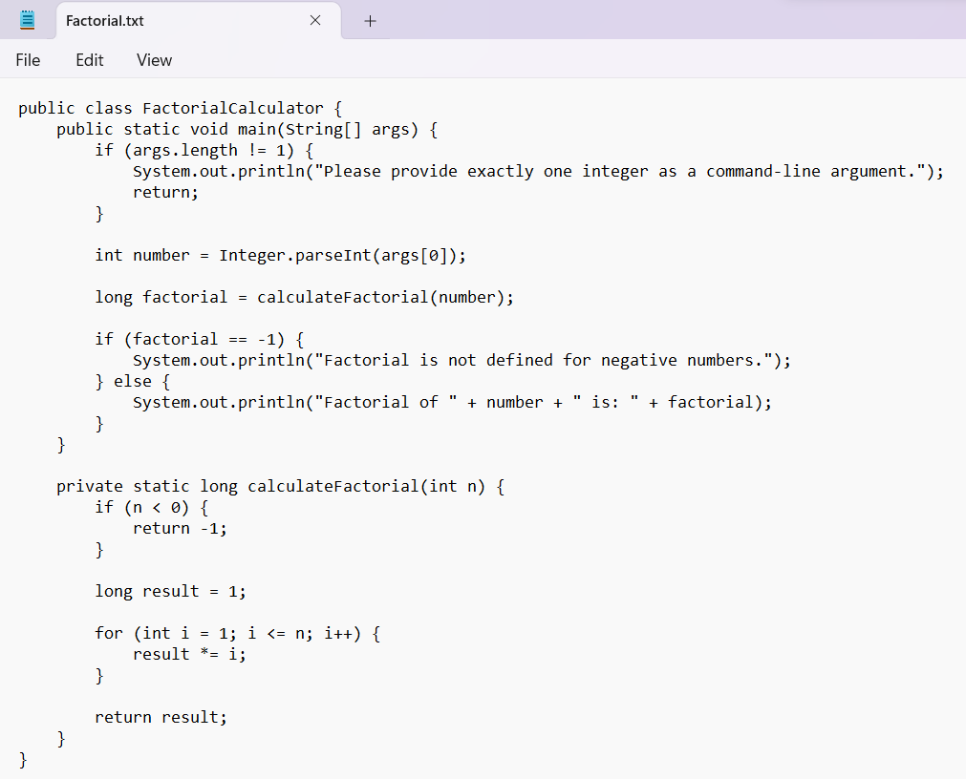
OUTPUT:
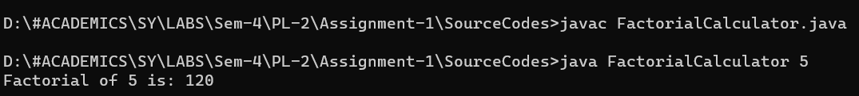

Q.9)Write a Java program to find transpose of matrix.
Solution:
Source Code:
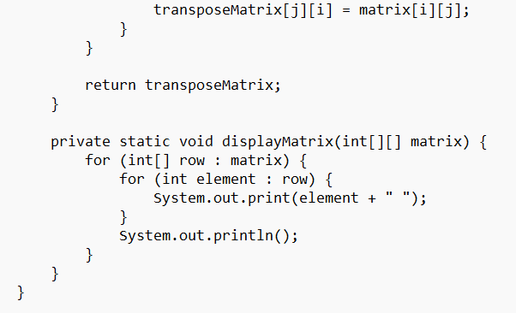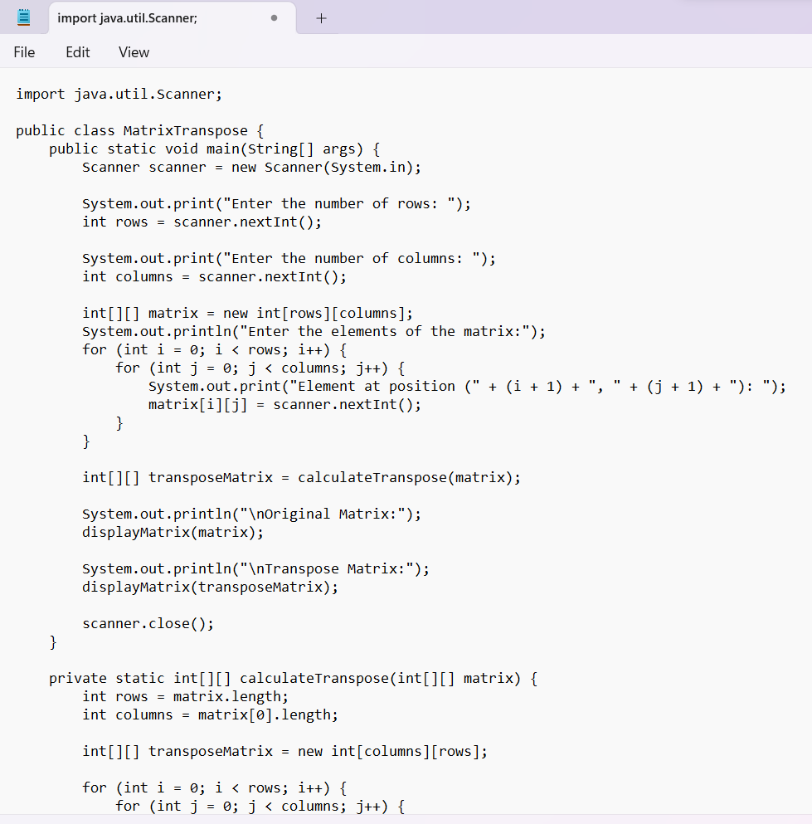

OUTPUT:
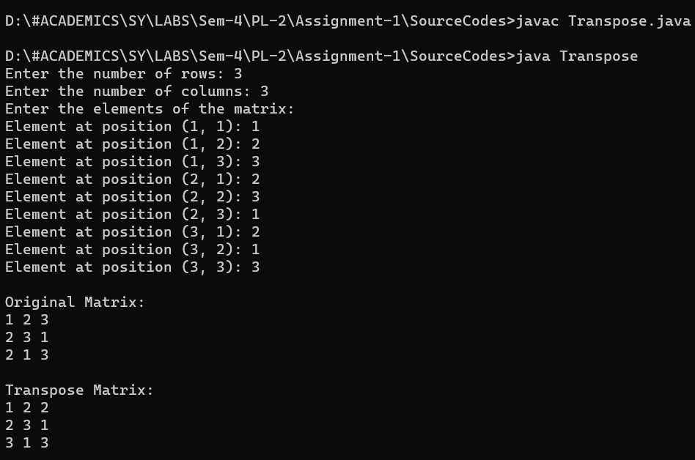

Q.10)Write a program to implement different types of constructors.
Solution:
Source Code:
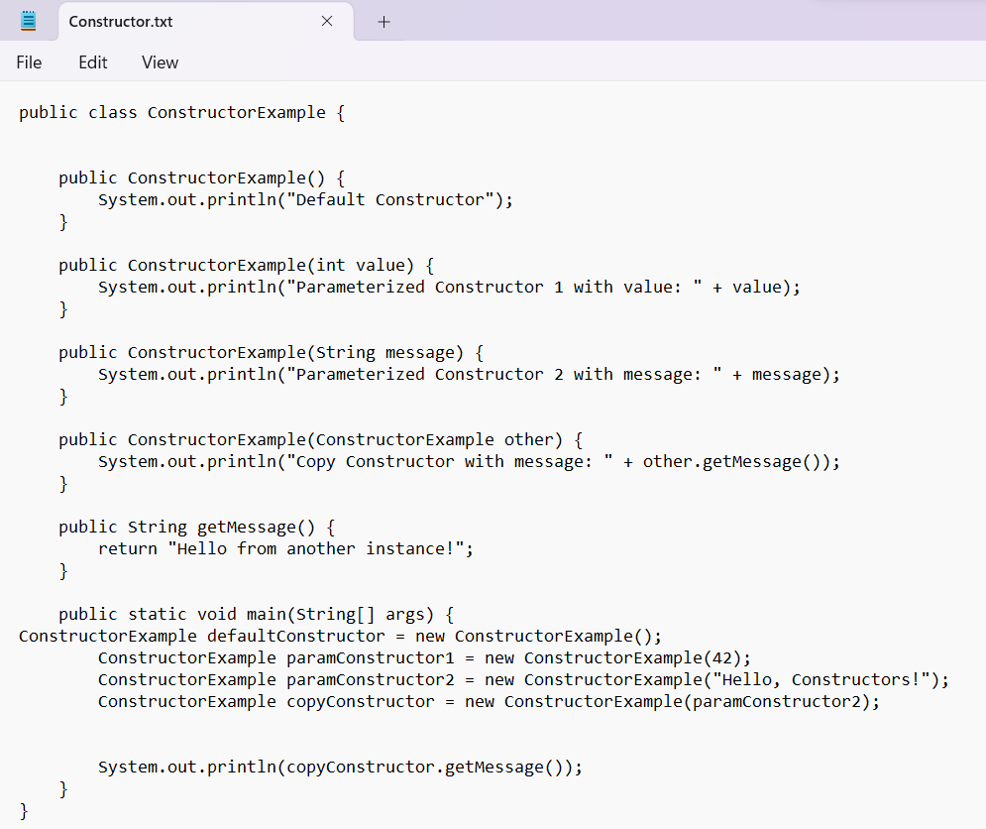
OUTPUT: 