ASSIGNMENT -2
PRN : 22510034 DATE : 12/01/24
Batch : S2
Subject : Programming Lab 2(6CS271)
Topic : Inheritence

Q.1) Explain difference between method overloading and method overriding.

Solution :

Method Overloading | Method Overriding
1)Method overloading is used to increase the readability of the program. | Method overriding is used to provide the specific implementation of the method that is already provided by its super class.
2)Method overloading is performed within class. | Method overriding occurs in two classes that have IS-A (inheritance) relationship  .
3)In case of method overloading, parameter must be different. | In case of method overriding, parameter must be same.
4)Method overloading is the example of compile time polymorphism. | Method overriding is the example of run time polymorphism.
5)In java, method overloading can't be performed by changing return type of the method only. Return type can be same or different in method overloading. But you must have to change the parameter. | Return type must be same or covariant in method overriding.

Q.2)Implement all string functions in Java
Solution :

1)Length of string :
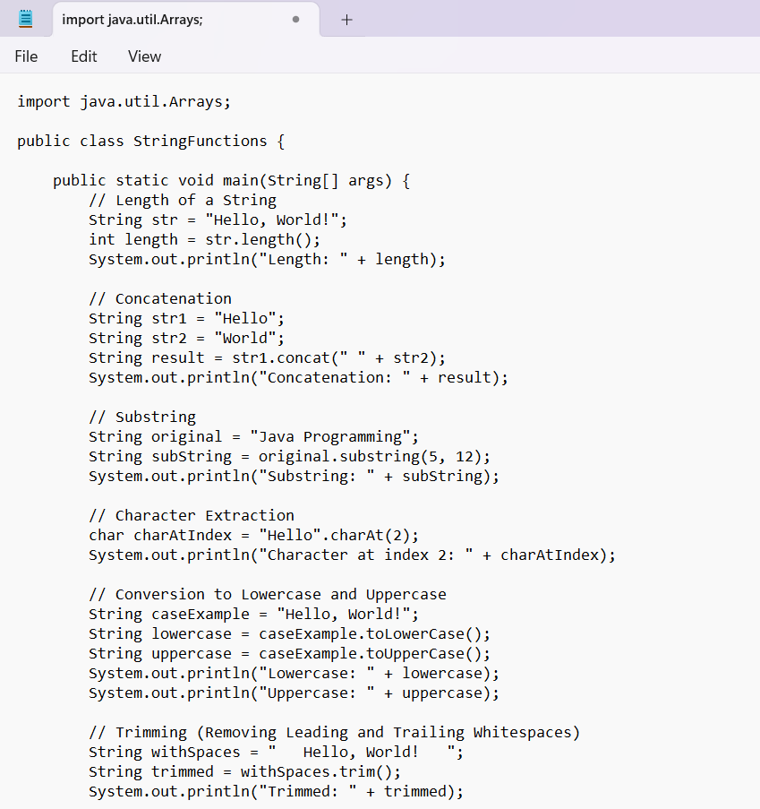
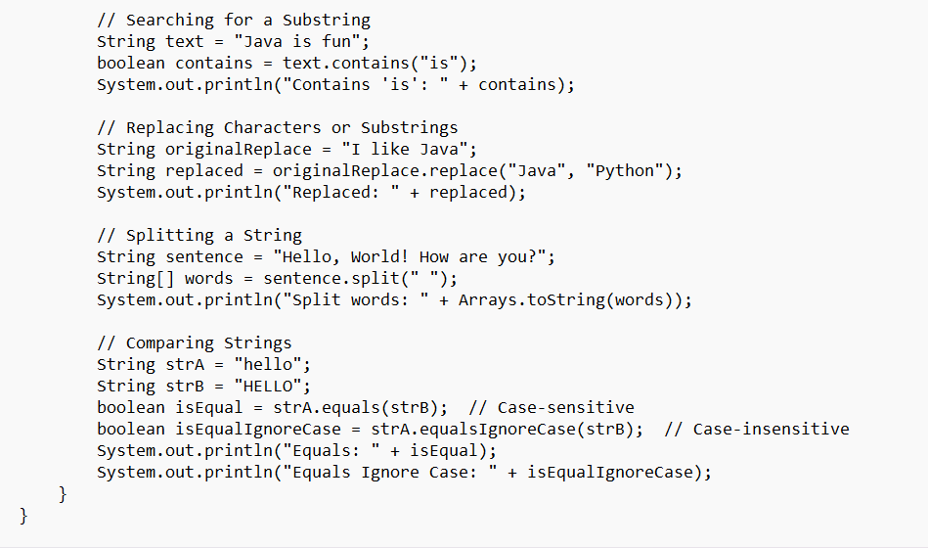
OUTPUT :
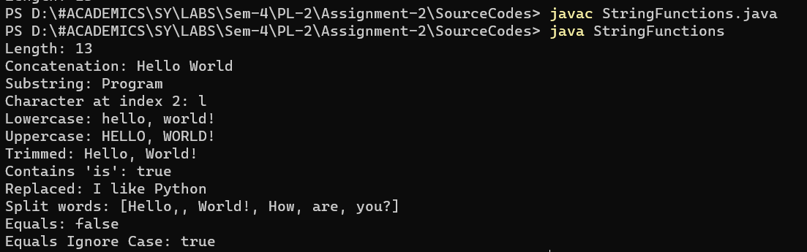

3) Implement all stringbuffer functions in java.
Solution :
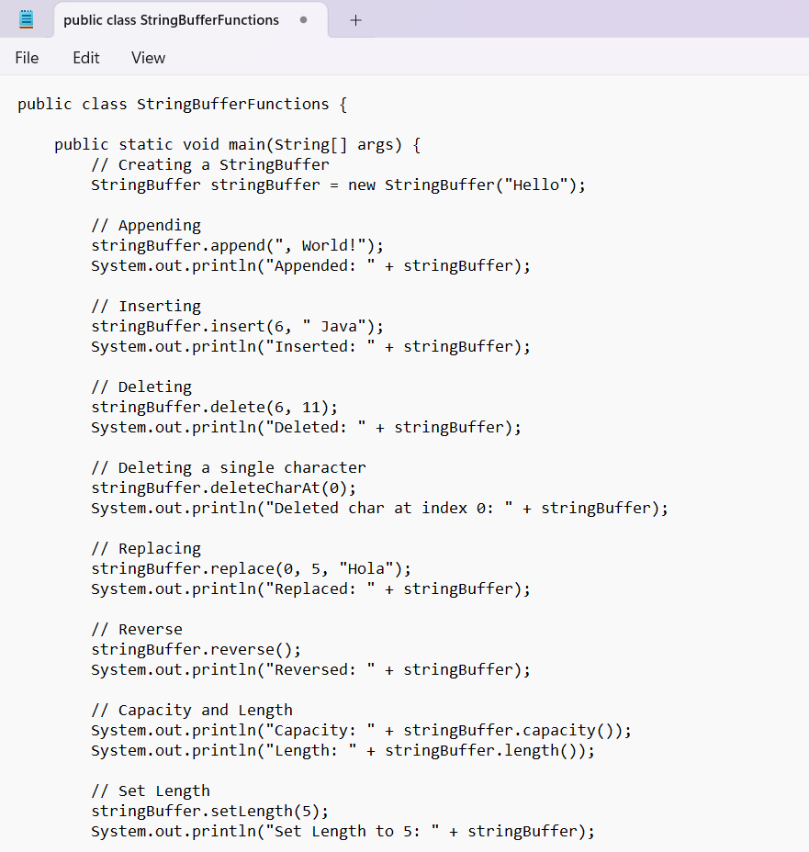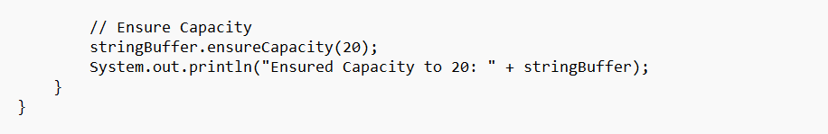

OUTPUT :
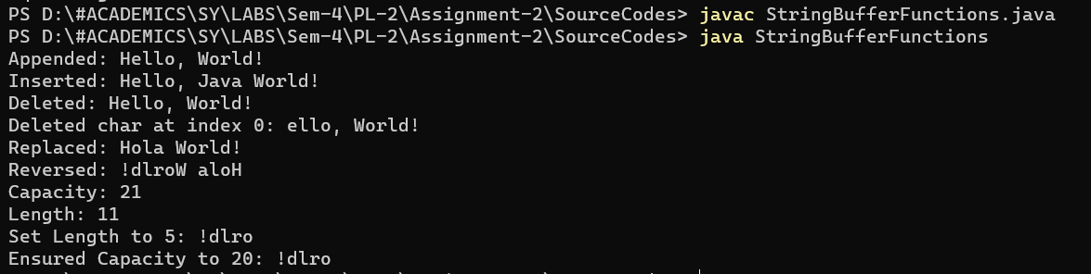

4) Explain with example declaration of string using string literal and new keyword.
Solution :
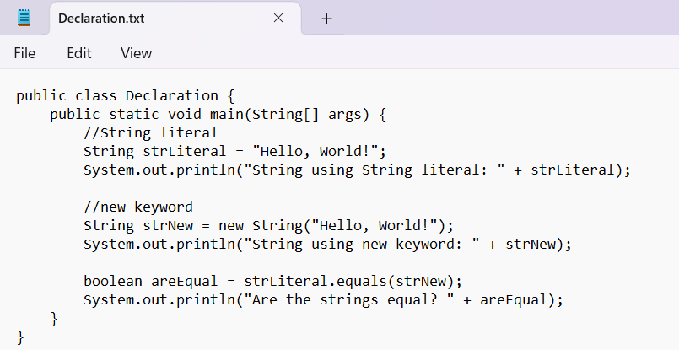
OUTPUT :
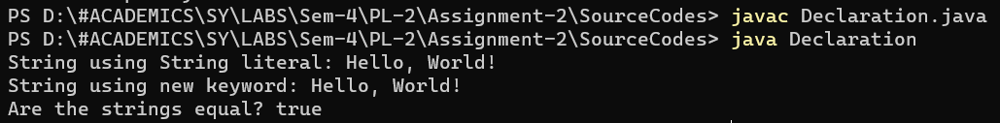

Q.5)
Create a class named 'Shape' with a method to print "This is This is shape". Then create two other classes named 'Rectangle', 'Circle' inheriting the Shape class, both having a method to print "This is rectangular shape" and "This is circular shape" respectively. Create a subclass 'Square' of 'Rectangle' having a method to print "Square is a rectangle". Now call the method of 'Shape' and 'Rectangle' class by the object of 'Square' class.

Solution :
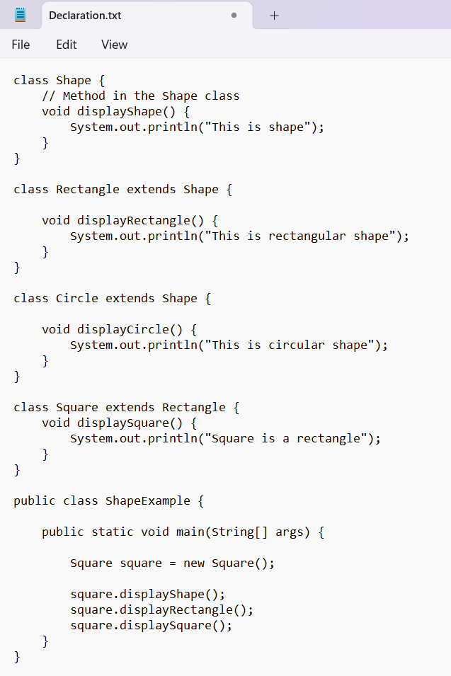
OUTPUT :
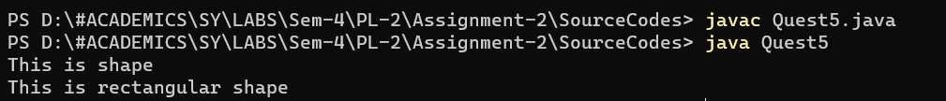

Q.6) WAP to manage the employee allowance from a specific department by creating class structure as follow,
InheritanceEx2
|
|
InheritanceEx2Main.java
|
|- dept | Deparment.java
|
|
|
|- emp | Employee.java extends Department
|
|
|
|- allowance | Allowance.java extends Employee
|
| [Multilevel Inheritance]

Source Code:
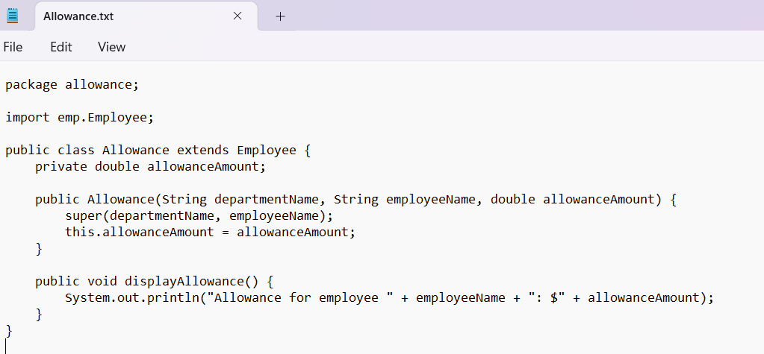
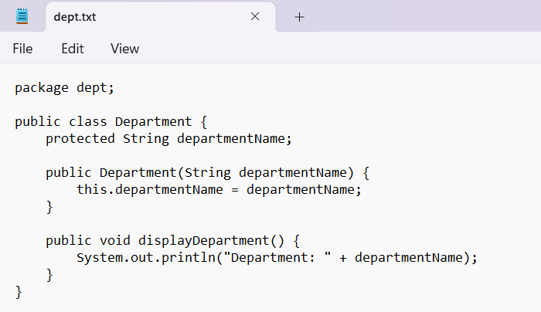
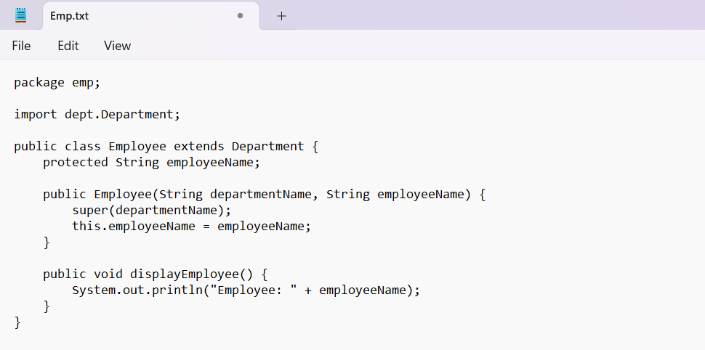
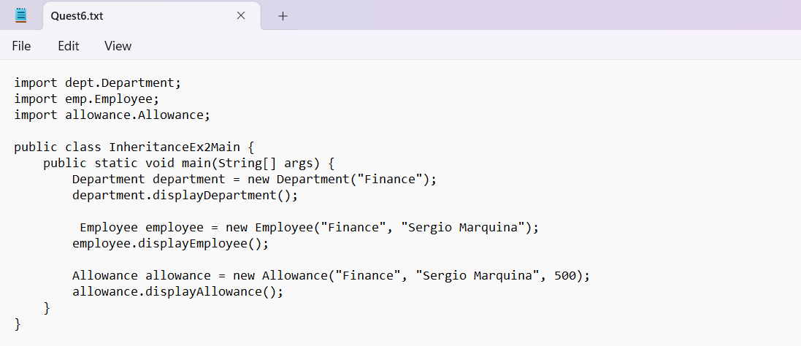
OUTPUT :
Q.7)
Write a Java Program to demonstrate StringBuilder class methods.
SourceCode :
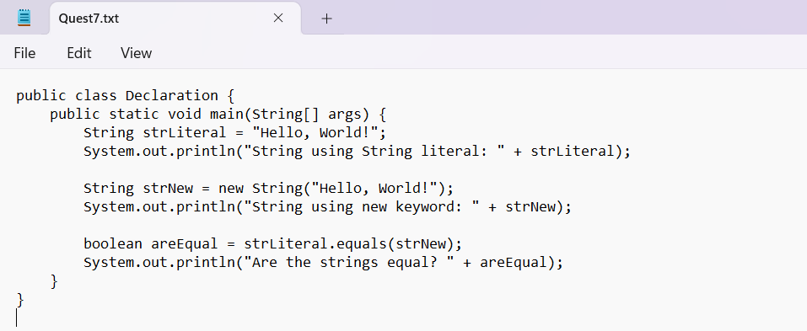
OUTPUT :
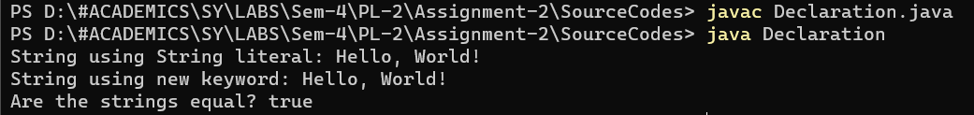
Q.8)
Write a Java Program to demonstrate Method overriding.( create class Result with method result(). Override method result() in UGResult and PGResult class)

Source Codes:
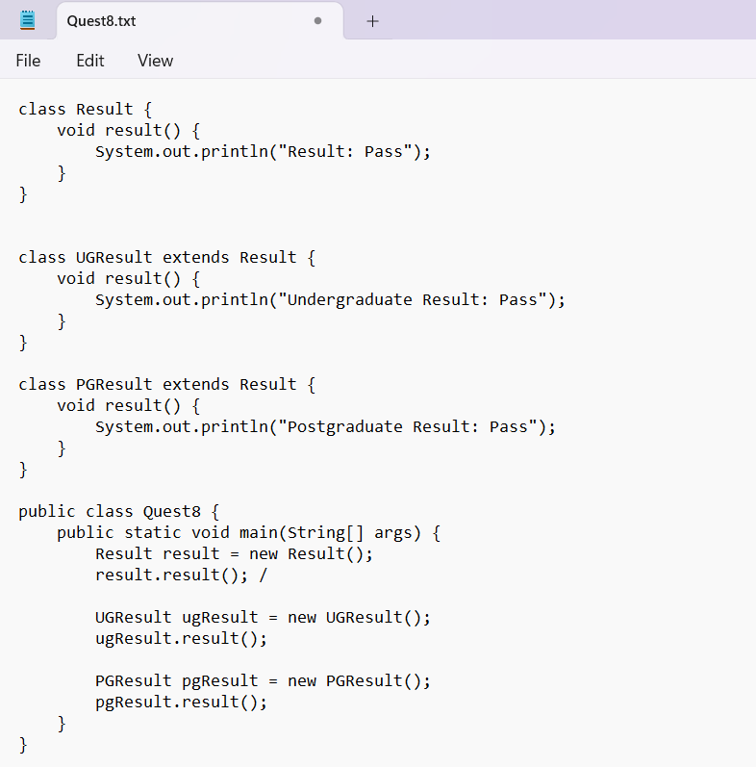
OUTPUT :
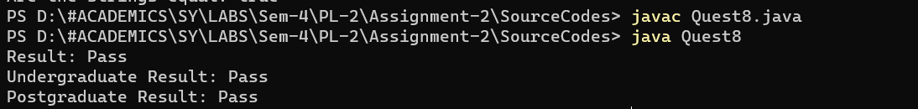
Q.9)
Write a java program to create a class called STUDENT with data members PRN, Name and age. Using inheritance, create a classes called UGSTUDENT and PGSTUDENT having fields as semester, fees and stipend. Enter the data for at least 5 students. Find the semester wise average age for all UG and PG students separately.
Source Codes :
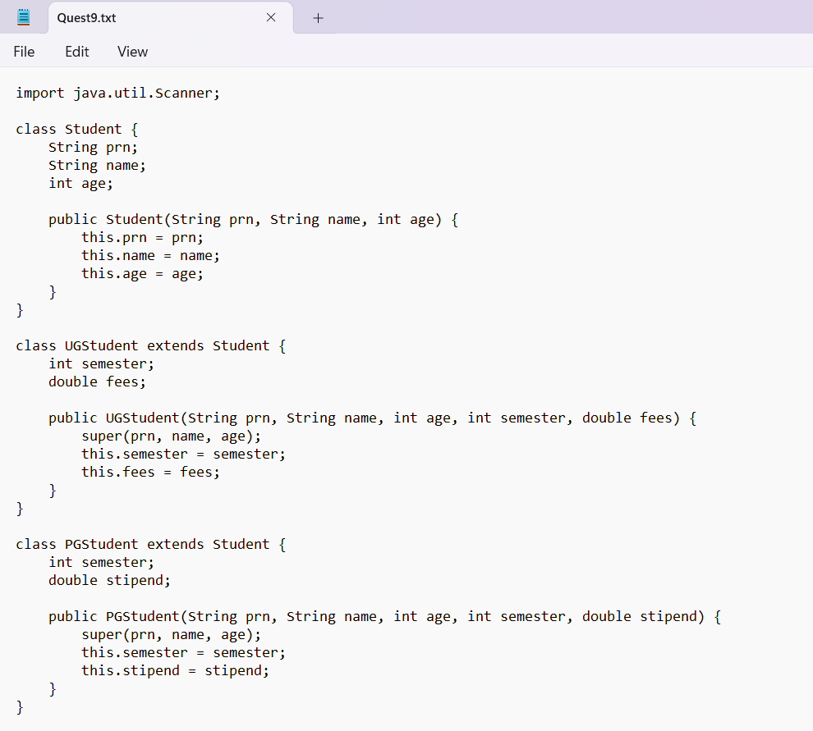
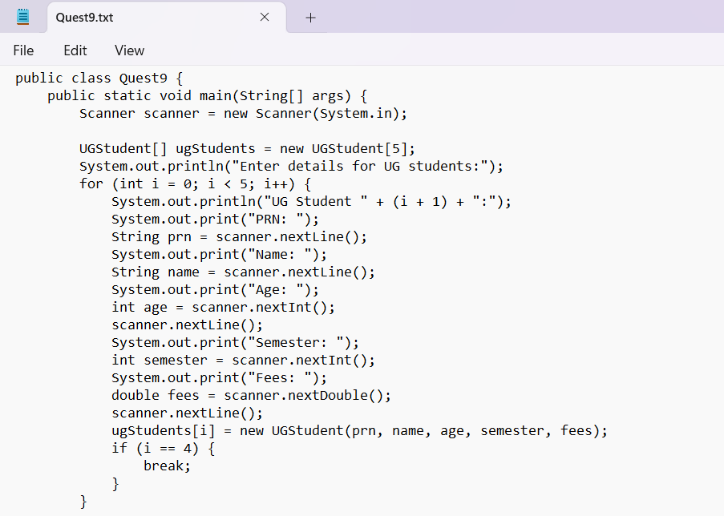
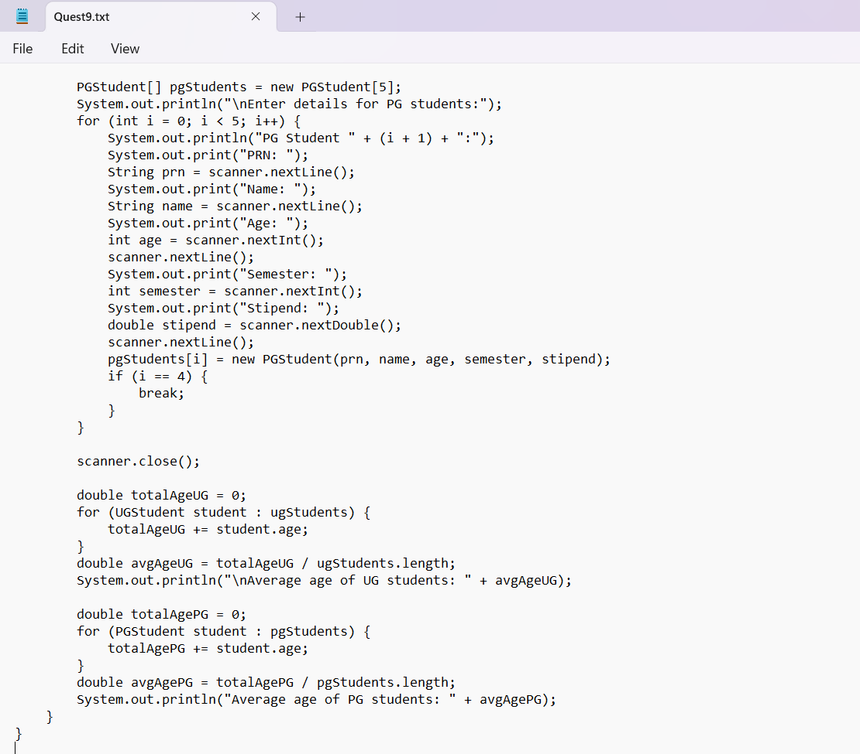
OUTPUT :
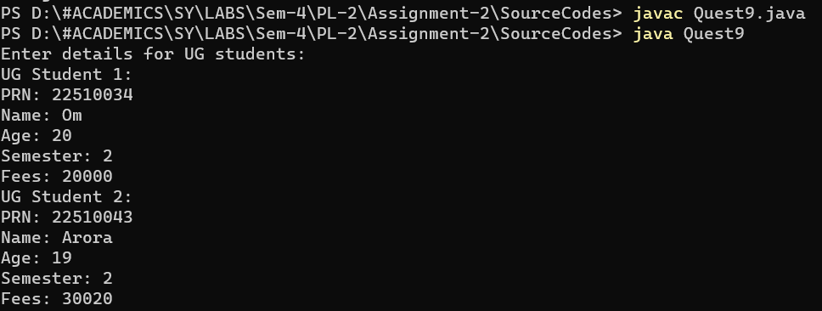

Q.10) Implement hybrid inheritance using all access specifiers (public, private, protected).
Source Codes:
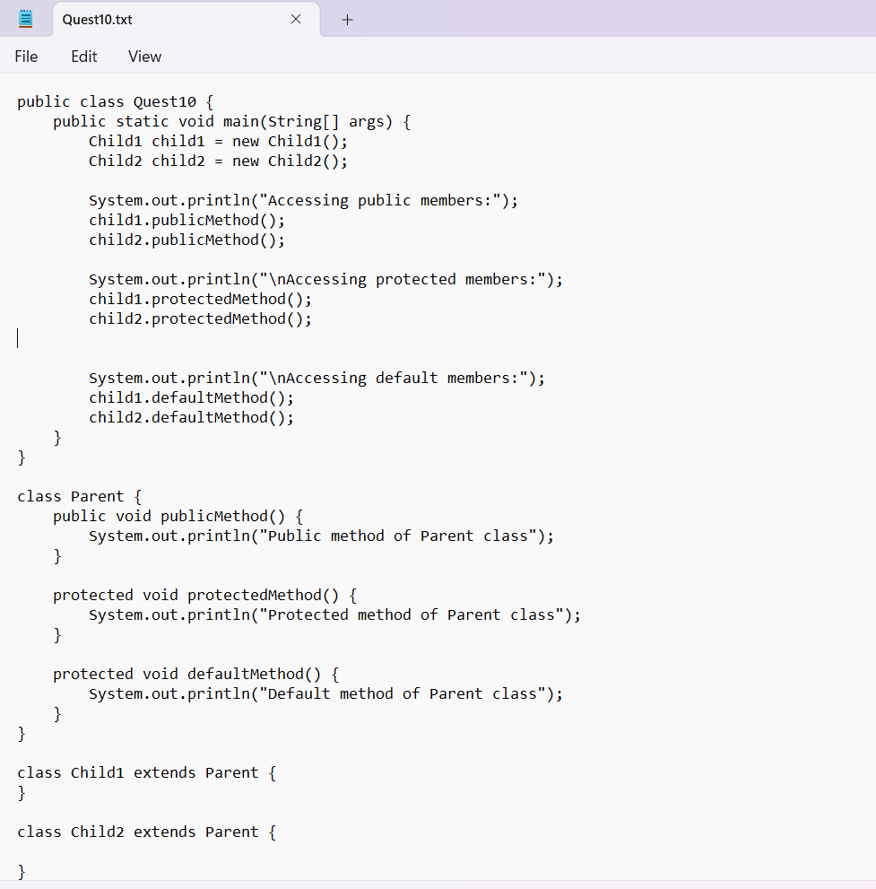
OUTPUT :
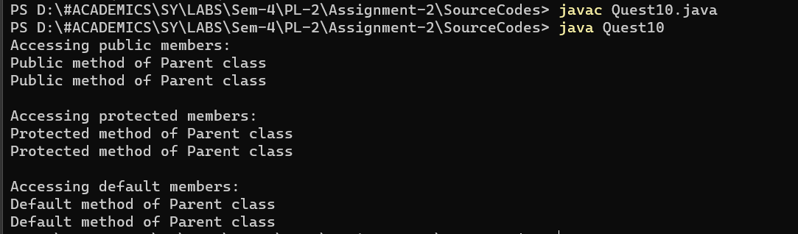
Q.11) Write a program to implement a class Teacher contains two fields Name and Qualification. Extend the class to Department, it contains Dept. No and Dept. Name. An Interface named as College it contains one field Name of the College. Using the above classes and Interface get the appropriate information and display it.
Source Codes :
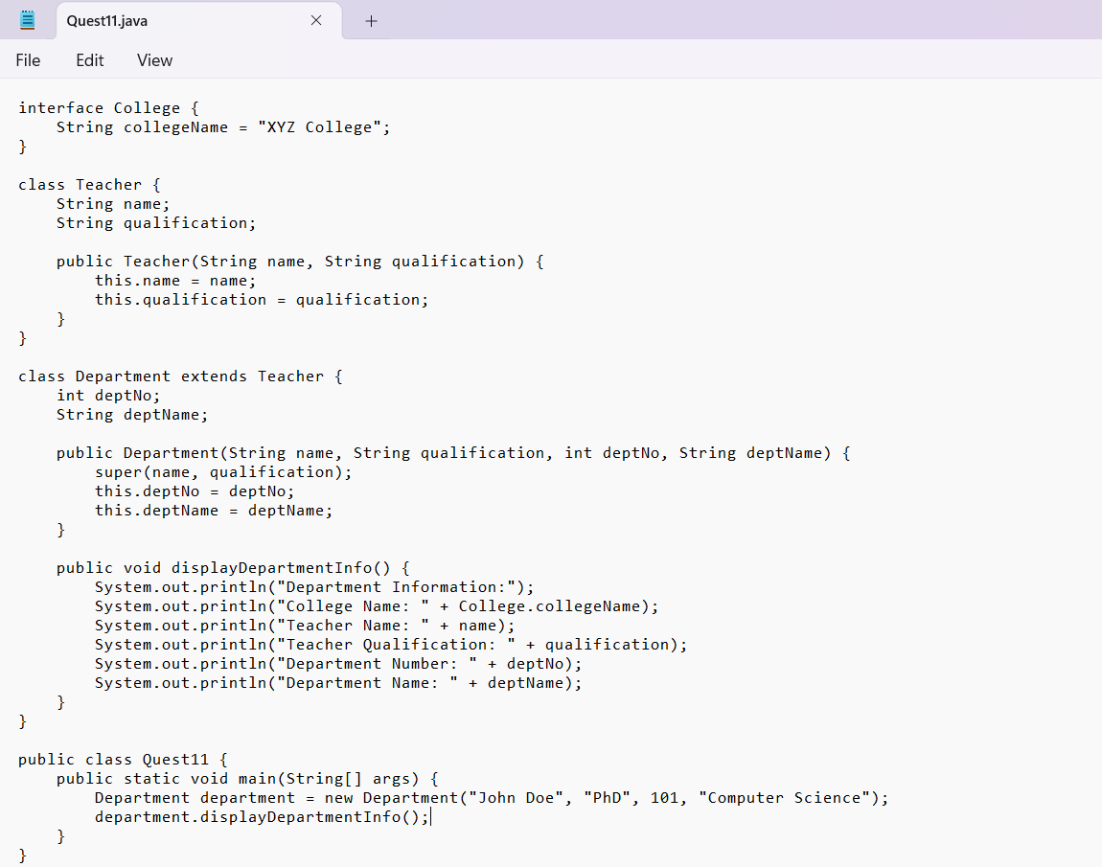
OUTPUT :
