ASSIGNMENT -3
PRN : 22510034 DATE : 21/02/24
Batch : S2
Subject : Programming Lab 2(6CS271)
Topic :

Q.1) Write a program to calculate area and volume of sphere using static variable and method create two static methods for area and volume calculation. (insert data from user).
Source Codes :
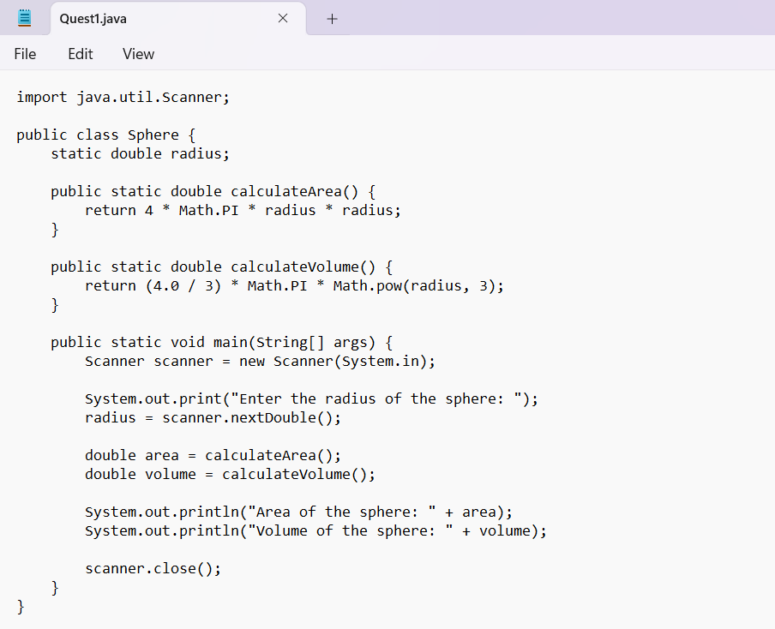
OUTPUT :
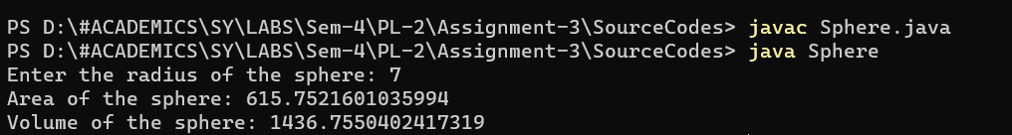
Q.2)
Display all your information (prn, name, age, address, class) on console without creating any object and writing any code in main method.
Source Codes :
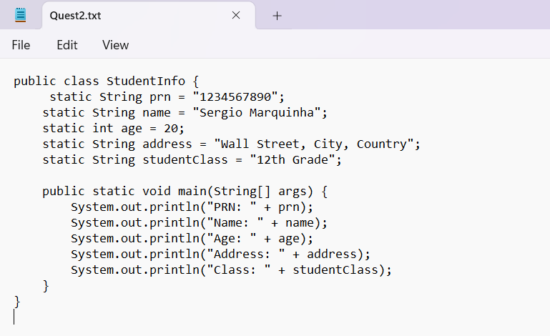
OUTPUT :
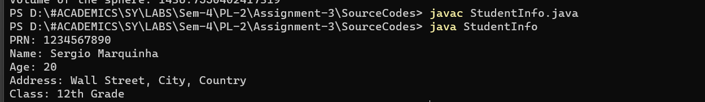
Q.3)
Demonstrate how to use static inner class and non-static inner class to access static and non-static members of outer class.
Source Codes :
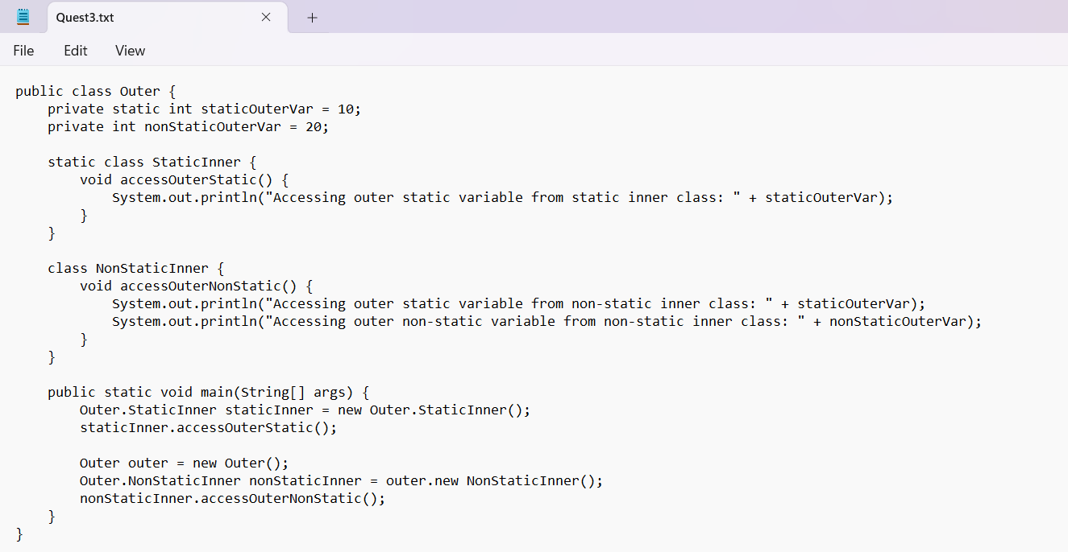
OUTPUT :
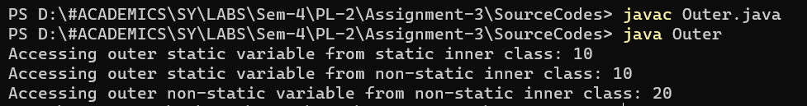
Q.4)
Write a program using final variable to check speed limit exceeds or not on highway. If speed is greater than 100. Then generate alert message.
Source Codes :
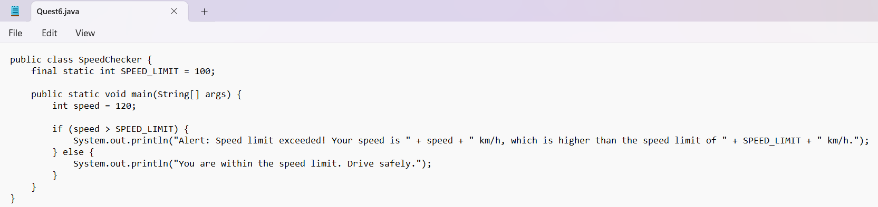
OUTPUT :

Q.5) Create an abstract class 'Bank' with an abstract method 'getBalance'. $100, $150 and $200 are deposited in banks A, B and C respectively. 'BankA', 'BankB' and 'BankC' are subclasses of class 'Bank', each having a method named 'getBalance'. Call this method by creating an object of each of the three classes.
Source Codes :
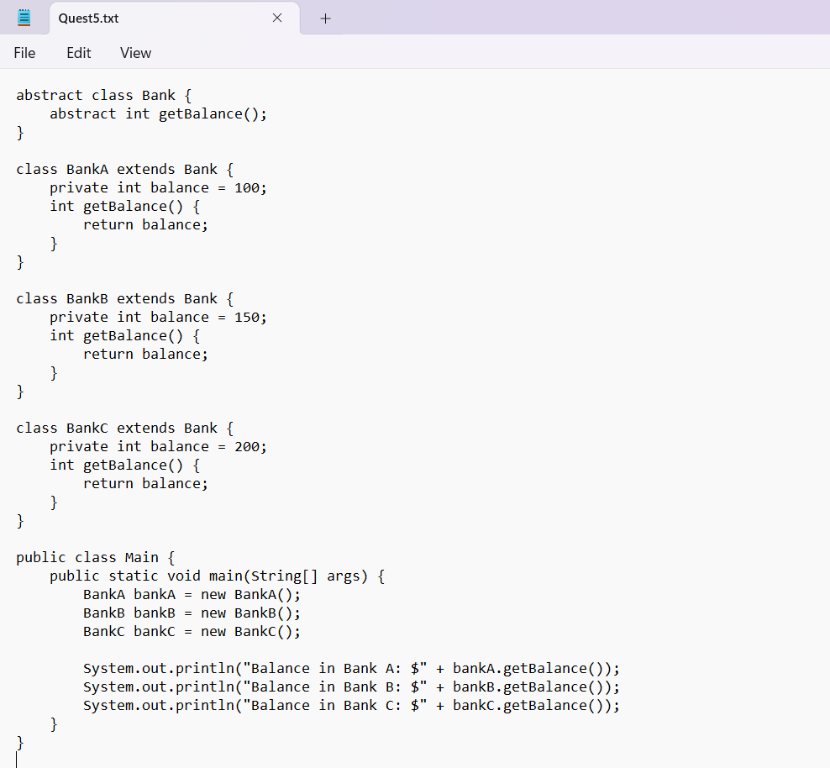
OUTPUT :
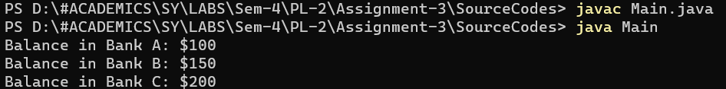
Q.6)
An abstract class has a construtor which prints "This is constructor of abstract class", an abstract method named 'a_method' and a non-abstract method which prints "This is a normal method of abstract class". A class 'SubClass' inherits the abstract class and has a method named 'a_method' which prints "This is abstract method". Now create an object of 'SubClass' and call the abstract method and the non-abstract method.
Source Codes :
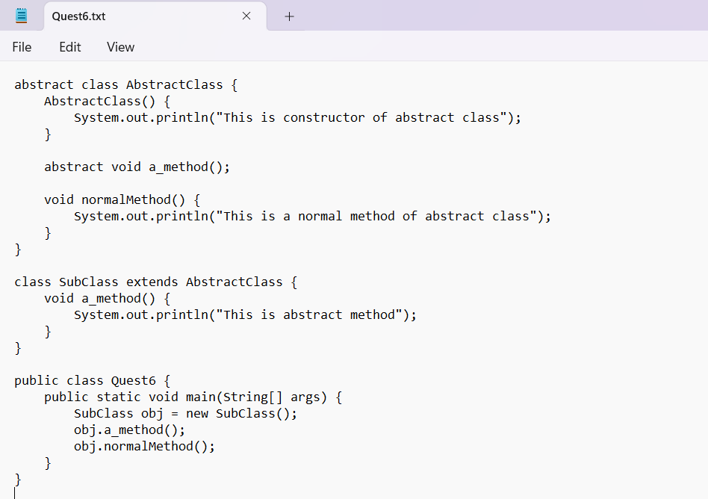
OUTPUT :
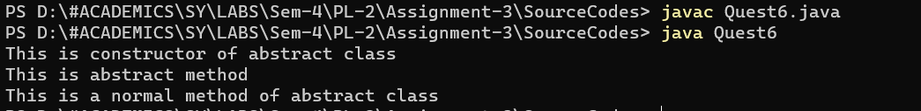
Q.7)
We have to calculate the area of a rectangle, a square and a circle. Create an abstract class 'Shape' with three abstract methods namely 'RectangleArea' taking two parameters, 'SquareArea' and 'CircleArea' taking one parameter each. The parameters of 'RectangleArea' are its length and breadth, that of 'SquareArea' is its side and that of 'CircleArea' is its radius. Now create another class 'Area' containing all the three methods 'RectangleArea', 'SquareArea' and 'CircleArea' for printing the area of rectangle, square and circle respectively. Create an object of class 'Area' and call all the three methods.’
Source Codes :
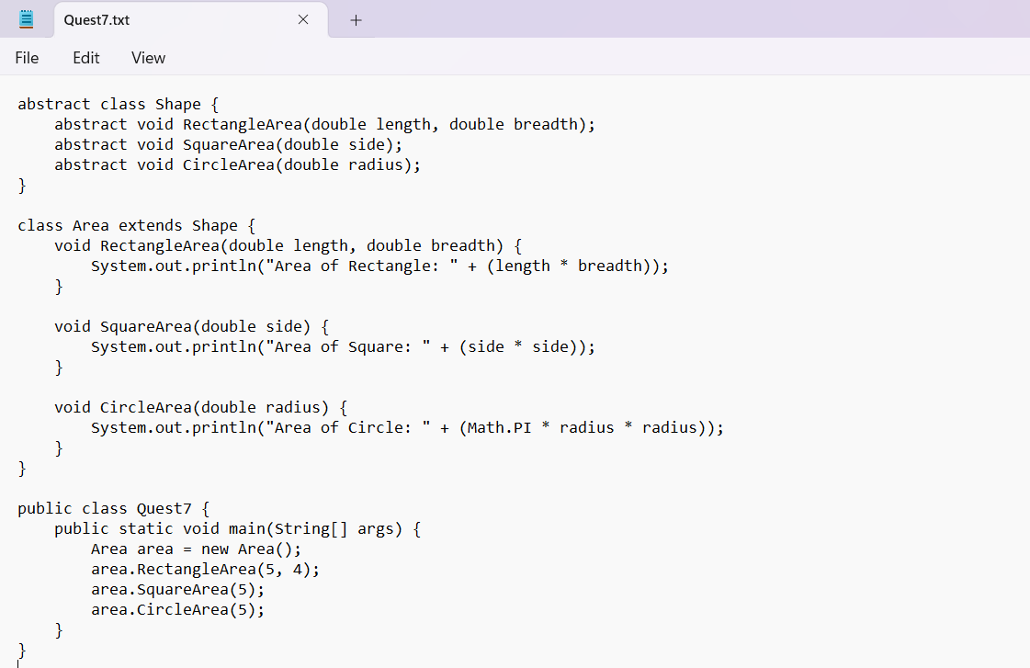
OUTPUT :
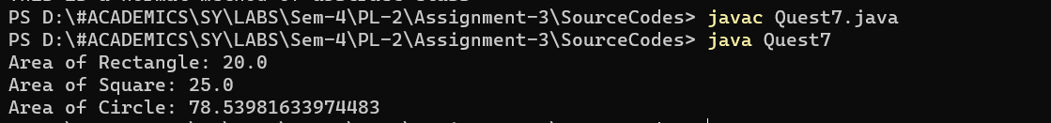
Q.8)
Define a package named ‘useful’ with a class name ‘Useme’ having following methods: 1. area() ◊ To calculate area of given shape. 2. percentage() ◊ to calculate percentage given total marks and marks obtained. Develop a program to import above package and use both methods.

Source Codes :
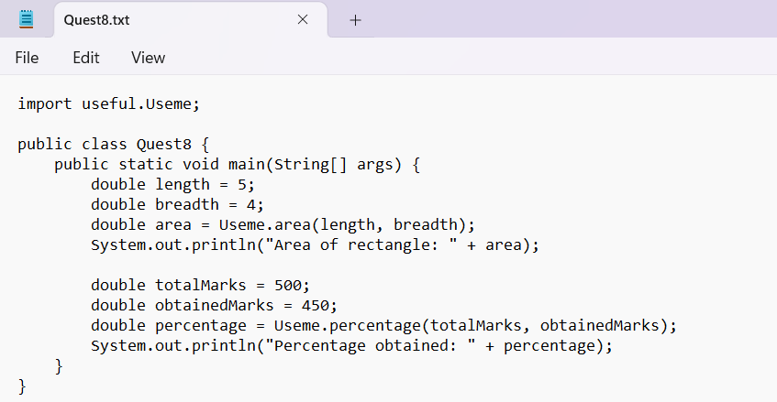
OUTPUT :

