MENOUFIA UNIVERSITY
Faculty of Computers and Information

SYSTEM ANALYSIS & DESIGN PROJECT
League Fixture Generator System

Item | Details
Project Number | 84
Project Name | League Fixture Generator System
Project Type | System Analysis & Design
Academic Year | 2026–2027
Prepared By | Student 1: ____________________  Student 2: ____________________
Section | ____________________
Supervisor | ____________________
Prepared according to the supplied System Analysis & Design template.

1. Planning (Project Plan)

1.1 Project Identification
Field | Project Details
Project Name | League Fixture Generator System
Project Number | 84
System Type | Web-based league fixture scheduling and management system
Main Users | League Administrator, Team Manager, Viewer
Main Goal | Automatically generate valid league fixtures and publish them clearly.

Current Problems
- Creating fixtures manually takes time and can lead to duplicate or missing matches.
- Balancing home/away matches manually is difficult.
- Updating a schedule after postponements can create conflicts.
- Teams and viewers may not have one reliable, up-to-date schedule.
- Preparing reports and exporting fixtures manually requires extra effort.

Project Description
The system stores league, season, team, venue and fixture information. The administrator selects a league, registers participating teams, chooses the competition format, and asks the system to generate the fixture list. The system validates the inputs, creates rounds using a round-robin scheduling algorithm, checks for duplicate pairings and conflicts, and then saves and publishes the final schedule. Team managers can view their fixtures, while viewers can browse the published schedule and reports.

2. System Request
Category | Requirement
Project Sponsor | League Administration / Competition Organizer
Business Need | Reduce manual effort and scheduling errors when creating league fixtures.
Business Need 2 | Provide one centralized source for the current fixture list.
Business Need 3 | Make schedule publication faster and easier.
Business Requirements | Manage leagues and seasons; manage teams; generate fixtures; validate conflicts; publish schedules; search/filter fixtures; export reports.
Business Value | Time saving, fewer errors, consistent scheduling, faster communication, easier reporting.
Constraints | Correct team data is required; changes after publication require administrator permission; venue/date conflicts must be handled.
Assumptions | Users have internet access; the administrator provides valid teams and competition rules.

Success Criteria
- Fixture generation completes quickly for a normal league size.
- No team is scheduled to play two matches in the same round.
- Each required pair of teams is scheduled according to the selected format.
- Published fixtures can be searched and filtered.
- Unauthorized users cannot change league data.

3. Feasibility Analysis

3.1 Technical Feasibility
- The system can be implemented as a web application using HTML/CSS/JavaScript for the interface and a server-side application with a relational database.
- A standard relational DBMS can store teams, seasons, fixtures, venues and users.
- The fixture generator can use a deterministic round-robin algorithm, making the core process technically straightforward.
- The system can be hosted on a local server for the academic prototype and later deployed online.

3.2 Economic Feasibility
- Development can use free/open-source software, reducing software licensing cost.
- The main cost is development time and optional hosting.
- The expected benefit is significant because manual fixture preparation and correction take staff time.
- The project is suitable for a student prototype because it does not require specialized hardware.

3.3 Organizational Feasibility
- The league administrator remains responsible for official data.
- Team managers receive access to view relevant fixtures.
- Users need only short training because the workflow is based on familiar forms and tables.
- The system can fit an existing league workflow without changing the competition rules.

3.4 Schedule Feasibility
The project can be completed as a staged academic project: requirements → analysis → modeling → design → implementation → testing.

4. Time Estimation
Phase | Standard % | Estimated Duration | Main Output
Planning | 15% | 4 days | Project plan and system request
Analysis | 20% | 6 days | Requirements, interviews, questionnaire, DFD
Design | 35% | 10 days | ERD, normalization, UML, architecture, interfaces
Implementation | 30% | 9 days | Prototype, database, testing and documentation

4.1 Project Task Identification
Task | Schedule | Priority | Resources | Est. Time
System Request | Day 1–2 | High | Word | 6 hours
Feasibility Study | Day 2–4 | High | Word / spreadsheet | 8 hours
Interview | Day 4–6 | Medium | Word | 6 hours
Questionnaire | Day 5–7 | Medium | Google Forms / spreadsheet | 5 hours
DFD | Day 7–10 | High | Draw.io / Visio | 10 hours
Data Dictionary | Day 9–11 | High | Word | 8 hours
Process Specification | Day 10–12 | High | Word | 8 hours
ERD & UML | Day 12–16 | High | StarUML / Draw.io | 12 hours
Normalization | Day 14–16 | High | Word | 7 hours
Design | Day 16–22 | High | VS Code / Word | 16 hours
Implementation & Testing | Day 22–31 | High | VS Code / DBMS | 25 hours

5. PERT Chart and Gantt Chart
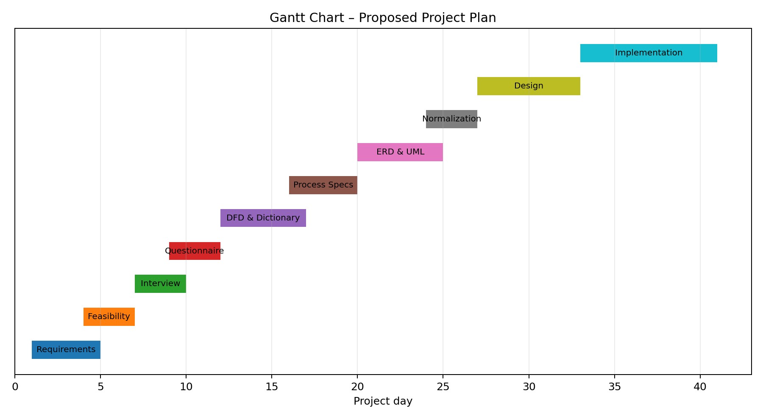
Figure 5.1 — Proposed Gantt chart
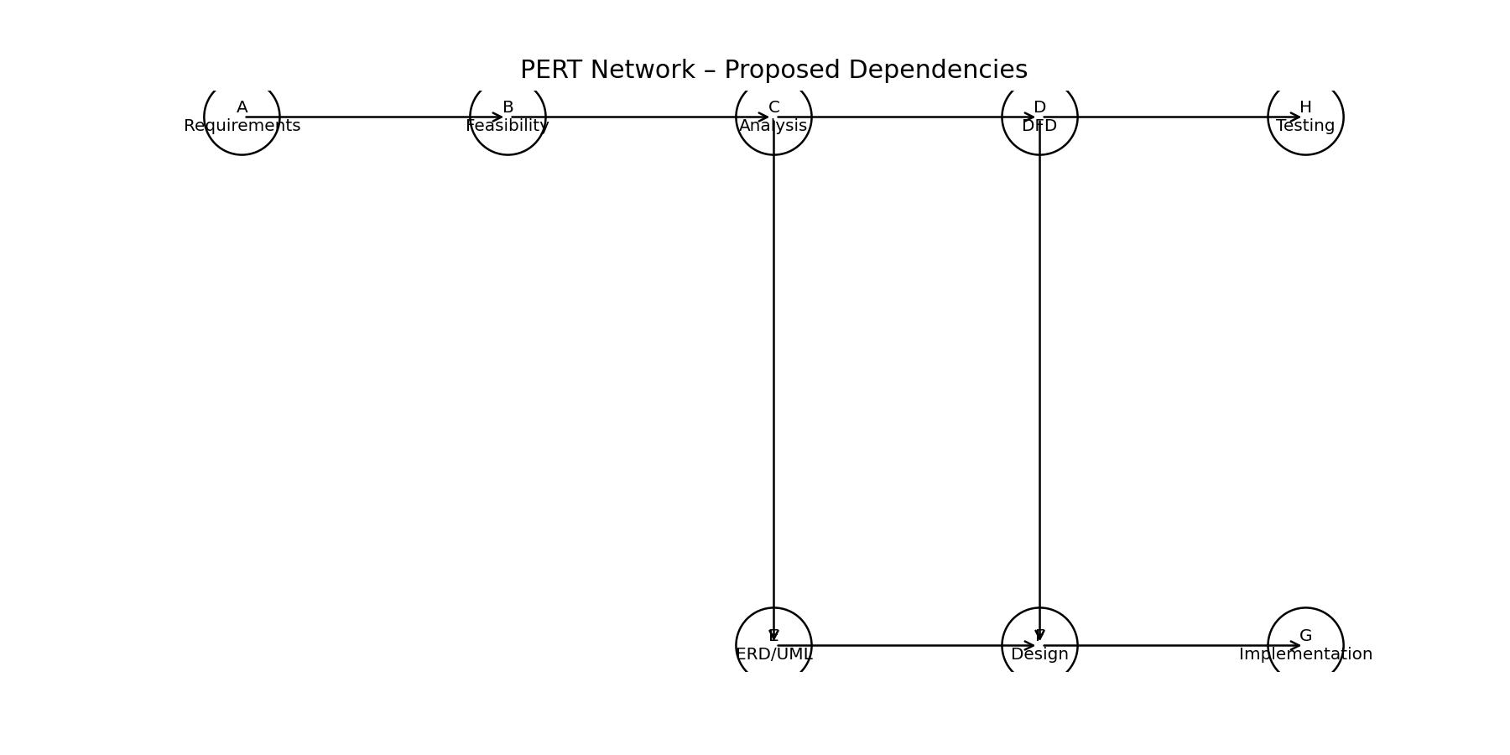
Figure 5.2 — Proposed PERT network
Note: durations are proposed planning estimates for the academic project and can be adjusted to the team's actual schedule.

6. Analysis (Project Proposal)

6.1 Interview
Question | Answer
1. What is the main problem with the current fixture process? | Fixtures are often prepared manually, which takes time and can cause duplicate matches or missed games.
2. Who prepares the official schedule? | The league administrator or competition organizer.
3. What information is needed before generating fixtures? | League name, season, teams, competition format, and optional venue/date constraints.
4. How should the system generate fixtures? | It should generate a round-robin schedule according to the selected format.
5. What are common errors? | Duplicate pairings, two matches for one team in the same round, and incorrect dates.
6. What are the critical objectives? | Correct fixture generation, easy updates, fast publication, and clear access for viewers.
7. What technology is suitable? | A web interface connected to a relational database and a scheduling service.
8. Should users be able to edit published fixtures? | Only authorized administrators should edit official fixtures.
9. What reports are useful? | Full league schedule, team-specific fixtures, round list, and postponed/cancelled matches.
10. Is there anything else to add? | The system should keep a history of fixture changes and provide clear status information.

7. Interview Reports

Interview Report — Competition Organizer
Role: Primary stakeholder
Summary: Needs a reliable way to generate and publish the official fixture list.
- Manage seasons and teams.
- Generate fixtures automatically.
- Approve and publish the schedule.
- Export reports.

Interview Report — Team Manager
Role: Secondary stakeholder
Summary: Needs quick access to the team's matches and updates.
- View team fixtures.
- Filter by round/date.
- Receive updated schedule information.
- Cannot alter official fixtures.

Interview Report — Viewer / Fan
Role: End user
Summary: Needs simple public access to the current schedule.
- Browse fixtures.
- Filter by team or round.
- See match status.
- View published updates.

8. Questionnaire & Responses
The questionnaire below is designed for league administrators, team managers and viewers. The statistics in the next section are a proposed sample dataset for documentation; replace them with actual Google Forms results before final submission if required.
No. | Question | Response Type
1 | Do you currently find manual fixture creation time-consuming? | Yes / No
2 | Have you experienced duplicate or missing fixtures? | Yes / No
3 | Would automatic fixture generation reduce your work? | Yes / No
4 | Is team-specific fixture search important? | Yes / No
5 | Is it important to prevent two matches for one team in the same round? | Yes / No
6 | Would you use a web-based published schedule? | Yes / No
7 | Is filtering by date/round/team useful? | Yes / No
8 | Should only administrators edit fixtures? | Yes / No
9 | Would export to PDF/Excel be useful? | Yes / No
10 | Do you want visible status for postponed/cancelled matches? | Yes / No

9. Questionnaire Statistics
Q | Topic | Yes (sample) | Percentage
1 | Manual fixture creation is time-consuming | 24/30 | 80%
2 | Experienced duplicate/missing fixtures | 18/30 | 60%
3 | Automatic generation would reduce work | 28/30 | 93%
4 | Team-specific search is important | 27/30 | 90%
5 | Conflict prevention is important | 29/30 | 97%
6 | Would use web-based schedule | 26/30 | 87%
7 | Filtering is useful | 25/30 | 83%
8 | Only admins should edit | 29/30 | 97%
9 | PDF/Excel export is useful | 23/30 | 77%
10 | Status for postponed/cancelled matches is useful | 28/30 | 93%
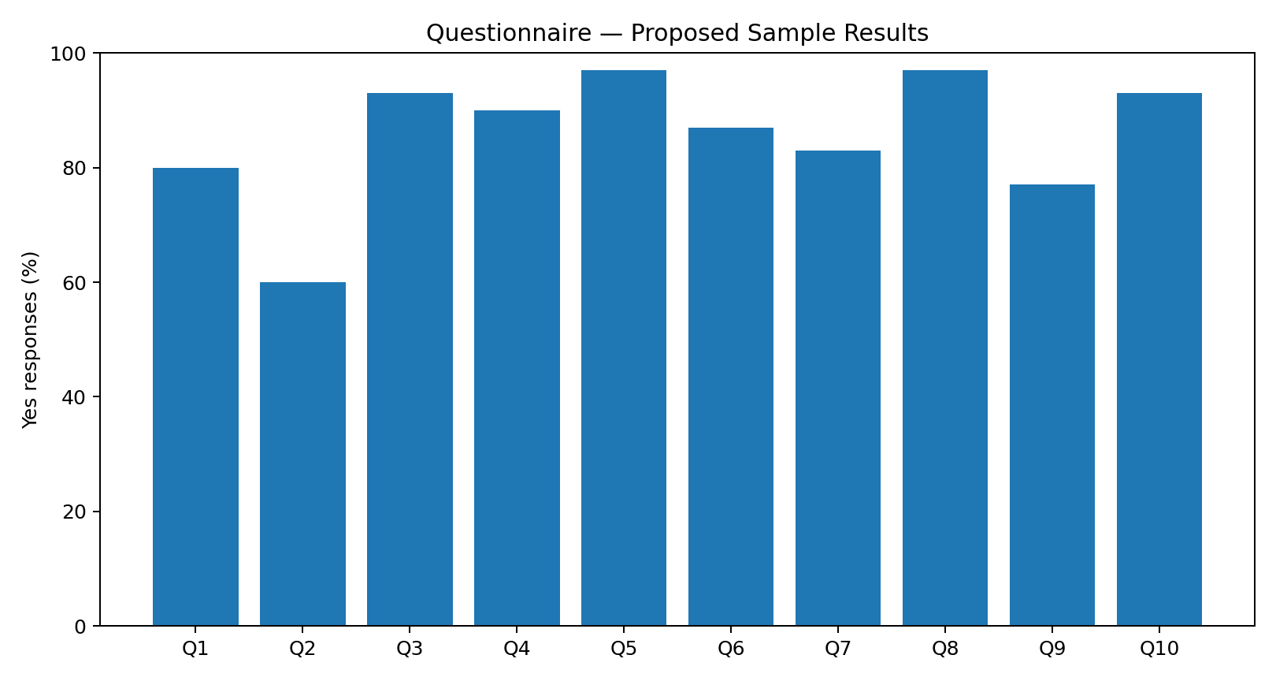
Figure 9.1 — Proposed questionnaire results (30 sample responses)

10. Data Flow Diagram — Context Diagram
The context diagram treats the League Fixture Generator System as one process and shows its main external entities and information exchanges.
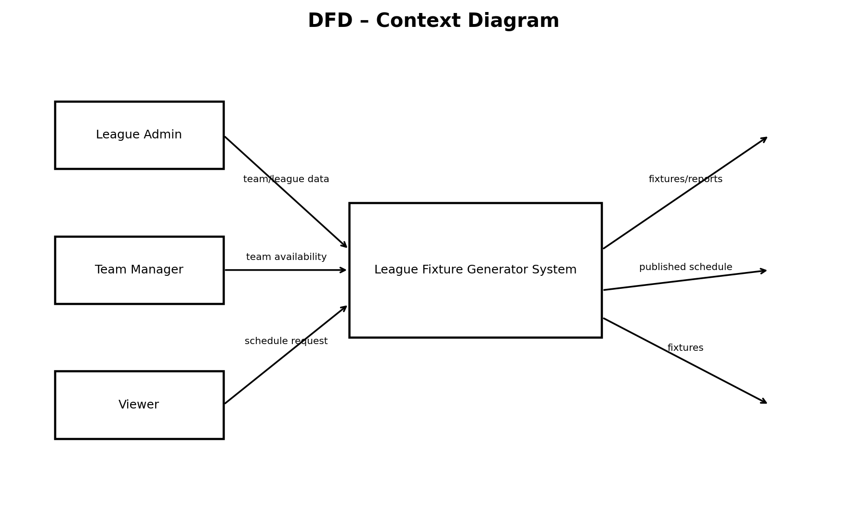
Figure 10.1 — Context DFD
External Entity | Input | Output
League Admin | League/team data, generation request, update request | Generated schedule, validation messages, reports
Team Manager | Team information / availability | Team fixtures, update notifications
Viewer | Search/filter request | Published fixtures and statuses

11. Data Flow Diagram — Level 0
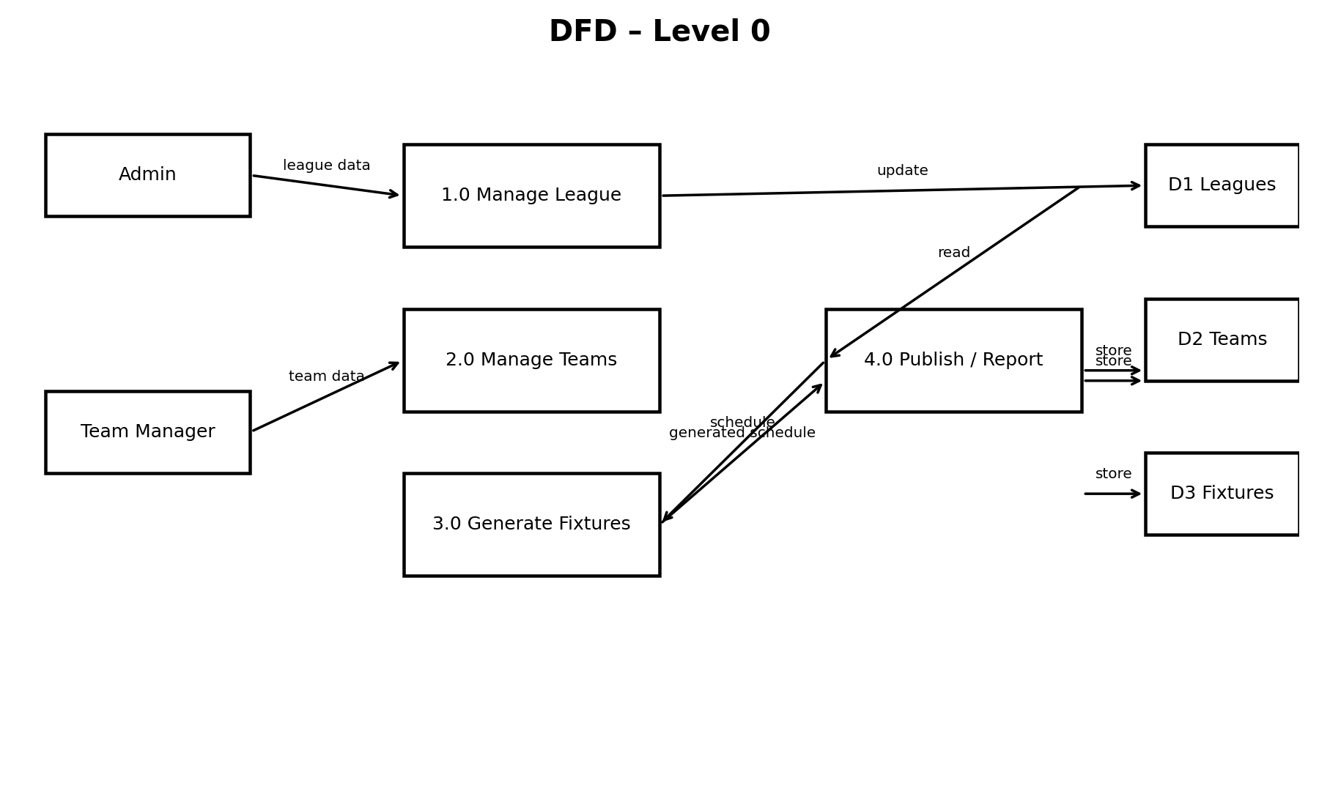
Figure 11.1 — Level 0 DFD
Process | Description
1.0 Manage League | Create/update league and season information.
2.0 Manage Teams | Register teams and maintain team information.
3.0 Generate Fixtures | Validate teams, select format, generate rounds and check conflicts.
4.0 Publish / Report | Publish approved fixtures and generate reports.

12. Data Flow Diagram — Level 1
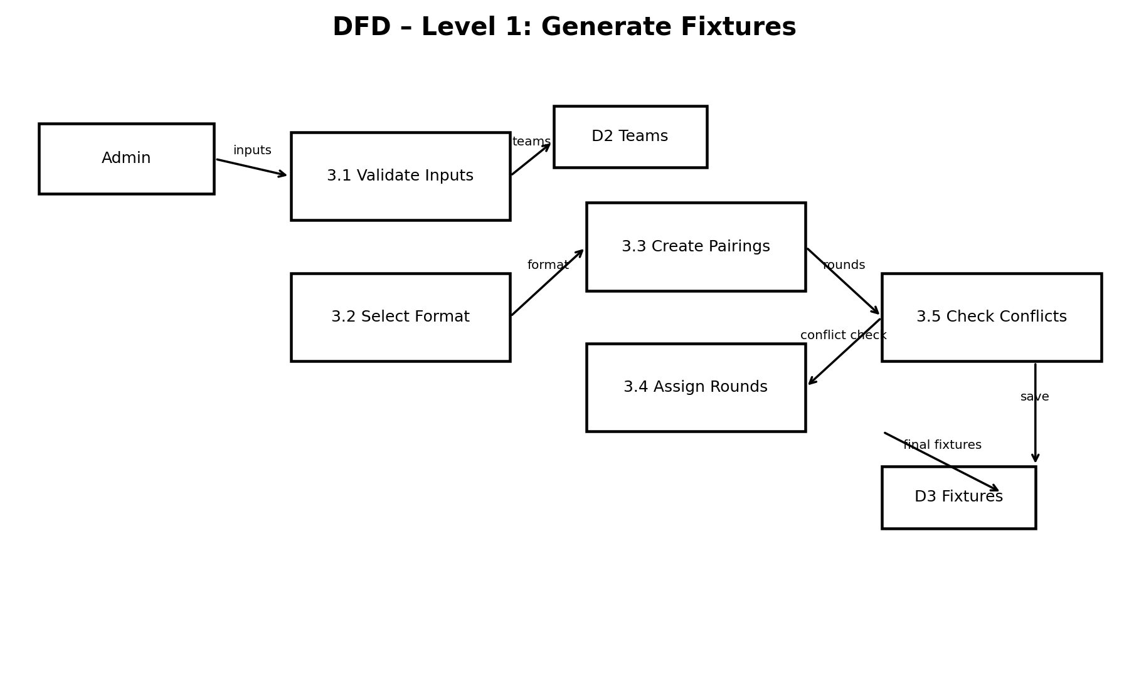
Figure 12.1 — Level 1 for Process 3.0 Generate Fixtures
- Validate the number and status of participating teams.
- Read the selected competition format.
- Generate pairings using round-robin logic.
- Assign matches to rounds and dates where possible.
- Check for conflicts and duplicate pairings.
- Save the final fixture set and return the result to the administrator.

13. Data Dictionary

13.1 Data Flow Description
ID | Name | Source → Destination | Description
F1 | League Data | League Admin → Manage League | League name, format, season
F2 | Team Data | Team Manager/Admin → Manage Teams | Team ID, name, city, status
F3 | Generation Request | Admin → Generate Fixtures | League, season, format, constraints
F4 | Generated Fixtures | Generate Fixtures → Publish/Report | Fixture ID, teams, round, date, venue, status
F5 | Published Schedule | Publish/Report → Viewer/Team Manager | Official fixture information
F6 | Conflict Message | Generate Fixtures → Admin | Validation/conflict details
F7 | Report Request | Admin → Publish/Report | Report type and filters
F8 | Schedule Report | Publish/Report → Admin | Filtered/exportable schedule

14. Data Structures for Data Flow
Structure | Elements
LeagueData | LeagueID + Name + Format + SeasonID + Status
TeamData | TeamID + TeamName + City + Contact + Status
GenerationRequest | LeagueID + SeasonID + Format + StartDate + Frequency + Constraints
FixtureData | FixtureID + SeasonID + RoundNo + MatchDate + HomeTeamID + AwayTeamID + VenueID + Status
PublishedSchedule | SeasonID + RoundNo + FixtureData + PublicationDate
ReportData | ReportID + ReportType + Filters + GeneratedDate + CreatedBy

14.1 Structural Record
A structural record groups related elements into a single logical record. For example, FixtureData represents one scheduled match and can be stored as one database record.

15. Data Elements
Name | Description | Type | Length/Format | Base/Derived
LeagueID | Unique league identifier | Integer | 10 digits | Base
LeagueName | Official league name | Text | 100 chars | Base
SeasonID | Unique season identifier | Integer | 10 digits | Base
TeamID | Unique team identifier | Integer | 10 digits | Base
TeamName | Team name | Text | 100 chars | Base
Format | Competition format | Text | 20 chars | Base
FixtureID | Unique fixture identifier | Integer | 10 digits | Base
RoundNo | Round number | Integer | 3 digits | Derived/Base
MatchDate | Scheduled match date/time | DateTime | Standard date-time | Base
VenueID | Venue identifier | Integer | 10 digits | Base
Status | Scheduled/Postponed/Cancelled/Completed | Text | 20 chars | Base
CreatedBy | User/admin identifier | Integer | 10 digits | Base

16. Data Stores
ID | Name | Type | Data | Primary Key | Comments
D1 | LeagueStore | Database | League and season records | LeagueID / SeasonID | Stores league setup information.
D2 | TeamStore | Database | Team records | TeamID | Stores participating teams.
D3 | FixtureStore | Database | Fixture records | FixtureID | Stores generated and published matches.
D4 | VenueStore | Database | Venue records | VenueID | Stores optional venue details.
D5 | UserStore | Database | User/admin records | UserID | Stores authenticated users and roles.
D6 | AuditStore | Database | Change history | AuditID | Stores important schedule changes.

17. Process Specification

17.1 Process 1.0 — Manage League
Input: LeagueData. Output: stored/updated league record.
Process Logic:
- Receive league details.
- Validate required fields.
- Create or update league and season records.
- Return success or validation message.

17.2 Process 2.0 — Manage Teams
Input: TeamData. Output: updated TeamStore.
- Receive team information.
- Check unique TeamID/name rules.
- Save active team record.
- Return confirmation.

17.3 Process 3.0 — Generate Fixtures
Input: GenerationRequest + TeamStore. Output: FixtureData or conflict message.
- IF number of active teams is less than the minimum required, return an error.
- IF the number of teams is odd, add a BYE placeholder for single round-robin generation.
- Generate pairings using the selected round-robin method.
- Assign each pairing to a round.
- Validate that each team appears at most once per round.
- Validate duplicate pairings and apply home/away rules where applicable.
- Save valid fixtures.

18. Process Specification — Continued

18.1 Process 4.0 — Publish / Report
Input: FixtureData. Output: PublishedSchedule + ReportData.
- Retrieve approved fixtures.
- Apply selected filters such as team, round, date or status.
- Generate the display/report format.
- Publish the official schedule.
- Store the publication/change event in the audit log.

18.2 Decision Table — Fixture Validation
Condition / Action | Case 1 | Case 2 | Case 3 | Case 4
Valid team count | Y | Y | N | N
No duplicate pairings | Y | N | - | -
No same-round conflict | Y | - | - | -
Action | Save fixtures | Return duplicate error | Return team-count error | Return validation error

19. Normalization

19.1 Unnormalized Relation
A single wide record might contain repeated team, season and fixture information. Example:
LeagueID | LeagueName | Season | Team1 | Team2 | Round | Date | Venue | Status
L01 | Premier League | 2026 | Tigers | Lions | 1 | 2026-09-01 | Main Stadium | Scheduled
L01 | Premier League | 2026 | Eagles | Sharks | 1 | 2026-09-01 | City Stadium | Scheduled
L01 | Premier League | 2026 | Tigers | Eagles | 2 | 2026-09-08 | Main Stadium | Scheduled

19.2 First Normal Form (1NF)
All fields are atomic and each row represents one fixture. Repeating groups are removed.
FixtureID | LeagueID | SeasonID | HomeTeamID | AwayTeamID | RoundNo | MatchDate | VenueID | Status
F001 | L01 | S01 | T01 | T02 | 1 | 2026-09-01 | V01 | Scheduled
F002 | L01 | S01 | T03 | T04 | 1 | 2026-09-01 | V02 | Scheduled

20. Normalization — 2NF and 3NF

20.1 Second Normal Form (2NF)
Partial dependencies are removed by separating league, season, team, venue and fixture data. Fixture-specific attributes remain dependent on FixtureID.
Table | Key | Main Attributes
League | LeagueID | LeagueName, Format
Season | SeasonID | LeagueID, SeasonYear, Status
Team | TeamID | TeamName, City, Status
Venue | VenueID | VenueName, Location
Fixture | FixtureID | SeasonID, HomeTeamID, AwayTeamID, RoundNo, MatchDate, VenueID, Status

20.2 Third Normal Form (3NF)
Transitive dependencies are removed. For example, LeagueName is stored only in League, and TeamName is stored only in Team. Fixture stores foreign keys rather than repeating descriptive data.
3NF Table | Primary Key | Foreign Keys
League | LeagueID | —
Season | SeasonID | LeagueID
Team | TeamID | —
Venue | VenueID | —
Fixture | FixtureID | SeasonID, HomeTeamID, AwayTeamID, VenueID
User | UserID | —
AuditLog | AuditID | UserID, FixtureID

21. Entity Relationship Diagram (ERD)
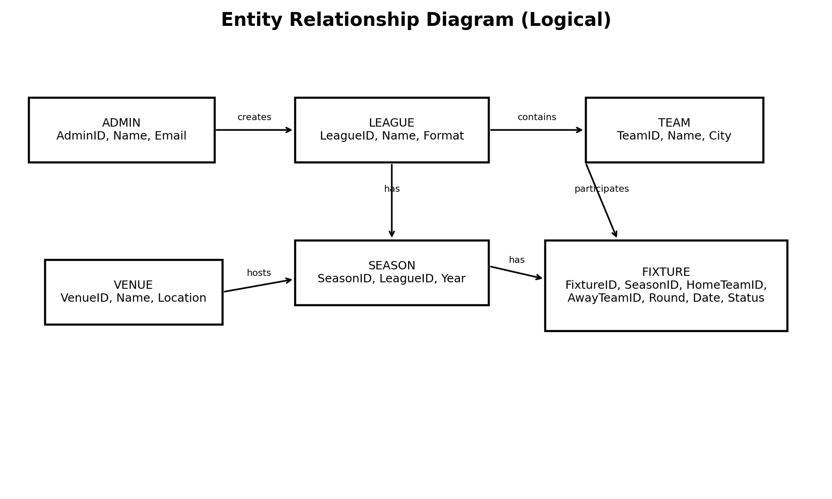
Figure 21.1 — Logical ERD

21.1 Main Relationships
- One League can have many Seasons.
- One Season can contain many Fixtures.
- A Team can appear in many Fixtures as home team and many Fixtures as away team.
- One Venue can host many Fixtures.
- One Admin/User can create or publish many fixtures.
- Audit records preserve important changes to official fixtures.

22. UML – Use Case Diagram
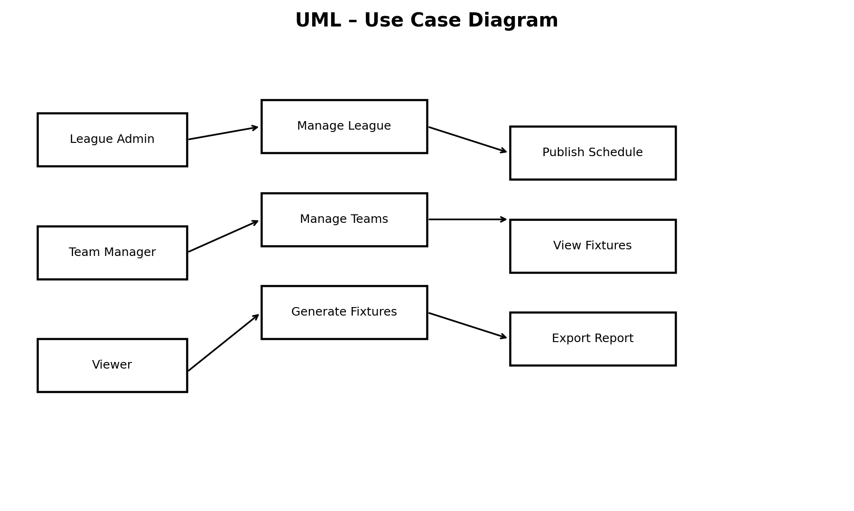
Figure 22.1 — Use Case Diagram
Actor | Use Cases
League Admin | Login, Manage League, Manage Teams, Generate Fixtures, Validate Conflicts, Publish Schedule, Export Reports
Team Manager | Login, View Team Fixtures, View Updates
Viewer | View Published Fixtures, Search/Filter Schedule

23. UML – Class Diagram
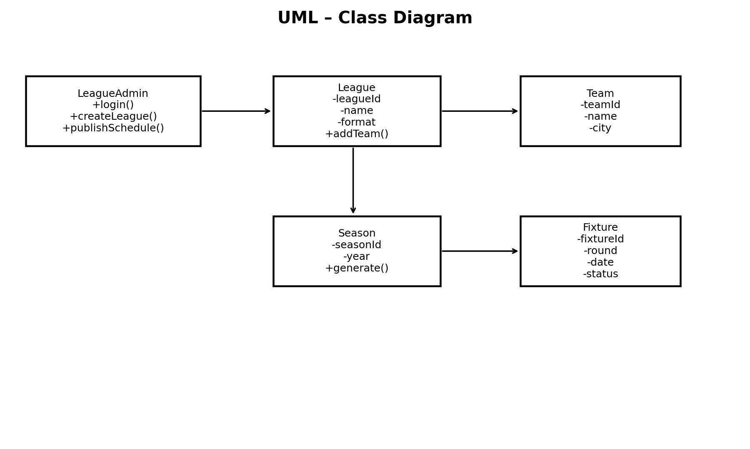
Figure 23.1 — Class Diagram
Class | Important Attributes | Important Methods
League | leagueId, name, format | addTeam(), createSeason()
Season | seasonId, year, status | generateFixtures(), publish()
Team | teamId, name, city | getFixtures()
Fixture | fixtureId, round, date, status | validate(), updateStatus()
LeagueAdmin | adminId, name, email | login(), manageLeague(), publishSchedule()

24. UML – Sequence Diagram
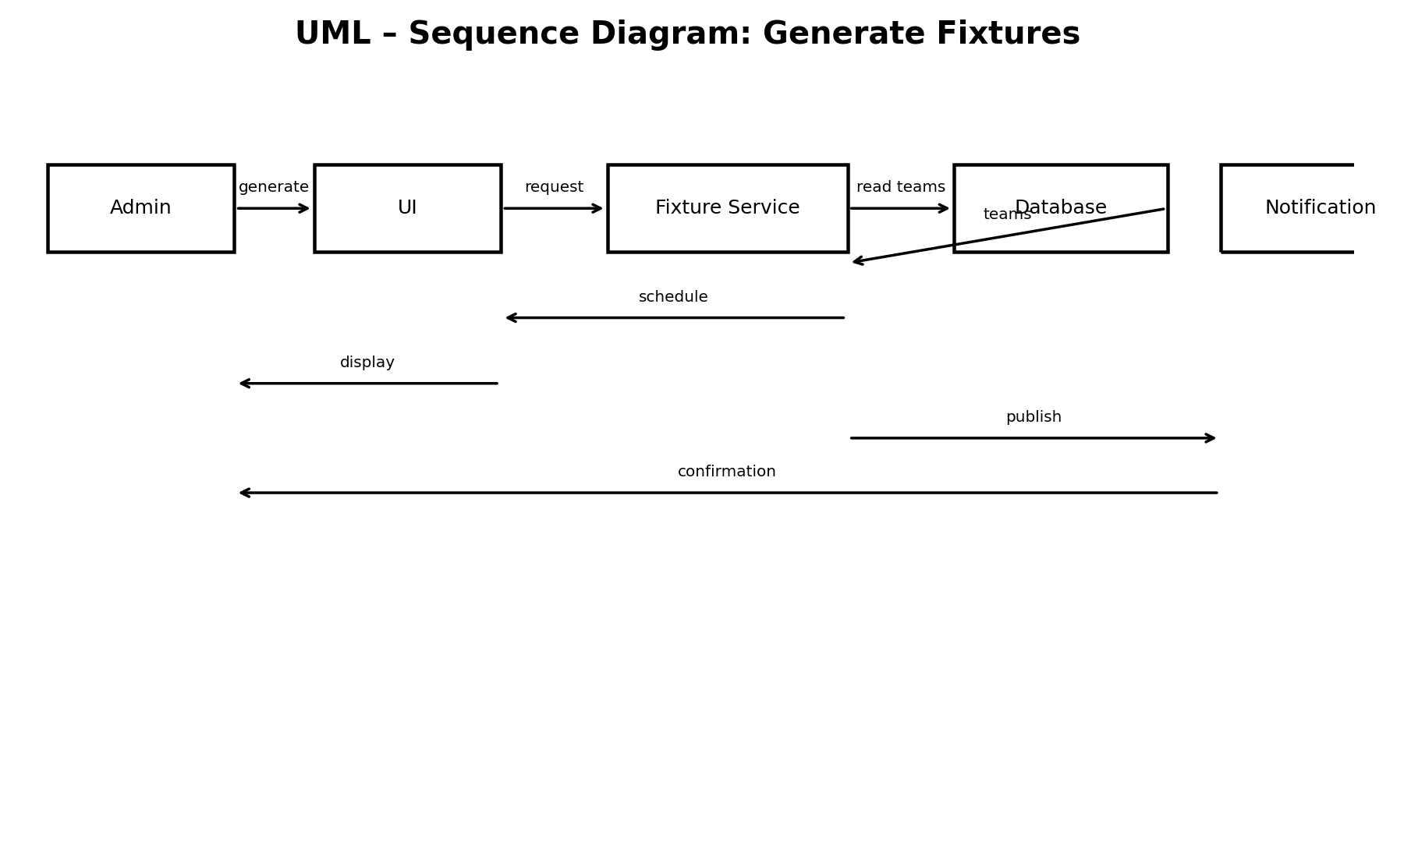
Figure 24.1 — Sequence Diagram: Generate Fixtures
- Administrator chooses a league/season and clicks Generate Fixtures.
- UI sends a generation request to the Fixture Service.
- Fixture Service reads active teams from the database.
- The service creates pairings and assigns rounds.
- The service checks conflicts and duplicate pairings.
- Valid fixtures are saved to the database.
- The UI displays the generated schedule and confirmation.

25. Design (Project Specification)

25.1 Architecture Design — Operational Requirements
Requirement | Specification
Technical Environment | Web browser, application server, relational database.
System Integration | Application layer communicates with database through secure APIs/services.
Portability | Responsive interface usable on desktop, tablet and mobile.
Maintainability | Layered structure: UI, business logic, data access.
Backup | Regular database backups and audit history.

25.2 Performance Requirements
Requirement | Target
Speed | Normal page actions should respond within a few seconds in the academic environment.
Capacity | Support typical league sizes such as 8–32 teams.
Availability | System should remain available during schedule publication periods.
Reliability | Generated fixture set must pass validation before publication.

25.3 Security Requirements
Requirement | Specification
Access Control | Role-based permissions.
Authentication | Secure login for administrators/team managers.
Encryption | HTTPS in deployment; passwords stored as hashes.
Audit | Record important schedule changes.
Virus/Abuse Control | Server-side validation, file restrictions and regular backups.

26. Data Storage Design

26.1 Data Storage Format
Relational database. Suggested tables: Users, Leagues, Seasons, Teams, Venues, Fixtures, AuditLogs.

26.2 Physical Table Specification
Table | Key | Fields
Leagues | LeagueID INT PK | Name VARCHAR(100), Format VARCHAR(20), Status VARCHAR(20)
Seasons | SeasonID INT PK | LeagueID INT FK, SeasonYear INT, Status VARCHAR(20)
Teams | TeamID INT PK | Name VARCHAR(100), City VARCHAR(100), Status VARCHAR(20)
Venues | VenueID INT PK | Name VARCHAR(100), Location VARCHAR(150)
Fixtures | FixtureID INT PK | SeasonID INT FK, HomeTeamID INT FK, AwayTeamID INT FK, RoundNo INT, MatchDate DATETIME, VenueID INT FK, Status VARCHAR(20)
Users | UserID INT PK | Name VARCHAR(100), Email VARCHAR(150), PasswordHash VARCHAR(255), Role VARCHAR(30)
AuditLogs | AuditID INT PK | UserID INT FK, FixtureID INT FK, Action VARCHAR(50), ActionDate DATETIME

27. Convert Logical ERD to Physical ERD
The logical entities are converted to database tables with primary keys and foreign keys. Referential integrity is enforced between Seasons–Leagues, Fixtures–Seasons, Fixtures–Teams and Fixtures–Venues.
Relationship | Cardinality | Foreign Key
League → Season | 1 : M | Season.LeagueID
Season → Fixture | 1 : M | Fixture.SeasonID
Team → Fixture (Home) | 1 : M | Fixture.HomeTeamID
Team → Fixture (Away) | 1 : M | Fixture.AwayTeamID
Venue → Fixture | 1 : M | Fixture.VenueID
User → AuditLog | 1 : M | AuditLog.UserID

28. Program Design

28.1 Convert Logical DFD to Physical DFD
- Browser UI sends authenticated requests to the application server.
- Application server validates input and applies scheduling rules.
- Fixture Generator Service runs the round-robin algorithm.
- Database stores leagues, teams, seasons, fixtures and audit logs.
- Reporting service formats schedule data for screen and export.

28.2 Core Fixture Generation Logic
For an even number of teams, pair teams round by round using a round-robin rotation. For an odd number, add a BYE placeholder. After pair generation, validate that each team appears once per round and that every required pairing occurs the required number of times.

28.3 Validation Rules
- Team IDs must be unique.
- League and season must exist before fixture generation.
- Only active teams participate.
- HomeTeamID and AwayTeamID cannot be equal.
- One team cannot have two fixtures in the same round.
- Published fixtures can only be changed by authorized roles.
- Every fixture must have a valid status.

29. Interface Design

29.1 Use Scenario Development
Scenario | Steps
Generate Fixtures | Admin logs in → selects league/season → selects format → clicks Generate → reviews validation → saves → publishes.
Manage Teams | Admin opens Teams → adds/edits team → validates unique name/ID → saves.
View Team Fixtures | Team Manager logs in → selects team → filters season → views matches.
Publish Schedule | Admin reviews generated fixtures → confirms → publishes → system records audit event.
Export Report | Admin selects filters → chooses PDF/Excel → system generates report.

29.2 Interface Structure
- Login Page
- Dashboard
- League & Season Management
- Team Management
- Fixture Generator
- Fixture Review / Conflict Panel
- Published Schedule
- Reports & Export
- User / Role Management
- Audit Log

30. Interface Standards Design

30.1 Interface Metaphor
The interface uses a sports-league dashboard metaphor: teams, rounds, fixtures and statuses are presented as familiar cards, tables and filters.

30.2 Interface Template
Screen | Main Controls
Dashboard | League selector, season selector, summary cards, latest updates
Fixture Generator | Team list, format selector, start date, generate button
Fixture Review | Round tabs, conflict warnings, save/publish controls
Schedule | Search, team filter, round filter, date filter
Reports | Report type, date range, export buttons

30.3 Interface Design Rules
- Use consistent navigation and labels.
- Show validation errors beside the relevant field.
- Require confirmation before publishing or deleting official data.
- Use clear status labels: Scheduled, Postponed, Cancelled, Completed.
- Keep tables readable on mobile through responsive layout.

31. Interface Design Prototyping

31.1 Dashboard Prototype
Area | Prototype Content
Header | League Fixture Generator | User | Logout
Summary Cards | Teams: 16 | Fixtures: 240 | Next Round: 8 | Conflicts: 0
Quick Actions | Manage Teams | Generate Fixtures | Publish Schedule | Reports
Upcoming Fixtures | Round, Date, Home Team, Away Team, Venue, Status
Alerts | Postponed matches, conflicts and unpublished changes

31.2 Fixture Generator Prototype
Control | Example
League | Premier League
Season | 2026/2027
Format | Double Round-Robin
Start Date | 01/09/2026
Match Frequency | Weekly
Generate | [ Generate Fixtures ]
Validation | No duplicate pairings / No same-round conflict

32. Implementation (New System)

32.1 Suggested Technology Stack
Layer | Suggested Technology
Frontend | HTML5, CSS3, JavaScript
Backend | Java Spring Boot or Node.js/Express
Database | MySQL or PostgreSQL
Modeling | Draw.io / StarUML
Development | Visual Studio Code
Version Control | Git / GitHub

32.2 Implementation Modules
- Authentication and role management.
- League and season management.
- Team management.
- Fixture generation engine.
- Conflict validation.
- Fixture publication.
- Search and filtering.
- Reports/export.
- Audit logging.

32.3 Testing Plan
Test ID | Test Case | Expected Result
T01 | Create league with valid data | League saved successfully
T02 | Add duplicate team | Validation error
T03 | Generate fixtures for 8 teams | Valid round-robin schedule generated
T04 | Check same team twice in a round | System rejects conflict
T05 | Publish valid schedule | Schedule becomes visible to viewers
T06 | Unauthorized edit | Access denied
T07 | Filter by team | Only selected team's fixtures shown
T08 | Export report | Correct filtered report generated

33. Implementation — Database Example
The following SQL-style definitions show the intended physical structure. They are documentation examples and can be adapted to the selected DBMS.
CREATE TABLE Teams (
TeamID INT PRIMARY KEY,
Name VARCHAR(100) NOT NULL UNIQUE,
City VARCHAR(100),
Status VARCHAR(20) NOT NULL
);
CREATE TABLE Seasons (
SeasonID INT PRIMARY KEY,
LeagueID INT NOT NULL,
SeasonYear INT NOT NULL,
Status VARCHAR(20) NOT NULL
);
CREATE TABLE Fixtures (
FixtureID INT PRIMARY KEY,
SeasonID INT NOT NULL,
HomeTeamID INT NOT NULL,
AwayTeamID INT NOT NULL,
RoundNo INT NOT NULL,
MatchDate DATETIME,
VenueID INT,
Status VARCHAR(20) NOT NULL,
FOREIGN KEY (SeasonID) REFERENCES Seasons(SeasonID),
FOREIGN KEY (HomeTeamID) REFERENCES Teams(TeamID),
FOREIGN KEY (AwayTeamID) REFERENCES Teams(TeamID)
);
Application logic must additionally enforce HomeTeamID <> AwayTeamID and the one-match-per-team-per-round rule.

34. End-to-End System Workflow
- Administrator logs in.
- Administrator creates or selects a league.
- Administrator creates/selects a season.
- Administrator adds participating teams.
- Administrator selects competition format.
- System validates the number and status of teams.
- Fixture engine generates pairings and rounds.
- System checks duplicate and same-round conflicts.
- Administrator reviews generated fixtures.
- Administrator saves and publishes the official schedule.
- Team managers and viewers access the published schedule.
- Changes such as postponements are recorded and republished.
- Reports can be filtered and exported.

34.1 Benefits of the New System
- Faster fixture generation.
- Lower risk of manual scheduling errors.
- Centralized and consistent schedule.
- Easy team-specific search.
- Controlled publishing and auditing.
- Reusable for different leagues and seasons.

35. Conclusion
The League Fixture Generator System provides a structured solution to the main problems associated with manual league scheduling. The analysis identifies the stakeholders, requirements, data flows and business rules. The design defines the database, ERD, DFDs, UML models, architecture and interface structure. The proposed implementation uses a relational database and a fixture-generation service to create, validate and publish schedules.

35.1 Future Enhancements
- Automatic SMS/email notifications for schedule changes.
- Venue availability integration.
- Referee assignment.
- Live match results and standings.
- Mobile application.
- Advanced optimization for travel distance and home/away balance.
- Public API for external sports applications.

35.2 Submission Checklist
Item | Status
Project Identification | Completed
System Request | Completed
Feasibility Analysis | Completed
Time Estimation / Tasks | Completed
PERT / Gantt | Completed
Interview | Completed
Questionnaire + sample statistics | Completed — replace sample stats with real responses if required
Context DFD / Level 0 / Level 1 | Completed
Data Dictionary | Completed
Process Specification | Completed
Normalization 1NF / 2NF / 3NF | Completed
ERD / Use Case / Class / Sequence | Completed
Architecture / Storage / Program Design | Completed
Interface Design / Prototype | Completed
Implementation / Testing | Completed
End of Project Documentation

