BeeVM: step-by-step build guide
This guide lets anyone rebuild BeeVM from nothing, in the same order we built it. Every command is here, with what it does, why we do it, and the problems we hit (or that people commonly hit).
It grows with the project: each finished milestone adds a section. The reasons behind each choice are explained in more depth in the learning notes (developer-guide/learning-notes.docx).
Covered so far | Status
Quick path: fresh laptop to a running function | —
Part 0: what we are building | —
Part 1: prepare Windows and WSL2 | Done
Part 2: get the code, understand the layout | Done
Part 3: Milestone 1, a hand-booted MicroVM | Done
Part 4: Milestone 2, boot and stop a VM from Go | Done
Part 5: Milestone 3, guest agent over vsock, first function runs | Done
Part 6: the repository, GitHub and renames | Done
Appendices: cheat sheet, versions, numbers, troubleshooting, regenerating these documents | —

Quick path: fresh laptop to a running function
Every step in order. Each one is explained in the parts below.
# | Where | Command | Part
1 | BIOS / Task Manager | Make sure CPU virtualization is enabled | 1.1
2 | PowerShell | wsl --install -d Ubuntu-24.04 | 1.2
3 | WSL | ls -l /dev/kvm (must exist) | 1.3
4 | WSL | sudo apt update && sudo apt install -y git make | 2.1
5 | WSL | git config --global user.name "<name>" and user.email "<email>" | 2.1
6 | WSL | cd /mnt/c/Users/<you>/Desktop && git clone https://github.com/om8P/BeeVM.git && cd BeeVM | 2.2
7 | WSL | make setup (asks for your sudo password once) | 3.1
8 | PowerShell | wsl --shutdown, then reopen the WSL terminal and cd back to the repo | 3.1
9 | WSL | id (must list kvm) | 3.1
10 | WSL | make boot-test (milestone 1 check: PASS) | 3.4
11 | WSL | make build && ./bin/beevmd boot (milestone 2: boot and stop from Go) | 4.4
12 | WSL | make examples && ./bin/beevmd invoke --code bin/functions/hello-go-binary --payload '{"name":"Om"}' (milestone 3: run a function in a VM) | 5.6
13 | WSL | make test && make test-kvm (all tests) | 4.4, 5.7

Part 0: what we are building
BeeVM is a Function-as-a-Service (FaaS) runtime, like a tiny AWS Lambda. A user uploads a function; BeeVM runs it inside its own Firecracker MicroVM (a very small virtual machine) so different users cannot affect each other. The grading targets are: cold start under 50 ms (via snapshots), tenant isolation, and VM density per machine.
On this laptop everything runs in layers:
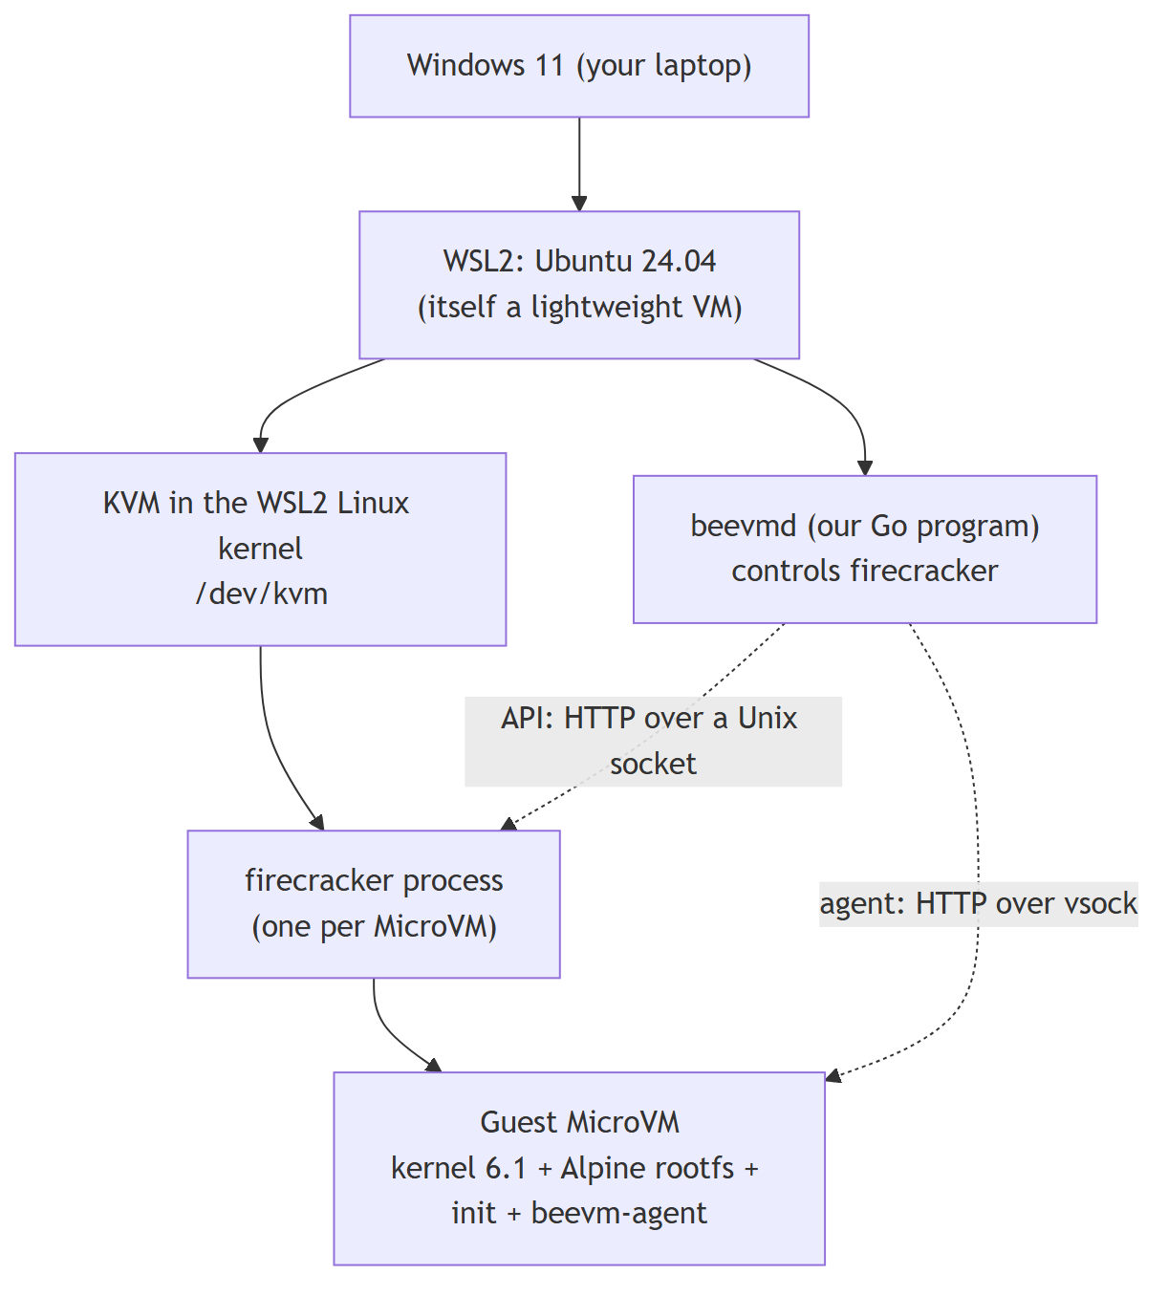
Why the layers matter: a MicroVM inside WSL2 is a VM inside a VM ("nested virtualization"). It works, but it is slower than on a real Linux server. That is why our boot numbers here (about 1.7 s) are only a development baseline.

Part 1: prepare Windows and WSL2

1.1 Check that the CPU supports virtualization
What: Intel VT-x or AMD-V must be turned on in the BIOS/UEFI.
Why: KVM (and so Firecracker) needs hardware virtualization.
In Windows: Task Manager → Performance → CPU → "Virtualization: Enabled". If it says Disabled, turn it on in the BIOS setup.

1.2 Install WSL2 with Ubuntu 24.04
In Windows PowerShell:
wsl --install -d Ubuntu-24.04
wsl -l -v
wsl -l -v must show VERSION 2. WSL1 has no real Linux kernel and no KVM.

1.3 Check that KVM works inside WSL2
In the WSL (Ubuntu) terminal:
uname -m # must print x86_64
ls -l /dev/kvm # must exist: crw-rw---- root kvm
cat /sys/module/kvm_intel/parameters/nested # Intel: Y means nested virtualization is on
cat /sys/module/kvm_amd/parameters/nested # AMD: 1 means on
On our laptop (i7-13620H, Windows 11) all of this worked without changing anything.
Common problems
Symptom | Cause | Fix
/dev/kvm: No such file | Nested virtualization off for WSL2 (it is on by default on Windows 11, but can be turned off) | Create or edit C:\Users\<you>\.wslconfig with [wsl2] and nestedVirtualization=true, then wsl --shutdown in PowerShell and wait a few seconds before reopening
Still no /dev/kvm | Virtualization off in BIOS, or an old Windows build | Enable VT-x/AMD-V in BIOS; update Windows 11
nested file missing | Wrong CPU vendor file (Intel vs AMD) | Read the other one

Part 2: get the code and understand the layout

2.1 Basic tools and your Git identity
Ubuntu on WSL normally has git and make already. If not:
sudo apt update && sudo apt install -y git make
Tell Git who you are (it is written into every commit, and is public on GitHub):
git config --global user.name "Your Name"
git config --global user.email "you@example.com" # or GitHub's no-reply address, see Part 6.4
Everything else (Go, Firecracker, kernel, image) is installed by make setup in Part 3.

2.2 Clone the repository
In the WSL terminal (choose your own Windows folder):
cd /mnt/c/Users/<you>/Desktop
git clone https://github.com/om8P/BeeVM.git
cd BeeVM
/mnt/c/... is your Windows C: drive seen from Linux. Keeping the code there means you can edit it with Windows tools (VS Code, Claude) while building it in WSL.
The course case-study .docx is not in the repo (it is course material). Get it from the course page if you need it.

2.3 Two places on disk, on purpose
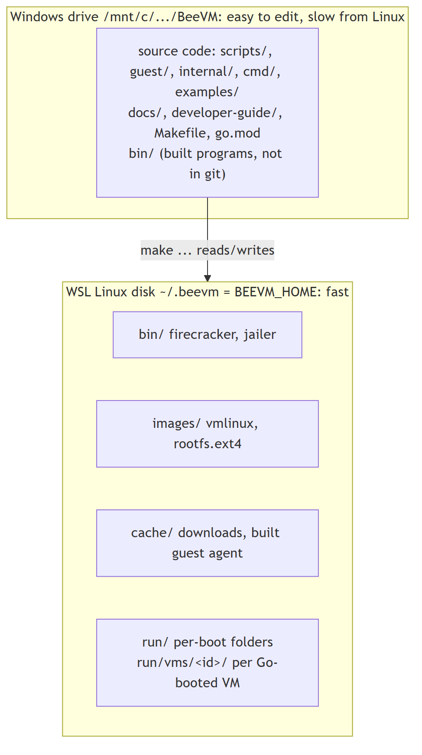
Why: reading files on /mnt/c from Linux goes through a slow translation layer. VM disk images and (later) snapshots need fast disk access, so they live in ~/.beevm. To put them elsewhere: export BEEVM_HOME=/some/linux/path before running make.

2.4 Line endings (a problem we hit)
Windows Git had core.autocrlf=true, which turns line endings into Windows-style CRLF on checkout. Bash then fails with errors like $'\r': command not found.
Fix (already in the repo): .gitattributes contains * text=auto eol=lf, which forces LF for every text file regardless of the Git settings. Check with:
git ls-files --eol | grep -E "\.sh|Makefile" # should show w/lf
If a script was already checked out with CRLF: sed -i 's/\r$//' path/to/script.sh.

Part 3: Milestone 1, a hand-booted MicroVM
Goal: prove KVM and Firecracker work, by booting a VM with the plain firecracker command and a JSON config file.

3.1 One-time setup: make setup
In the WSL terminal, in the repo folder:
make setup
It asks for your sudo password once. It runs scripts/setup-wsl.sh, which does these steps, each skipped if already done (so it is safe to run again):
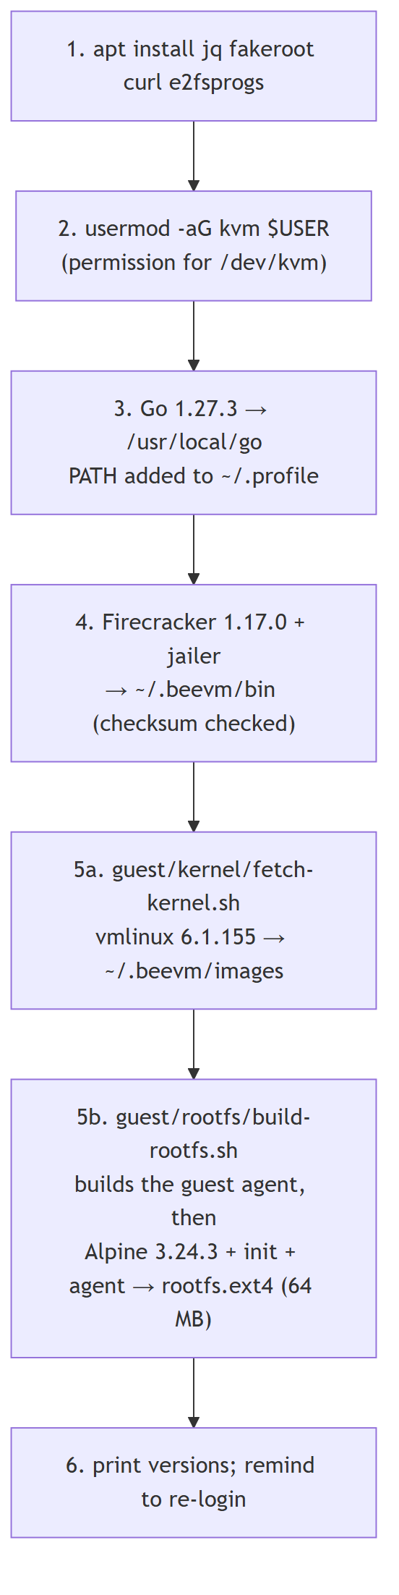
All versions and SHA-256 checksums are pinned in scripts/common.sh. Every download is checked against its checksum and refused if it does not match.
Then, once, in Windows PowerShell:
wsl --shutdown
and open the WSL terminal again. Why: adding a user to a group only takes effect at the next login. Check with id (must list kvm).
What each piece is:
- firecracker: the virtual machine monitor (VMM). It uses KVM to run a MicroVM with only a few emulated devices (serial port, disk, network, vsock), which is why it starts fast.
- jailer: Firecracker's sandboxing helper. Installed now, used in milestone 9.
- vmlinux: the guest Linux kernel as an uncompressed file. Firecracker loads it straight into guest memory; there is no BIOS or bootloader.
- rootfs.ext4: the guest's disk (its /), containing Alpine Linux, our init script and (since milestone 3) the guest agent.
Setup takes a few minutes the first time (it downloads well over 100 MB: Go, Firecracker, the 43 MB kernel, Alpine). Running it again takes under a second.

3.2 How the rootfs is built (no sudo, no Docker)
make rootfs # or: bash guest/rootfs/build-rootfs.sh
- Build the guest agent (milestone 3) as a static Go binary: CGO_ENABLED=0 go build -trimpath -ldflags="-s -w" ./cmd/beevm-agent into ~/.beevm/cache/beevm-agent. If the new binary is identical to the old one, the old file is kept.
- Download alpine-minirootfs-3.24.3-x86_64.tar.gz (about 3.6 MB).
- Inside one fakeroot session: unpack it, copy guest/rootfs/init to /sbin/beevm-init and the agent to /sbin/beevm-agent, then run mkfs.ext4 -d <folder> rootfs.ext4 64M.
- mkfs.ext4 -d creates a filesystem image and fills it from a folder without mounting it, so no root rights are needed.
- fakeroot makes the files look owned by root inside that session, so they are root-owned inside the image (the guest expects that).
The image is rebuilt automatically when guest/rootfs/init, the build script or the agent binary changes. After changing agent code, run make images (or make rootfs), otherwise the VM still runs the old agent. The image uses 20 MB on disk.

3.3 The guest's init script (PID 1)
guest/rootfs/init is the first program the guest kernel runs. It mounts /proc, /sys, /dev, prints a banner, then acts on the beevm.mode= value in the kernel command line:
Mode | Used by | Behaviour
selftest | make boot-test | prints BEEVM_BOOT_OK, then reboot -f (VM exits)
idle | beevmd boot, Go tests (milestone 2) | prints BEEVM_READY, waits until stopped
agent | beevmd invoke, agent tests (milestone 3) | mounts a RAM disk on /run, starts /sbin/beevm-agent, prints BEEVM_AGENT_STARTED; if the agent ever exits it prints BEEVM_AGENT_EXITED code=N and powers the VM off
none | make boot | gives you a shell; reboot -f exits

3.4 Boot a VM: make boot-test and make boot
make boot-test # automatic: boots, checks, prints the time
make boot # interactive: you get a shell inside the VM
scripts/boot-vm.sh makes a run folder ~/.beevm/run/<timestamp>/, copies rootfs.ext4 into it (the clean original is never changed), writes vm-config.json, and runs firecracker --no-api --config-file vm-config.json.
The kernel arguments it passes:
Argument | Meaning
console=ttyS0 | kernel messages go to the serial port, which Firecracker connects to your terminal
reboot=k | a guest reboot happens through the keyboard controller, which Firecracker treats as "exit"
panic=1 | if the kernel crashes, reboot after 1 s instead of hanging
pci=off | Firecracker has no PCI bus, so don't look for one
init=/sbin/beevm-init | run our script as PID 1
beevm.mode=... | our own flag, read by the init script

What happens during make boot-test:
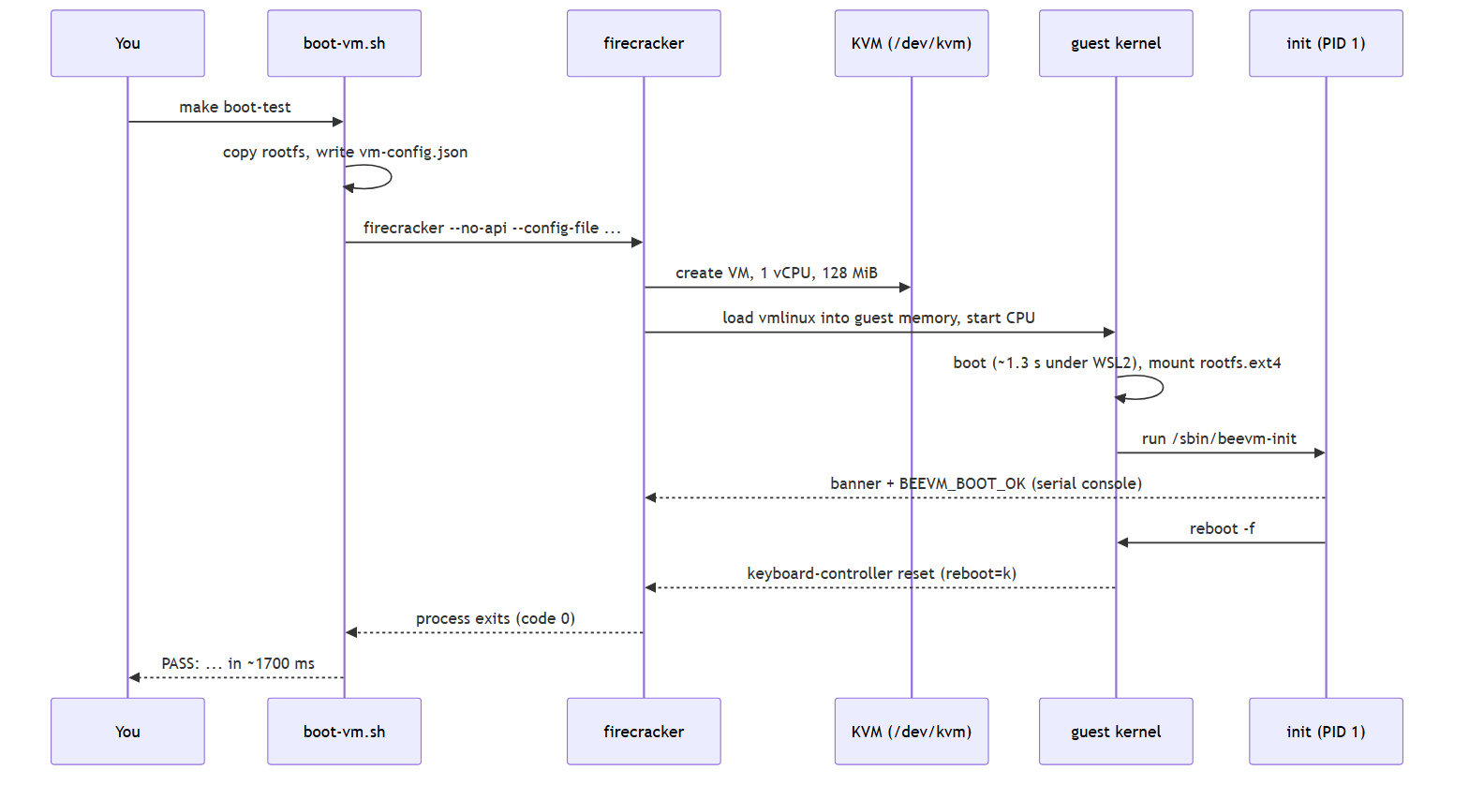
In make boot, check that you are really in a different system: uname -r shows 6.1.155 inside the VM but 6.6... in WSL.
Result: make boot-test passes in 1.7 to 2.0 s. make clean-images && make setup && make boot-test rebuilds everything from scratch and passes again.

3.5 Problems we hit in milestone 1
Problem | What happened | Fix
No kernel for Firecracker 1.17 | Firecracker's CI storage had no vmlinux-6.1 under v1.17 or v1.16 | Took vmlinux-6.1.155 from the v1.15 folder. The kernel does not depend on the Firecracker version
HTTPS certificate error listing the kernel bucket | https://spec.ccfc.min.s3.amazonaws.com fails, since bucket names with dots break the S3 certificate | Use the path-style URL https://s3.amazonaws.com/spec.ccfc.min/...
sudo needs a password | Automation tools cannot type it | You run make setup yourself; everything after it needs no sudo
Permission denied on /dev/kvm after setup | The group change is not active until next login | wsl --shutdown in PowerShell, reopen WSL
Shell scripts fail with \r errors | CRLF line endings from Windows Git | .gitattributes (Part 2.4)
Commands run from Windows into WSL lose $VARS and quotes | Each layer (Git Bash, wsl.exe, bash) re-parses the text; Git Bash also rewrites /mnt/... paths | Put commands in a script file and run wsl.exe -- bash file.sh, set MSYS_NO_PATHCONV=1, or just use make targets. Typing directly in the WSL terminal avoids all of this
Slow Alpine download | Mirror speed (about 130 KB/s once) | Only happens once; files are cached in ~/.beevm/cache

Other common problems
- make: command not found or strange errors: you ran it in PowerShell. Run it in the WSL terminal.
- firecracker not found: make setup did not finish. Run it again; finished steps are skipped.
- Boot hangs or FAIL: read the log path printed by the script (~/.beevm/run/<...>/console.log). The last lines usually say what went wrong.
- ls: cannot access /dev/kvm after a Windows update: check Part 1.3 again.

Part 4: Milestone 2, boot and stop a VM from Go
Goal: replace the shell script with Go code that the rest of BeeVM can call: create, start, stop, kill and clean up a VM, leaving nothing behind.

4.1 Go module and the Firecracker SDK
Already done in the repo; for a fresh clone you only need:
make build # downloads Go dependencies the first time, builds bin/beevmd
For the record, the module was created with the commands below (it was first named after the old GitHub account; see Part 6.3 for the renames):
go mod init github.com/om8P/BeeVM
go get github.com/firecracker-microvm/firecracker-go-sdk@6fb280e993d4
go mod tidy
- A Go module is a project with its own name (the module path) and a list of pinned dependencies (go.mod and checksums in go.sum).
- firecracker-go-sdk starts the firecracker process and talks to its API for us.
- Why a commit instead of a release? The SDK's last release (v1.0.0) is from 2022. Its main branch (December 2025) has updated, security-fixed dependencies. It is tested against Firecracker 1.4.1, but worked with our 1.17.0 without changes. It requires Go 1.24 or newer.
If go is "not found" in a new terminal: source ~/.profile, or use make (it calls /usr/local/go/bin/go directly).

4.2 The API socket: how Go controls Firecracker
In milestone 1 we used --no-api and a JSON file. Now Firecracker runs with --api-sock <file>: it listens on a Unix domain socket (a file that acts like a local network port) and is configured with HTTP requests:
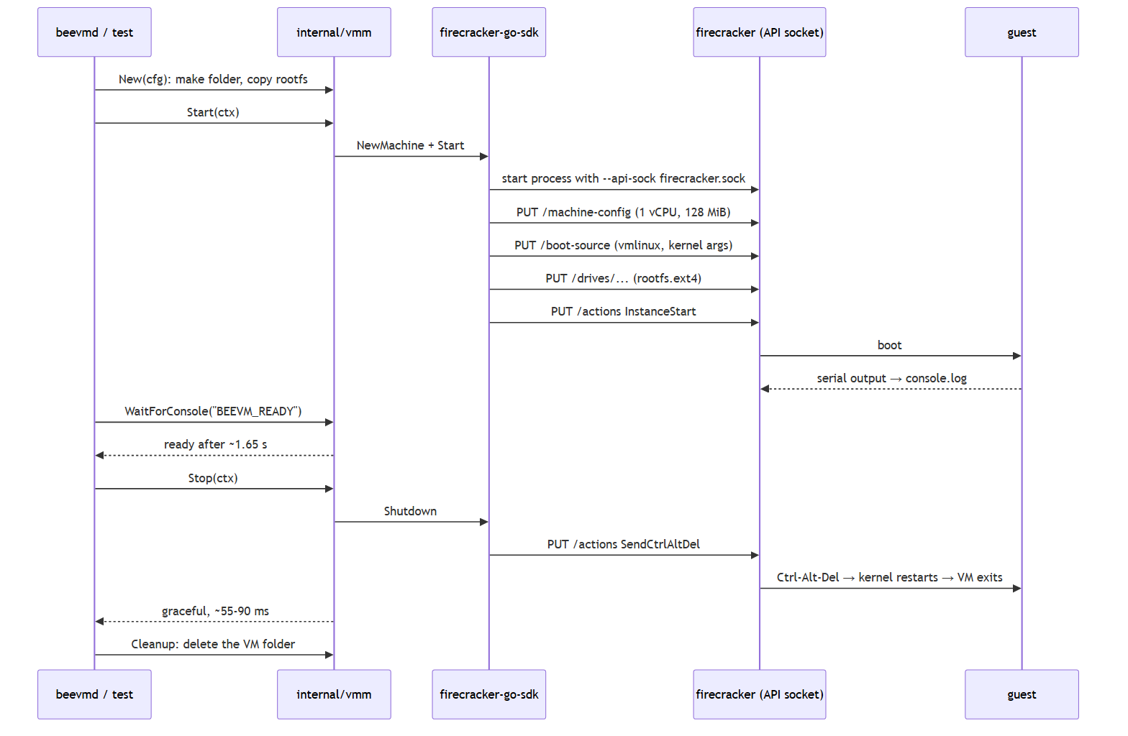

4.3 The VM lifecycle in internal/vmm
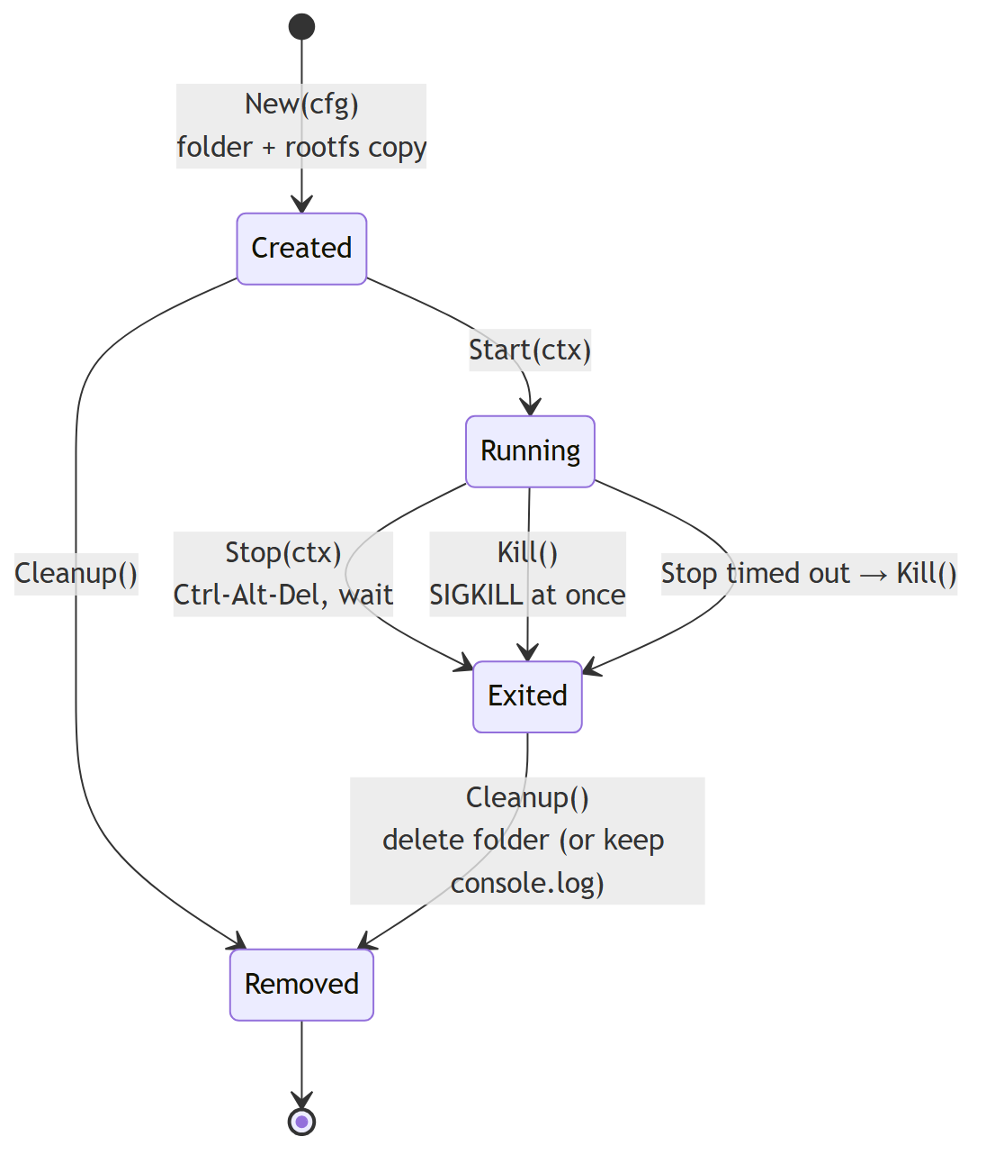
Files:
File | What it holds
internal/vmm/config.go | Config (paths, vCPUs, memory, extra kernel args), defaults, Validate(), the per-VM paths
internal/vmm/vm.go | New, Start, WaitForConsole, Stop, Kill, Cleanup, PID, Exited
internal/vmm/vm_test.go | 9 unit tests that need no KVM
internal/vmm/vm_kvm_test.go | 3 tests that boot real VMs (//go:build kvm)
cmd/beevmd/main.go | the beevmd boot command

Each VM gets its own folder ~/.beevm/run/vms/<id>/ with rootfs.ext4, firecracker.sock, console.log and (since milestone 3) v.sock. The library never reads environment variables; the caller passes all paths. Only beevmd reads BEEVM_HOME.

4.4 Run it
make test # unit tests, no KVM needed
make test-kvm # boots real VMs: graceful stop, kill, cancelled start
make vet # Go's static checks
make build
./bin/beevmd boot # boot, show console, stop, clean up
./bin/beevmd boot --hold 30s # keep it running 30 s (Ctrl-C kills it)
./bin/beevmd boot --keep-logs # keep console.log afterwards
./bin/beevmd boot --mem 256 --vcpus 2 # different size
Check that nothing is left behind (after any of the above, including Ctrl-C):
pgrep -a firecracker || echo "no firecracker processes"
ls ~/.beevm/run/vms/
Result: all tests pass; ready in about 1.65 s, graceful stop in 55 to 90 ms; Ctrl-C exits with code 130; no leftovers in any case we tried.
Build tags: //go:build kvm at the top of vm_kvm_test.go means it is only compiled with go test -tags kvm. So make test passes on machines without KVM, and make test-kvm runs the real thing.

4.5 Problems we hit in milestone 2
Problem | Why | What we did
The VM would die when a start timeout expired | The SDK ties the firecracker process to the context used to start it | The VM gets its own long-lived context; the caller's timeout only limits how long Start waits
Calling Shutdown twice would panic | The SDK closes an internal channel in Shutdown | Stop wraps it in sync.Once
Ctrl-C in beevmd went straight to firecracker | The SDK forwards signals to firecracker by default | Set ForwardSignals to an empty list; beevmd decides (it kills the VM and cleans up)
StopVMM could hang | It sends SIGTERM and waits | Kill sends SIGKILL to the process directly and waits at most 5 s
Init's SIGINT handler never runs on stop | By default the kernel restarts immediately on Ctrl-Alt-Del, without telling PID 1 | Fine: the VM still exits cleanly. The handler stays as a safety net
The kernel takes ~1.3 s to boot | Partly WSL2 nesting; the log also shows a ~460 ms gap around clk: Disabling unused clocks | Noted for tuning in milestone 6
go mod tidy requires Go 1.24 | The SDK's main branch needs it | Fine with our Go 1.27.3; docs updated to "Go 1.24+"

Other common problems
- go: command not found: source ~/.profile or open a new WSL terminal.
- KVM tests print SKIP: /dev/kvm or the images are missing. Run make setup and check id for kvm.
- address already in use for the socket: a folder from a crashed run is left over. Delete ~/.beevm/run/vms/<id>.
- First make build is slow: Go is downloading dependencies; later builds are cached.

Part 5: Milestone 3, guest agent over vsock, first function runs
Goal: talk to code inside the VM. A small Go program, the guest agent, runs in every VM. The host uploads a function binary to it, sends a JSON payload, and gets the function's JSON output back.

5.1 What was added
File | What it holds
internal/agentproto/agentproto.go | Shared request/response types, the port (10000), the limits. Host and guest both import it, so they can never disagree
internal/agent/server.go | The agent's HTTP handlers and the function runner (no vsock code, so it is testable without a VM)
internal/agent/server_test.go | 12 unit tests (no KVM)
cmd/beevm-agent/main.go | The guest program: listens on vsock port 10000 and serves internal/agent
internal/vmm/agent.go | Host side: the vsock handshake (dialVsock) and AgentClient (Health, UploadFunction, Invoke)
internal/vmm/agent_test.go | 6 unit tests with a fake Firecracker
internal/vmm/vm_agent_kvm_test.go | 3 tests that boot real VMs and run functions
internal/vmm/config.go, vm.go | Every VM now gets a vsock device (v.sock, guest CID 3); new vm.Agent() and vm.WaitForAgent()
cmd/beevmd/invoke.go | The beevmd invoke command
examples/functions/hello-go-binary/ | Example function
examples/functions/testfn/ | Test function with modes: echo, fail, sleep, garbage, big
guest/rootfs/init, build-rootfs.sh | agent mode; the agent is built and baked into the image
Makefile | New target examples

New dependency: github.com/mdlayher/vsock v1.3.0 (added with go get github.com/mdlayher/vsock@v1.3.0, then go mod tidy). It also upgraded a few golang.org/x/... packages.

5.2 Build everything
In the WSL terminal, in the repo folder:
make images # rebuilds the rootfs so it contains the current guest agent
make build # bin/beevmd
make examples # bin/functions/hello-go-binary and bin/functions/testfn
- make images builds the agent with CGO_ENABLED=0 (a static binary) and puts it in the image as /sbin/beevm-agent. Run it again whenever agent code changes.
- make examples builds the example functions the same way. Functions must be static Linux x86-64 binaries: the guest runs Alpine, which uses the musl C library, so a normal Ubuntu binary (built against glibc) will not start there. For Go, CGO_ENABLED=0 GOOS=linux GOARCH=amd64 go build is enough.

5.3 How a call flows
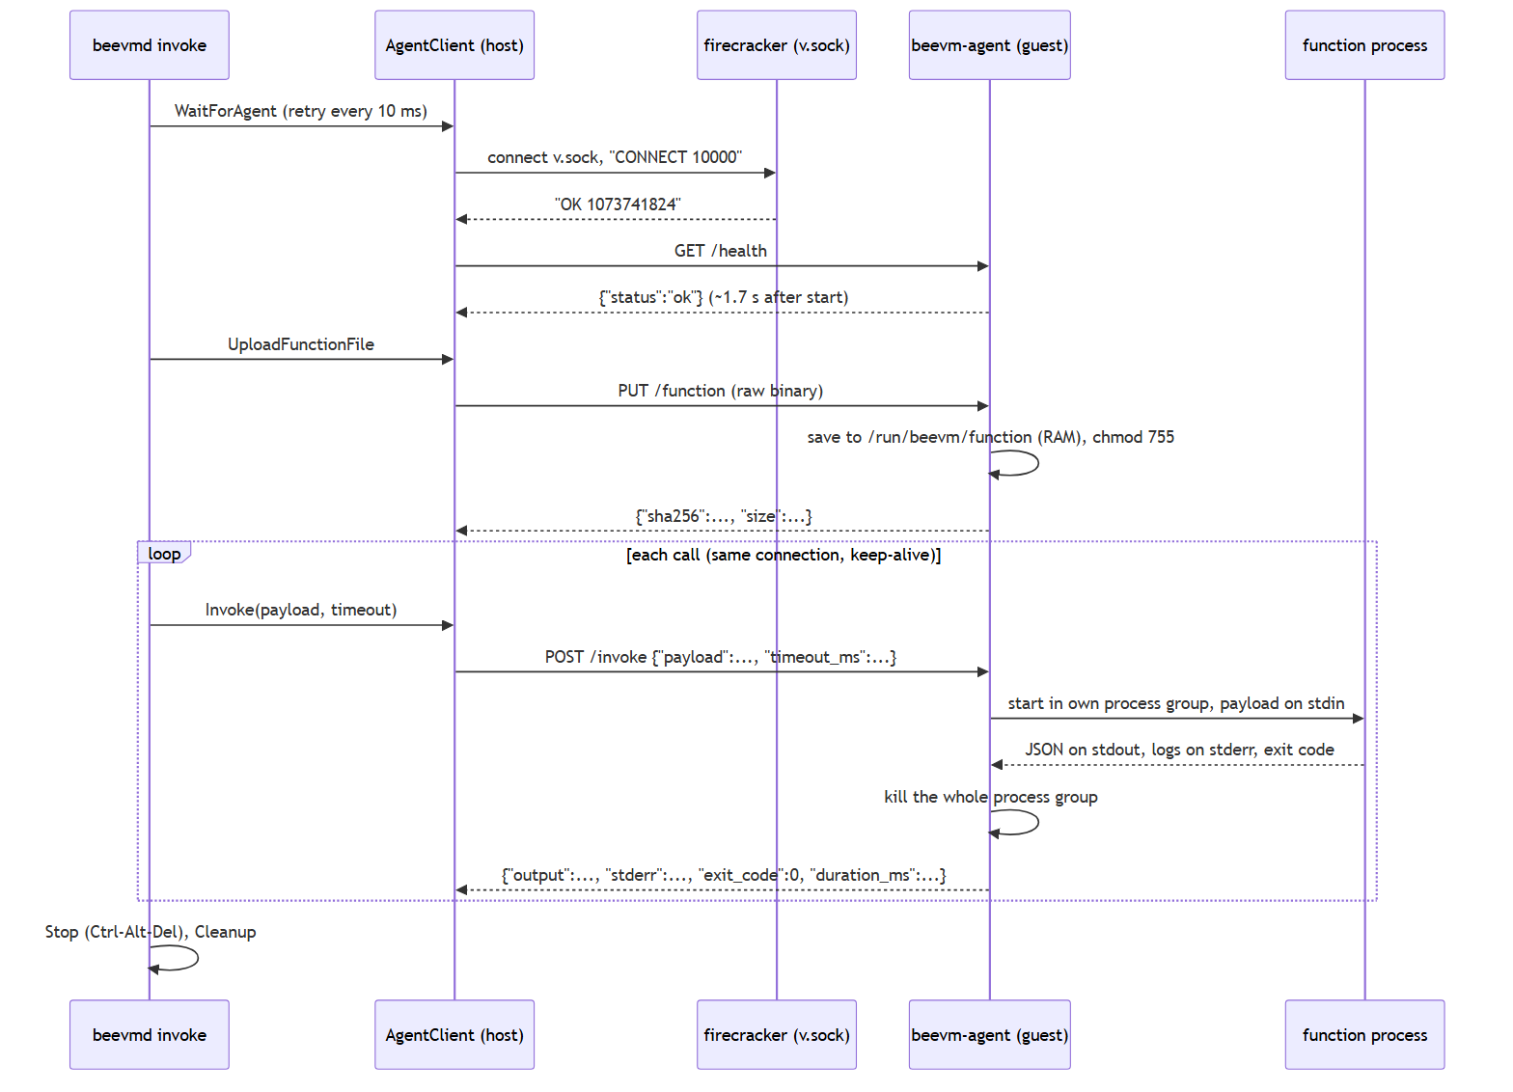
The vsock handshake. On the host, Firecracker turns the guest's vsock into a Unix socket file (v.sock in the VM folder). To reach guest port 10000, connect to that file, send the line CONNECT 10000, and read back OK <number>. After that it is a plain byte stream to the agent, and normal HTTP runs over it. If the agent is not listening yet, Firecracker closes the connection, which is why WaitForAgent simply retries.

5.4 The agent's protocol
Request | Body | Answer
GET /health | — | {"status":"ok","agent_version":"0.1.0","uptime_ms":...}
PUT /function | the raw binary (≤ 50 MB) | {"sha256":"...","size":...}
POST /invoke | {"payload": <any JSON>, "timeout_ms": N} (payload ≤ 6 MB, timeout default 10 s, max 60 s) | {"output":..., "stderr":"...", "exit_code":N, "duration_ms":N, "error":"..."}

- A function failure (non-zero exit code, timeout, output that is not JSON, output over 6 MB) comes back as HTTP 200 with error set: the agent worked, the function did not.
- An agent or request problem is a 4xx code: 409 no function uploaded yet, 400 bad request or bad timeout, 413 payload or upload too large.
- stdout is only included when the output was not valid JSON (first 4 KB), to help debugging. Only the last 64 KB of stderr is kept.
- One call runs at a time per VM; a second call waits for the first.

5.5 Write your own function
The contract: payload JSON on stdin, result JSON on stdout, logs on stderr. A shortened version of examples/functions/hello-go-binary/main.go (the real file also defaults the name to "world"):
func main() {
var in struct{ Name string `json:"name"` }
if err := json.NewDecoder(os.Stdin).Decode(&in); err != nil {
fmt.Fprintln(os.Stderr, "bad input:", err)
os.Exit(1)
}
fmt.Fprintln(os.Stderr, "hello-go-binary: greeting", in.Name) // becomes a log line
json.NewEncoder(os.Stdout).Encode(map[string]string{ // becomes the output
"greeting": "Hello, " + in.Name + "!", "runtime": "binary"})
}
Build it as a static binary and run it:
CGO_ENABLED=0 GOOS=linux GOARCH=amd64 go build -o bin/functions/myfn ./path/to/myfn
./bin/beevmd invoke --code bin/functions/myfn --payload '{"name":"Om"}'
The function runs in /tmp with only PATH and HOME set. Anything it starts in the background is killed when the call ends.

5.6 Run it
./bin/beevmd invoke --code bin/functions/hello-go-binary --payload '{"name":"Om"}' --repeat 5
Expected output (times vary):
== starting VM f5eacc8a (1 vCPU, 128 MiB)
== agent ready after 1.844s
== uploaded bin/functions/hello-go-binary (2580640 bytes, sha256 8f311e18de83...) in 75ms
#1 {"greeting":"Hello, Om!","runtime":"binary"} (9ms in function, 11.6ms round trip)
log: hello-go-binary: greeting Om
#2 {"greeting":"Hello, Om!","runtime":"binary"} (5ms in function, 6.5ms round trip)
...
== summary: agent ready 1.844s, 5 call(s), median round trip 4.5ms, stopped gracefully in 68ms
Other things to try (all with --code bin/functions/testfn):
Payload | What you should see
'{"mode":"echo","x":1}' | {"echo":{"mode":"echo","x":1}}
'{"mode":"fail"}' | FAILED: function exited with code 3, plus the log line boom: ...; exit code 1
'{"mode":"sleep","ms":30000}' --timeout 500ms | FAILED: timeout after 500ms after about half a second
'{"mode":"garbage"}' | FAILED: function output is not valid JSON, with the text it printed

Flags of beevmd invoke:
Flag | Default | Meaning
--code PATH | (required) | the function binary
--payload JSON | {} | input for the function
--repeat N | 1 | how many calls
--timeout D | 10s | time limit per call, inside the guest
--ready-timeout D | 20s | how long to wait for the agent
--console | off | stream the VM console (it is printed automatically when something fails)
--keep-logs | off | keep console.log in ~/.beevm/run/vms/<id>/
--mem N, --vcpus N | 128, 1 | VM size

Ctrl-C kills the VM, cleans up and exits with code 130.

5.7 Tests
make test # unit tests: agent (12), host client with a fake Firecracker (6), VM lifecycle (9)
make test-kvm # also boots real VMs: milestone 2 tests + 3 agent tests
The agent tests in real VMs check: 20 echo calls each get their own correct answer; a failing function reports exit code 3 and its log; non-JSON output is reported; a function that sleeps too long is killed after 300 ms and the VM keeps working; the hello example returns the right greeting; calling before uploading gives a 409; and nothing is left behind afterwards.
Result: all pass. Agent ready 1.64 to 1.85 s after start; uploading a 2.5 MB function about 75 ms; a warm call 4 to 5 ms round trip (median), the first about 11 ms; graceful stop 56 to 85 ms.

5.8 Problems we hit in milestone 3
Problem | Why | What we did
go get for vsock also upgraded golang.org/x/net, x/sys and others | The library needs newer versions | Accepted after make vet and all tests passed
A `go test -run "A | B"pattern failed withcommand not found` | The `
Ctrl-C printed the VM console as if it were an error | The failure path did not check for Ctrl-C | It now prints == interrupted: VM killed, cleaning up and exits 130
make images printed the size with the full path | cut -d' ' on du output, which uses a tab | Changed to cut -f1

Other common problems
- exec format error from a call: the uploaded file is not a Linux x86-64 executable (for example a Windows .exe or a text file).
- no such file or directory when the function starts, although it exists: it is a dynamically linked (glibc) binary. Rebuild it static (CGO_ENABLED=0).
- waiting for agent: context deadline exceeded: the agent did not start. Run with --console and look for beevm-agent: lines or BEEVM_AGENT_EXITED. Did you run make images after changing agent code?
- agent returned 409: no function uploaded yet: upload before invoking (beevmd invoke does this for you).
- A call never returns: check the --timeout value; the host waits the function's timeout plus 10 s.

Part 6: the repository, GitHub and renames
What we did, so you can do the same for your own fork or a new repository.

6.1 Create and publish the repository
gh auth login # once: log the GitHub CLI in
gh repo create <user>/beevm --public --source=. --remote=origin --push
gh repo create ... --source=. --push creates the repository on GitHub, adds it as origin and pushes the current branch. We chose public so the group and graders can see it.

6.2 Removing a file from history before going public
The first commit contained the course case-study .docx. Deleting it in a new commit would still leave it in the history, visible to anyone. So, before the first push, we rewrote the local history:
git branch backup-before-rewrite # safety copy of the old history (stays local)
git filter-branch -f --index-filter \
'git rm -q --cached --ignore-unmatch "Advanced Cloud System Software Design_ 30 Case Studies.docx"' -- main
rm -rf .git/refs/original
echo "Advanced Cloud System Software Design_ 30 Case Studies.docx" >> .gitignore
git show backup-before-rewrite:"Advanced Cloud System Software Design_ 30 Case Studies.docx" \
> "Advanced Cloud System Software Design_ 30 Case Studies.docx" # put the file back on disk
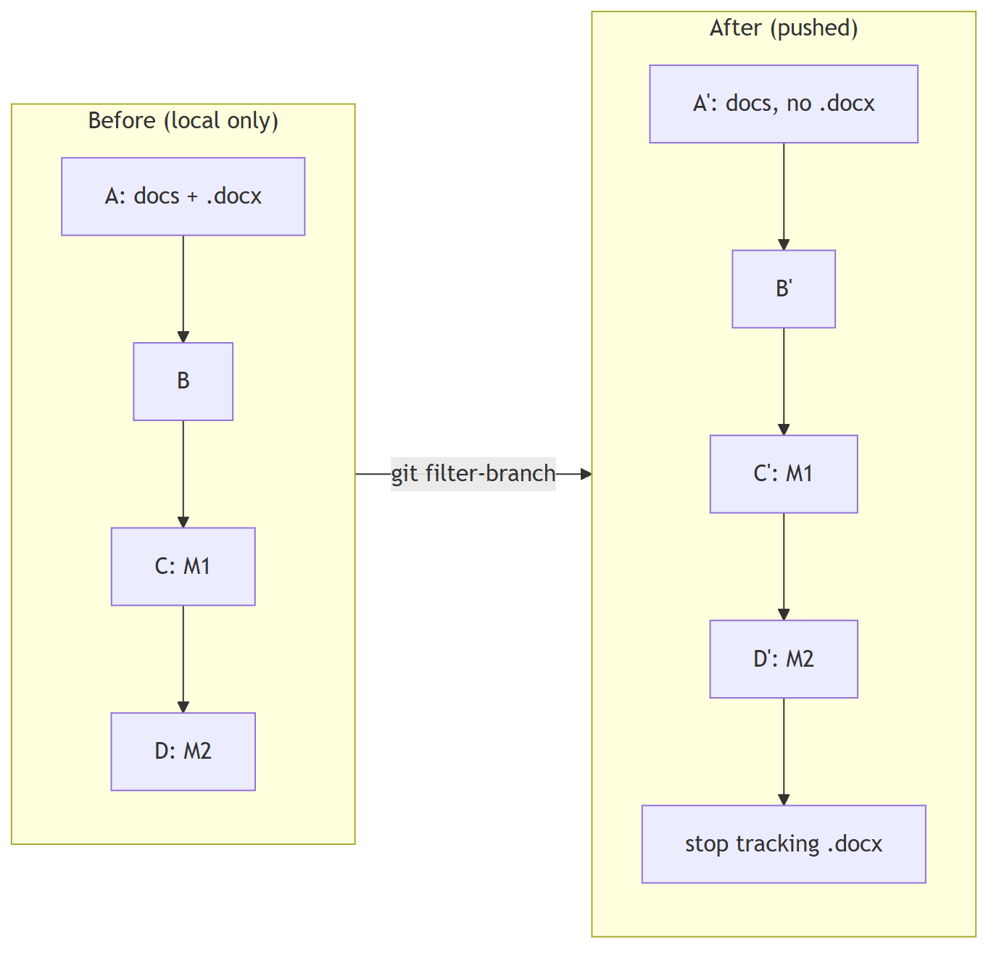
Things to know:
- Every rewritten commit gets a new hash. Only do this before anyone else has the old history.
- The rewrite deleted the file from the working folder (it was no longer tracked), hence the git show line to restore it.
- Git's own documentation now recommends git filter-repo for this job; filter-branch was enough for four local commits.
- When you are sure you do not need it: git branch -D backup-before-rewrite.

6.3 Renames: repository, module path, GitHub username
The Go module path is both the name in every import line and the address other people download the code from, so it should always match the repository.
When | What changed | Commands
After the first push | Repository beevm renamed to BeeVM | gh repo rename BeeVM --repo <user>/beevm --yes and git remote set-url origin https://github.com/<user>/BeeVM.git
Same day | Module path renamed to match | find-and-replace the old path in go.mod and every .go file, then make vet build test
Later | GitHub username changed from OmMhatre-99 to om8P; GitHub moved the repository and redirects the old address | git remote set-url origin https://github.com/om8P/BeeVM.git, then the module path became github.com/om8P/BeeVM the same way

To find every old reference before a rename: grep -rIl "old-name" --exclude-dir=.git --exclude-dir=node_modules .

6.4 Things to know about commits
- Commit author name and email come from git config and are public on GitHub. To hide your email, use GitHub's no-reply address: git config --global user.email "<id>+<username>@users.noreply.github.com". Old commits keep the old values.
- Every milestone ends with: tests pass, docs/progress.md updated, one commit.

6.5 The documentation folders
Folder | For whom | In Git
docs/ | the project and Claude: architecture.md, milestones.md, progress.md | yes
developer-guide/ | people: this guide (guide.md, plus a Word copy) and the learning notes (learning-notes.docx) | yes, the documents only
developer-guide/tools/ | the scripts that generate the Word files | no (local only, see Appendix E)

6.6 Commit history on GitHub
Commit | What
918d884 | planning docs and project setup
e6fdccb | 13-milestone session guide
e6dad4a | Milestone 1
bd71997 | Milestone 2
717a840 | stop tracking the course document
6364ecd | rename Go module to match the repository name
c70ccc2 | add this build guide
6a31586 | move the guide and learning notes to developer-guide/
7464297 | Milestone 3
aded71e | rename Go module to github.com/om8P/BeeVM

Appendix A: command cheat sheet
All in the WSL terminal, in the repo folder, unless marked PowerShell.
Command | What it does
make help | list targets
make setup | one-time install (sudo); safe to re-run
wsl --shutdown (PowerShell) | restart WSL so the kvm group takes effect
make images / make kernel / make rootfs | (re)build guest images; rootfs also rebuilds the guest agent
make boot-test | milestone 1 automatic boot check
make boot | milestone 1 interactive VM (reboot -f to exit)
make build | build bin/beevmd
make examples | build example functions into bin/functions/
./bin/beevmd boot [--hold D] [--keep-logs] [--mem N] [--vcpus N] | milestone 2: boot, show console, stop
./bin/beevmd invoke --code F [--payload J] [--repeat N] [--timeout D] [--console] [--keep-logs] | milestone 3: run a function in a VM
make test / make test-kvm / make vet | Go tests and checks
make clean-images | delete ~/.beevm/images and ~/.beevm/run
pgrep -a firecracker | find leftover VMs
id | check you are in the kvm group

Appendix B: pinned versions
Component | Version | Where pinned
Firecracker + jailer | 1.17.0 | scripts/common.sh
Go | 1.27.3 (module needs ≥ 1.24) | scripts/common.sh, go.mod
Guest kernel | vmlinux 6.1.155 (Firecracker CI, v1.15 folder) | scripts/common.sh
Alpine minirootfs | 3.24.3 | scripts/common.sh
firecracker-go-sdk | main @ 6fb280e993d4 (Dec 2025) | go.mod
mdlayher/vsock | v1.3.0 | go.mod
Guest agent | 0.1.0 | cmd/beevm-agent/main.go
Host | Windows 11, WSL2 Ubuntu 24.04.3, WSL kernel 6.6.87 | —

Appendix C: measured numbers (WSL2, i7-13620H, 1 vCPU, 128 MiB)
Measurement | Value | Milestone
Cold boot, shell script, process start to exit | 1.7 to 2.0 s | 1
Guest kernel reaches init | ~1.3 s | 1
Cold boot via Go, Start to BEEVM_READY | 1.58 to 1.71 s | 2
Graceful stop (Ctrl-Alt-Del) | 55 to 91 ms | 2, 3
Agent answers /health after Start | 1.64 to 1.85 s | 3
Upload a 2.5 MB function | ~75 ms | 3
Function call round trip, warm (median) | 4 to 5 ms | 3
Function call round trip, first call | ~11 ms | 3
Guest agent binary / rootfs on disk | 6.8 MB / 20 MB | 3
make setup re-run when all done | 0.6 s | 1
Target cold start (snapshot restore) | < 50 ms | 6 (to do)

Appendix D: general troubleshooting
- Where am I? Most problems come from running a command in the wrong place. Prompt PS C:\...> is PowerShell; user@host:~$ is WSL.
- Read the console log. Every boot writes one: ~/.beevm/run/<timestamp>/console.log (script) or ~/.beevm/run/vms/<id>/console.log (Go, with --keep-logs, or --console to watch it live).
- Check KVM access: ls -l /dev/kvm and id.
- Stale guest agent? make images after changing anything in cmd/beevm-agent or internal/agent.
- Start clean: make clean-images && make setup.
- Leftover processes: pgrep -a firecracker, then kill <pid>; leftover folders: rm -rf ~/.beevm/run/vms/*.
- Running commands from Windows tools into WSL: put them in a script file and run wsl.exe -- bash file.sh, or use make; inline $VARS, quotes and | get mangled.

Appendix E: regenerating these documents
The Word files are generated; only the generated documents are in Git. The generator lives in developer-guide/tools/ on the machine that made them (it is not in the repository). To set it up somewhere else, copy that folder, then on the Windows side (needs Node.js):
cd developer-guide/tools
npm install docx marked @mermaid-js/mermaid-cli # once
npx puppeteer browsers install chrome-headless-shell # once: a small headless browser to draw the diagrams
npm run guide # guide.md -> BeeVM-guide.docx (diagrams rendered to PNG)
npm run build # notes-data.js -> learning-notes.docx
puppeteer.json in that folder points the diagram renderer at the downloaded browser; it holds a machine-specific path. Close the Word files first: Windows will not let a program overwrite a file that is open in Word.

