**Exercise 1: Freestyle Job - Windows File Transfer Automation**

**1. Objective:** Automate file transfer between two directories on a Windows

machine.

**2. Steps:**

o Create a Freestyle Job in Jenkins.

o **Configure the job to execute a Windows batch command:**

xcopy C:\source-directory C:\target-directory /E /I /H /Y

o Add a post-build action to check the success of the transfer using a

custom message.

3. **Task:** Test the job by placing some files in the source directory and verifying they

are transferred to the target directory

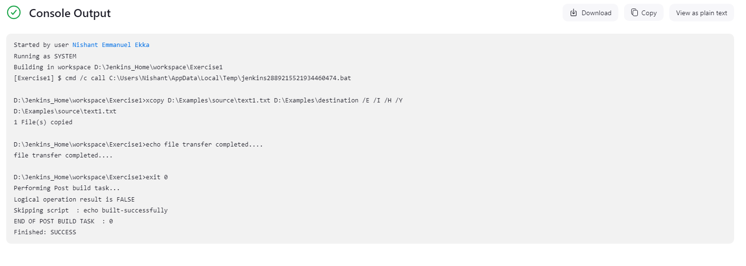

**Exercise 2: Freestyle Job - Build and Deploy a JavaScript Project**

1. **Objective:** Build and deploy a JavaScript-based web project.

**2. Steps:**

o Create a Freestyle Job.

o **Configure the job to:**

▪ Clone a JavaScript repository (e.g., a React project) from GitHub.

▪ Run npm install to install dependencies.

▪ Build the project using npm run build.

▪ Copy the build folder to a deployment directory using a Windows

batch command or PowerShell.

o Archive the build artifacts for future reference.

**3. Task:** Verify the deployment by accessing the web application from the

deployment directory.

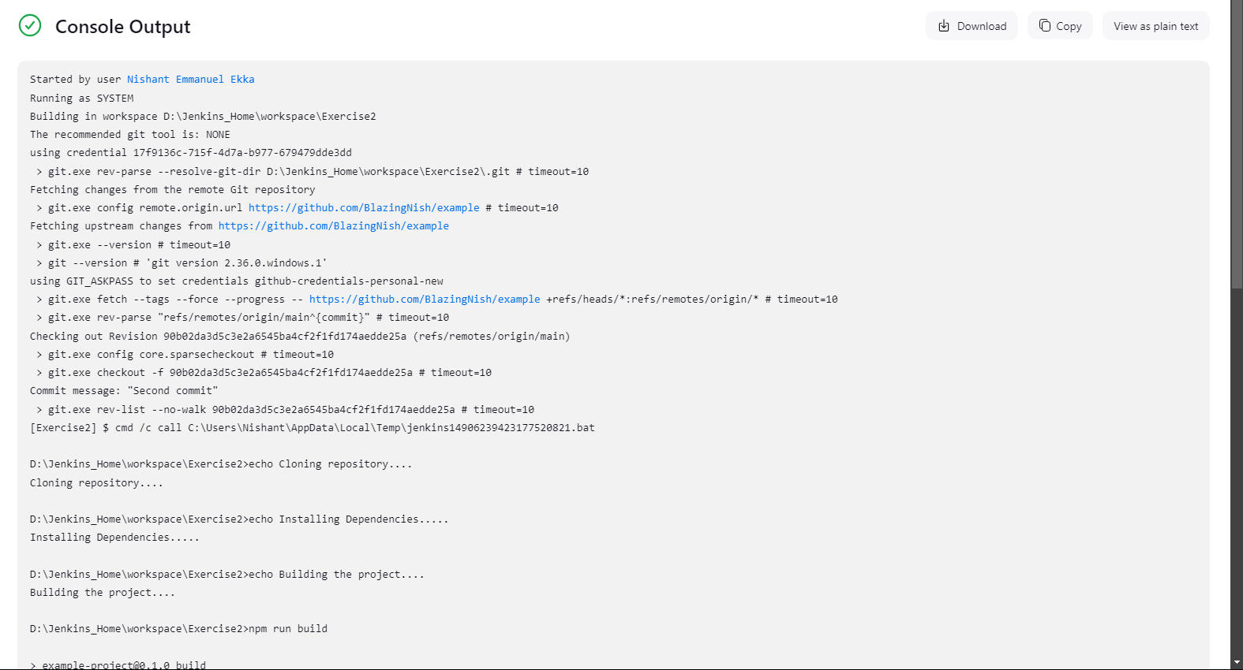

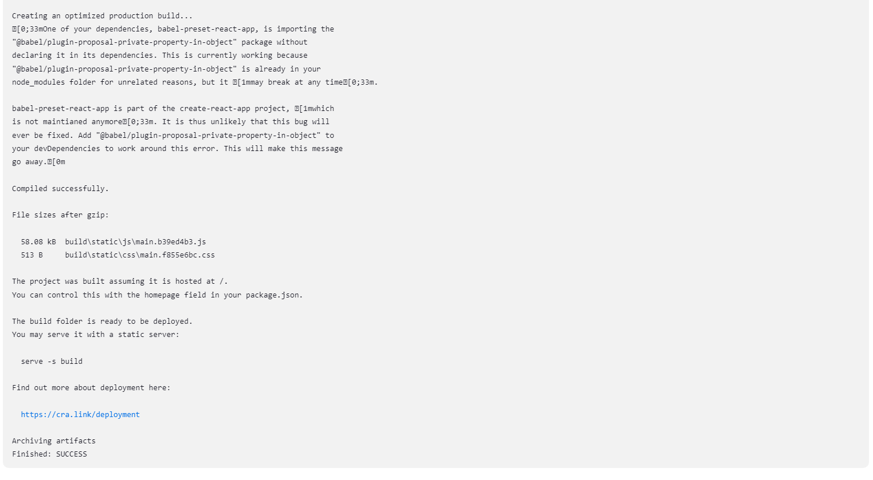

**Exercise 3: Freestyle Job - Flask Application Deployment**

**1. Objective:** Automate the deployment of a Flask application.**2. Steps:**

o Create a Freestyle Job.

o **Configure the job to:**

▪ Pull the Flask application repository from GitHub.

▪ **Set up a virtual environment using Python:**

python -m venv venv

.\venv\Scripts\activate

pip install -r requirements.txt

▪ Start the Flask development server.

o Add a post-build action to verify the server is running (e.g., using curl or a

similar tool to hit a test endpoint).

**3. Task:** Test the application deployment by accessing it via localhost.

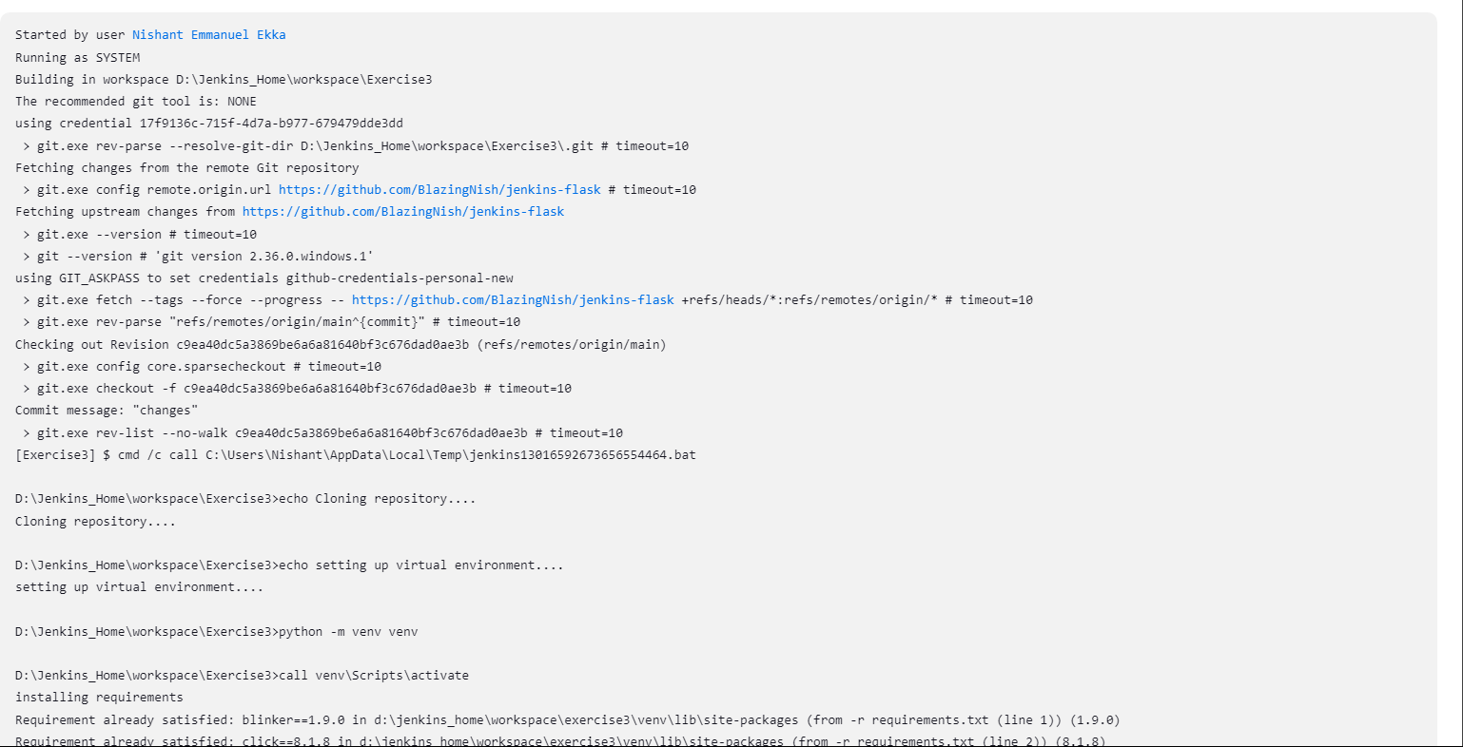

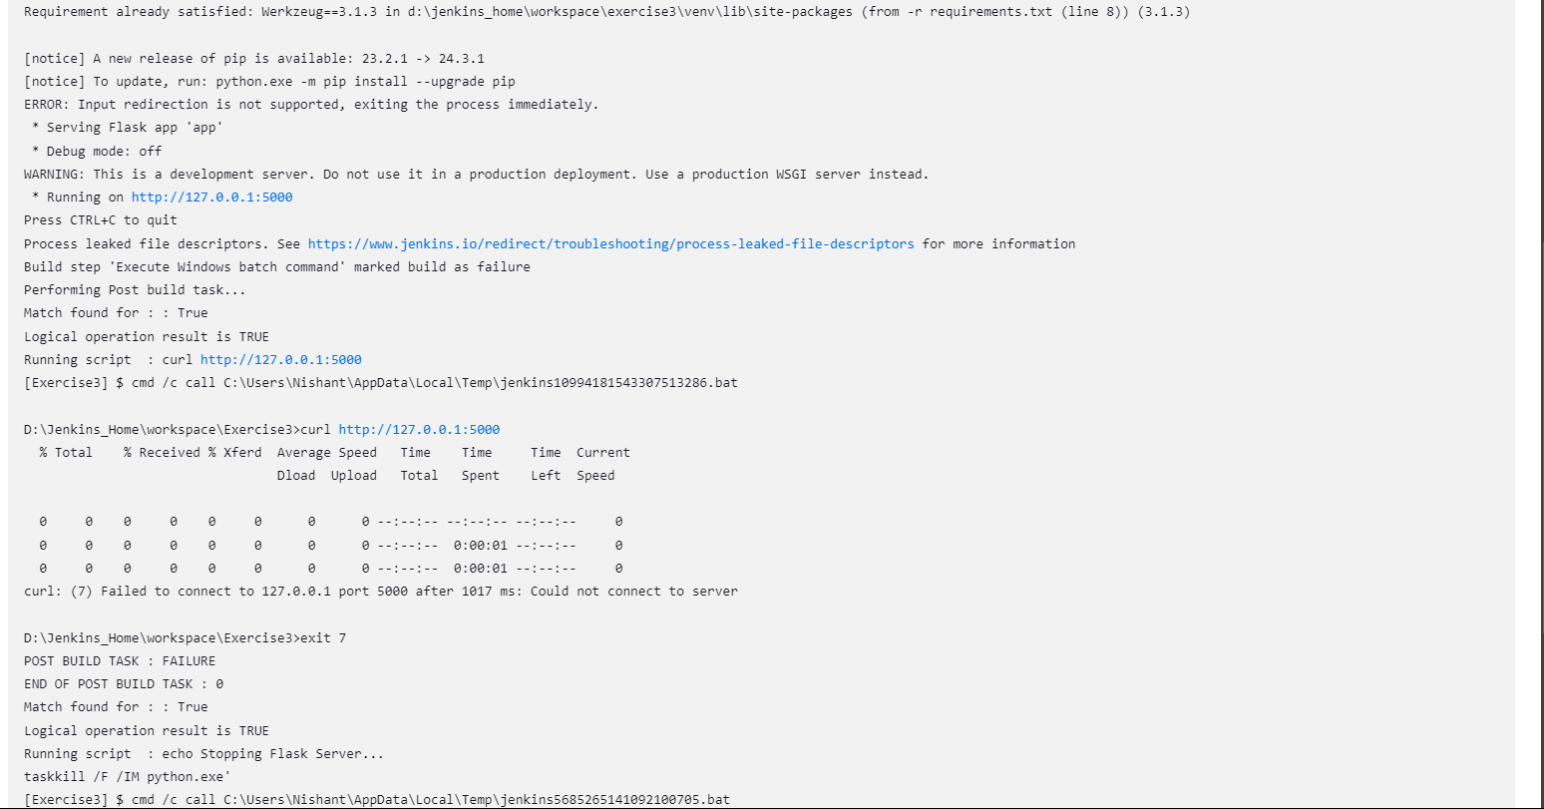

**Exercise 4: Pipeline Job - End-to-End CI/CD for a React Application**

1. **Objective:** Implement a CI/CD pipeline for a React web application.

**2. Steps:**

o Create a Pipeline Job.

o **Write a Jenkinsfile to:**

▪ Clone the React project from GitHub.

▪ Install dependencies (npm install).

▪ Run tests (npm test).

▪ Build the project (npm run build).

▪ Deploy the application by copying the build folder to a deployment

directory.

o **Add stages for:**

▪ Linting using ESLint.

▪ Post-deployment testing using curl to verify the app is running.

**3. Task:** Run the pipeline and validate each stage's output.

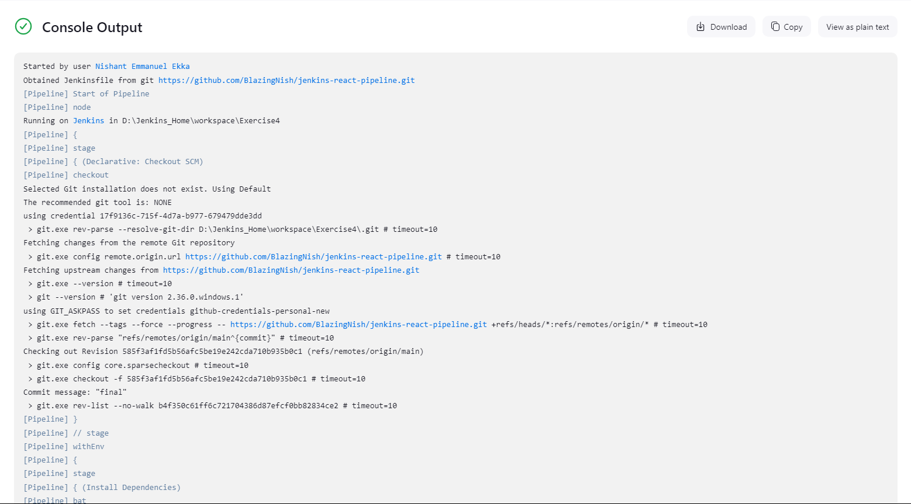

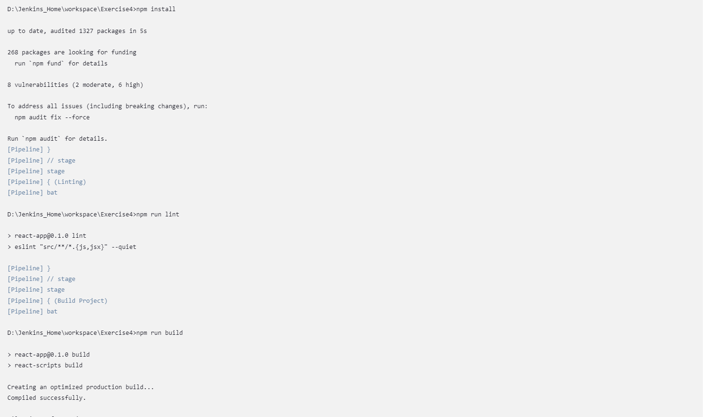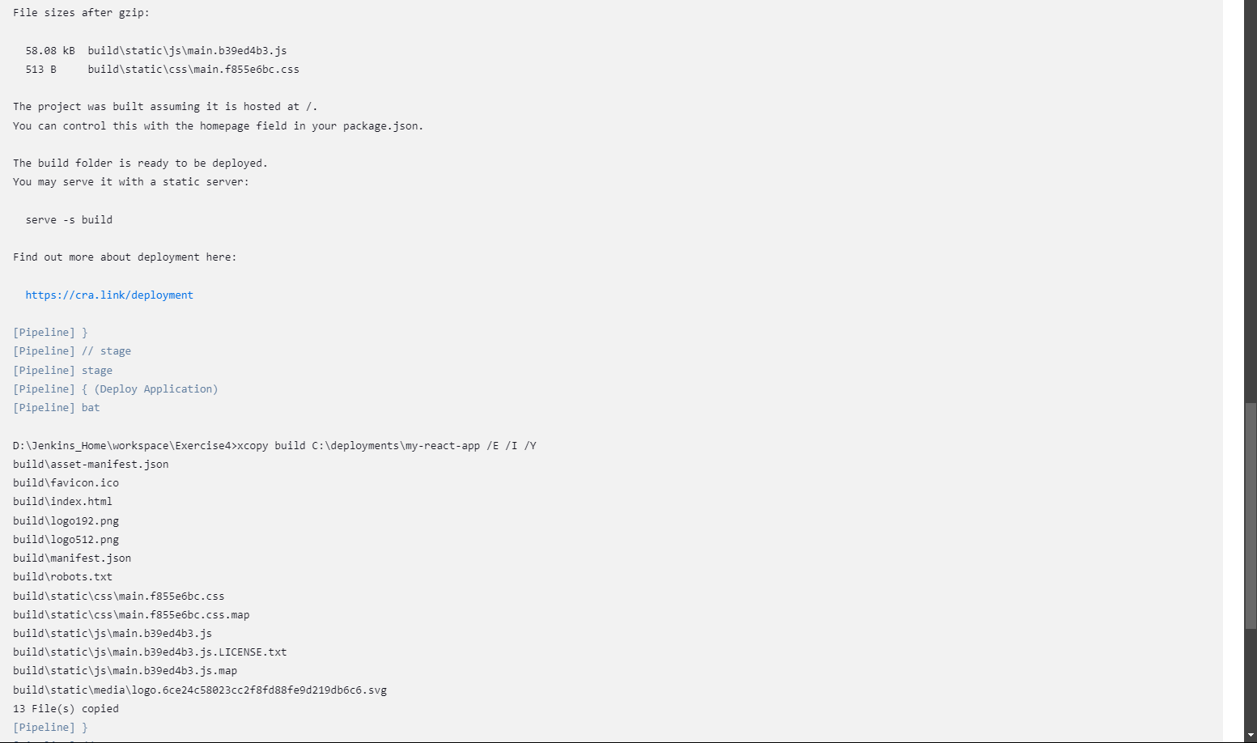

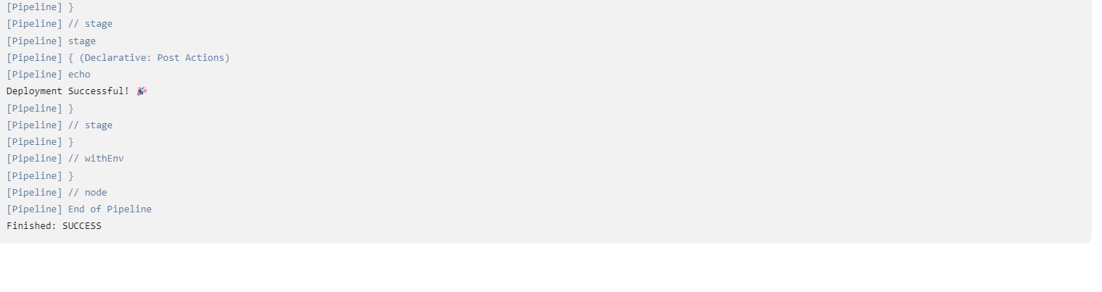

**Exercise 5: Pipeline Job - Deploy a Flask Application with Gunicorn**

**1. Objective:** Automate the deployment of a Flask application with Gunicorn on

Windows.

**2. Steps:**

o Create a Pipeline Job.

o **Write a Jenkinsfile to:**

▪ Clone a Flask application from GitHub.

▪ Set up a Python virtual environment.

▪ Install required packages using pip install -r requirements.txt.

▪ Configure and start the Gunicorn server:

gunicorn -b 127.0.0.1:8000 app:app

▪ Verify the deployment using a curl command in the pipeline.

o **Add stages for:**

▪ Unit tests using pytest.

▪ Post-deployment endpoint checks.

**3. Task:** Trigger the pipeline and ensure the Flask app is accessible on localhost.

