Project Name: Rick Store System

# Version Number: v1.1

## Abstract:

In this version of the System, I try to make more organize in the FindGuitarTester class which in version v1.0 has two methods in the same class:

* checker(Guitar) void
* initializeInventory(Inventory) void

### What I did do?

I separate the main class ( FindGuitarTester) in seprate package with two classes which has checkerClass and initializeInventoryClass, they have the previous methods to make the code more organize.

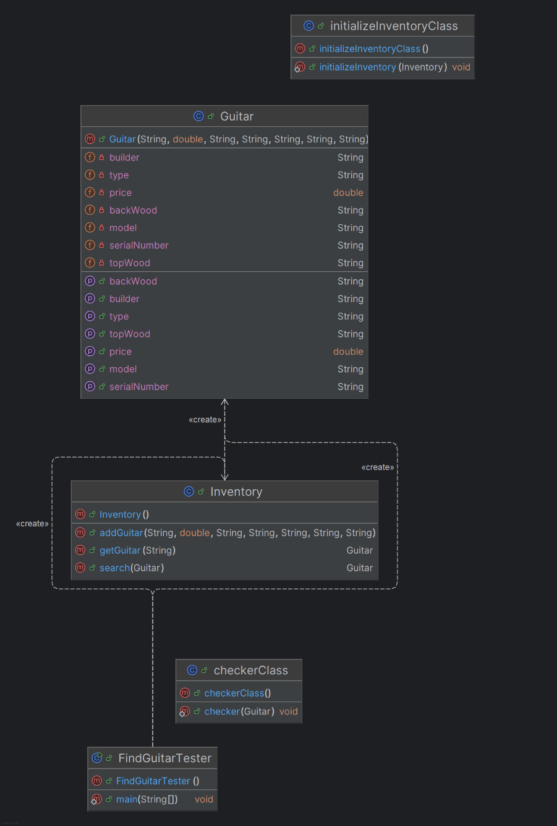UML: