# Project description

The project is about controlling two actuators using two Atmega32 microcontrollers via SPI and UART communication protocols. Briefly, MCU1 receives the user input (written in the virtual terminal) through UART. The virtual terminal acts as the transmitter and MCU1 acts as the receiver. Then, the received data is once again transmitted to MCU2 through SPI communication protocol. MCU1 acts as the master and MCU2 acts as its slave. Once the data is received in MCU2, it’s interpreted quickly as based on it one of the two actuators is activated. And here’s a flow chart that demonstrate the project flow:

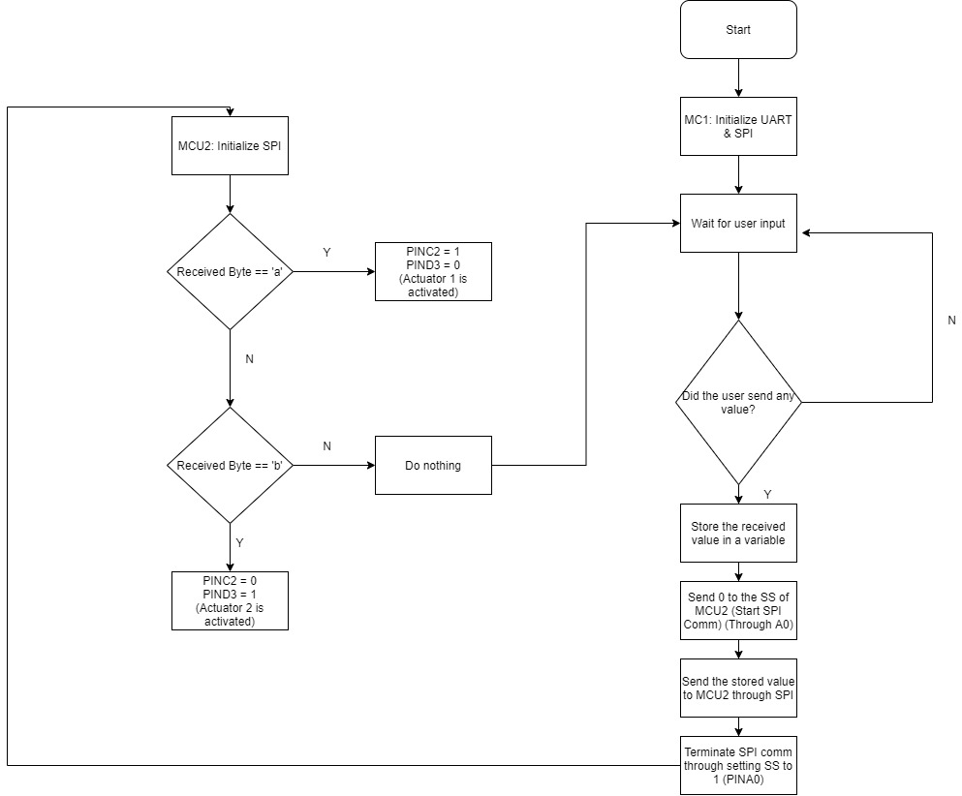

## Components Used

* 2x Atmega32a
* 2x LED (acts as the actuators)
* 2x 330 Resistors
* 1x virtual terminal (To replace the Bluetooth module)
* 1x SPI simulator (To track the sent data from MCU1)

## Drivers used

MCU1

* Digital I/O driver (to use the atmega32a pins)
* UART driver (to receive the data from the virtual terminal)
* SPI (to send the received data to MCU2)

MCU2

* Digital I/O driver (to use the atmega32a pins)
* SPI (to receive the data from MCU1)

## Simulation

Proteus simulation

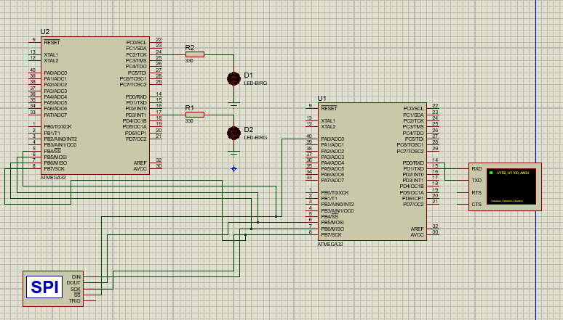

MCU1 & MCU2 settings

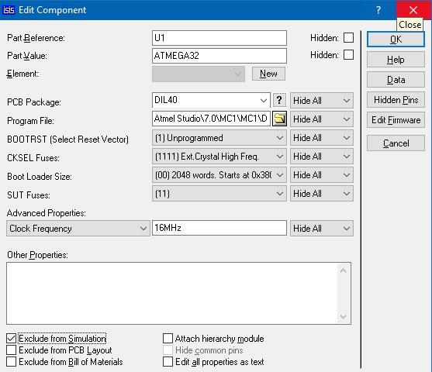 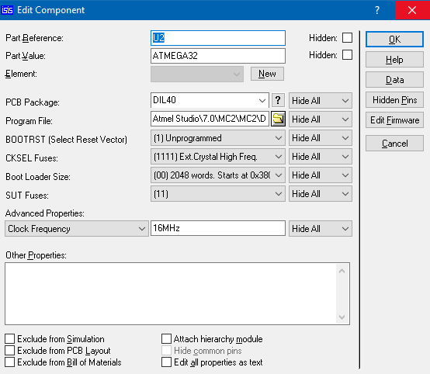

Virtual terminal and SPI debugger settings

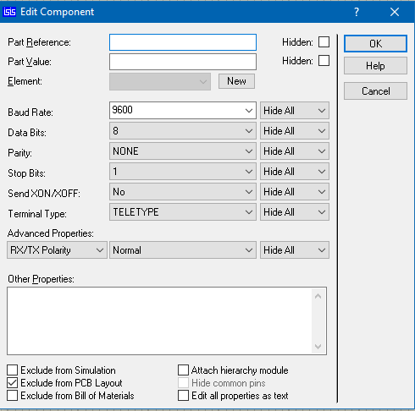 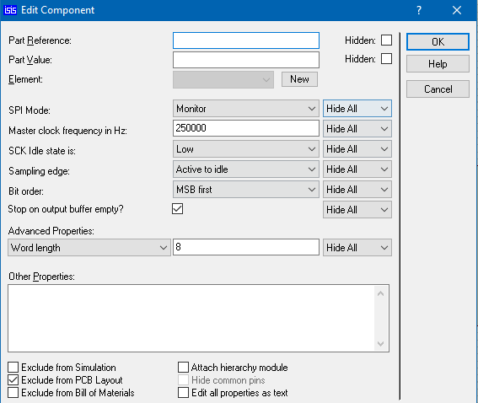

When the user enters ‘a’:

* ‘a’ is 61 in ASCII and LED1 (the first actuator) is activated

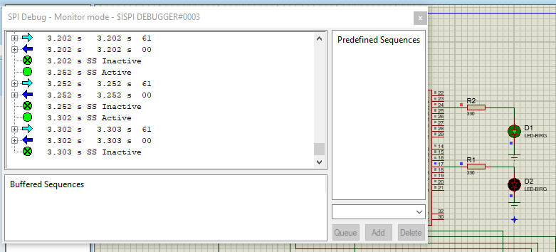

When the user enters ‘b’:

* ‘b’ is 62 in ASCII and LED2 (the second actuator) is activated

