

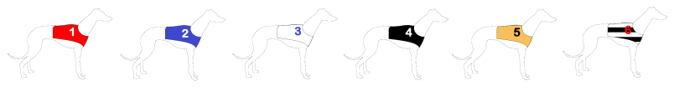

Department of Psychology
Downing Street, Cambridge, CB2 3EB, UK

Lab for Affect, Risk and Gambling Experiments
Greyhound Racing Study Kate Champion kesc2@cam.ac.uk | Greyhound Racing Study Kate Champion kesc2@cam.ac.uk | Greyhound Racing Study Kate Champion kesc2@cam.ac.uk | Greyhound Racing Study Kate Champion kesc2@cam.ac.uk | Greyhound Racing Study Kate Champion kesc2@cam.ac.uk | Greyhound Racing Study Kate Champion kesc2@cam.ac.uk | Greyhound Racing Study Kate Champion kesc2@cam.ac.uk | Greyhound Racing Study Kate Champion kesc2@cam.ac.uk | Greyhound Racing Study Kate Champion kesc2@cam.ac.uk | Greyhound Racing Study Kate Champion kesc2@cam.ac.uk | Greyhound Racing Study Kate Champion kesc2@cam.ac.uk | Greyhound Racing Study Kate Champion kesc2@cam.ac.uk
Participants Needed
You will be paid £5 for 1 hour of your time, with the chance to win more
We are interested in decision-making during gambling, and what makes greyhound races exciting to watch.

The study involves a game made up of a series of greyhound races. Experience not required!

For more information please contact
Kate Champion kesc2@cam.ac.uk

