PROJECT SYNOPSIS REPORT

On

NextGen Careers: Navigating Careers with AI

|  |  |
| --- | --- |
| **Submitted By**   1. Ombhushan U. Adokar 2. Shreyash G. Bhojane 3. Vedant M. Lavhale 4. Anshul D. Kalamkar |  |
| Prof. M. K. Nichat  **Guide** | Dr. V. B. Kute  **HOD, CSE** |

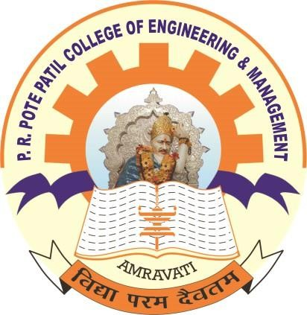

**Department of Computer Science & Engineering**

P. R. Pote (Patil) Education and Welfare Trust’s College of Engineering & Management , Amravati-444605

2024-2025

**Format of synopsis**

# Title

* + **Project Title:** NextGen Careers: Navigating Careers with AI.

# Abstract

The NextGen Careers project leverages machine learning and data analytics to provide personalized career guidance to students. By analyzing individual profiles, including academic performance, interests, and aptitudes, the system predicts optimal career paths. This project aims to bridge the gap between education and career choices, ensuring students make informed decisions that align with their strengths and aspirations.

# Introduction

**Motivation:** In the rapidly evolving job market, students often struggle to identify career paths that align with their strengths, interests, and aptitudes. Current career guidance systems are outdated and fail to provide personalized, data-driven advice, leading to misaligned career choices.

**Problem Statement:** The existing career guidance systems are inefficient and lack the ability to offer personalized recommendations based on comprehensive data analysis, resulting in students choosing career paths that do not match their potential or interests.

## Objectives

* + Develop a machine learning-based system to analyze student data and predict suitable career paths.
  + Create a user-friendly web-based platform for students to input their data and receive career recommendations.
  + Validate the accuracy of the system's predictions with real-world data.

# Methodology

**Problem Definition:** The problem involves creating an intelligent system that can predict the most suitable career paths for students based on their academic performance, interests, and aptitudes using machine learning algorithms.

## Approach

* + Implement machine learning algorithms to analyze and predict career interests.
  + Develop a web-based platform for user interaction and data input.
  + Integrate data from multiple sources to ensure comprehensive analysis and accurate predictions.

**Proposed System Architecture:** The system architecture includes data collection, preprocessing, model training, and prediction phases. The architecture employs a network of interconnected modules that handle different aspects of the process, from data ingestion to prediction output.

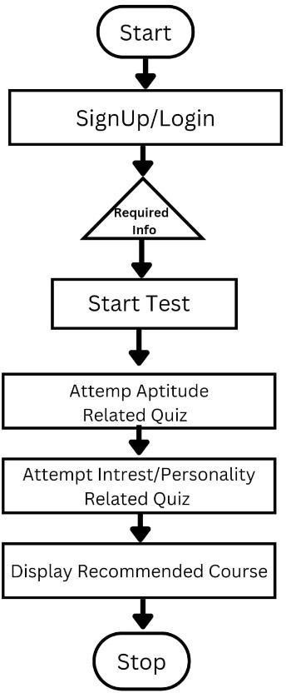

## Techniques/Tools

* + **Programming Languages:** Python
  + **Machine Learning Framework:** TensorFlow
  + **Web Framework:** Django
  + **Data Processing:** Pandas, NumPy
  + **Machine Learning Algorithms:** Random Forest, Label Encoder, Standard Scaler, MultiLabelBinarizer

**Data Collection:** Data will be collected from student surveys and academic records, including grades, favourite subjects, hobbies, strengths, weaknesses, and aptitude test scores.

**Analysis:** Data will be analysed using classification algorithms to predict career interests. The system will be validated using metrics such as accuracy, precision, recall, and F1-score.

# Project Plan

## Timeline

* + **Month 1-2:** Literature review, data collection, and initial planning.
  + **Month 3-5:** Development of data preprocessing pipeline and initial machine learning models.
  + **Month 6-8:** Integration of machine learning models with the web-based platform and user interface design.
  + **Month 9-12:** Testing, validation, and deployment of the intelligent career guidance system.

## Resources

* + **Personnel:** Team of 4 members
  + **Budget:** $20,000 for software and data acquisition
  + **Collaboration:** Educational institutions for data access

# Expected Outcomes

## Results

* + Accurate prediction of career paths with a significant increase in student satisfaction.
  + Improved alignment of chosen careers with personal strengths and interests.

## Impact

* + Empower students with data-driven career guidance.
  + Reduce the mismatch between education and career.
  + Improve long-term job satisfaction and performance.

# Conclusion

**Summary:** This project leverages machine learning to create an innovative career guidance system that provides personalized, data-driven career advice to students.

**Future Scope:** The system can be expanded to include more diverse datasets, integrate with educational platforms, and be adapted for use in different educational systems worldwide.

# References

1. Mopelola, O. & Benjamin B. (2013) Career Guidance for Nigerian Students: Why Career Choice Is Becoming More Difficult. Retrieved From, pp. 2013.
2. Paolo Giuliodori,University of Camerino” An Artificial Neural Network-based Prediction Model for Underdog Teams in NBA Matches”, Paolo Giuliodori on 27 pp. February 2019. 19913743
3. Abisoye, O. A., Alabi, I., Ganiyu, S. O., Abisoye, B. O., and Omokore, J. (2015). A Web-Based Career Guidance Information System for Pre-Tertiary Institutions Students in Nigeria. The International Journal of Scientific Research in Science,

Engineering and Technology, Vol. 1, Issue 3, pp. Nigeria 2015.

1. Paolo Giuliodori,University of Camerino” An Artificial Neural Network-based Prediction Model for Underdog Teams in NBA Matches”, Paolo Giuliodori on 27, pp. February 2019. 19913743
2. Ankit, M., Ashutosh, S., Sunil, K. S., Pardeep, K., and Durg, S. C. (2014). Decision Support System for Determining: Right Education Career Choice. Elsevier, Vol. 4, No.1, pp. 8 – 174 p. 2014.
3. Briggs and Katharine C., “Myers-Briggs type indicator,” Palo Alto, CA: Consulting Psychologists Press, pp. (1963- 1987)
4. Balogun, V. F., and Thompson, A. F. (2009) Career Master: A Decision Support System (DSS) for Guidance and Counselling in Nigeria. The Pacific Journal of Science and Technology, Vol. 1, No, pp. Nigeria 2009.
5. Walter, F. (1997). Intelligent Systems and their Societies. Online pp. (4-17), September 2017.
6. Crystal D’Mello “Online Career Guidance System”, In International Journal of Advanced Research in Computer Science and Software.Vol 7, Issue 2, pp. February 2018
7. JoAnn Harris-Bowlsbey, Ed.D. Kuder Research Faculty “Overview of Career Guidance: Its Foundations, Objectives, and Methodology”, White Paper, Kuder.2321 – 8169 pp December 2017
8. Hooley, T. (2012). "How The Internet Changed Career: Framing the Relationship Between Career Development and Online Technologies". Journal Of the National Institute for Career Education and Counseling (NICEC) 29: 3 pp.2012.
9. H. Demuth and M. Beale, Matlab Neural Networks Toolbox,User’s Guide, Copyright 1992–2001.

|  |  |  |  |  |  |
| --- | --- | --- | --- | --- | --- |
| **Sr.**  **No.** | **Name of group**  **member** | **Role in Project** | **Email id** | **Contact No.** | **Sig n** |
| 1. | Ombhushan  U. Adokar | Backend  Developer | [omadokar@gmail.com](mailto:omadokar@gmail.com) | 7666094310 |  |
| 2. | Shreyash G.  Bhojane | Database  Manager | [shreyashbhojane7@gmail.com](mailto:shreyashbhojane7@gmail.com) | 8806849782 |  |
| 3. | Vedant M. Lavhale | Backend Developer | [vedantlavhale2003@gmail.com](mailto:vedantlavhale2003@gmail.com) | 7666505473 |  |
| 4. | Anshul D. Kalamkar | Fronted Developer | [anshulkalamkar31@gmail.com](mailto:anshulkalamkar31@gmail.com) | 7720998183 |  |

|  |  |  |  |  |
| --- | --- | --- | --- | --- |
| **Sr.**  **No.** | **Name of Guide** | **Email id** | **Contact No.** | **Sign** |
| 1. | Prof. M. K. Nichat |  | 8208168187 |  |