How to create a user?
- useradd <user_name>
- useradd -g <group_name> -s /bin/bash -c "description" -m -d /home/<user_name> <user_name>
- sudo useradd --system sysacc
How to delete a user?
- userdel <name_of_user>
- userdel -r (will remove home directory)
- userdel -f (force delete even if the user is logged in)
How to modify a user?
- To add user to a new group, but default group will remain same
- usermod -G <group_name> <user_name>
- To change the default group
- usermod -g <group_name> <user_name>
Other usermod options:
- -m -d /home/newfolder (to move the content of home folder to this new folder)
- -p (we can use passwd command also)
- -s shell type
- -L -U (Lock/Unlock a user)
How to create a group?
- groupadd <group_name>
- groupdel <group_name>
Commands:
- ip <user_name> // to fetch the details of user
o/p – uid=____ gid=_____ groups=_____
- less etc/group // to see details of group, group id and user of group
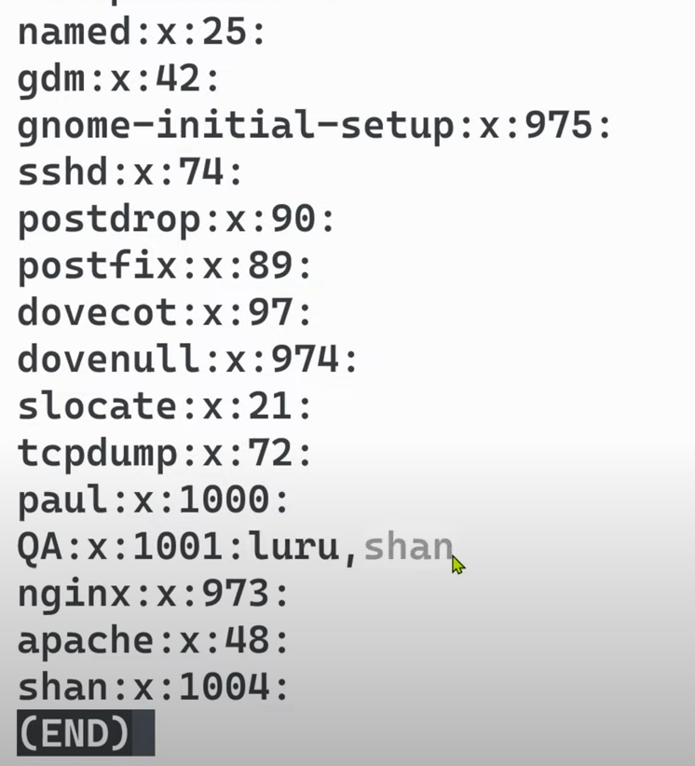

- less etc/passwd // to see user details like default user or root user
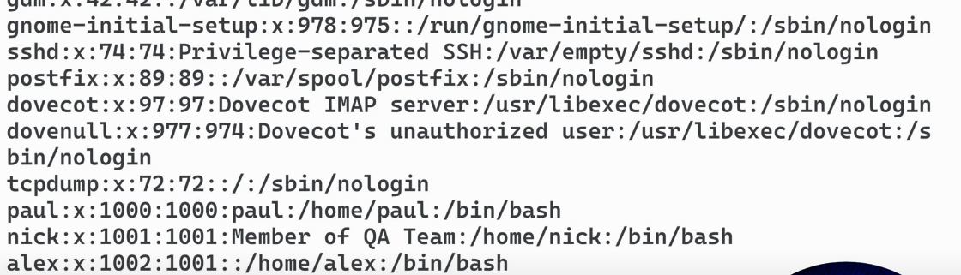

- less etc/shadow // to see user encrypted password
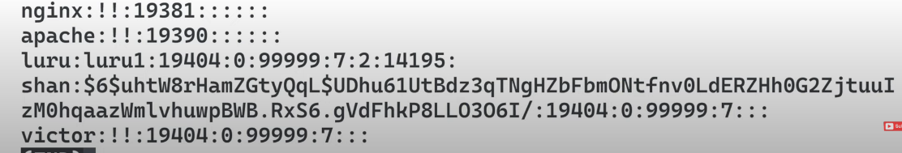

- CPU information
- cat /proc/cpuinfo

