INTERDIGITATED ELECTRODES IN MICROFLUIDICS

Erin Ingram & Omar Mahmood

**Functional System Requirements**

REVISION – Draft

3 October, 2022

Functional System Requirements

for

Interdigitated Electrodes in Microfluidics

Prepared by:

Erin Ingram and Omar Mahmood, 9/30/22

Authors Date

Approved by:

_____________________________

Erin Ingram Date

_____________________________

John Lusher, P.E. Date

_____________________________

T/A Date

**Change Record**

| **Rev.** | **Date** | **Originator** | **Approvals** | **Description** |
| --- | --- | --- | --- | --- |
| **1** | 10/3/2022 | Erin Ingram and Omar Mahmood |  | Draft Release |
| **2** | 12/4/2022 | Erin Ingram and Omar Mahmood |  | Final Report |

**Table of Contents**

**Table of Contents III**

**List of Tables IV**

**List of Figures V**

**1.** **Introduction 1**

1.1. Purpose and Scope 1

1.2. Responsibility and Change Authority 1

**2.** **Applicable and Reference Documents 2**

2.1. Applicable Documents 2

2.2. Reference Documents 2

2.3. Order of Precedence 3

**3.** **Requirements 4**

3.1. System Definition 4

3.2. Characteristics 4

3.2.1. Functional / Performance Requirements 4

3.2.2. Physical Characteristics 5

3.2.3. Electrical Characteristics 6

3.2.4. Environmental Requirements 8

3.2.5. Failure Propagation 9

**4.** **Support Requirements 10**

**Appendix A Acronyms and Abbreviations 11**

**Appendix B Definition of Terms 12**

**List of Tables**

No table of figures entries found.

**List of Figures**

**Figure 1. Conceptual Image 1**

**Figure 2. Block Diagram of System 4**

# 

# 

# 

# 

# 

# 

# 

# 

# 1. Introduction

## 1.1. Purpose and Scope

In the field of microfluidics, the “mother” droplet is the desired droplet, and this is usually attainable. However, the majority of the time, the mother droplet will be followed by an unwanted, much smaller “satellite” droplet. This satellite droplet can cause cross-contamination, altered test results, and distorted size. To address these issues, a size based filtration system has been put in place, which uses spatial channels to help direct specific sized droplets to certain outlets to prevent mixing of mother and satellite droplets. This method can be further enhanced with the integration of interdigitated electrode (IDE) arrays. These are arrays powered by a power source, and have the ability to control and tune electric fields for a more accurate size based separation. The droplets will flow through the channel, and then meet the IDE, which will separate the droplets based on their respective sizes. The satellites will be considered waste, while the regular sized “mother” droplets will be the output.

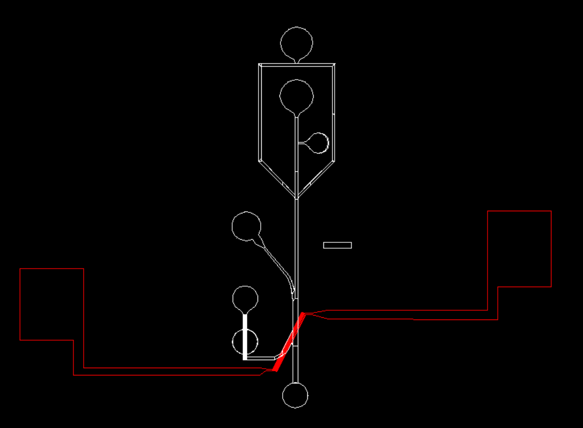

**Figure 1. Conceptual Image**

The following definitions differentiate between requirements and other statements.

Shall: This is the only verb used for the binding requirements.

Should/May: These verbs are used for stating non-mandatory goals.

Will: This verb is used for stating facts or declaration of purpose.

## 1.2. Responsibility and Change Authority

The team leader, Erin Ingram, will be responsible for verifying all requirements for the project are met. These requirements can only be changed with the approval of the team leader and the faculty sponsor, Dr. Arum Han.

| Subsystem | Responsibility |
| --- | --- |
| High Pass Filter | Omar Mahmood |
| Band Pass Filter | Erin Ingram |

**2.** **Applicable and Reference Documents**

## 2.1. Applicable Documents

The following documents, of the exact issue and revision shown, form a part of this specification to the extent specified herein:

| **Document Number** | **Revision/Release Date** | **Document Title** |
| --- | --- | --- |
| DOI: 10.1126/sciadv.abc9108 | 8/8/2022 | FIDELITY: A quality control system for droplet microfluidics |

## 2.2. Reference Documents

The following documents are reference documents utilized in the development of this specification. These documents do not form a part of this specification and are not controlled by their reference herein.

| **Document Number** | **Revision/Release Date** | **Document Title** |
| --- | --- | --- |
| DOI: 10.1039/d0lc00757a | 8/28/2022 | An ultra high-efficiency droplet microfluidics platform using automatically synchronized droplet pairing and merging |
| DOI: 10.1039/b715524g | 8/8/2007 | Droplet Microfluidics |
| DOI: 10.1039/c6lc00367b | 5/6/2016 | Droplet microfluidics for microbiology: techniques, applications and challenges |

## 2.3. Order of Precedence

In the event of a conflict between the text of this specification and an applicable document cited herein, the text of this specification takes precedence without any exceptions.

All specifications, standards, exhibits, drawings or other documents that are invoked as “applicable” in this specification are incorporated as cited. All documents that are referred to within an applicable report are considered to be for guidance and information only, except ICDs that have their relevant documents considered to be incorporated as cited.

# 3. Requirements

The droplet filtration device must be able to filter the droplets at least at 90% accuracy. The droplets will first enter the high pass filter, and they will meet an IDE which will separate the satellite droplets from the desired mother droplets. The mother droplets will then enter a PCR machine as an intermediary step. They will then enter the band pass filter, which will separate the post-PCR droplets into three categories based on size. The validation of this experiment will be able to be seen through a high-powered light microscope separate from our device, equipped with a high speed camera. As a result, this filtration device has two subsystems: a high pass filter and a band pass filter.

## 3.1. System Definition

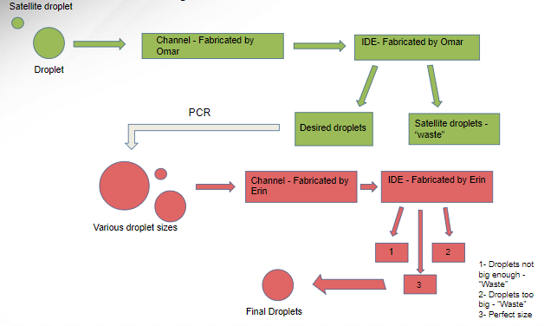

Figure 2. Block Diagram of System

The two separate subsystems are shown above in two different colors. The green represents the high pass filter and the red represents the band pass filter. All droplets, mother and satellites, will enter and travel through the high pass channel where they will ultimately meet an IDE array. The IDE array will apply an electric field which will separate the droplets into a satellite pocket, which will be considered waste, and a mother pocket, which will be considered as the output. The output will then be fed into a PCR machine using special microfluidic tubing. The PCR machine, as an intermediary step, will distort the sizes of the mother droplets, which will be fed into the band pass filter using the same microfluidic tubing. The droplets will then travel through the band pass filter and will be met with a different IDE, which will separate the post-PCR droplets based on size. Droplets that are too big or too small will be considered waste, and the regular sized droplets will be considered as the output of the system.

## 3.2. Characteristics

### 3.2.1. Functional / Performance Requirements

#### 3.2.1.1 90% Accuracy

The filtration device will have a 90% success rate of filtering out the satellite droplets and ensuring that the regular sized droplets are the output of the system.

*Rationale: The lab has indicated that a 90% success rate will be adequate.*

### 3.2.2. Physical Characteristics

#### 3.2.2.1. Portability

The filtration device should be portable and easy to move from one location to the other

*Rationale: This device is fabricated on the micro/nano scale. It is small and easily portable, although caution should be exercised when transporting the device as it is fragile and expensive.*

#### 3.2.2.2. Mounting/Connections

This device doesn’t require any special mounting. It can be placed on a tabletop or under a microscope for use during experiments. Since portability is a requirement, the devices should also be easily connected to the particular fluid that is being used to generate droplets. Input and output tubing will be attached to the inputs and outputs of the device. The tubing will be detachable on one end which will serve as the input.

*Rationale: As portability is important, the device will not be limited to a certain location. It can be used wherever needed.*

#### 3.2.3 Electrical Characteristics

#### 3.2.3.1. Inputs

1. The IDE will be powered by a DC source of 9V. Other equipment typically used in conjunction with our device during experiments, such as microscopes and syringe pumps, will require standard wall outlets at 120V (in North America). The fluids used for droplet generation will be pumped into the device using an electronic syringe pump from a third party.

*Rationale: The IDE is made on a micro/nano scale, and needs a small amount of power. The electrical syringe pump is not a part of our device but is needed to insert the fluids into the device at a steady pace.*

##### 3.2.3.2. Power Consumption

1. The power consumption is nearly negligible.

*Rationale: Since the scale of the IDE array is micrometers, power draw is of miniscule consideration for this device. The IDE array is made of pure gold, which has very little resistance and is one of the best materials to conduct electricity. Silver and copper, the other best conductors, are not used in this device due to their tendency to oxidize.*

##### 3.2.3.3. External Commands

The voltage applied to this device is user-controlled through an external DC voltage source.

#### 3.2.4. Outputs

##### 3.2.4.1 High Pass Filter

The high pass filter will use the IDE to deliver the normal sized “mother” droplets to the intermediate PCR machine.

*Rationale: The high pass filter separates the regular size droplets from the small satellite droplets*

##### 3.2.4.2. Band Pass Filter

The band pass filter will use the IDE to deliver regular sized droplets separate from the droplets that are too large or too small as a result of the PCR intermediate step.

*Rationale: Droplet size is largely distorted during the PCR process, and some droplet sizes may not be viable for the particular experiment.*

### 3.2.5. Environmental Requirements

The filtration device shall be designed to withstand and operate in the environments and laboratory tests specified in the following section.*.*

#### 3.2.6. Laboratory Environment

The device will operate primarily in a laboratory and/or clinical setting where other necessary equipment such as a syringe pump and microscope are readily available and natural elements such as dirt are at a minimum. We do not recommend using this device outdoors or in non-laboratory environments where dust and other microscopic contaminants could tamper with the user’s experimental results.

*Rationale: The device needs additional equipment to work as intended, found in a lab setting. Natural elements may interfere with the function of the device if they contaminate it.*

#### 3.2.7. Thermal

The device will not be able to function properly if the surrounding temperatures are below the freezing point or above the boiling point of the liquids used in experimentation. These boundaries are user-defined. Water is common to these experiments and presents the tightest temperature restriction, which is still very suitable for laboratory conditions. We do not recommend storing the device in laboratory cryogenic chambers that exceed -40℃, or ovens that exceed 150℃, as this will damage the device.

#### 3.2.8. External Contamination

Since the device is on a micro level, contaminants such as dust and dirt will affect the function of the device in a negative way. It needs to be kept free of external contamination. The device can be easily shielded from contamination during idle time by keeping it enclosed in a petri dish.

### 3.2.9. Failure Propagation and Safety Considerations

This is a delicate device that is susceptible to breakage through falling and excessive thermal conditions. If this should happen, the device will simply need to be replaced. If the IDE substrate part of the device shatters, users should beware of sharp corners and use proper laboratory PPE to prevent lacerations of the skin during cleanup. Other parts of the device are made of flexible material that will not shatter or create sharp edges. Breakage or damage of the device should not result in serious injury to users.

# 4. Support Requirements

The user of this device will need an electronic syringe pump for the fluid deposition into the channel. A PCR machine will be required to conduct the intermediary PCR step. A microscope may be wanted to perform a proof-of-concept trial but is not needed for the device to function. The system will come with built in filtration and a power source for the IDE. An instruction manual will be provided with the device.

# Appendix A: Acronyms and Abbreviations

DNA Deoxyribonucleic Acid

IDE Interdigitated Electrode

PCR Polymerase Chain Reaction

PDMS Polydimethylsiloxane

TBD To Be Determined

µm Micrometer

# Appendix B: Definition of Terms

**Interdigitated Electrode (IDE):** two electrode arrays combined in a zipper or comb-like arrangement. Fabricated via metal deposition on a glass substrate.

**Polymerase Chain Reaction (PCR):** A laboratory technique used to rapidly amplify segments of DNA, creating millions to billions of copies within hours, such that the genetic information can be studied in detail.