Adaptive Motion Synthesis and Motor Invariant Theory

## Chapter 4 Global Motion Invariant

## Introduction

Motion varies greatly, different people walk with different gait.

A question is why the different motion of different people is all called walk.

Our answer is walk is not determined by the details how it is carried out.

Walk capture the qualitative properties, and we agree on the walk becomes it is a property encoded in all our body, we all have the walking ability inborn, so that’s the reason why we can all identify it.

Our basic idea is motion primitives are “easy” to finish.

In this chapter, we will try to give the “easiness” definition.

The biological ideas can be provide a clear mathematical meaning.

### Basic Concepts of Qualitative Dynamics

This section develops the mathematical conceptualization of Global Motor Invariant.

Some mathematical background is needed in this discussion.

Throughout this paper, we take the geometrical viewport of mechanical system, a.For analyzing qualitative properties, we introduce the ideas from differential topology.

This idea can be traced back to Poincare\citep{Poincar'e1899,Poincar'e1885} and recently developed by the Smale School.

Please refer to other books and lectures such as \citep{abraham1978foundations}for introduction in details.

Dynamic motions are modelled as differential equations,

In the geometrical viewport, differential equation describes a differentiable manifold.

Qualitative Properties can be obtained by analyzing the topological structure of the differentiable manifold.

Global Motor Invariant is defined by the topology structure.

#### Dynamic System and Differential Manifold

The dynamic of a mechanical system is determined by its configuration $q$ and speed $\dot{q}$, configure ration and speed form the state $s=[q,\dot{q}]$, is described using state value in the state space.

we represent the state of a system as a vector $q$, $M$ is the state space, which is a manifold.

The motion is a trajectory in the state space parameterized by time. $q(t)$.

For a dynamic system, $q(t)$ usually described in the form of ordinary differential equation.

\begin{equation}

\dot{s}=F_{u}(s)=F(s,u),q\in M

\label{eq:ode}

\end{equation}

where $u$ is the control effort.

$F$ is determined by the system's natural property.

If $u=0$, no control effort is applied.

Such systems are \textbf{autonomous systems}.

For every point $q \in M$,

$F$ and $u$ determines a derivative vector $\dot{q}$.

All the vectors over the full space of $M$ form the \textbf{vector field} $V$.

The motion trajectory can be found by apply the integral operation on the vector filed $V$.

\[

I:M \times V \rightarrow M

\]

The result trajectory is defined as \textbf{flow} $\Phi$, all the flows form

the \text{phase portrait}, which illustrates all the possible motions of the dynamic system.

We usually visualize the differential manifold by phase plot.

An illustrative example repeatedly used in this report is the mass-spring system.

After linear transformation,

a linear mass spring system can be described in canonical form \eqref{eq:mass-spring}

\begin{equation}

\label{eq:mass-spring}

\ddot{x}+x=0.

\end{equation}

where $x$ is the position of the mass, $\dot{x}$ is the speed, and $\ddot{x}$ is the acceleration of mass.

If we chose the state variable $q=[x,\dot{x}]$, the ODE model should be

\[

\dot{q}=

\left[

\begin{array}{cc}

0 &-1\\

1 &0

\end{array}

\right]q

\]

#### Global Motor Invariant

Flows can only intersect at some special position called \textbf{equlibria}.

Basically there are three type of equilibrium.

if we want to include the chaos, inspectional position is also called no wandering points

At each \textbf{equilbria},

the local space can be divided into three subspace of sub manifold: centre sub manifold, stable manifold, and unstable sub manifold.

\begin{description}

\item[centre sub manifold]

If a flow $\theta$ pass through a point $m$ on centre sub manifold $W_{c}$,

flow$\theta$ will remain on the Centre Manifold

\[

\theta_{c}(t) \in W_{c}, t \in R

\]

An equilibria must be on center manifold.

\item [stable sub manifold]

For the flow $\theta_{s}$ passes through a point $m$ on stable sub manifold $W_{s}$, the flow will finally converge to a no wandering point on centre sub manifold.

\[

\theta_{s}(+\infty)=\theta_{c}

\]

\item[unstable sub manifold]

For the flow passes through a point $m$ on unstable sub manifold $W_{u}$, the flow will be repelled from the no wandering points on centre manifold.

An alternative perspective is the inverse of the flow converge to no wandering point.

\[

\theta_{u}(-\infty)=\theta_{c}

\]

\end{description}

The size and dimension of each sub manifold varies.

For some cases, the $W_{s}$ ( $W_{u}$) may not exist,

this can be seen as the dimension of $W_{s}$($W_{u}$) is $0$.

\textbf{Attractors} are the equilbria where the whole local space is stable, the dimension of unstable submanifold is zero $\mathbf{dim}(W_{u})=0$.

\textbf{Repellors} are the equilibrias where the whole local space is unstable,the dimension of stable submanifold is zero $\mathbf{dim}(W_{s})=0$.

For nonlinear system, globally, the shape of stable and unstable sub manifold may be bending and connect with itself or each other.

The unstable manifold of one equilibrium may be the stable sub manifold of another.

The equilibra and its connectivity sub manifold form a topological structure.

Thus the phase plane will be divide into different regions,result in a cellular structure.

there is only one attractor, all the flow in this region will converge to the attractor.

and the corresponding region is called basin of attraction.

In theory, in human perception and experiment, only observe the attractor of the dynamic system can be observed, motion task should be only rely on the attractor.

Global Motor Primitive is defined by the attractor type and its basin of attraction in the topology space.

We can also give the biological ideas clear mathematical meaning.

The UMH, the uncontrolled manifold is the basin of attraction.

For EPH, the equilibrium point is the attractor.

For Impendence Control, impedance control is control the shape of basin of attraction.

#### Motion Adaptation and Stability

Motion adaptation because of different reasons and in different situations.

If the state is in the basin of attraction then, it will converge to the attractor.

Start from different state position, it will result different flows, thus different motion.

The perturbation that move the state off the attractor is called State Perturbation, for only the state is changed, the dynamic system underline is not changed.

Such two kinds of perturbation are treated separately and result in differentiation strategy or control.

### State perturbation

The perturbation that move the state off the attractor is called State Perturbation, for only the state is changed, the dynamic system underline is not changed.

If the state is in the basin of attraction then, it will converge to the attractor.

Start from different state position, it will result different flows, thus different motion.

Such kind of motion adaptation is called Responsive Motion Adaptation.

Because usually, for characters, perturbation comes from the push or pull, while the character and environment is not changed.

To make the character more responsive without result in motion failure,

Motion controller should try to enlarge the basin of attraction.

### Structure Perturbation

Another type of Perturbation will affect the dynamic system; such kind of perturbation is called Structure Perturbation. Such kind of perturbation happens commonly in our daily life, when a man put a heavy box on his shoulder, it will result a change in the dynamic system.

Structural Perturbation will change the phase portrait; sometimes it will result in a different shape but keep the topology. As a result, the even the current state is on the attractor, motion will change, this kind of motion adaptation is called system adaptation, and one important application is dynamic motion retargeting, when you change the character, the dynamic system changed.

Sometimes it will change the topology the underlying dynamic system, such effects are called bifurcation.

If ability of a dynamic system maintains its topology structure is structural stability.

To make characters more adaptive to environment and body change, motor controller should boost the structural stability of the motion.

Even bifurcation happens; the attractor of motion primitives should not be affected.

### Structural Stability explanation Morphological Computation

Structural Stability is neglected in CMS research.

It is reasonable for natural animals to rely on structural stable autonomous system.

In natural environment, perturbation and uncertainty are everywhere. In many cases, if neural system

can’t respond quickly enough, the better solution is to select a more structure stable motion primitives.

Structural Stability and Qualitative Idea provides a better explanation for some motion phenomena than quantitative theory.

Qualitative Control Theory may help us understand the evolution of locomotion and neural Control.

Animals shift from the sea to the land. From quantitative computing viewport, the natural dynamics of the body and fluid environment are hard to predict or compute precisely. From the qualitative viewport, fluid is continuous

and uniform, the topology structure is very simple and stable, thus with little neural control fish can maintain its posture. On the other side, for human walking, although the rigid like

Environment can be calculated precisely, the topology structure is much more complex. On

the phase plane, there exist many equilibrium points, the topology structure is more complex and unstable. The control system has to be more complex to control the more complex qualitative properties.

Qualitative theory can also help to explain another fact of biological motion system. Animals that live in similar environment and moves in a similar manner usually have similar body structure, in spite of their different position on evolution chain. This is because animals moving in a similar is based on the same motion primitive, similarity in body structure promise the dynamic systems have the same topological structure.

This idea may help us to understand the body and environment effect in morphological computation theory.

For specific environment, body evolves to provide us with a structural stable dynamic system, thus save lots of control effort for neural control.

We can also know motion primitives are not only defined by the body, it also defined by the environment, for motion in a specific environment, the topology should be fixed, thus the number of motion primitives is quite limited.

### Global Motor Invariant Control

#### CPG and Entrainment

In nature, an animal's body and environment can be extremely complex.

It leads to high dimensional manifolds with complicated topological structure, which provides many motion primitives for our use.

For CMS application, one question we want to ask is the so many motion primitives can be controlled with a simple method.

We propose that even there are many type of motion primitives, the type of attractor is limited. Basically there are only two types of attrator, limit circle and fix point.

Even the dimension of dynamic system maybe large, the dimension of the attrator is known.

For fix point, its attractor is of dimension zero.

For limit circle, it is of dimension one.

Thus we can only focus on the type of attractor.

Biology Research suggested that the motor is mainly controlled by the Central Pattern Generator, which is a small autonomous network that generating rhythmic signals.

The idea of control motion by rhythmic signals can be modelled as entrainment \citep{Gonz'alez-Miranda2004}.

When coupling two oscillation system together, entrainment can happen when two system oscillator in synchronize. This effect will enhance the oscillation and also know as resonant.

Neural Oscillator

In previous section, we discussed two types of attractors: fix point and Limited Circle. One idea limit circle is a necessary, fix point can be controlled with by (1) terminate a circle, (2)a different controller, (3)approximate by a limit circle with small amplitude or damping the limit circle, (4) change the limit circle into a fix point through by bifurcation. It is a still open question which type is more important and serve as the foundation as motor control.

In this paper,

\begin{enumerate}

\item Periodic behaviour is very common in biological systems.

Besides the periodic motion in swimming and running, heart beating, wake and sleep also show periodic behaviour.

A periodic system has the potential to integrate with other bio system simulation to explore other motion features.

\item Periodic motion has the same effect of terminated motion when the amplitude of limited circle is very small.

For CMS research, both type of motion trajectory can be simulated with periodic motion.

##### Neural Oscillator Stability

A simple example.

Although it is difficult for neural system to carry out complex computation, it is easy to build oscillator structure with neurons.

It only needs two neurons with mutual inhibitive property.

The dynamic of a neuron can be model as a dynamic equation:

\begin{equation}

\dot{S}=L(S)+I(u)

\end{equation}

Where $S$ is the output electrical signal of neuron and $u$ is the input signal from other neuron.

An inhibit input $I$ has the property that when $u1>u2,I(u1)<I(u2)$.

One extensively studied oscillation model is developed by \citet{neurooscillation}.

The mathematical presentation is as follows:

\begin{eqnarray}

\tau_{1} \dot{x_{1}}&=&c-x_{1}-\beta v_{1}-\gamma [x_{2}]^{+}-\sum_{j}h_{j}[g_{j}]^{+}\\

\tau_{2} \dot{v_{1}}&=&[x_{1}]^{+}-v_{1}\\

\tau_{1} \dot{x_{2}}&=&c-x_{2}-\beta v_{2}-\gamma [x_{1}]^{-}-\sum_{j}h_{j}[g_{j}]^{-}\\

\tau_{2} \dot{v_{2}}&=&[x_{2}]^{+}-v_{2}\\

y_{i}&=&\mbox{max}(x_{i},0)\\

y_{out}&=&[x_{1}]^{+}-[x_{2}]^{+}=y_{1}-y{2}

\label{eq:matsuta}

\end{eqnarray}

where $x$ and $v$ are state variables of the oscillator, $\tau$,$c$,$\beta$,$\gamma$ are parameters of the oscillator.

Matuoka oscillator is an autonomous oscillator; it can begin to oscillator without any control effort.

Figure \ref{fig:natural-oscilation} shows the natural oscillator output.

\begin{figure}[h]

\includegraphics[height=0.4\textheight]{\figurepath/oscillation.eps}

\caption{Natural Oscillation}

\label{fig:natural-oscilation}

\end{figure}

\begin{figure}[h]

\includegraphics[height=0.4\textheight]{\figurepath/entraint_oscilation.eps}

\caption{Entrainment Oscillation}

\label{fig:entraint-oscilation}

\end{figure}

It is also adaptive; entrainment behaviour can happen between one Matuoka oscillator and different oscillators.

Figure \ref{fig:entraint-oscilation} shows the entrain oscillation,

where the oscillation of Matuoka oscillator synchronise with the input signal.

But because of the nonlinear properties, its behavior is not completely understood.

Matsuta\citep{Matsuoka1987} explains the adaptive properties from the location of the roots of characteristic equation.

Wilimas\citep{Williamson1998} explains the properties in frequency domain.

In our research, we find some important properties of neural oscillator by investigating simulation results.

\begin{figure}

\begin{center}

\includegraphics[height=0.5\textheight]{\figurepath/neuraloscilation1.eps}

\end{center}

\caption{The states of neural oscillator over Time}

\label{fig:oscilation}

\end{figure}

\begin{figure}

\begin{center}

\includegraphics[height=0.5\textheight]{\figurepath/neural1phase.eps}

\end{center}

\caption{The phase portrait of Neural Oscillators}

\label{fig:oscilationphase}

\end{figure}

From our simulation, we investigate the topological structure.

Basically, neural oscillator shows three important properties:

\begin{itemize}

\item{Simple Topological Structure.}

The topology structure of neural oscillator is simple,

it includes one attractive limit circle and one fix repellor.

\item{Large Basin of Attraction.}

All the simulations we carried out converged to the same limited circle.

\item{Fast Converging Speed.}

In most of the case, the flow will converge to the limit circle within one period time.

\end{itemize}

Features above are shown in Figure ~\ref{fig:time_timeAttraction}.

\begin{figure}

\begin{center}

\includegraphics[height=0.4\textheight]{\figurepath/neural_attraction.eps}

\end{center}

\caption{Neural output with different initial position}

\label{fig:time_timeAttraction}

\end{figure}

\begin{figure}

\begin{center}

\includegraphics[height=0.4\textheight]{\figurepath/neural_attraction_phase.eps}

\end{center}

\caption{Phase plot of oscillation with different initial condition}

\label{fig:phase_attraction}

\end{figure}

The large area of basin of attraction means the final behaviour is totally determined by parameters.

Initial condition will have no effects on the oscillator final output.

The converging speed can be seen as quick recovery ability.

When an impulse perturbation happens, it will recover in one period time.

Global Motor Invaraint Control Example

Bouncing ball is system ball bouncing by moving a pedal, a system with simple dynamic but difficult to control with optimizaiton or pd.

While this example capture the complexity of human interatction with the environment and object.

And can be the basic model for many motion tasks.

We show in this example how neural oscillator can turn the bouncing ball system into motion primitive.

## Dynamics

Hybrid dynamics, in incoperate two phase,

d^2p_ball/dt^2=-g x>0 p_ball>p_pedal (1)

(v_ball-v_mass)=e(v_ball+-v_mass+) p_vall=p_pedal(2)

Equation (1), is the flying phase equation, equation(2) is the bouncing equation

The -1<e<0.

Basically, the ball will continue bouncing with smaller height.



## Global Invaraint Control

couple with neural oscillator boucing we get an limit circle

g_in=g_in*v_ball, (3)

Pos_pedal=h*out_oscillator. (4)

The input of neural oscillator is the velocity of the ball multiply by the input coefficient, the output of neural oscillator drive the pedal position.

An limit circle emerge as the result of entrainment.

As show in figure drop from different position, all the ball will bouncing a about the same height of 5.



## Symmetry of Motion

For Physically-based animation,

Motion is usually described by the differential equation (1)

(1)

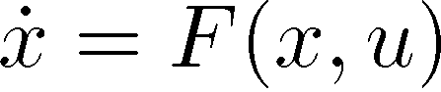

\dot{X}=F(x,u)

Physically possible motion is the solution of the equation.

An important property from one solution x, with a group action g, we ca get another solution x_a

(2)

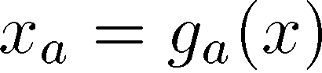

x_a=g_a(x).

for example

,

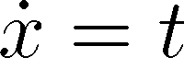

We have

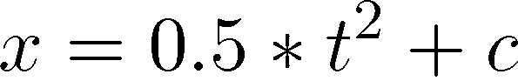

So the group action is

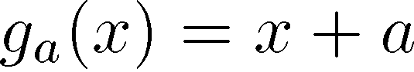

For equation (1), the group action g_a satisfy the symmetry property (2).

(3)

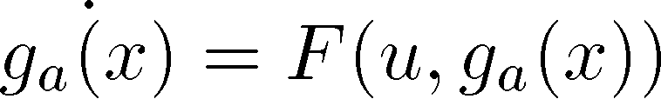

This provide us an idea about motion synthesis.Given an original motion m, and the corresponding group g, a new motion is generated by g(m).

## Local Motion Signature.

For every group G, we can find an function I(x) unchanged by the group action G,

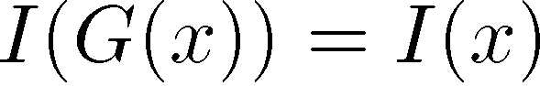

I(x) are called local motion signature.

For mechanical system, Lie Group and Symmetry has important physically meaning.

I(x) corresponding to the Conservative Law, like energy or angular momentum.

## Controlled Symmetry

For motion synthesis, usually the desired motion is ma and original motion m is known, but the corresponding group action g_a is not satisfied by differential equation.

For such situation, control input u is added, which modify the original equation to allow the designed G, this is called Controlled Symmetry.

Most dynamic motion can be modelled as an Lagrange System.

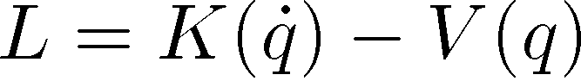

L=K(\dot(q)-V(q).

And the desired action G must keep the L invariant.

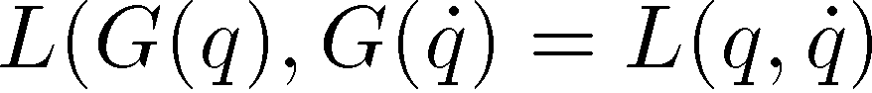

The original m is defined by the eural langrage equation

(4)

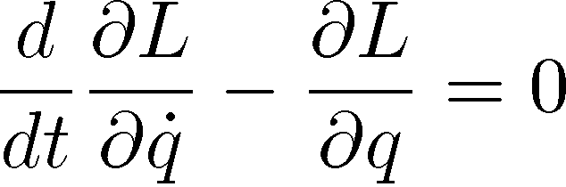

\frac{d}{dt}\frac{\partial L}{\partial \dot{q}}-\frac{\partial L}{\partial q} = 0

The modified system is

(5)

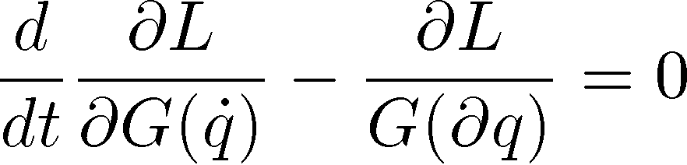

\frac{d}{dt}\frac{\partial L}{\partial G(\dot{q})}-\frac{\partial L}{G(\partial q)} = 0

Which is equal the controlled dynamic system

(6)

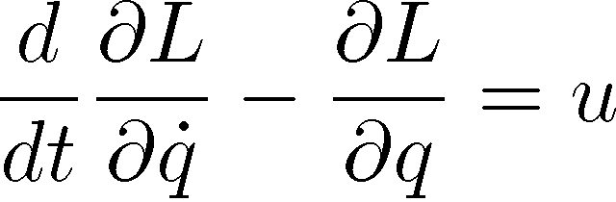

\frac{d}{dt}\frac{\partial L}{\partial \dot{q}}-\frac{\partial L}{\partial q} = u

(5) and (6) are the equivalent equation, by comparing equation (5) and (6), we can get u

### Some Specific example of Symmetry and Control

### 1 Offset Action

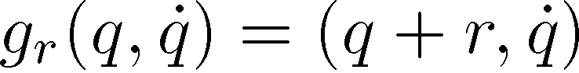

G_r(x)=(q+r,\d{q})

Which keep speed, but modify the pos. thus keep the K but modify V

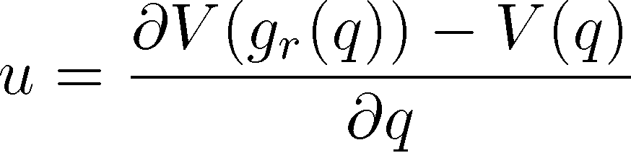

u=\frac{\partial V(g_r(q))-V(q)}{(\partial q)}

on phase space, if q is the horizontal axis, and \dot{q} is the vertical axis, this has the effect of moving the phase plot right and right.

## 2 Time Scalling.

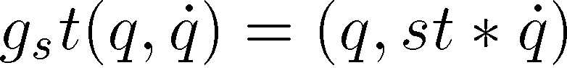

g_st(q,dot{q})=(q,st*dot{q})

we have

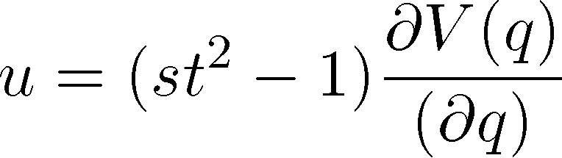

u=(st^2-1) \frac{\partial V(q)}{(\partial q)}

on phase space, this has the effect strength the phase plot in the vertical direction

## 3 energy scaling

For some system moving the the conservtime field with constant mass matrix.

The energy is preserved and different motion present different level of energy.

For such system, we have the

For such

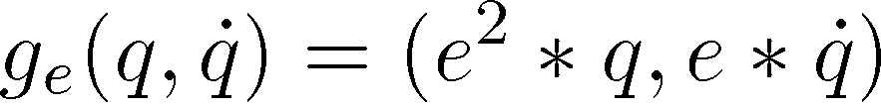

g_e(q,\dot{q})=(e^2*q,e*\dot{q}).

U can be developed by applying the pos scaling and time scaling in a combined manner.

On phase plot, this has the effect enlarge the phase portrait.

## 4 time offset

Is q(t) is solution to f(q)



g_{toff}(q(t) \dot{q}(t))=(q(t+toff),\dot{q}(t+toff))

For dynamic system, this seems obvious. And no control is need for such symmetry.

For system with limit circle, this g_toff has a special effects like phase modification.

On phase plot, this has the effect rotate on the limit circle about an angle.

Simple Example:

Bouncing Ball

Chapter