Passive Dynamic Walking
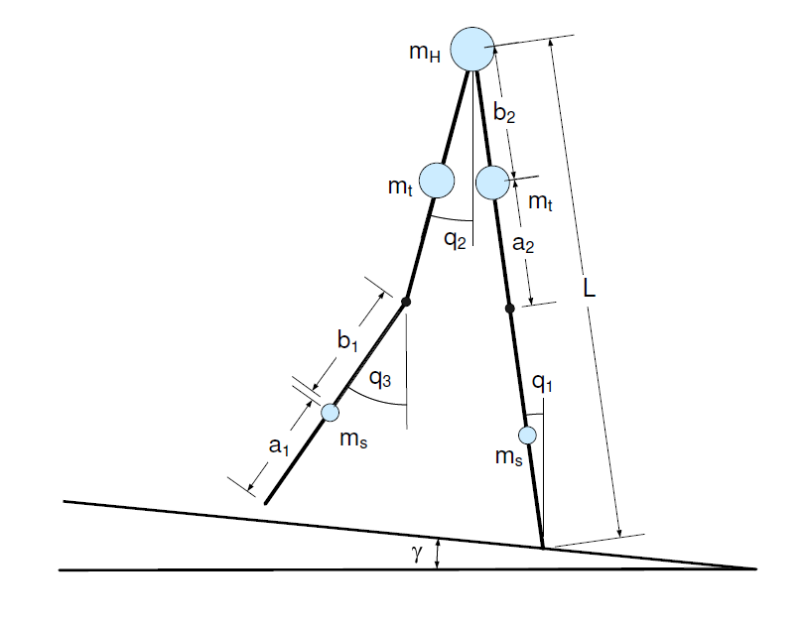
dynamic walking explore the dynamic property to walk, they can generate energy efficient walk

1 the dynamic model
fiure 1 shows the a two dimensional walking model.
Like bouncing ball, this system is also an hybrid system.
The motion include four phases.
1 in free swing phase.
Mddq/dt+Cdq+N=0
2 the knee strike phase
Qq=Qq
3 the knee lock phase
Mddq/dt+Cdq+N=0
4 the keel strike phase.
Qq=Qq
this system can do passive walking
under specific initial position, the walker can walk passively downstairs.
And exhibit a limit circle.
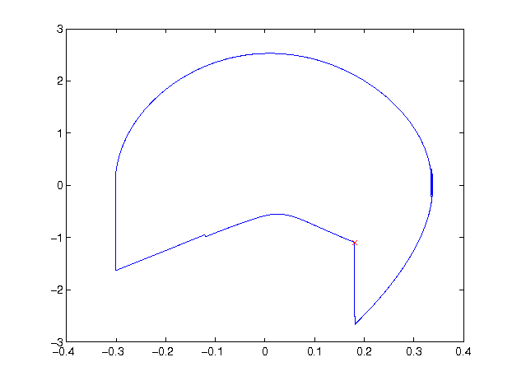

2 Global Invariant Control
just like mass spring system, the basic idea of control is using the entrainment oscillator to
motion adaptation.
The input of the nerual oscillator is the angle between the two legs.
The output of the nerual oscillator is acting on the hip joint
g_in=h*(q1-q2)
yout=hout*neural.
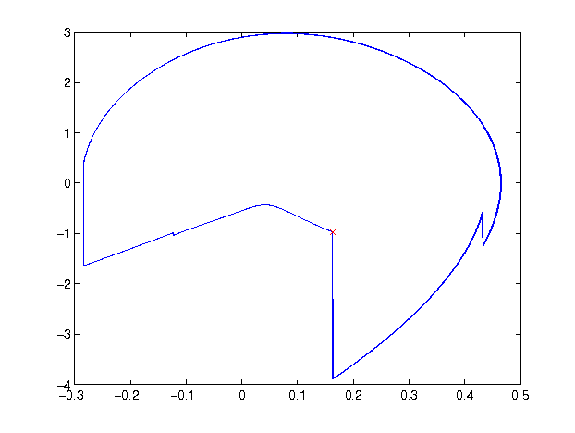

1 mass distribution change
the first parameters we change is change the mass distribution of the system.
Mh/Mt=0.3
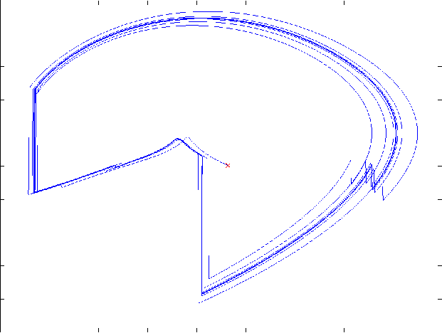
Mh/Mt=2
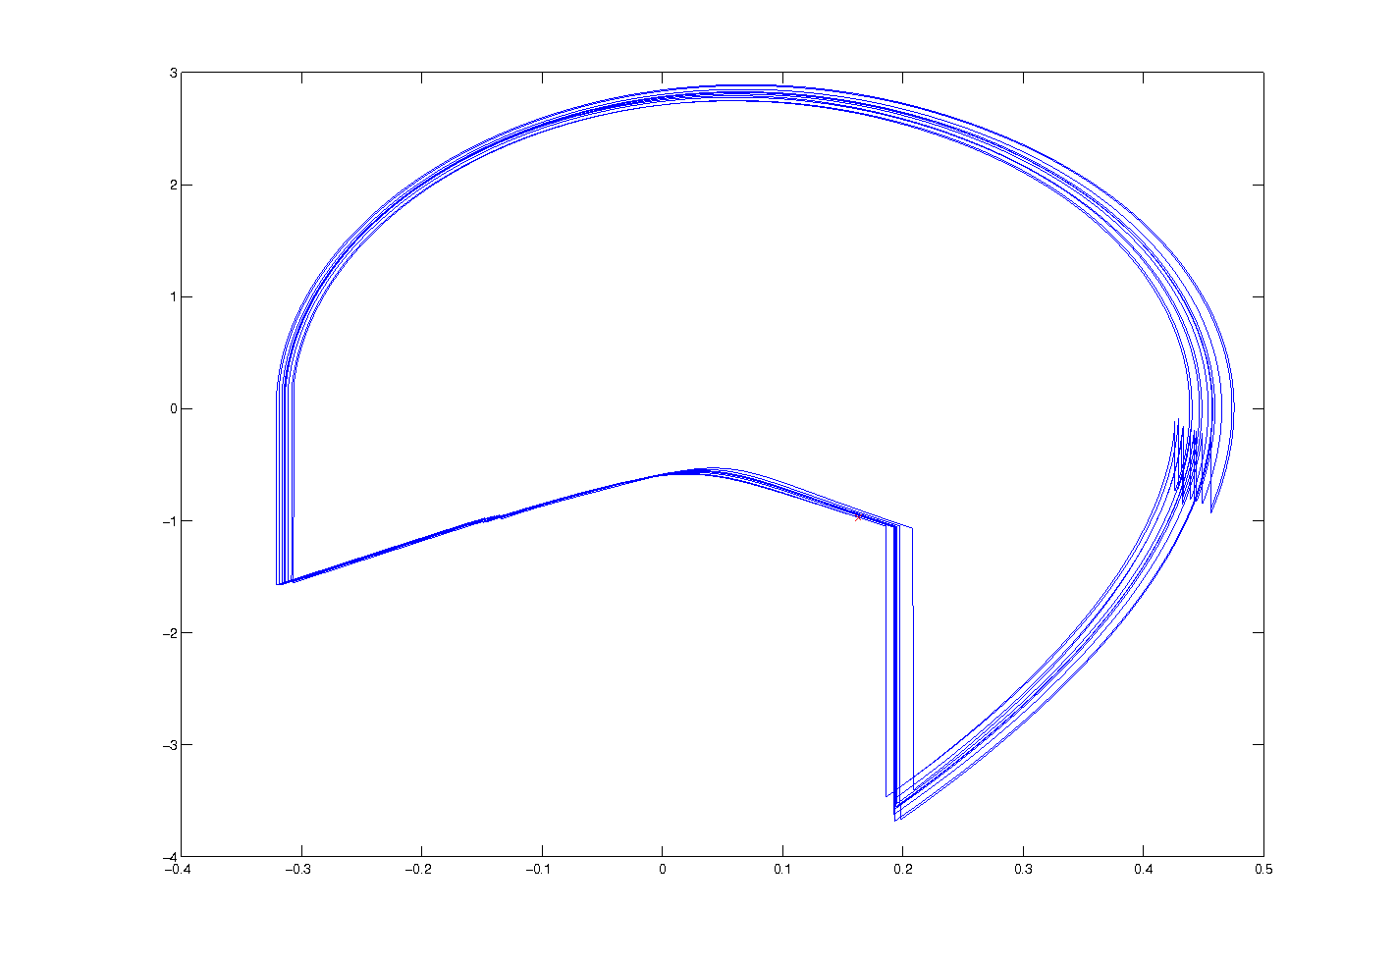
Mh/Mt=3
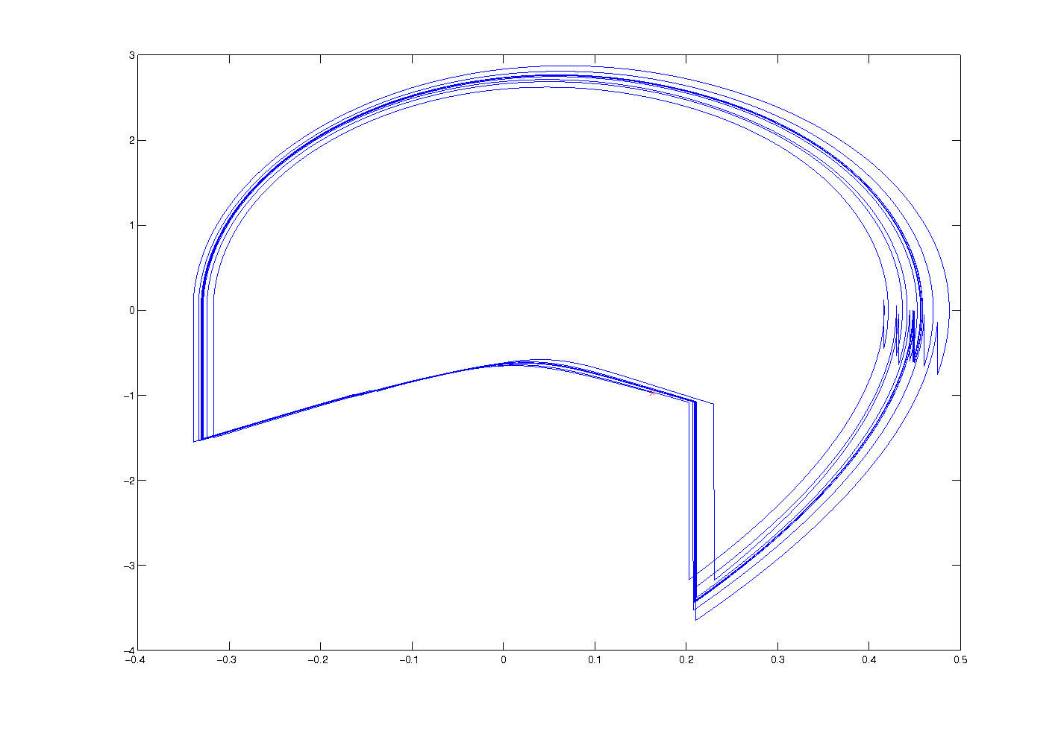

Mh/mt=10
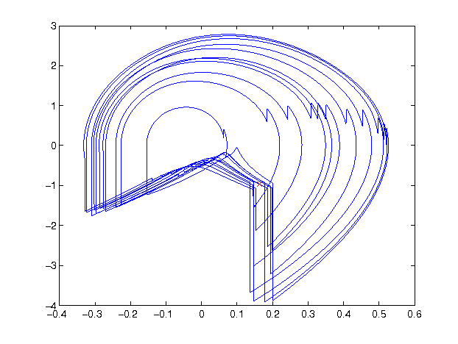

2 length lenth change
lt/ls=2 thing is twice the shank.
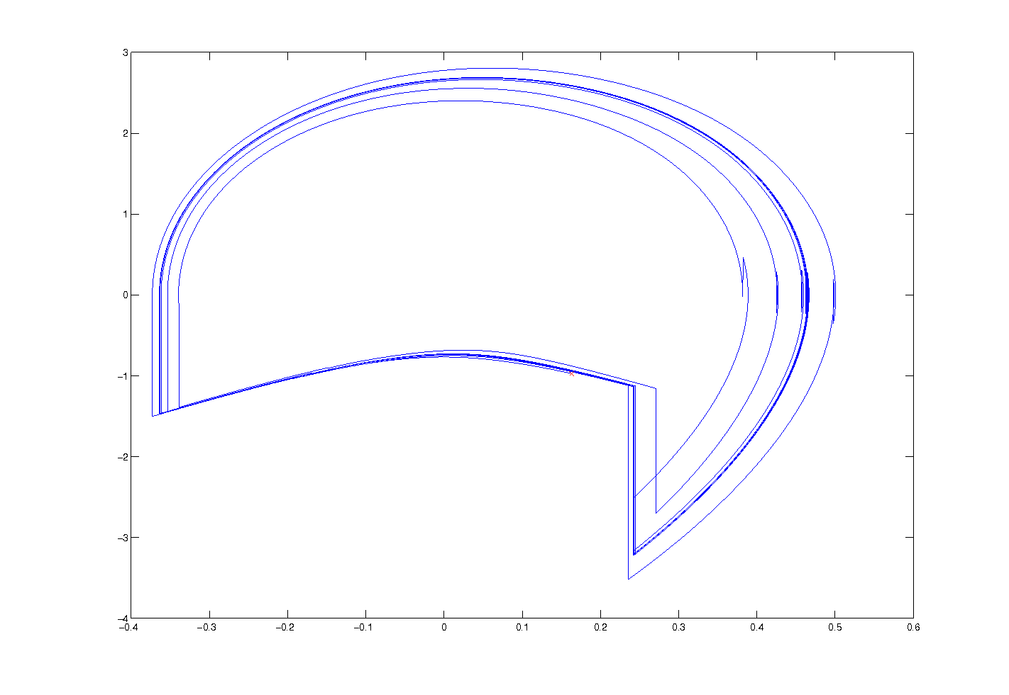

Lt/ls=0.5
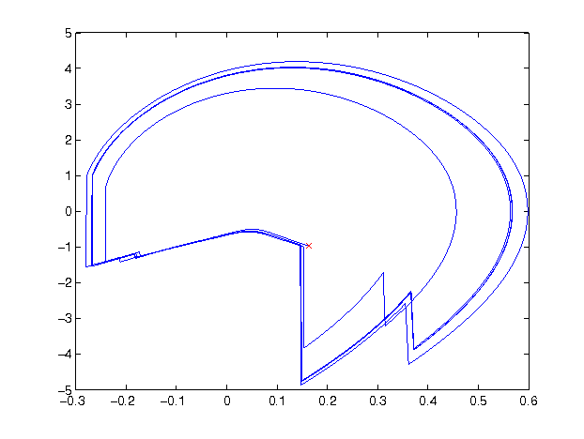

3 slope change and Walking Step Size
4 legmass adjust
lmass/rmass=1
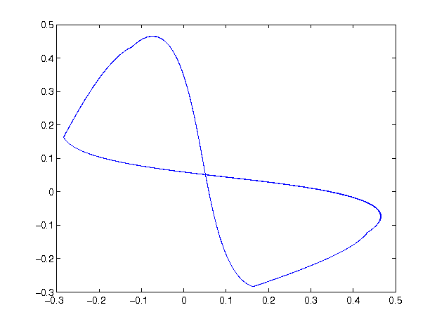
lmass/rmass=0.75
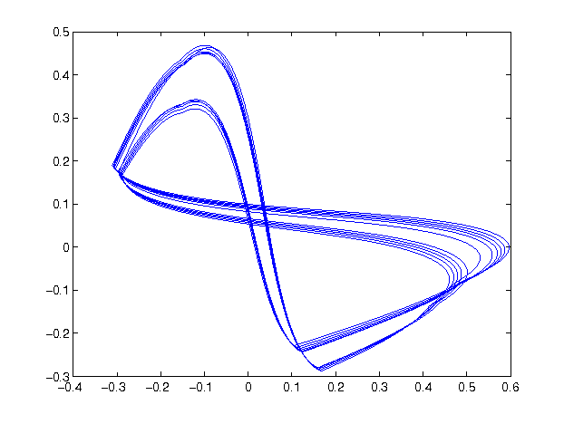

the period is double and the step is not symmetrical any more. So the two legs move in a slight different manner, but still, it keeps walking.

3 Local Invariant Control
lie group symmetry provide method for adapting the walking motion for different terrain and for at different speed.

Slope Change.
N=N*g.
u=N(g*cos(theta)-g)
Speed Change
u=Ng*(speed*speed-1)
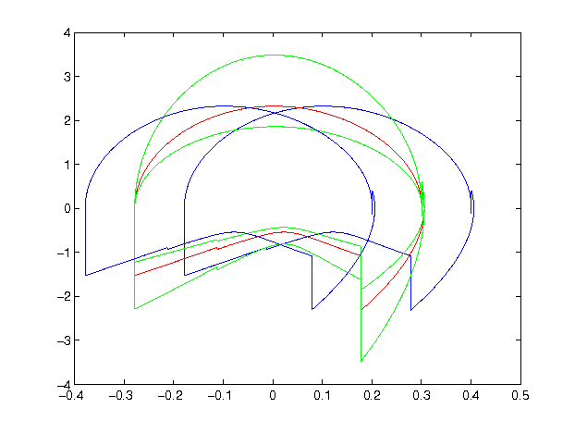

The red on is the origianl limit cricle.
Green one are apply speed action
blueone are applied locol stransform action
Motion Signature
q1-q2
q1-q3

dq1/dq2
dq2/dq3

4 Walking on any slope with any speed with any walking style
when Combined together, our system can walking on different terrian with any speed and any style.

