Application

Stance Example

1 Dynamic Model

the reduced model
linear bipedal model
suppose when standing, we hight vaiation is almost zero.
We only conside the horizontal movement

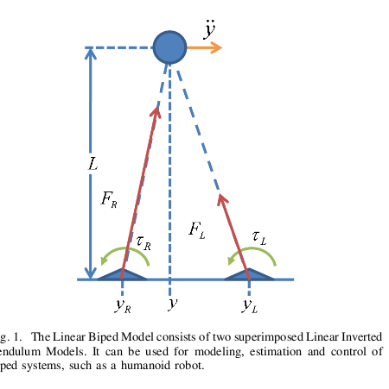
basicall the stance are divided into three phase

1 Single Support Phase
ddy=t/ml+g*y/L
2 double stance Phase
ddy=(TL+TR)/ML+g/l*wL(y-y_m)+g/l*wr(ym-yr)
3 fall
if ym >d
than the stance will fall.
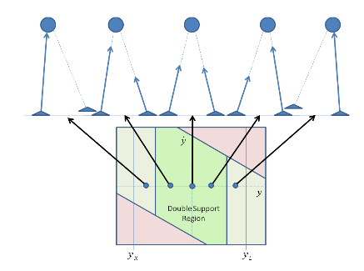
The goal of control is confine the flow withing the safe region

1 global control
the original system is simmilar to mass spring system.
It wil vibrate continutelly.

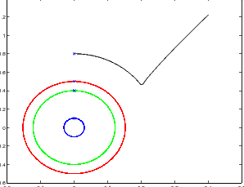

while in our method ,by coubling neural system the the oscillator, it form a limit circle
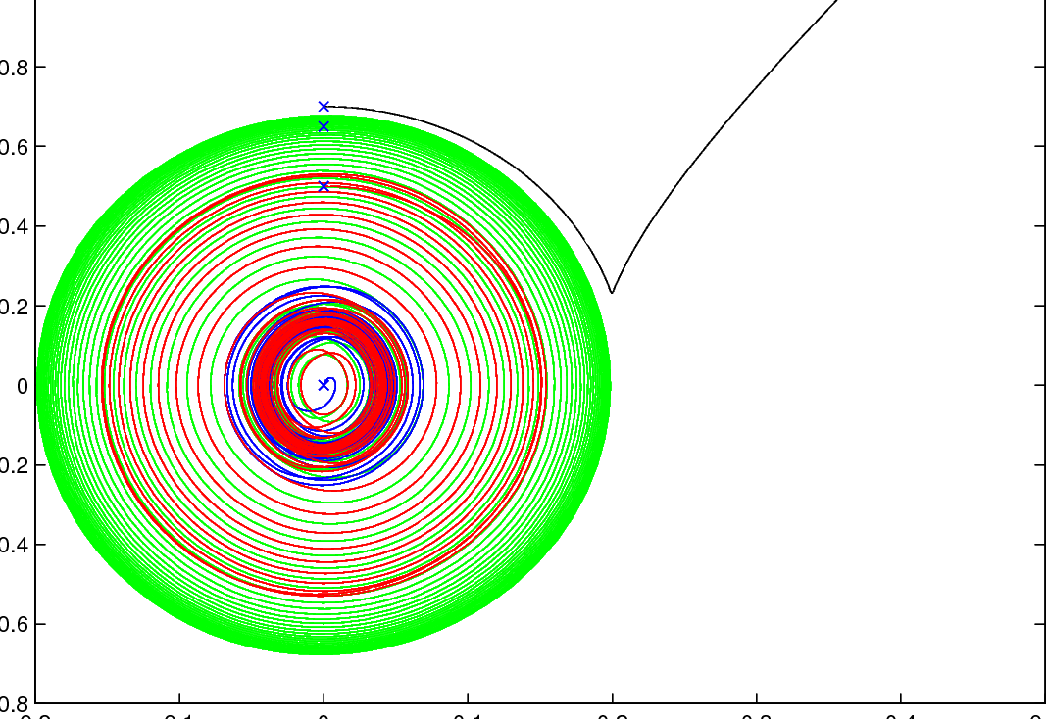
But because of the special characteristics of the stancing model, when move out the safe region,
It will fall.

2 lie group control
By the speed transformation,
The speed we can control the stance motion to move within the safe region.
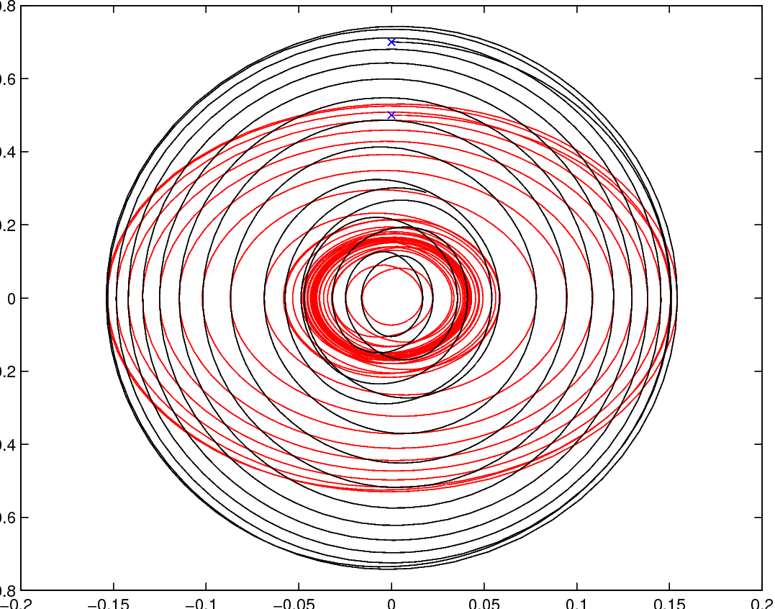
then the stance posture is controlled

by the energy transformation,
we can control the final vibration magnitude.

