Illustrative Example

# bouncing ball

Bouncing ball is system bouncing by moving a pedal, a system with simple dynamic but difficult to control. While this example capture the complexity of human interatction with the environment and object. And can be the basic model for many motion tasks, like catch and throw, ball playing, and even walking.

## Dynamics

Hybrid dynamics, in incoperate two phase,

d^2p_ball/dt^2=-g x>0 p_ball>p_pedal (1)

(v_ball-v_mass)=e(v_ball+-v_mass+) p_vall=p_pedal(2)

Equation (1), is the flying phase equation, equation(2) is the bouncing equation

The -1<e<0.

Basically, the ball will continue bouncing with smaller height.



## Global Invaraint Control

couple with neural oscillator boucing we get an limit circle

g_in=g_in*v_ball, (3)

Pos_pedal=h*out_oscillator. (4)

The input of neural oscillator is the velocity of the ball multiply by the input coefficient, the output of neural oscillator drive the pedal position.

An limit circle emerge as the result of entrainment.

As show in figure drop from different position, all the ball will bouncing a about the same height of 5.



## Local Invariant Control

Control Bouncing at different Height.

For example boucing at height 10, or 15.

if we define the a*5

the the boucing ball system have energy symmetry.

## Controlled Symmetry

If x(t) is a solution,

So it ax(sqrt(at)) is also a solution

Thus the neural oscillator is modified as follows.

tao=tao*sqrt(a)

out=ta*sqrt(a)

in=in/sqrt(a)

than the a*height is mapped the limit circle.

Following example shows the mapping effect, with a=1, a=3, where the bouncing height is controlled at about height =5 and height =15.

The two pictures are almost the same; this is because the symmetry is perfect.

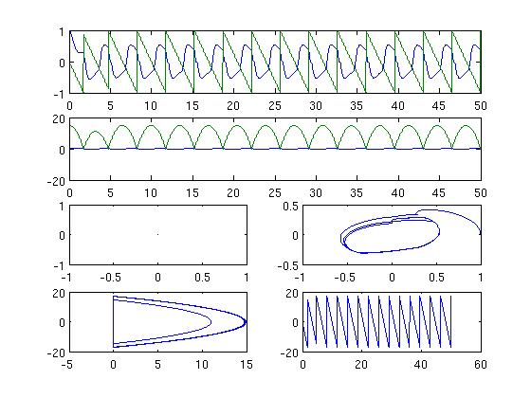

With Limit Circle At aoubt 15, a=3

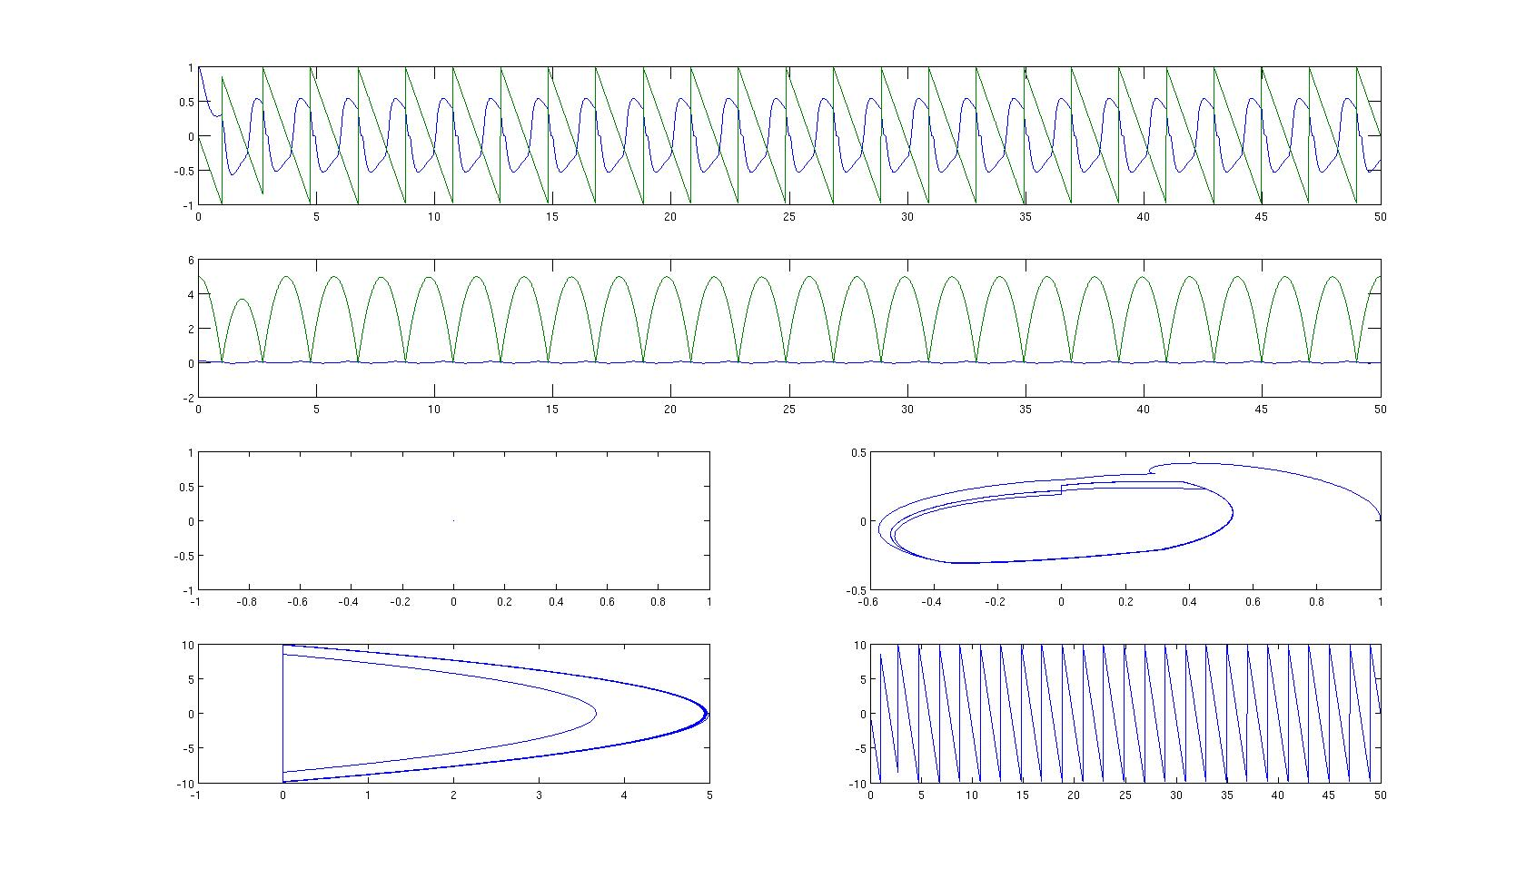

With limit circle at about 5, a=1

# Conclustion:

No matter where the initial position is ,the limit bouncing height can be exactly controlled by modifying the parameters of oscillator.