GStreamer × .NET 10
From playbin to production

A three-part blog series with a complete, tested C# reference project
Author: Umair Akhter
Code: https://github.com/omairkhan/gstreamer-dotnet
Stack: .NET 10 · C# 14 · GStreamer 1.24+ · GirCore bindings · ASP.NET Core
Part 1: Fundamentals. From the 2024 playbin sample to an async, testable pipeline host.
Part 2: C# in the media path. Pulling frames into .NET, SIMD motion detection, and generating video from C#.
Part 3: Production. A supervised 24/7 camera system with live HLS, recording, events and a web API.
Appendix: LinkedIn announcement posts (English and German).

Contents

Tip: in Word, right-click the table of contents and choose "Update Field" if page numbers are missing.

Part 1: From playbin to pipelines. GStreamer fundamentals in .NET 10
In 2024 I showed how to play a video with GStreamer from .NET 8 in about ten lines of C#. This post takes that same program, moves it to .NET 10, and turns it into a foundation you can build real software on.

Where we left off
The original article, "Bridging the Gap: GStreamer Integration for .NET Core 8 on Windows", covered three things: installing the GStreamer runtime on Windows, adding its bin folder to PATH, and running this program with the gstreamer-sharp-netcore NuGet package:
Application.Init(ref args);
var pipeline = Parse.Launch("playbin uri=http://download.blender.org/durian/trailer/sintel_trailer-1080p.mp4");
pipeline.SetState(State.Playing);
var bus = pipeline.Bus;
var msg = bus.TimedPopFiltered(Constants.CLOCK_TIME_NONE, MessageType.Eos | MessageType.Error);
pipeline.SetState(State.Null);
It works, and it teaches the core idea of GStreamer: you describe a pipeline of elements, set it to PLAYING, and listen on the bus for messages. But it blocks a thread forever, it ignores errors, and the bindings package it uses has not been maintained for years. Let us fix all three.

Step 1: Install GStreamer (2026 edition)

Windows
- Download the runtime installer from gstreamer.freedesktop.org/download and choose the Complete installation. Both MSVC and MinGW 64-bit builds work; MSVC is the usual choice today, MinGW (as in the 2024 article) is still fine.
- Add the bin folder to PATH, for example C:\Program Files\gstreamer\1.0\msvc_x86_64\bin, or C:\gstreamer\1.0\mingw_x86_64\bin for MinGW.
- Optionally set GST_PLUGIN_PATH to the lib\gstreamer-1.0 folder, then open a new terminal so the variables are picked up.

Linux and macOS
# Ubuntu / Debian
sudo apt install gstreamer1.0-tools gstreamer1.0-plugins-{base,good,bad,ugly} gstreamer1.0-libav gstreamer1.0-x \
gir1.2-gstreamer-1.0 gir1.2-gst-plugins-base-1.0
# macOS
brew install gstreamer
Verify with gst-launch-1.0 videotestsrc ! autovideosink, or with the project's own mediaflow doctor command, which lists every plugin the samples need and marks missing ones.

Step 2: Modern bindings with GirCore
GirCore generates C# bindings straight from GObject-Introspection data, so it follows current GStreamer releases, targets modern .NET and runs on Windows, Linux and macOS. Two packages are all you need:
dotnet add package GirCore.Gst-1.0 # core: pipelines, elements, bus, caps, buffers
dotnet add package GirCore.GstApp-1.0 # appsink / appsrc: exchange frames with C#
The 2024 program ported one-to-one (this is mediaflow classic in the repository):
Gst.Module.Initialize();
var args = Array.Empty<string>();
Gst.Functions.Init(ref args);

using var pipeline = Gst.Functions.ParseLaunch(
"playbin uri=http://download.blender.org/durian/trailer/sintel_trailer-1080p.mp4");
pipeline.SetState(Gst.State.Playing);

using var bus = pipeline.GetBus()!;
using var msg = bus.TimedPopFiltered(
new Gst.ClockTime(Gst.Constants.CLOCK_TIME_NONE), Gst.MessageType.Eos | Gst.MessageType.Error);

pipeline.SetState(Gst.State.Null);
Good to know: invalid pipeline syntax now throws a GLib.GException with a readable message such as no element "x264enc", instead of silently returning null.

Step 3: The vocabulary you need
Concept | What it means | Example
Element | One processing step | videotestsrc, x264enc, mp4mux, filesink
Pad | An element's input (sink) or output (src) | uridecodebin creates video/audio src pads at runtime
Caps | The media format negotiated between pads | video/x-raw,width=1280,height=720,framerate=30/1
Bin / Pipeline | A container of elements; the pipeline also owns the clock and bus | playbin is a ready-made bin
Bus | Thread-safe message queue from pipeline to your app | EOS, ERROR, WARNING, BUFFERING, element messages
States | NULL → READY → PAUSED → PLAYING | PAUSED = prerolled: first frame ready, duration known

Step 4: Stop concatenating strings
Pipelines are usually written as gst-launch strings. That is great in a terminal and fragile in code: the first file path with a space or a quote breaks it. PipelineDescription is a small typed builder that renders correct, quoted syntax and can be unit-tested:
var description = PipelineDescription.Create()
.Element("videotestsrc", ("pattern", "ball"), ("num-buffers", 150))
.Caps("video/x-raw", ("width", 1280), ("height", 720), ("framerate", new Fraction(30, 1)))
.Element("textoverlay", ("text", "Hello GStreamer from C# 14 / .NET 10"))
.Element("videoconvert")
.Element("x264enc", ("speed-preset", "veryfast"))
.Element("h264parse")
.Element("mp4mux")
.Element("filesink", ("location", @"C:\videos\my clip.mp4")); // quoted automatically

Step 5: An async pipeline host
TimedPopFiltered(CLOCK_TIME_NONE) blocks the calling thread until the video ends. In a real application you want async/await, typed events and proper errors. PipelineHost wraps a pipeline and runs a small bus pump on a dedicated thread: every 100 ms it pops messages and writes typed records into a Channel<PipelineEvent>.
await using var host = PipelineHost.Parse(description);
await host.StartAsync(ct); // throws PipelineFailedException with the real cause

await foreach (var e in host.Events.ReadAllAsync(ct))
{
switch (e)
{
case Buffering b: Console.WriteLine($"buffering {b.Percent}%"); break;
case PipelineWarning w: Console.WriteLine($"warning: {w.Message}"); break;
case EndOfStream: return;
}
}
The host also exposes what a player needs:
- Position and Duration (position and duration queries in nanoseconds, converted to TimeSpan).
- Seek(TimeSpan): a flushing, frame-accurate seek that waits until the pipeline has prerolled at the new position.
- SetRate(2.0) for fast-forward, 0.5 for slow motion and negative values for reverse playback (trick-play).
- StopAsync(): sends EOS and waits for it to reach every sink before tearing down, so MP4 files are finalised. More on this in Part 3.
- ToDot(): a Graphviz picture of the live pipeline, invaluable when negotiation fails.
Lesson learned: GStreamer often posts a cascade of errors. The host keeps the first one because it names the root cause ("No such file"); later ones are fallout ("Failed to start"). A test in the repository caught this.

Step 6: Building pipelines by hand (dynamic pads)
Strings cannot express everything. A file's streams are only known once the demuxer has read its header, so uridecodebin creates its output pads at runtime ("sometimes pads"). The transcode sample reacts to the pad-added signal, looks at the caps, and attaches a matching encoder branch while the pipeline is running:
source.OnPadAdded += (_, e) =>
{
using var caps = e.NewPad.GetCurrentCaps() ?? e.NewPad.QueryCaps(null);
var media = caps?.GetStructure(0).GetName() ?? ""; // "video/x-raw" or "audio/x-raw"
var kind = branches.Keys.FirstOrDefault(k => media.StartsWith(k));
if (kind is null || !linked.Add(kind)) return;

var branch = Gst.Functions.ParseBinFromDescription(branches[kind], true); // ghost pads
pipeline.Add(branch);
branch.Link(mux); // requests video_0 / audio_0 on mp4mux
branch.SyncStateWithParent(); // bring it to PLAYING like the rest
e.NewPad.Link(branch.GetStaticPad("sink")!);
};
Note that the callback runs on a GStreamer streaming thread: keep it short and thread-safe. The branch is added only when the stream actually exists; pre-linking an audio branch to the muxer for a silent file would make the muxer wait forever.

Try it
dotnet run --project src/MediaFlow.Cli -- doctor
dotnet run --project src/MediaFlow.Cli -- classic
dotnet run --project src/MediaFlow.Cli -- hello # writes hello.mp4
dotnet run --project src/MediaFlow.Cli -- play hello.mp4 --seek 1 --rate 2
dotnet run --project src/MediaFlow.Cli -- transcode hello.mp4 small.mp4 --height 360 --dot graph.dot
Next: in Part 2 we stop treating GStreamer as a black box and put our own C# code into the media path, reading frames out and pushing frames in.

Part 2: C# in the media path. Frames, motion detection and synthetic video
GStreamer is excellent at decoding, scaling and encoding. Your business logic lives in C#. This post connects the two in both directions, efficiently and without leaking memory or stalling the pipeline.

The division of labour
The trick is to let GStreamer do the heavy, native work and hand C# only what it needs. For motion detection we do not need 1080p colour frames; 320×180 greyscale at 10 frames per second is plenty, and GStreamer produces it for us:
videotestsrc | uridecodebin(rtsp://...)
! videoconvert ! videoscale ! videorate drop-only=true
! video/x-raw,format=GRAY8,width=320,height=180,framerate=10/1
! appsink name=frames
That is 57,600 bytes per frame, a tiny amount of work for .NET.

Reading frames: appsink as IAsyncEnumerable
FrameReader wraps an appsink. A dedicated thread calls TryPullSample with a timeout, copies the buffer into an ArrayPool<byte> rental and hands a VideoFrame to a bounded Channel. Consumers simply write:
var reader = new FrameReader(host.GetElement<GstApp.AppSink>("frames"));
await foreach (var frame in reader.ReadAllAsync(ct))
{
using (frame) // returns the pooled buffer: zero allocations in steady state
{
Console.WriteLine($"{frame.Format.Width}x{frame.Format.Height} {frame.Format.PixelFormat} pts={frame.Pts}");
}
}
Each frame carries its negotiated format (read from the caps) and its presentation timestamp (PTS). GirCore does not expose PTS directly, so the project adds it with a C# 14 extension property:
extension(Gst.Buffer buffer)
{
public TimeSpan? Pts
{
get
{
var pts = buffer.Handle.GetPts();
return pts == Gst.Constants.CLOCK_TIME_NONE ? null : ((long)pts).NanosecondsToTimeSpan();
}
set => buffer.Handle.SetPts(value is { } v ? (ulong)v.ToNanoseconds() : Gst.Constants.CLOCK_TIME_NONE);
}
}

Live vs. offline: two kinds of back-pressure
What should happen when your C# code is slower than the camera? There are two correct answers, and choosing the wrong one is a classic bug:
Scenario | Setting | Behaviour
Live camera analytics | dropWhenBehind: true (default) | appsink drop=true, channel DropOldest. Old frames are discarded and counted in a metric; the camera never stalls.
Files and batch jobs | dropWhenBehind: false | appsink drop=false, channel Wait. The pull thread blocks, appsink fills up and GStreamer slows the source. Every frame is processed.

Lesson learned: the first version always dropped. An integration test that expected 12 frames from a 12-frame file received 5, and that test is why the lossless mode exists.

SIMD motion detection in managed code
Frame differencing is simple: count the pixels whose brightness changed by more than a threshold since the previous frame. With Vector256 we compare 32 pixels per instruction:
var limit = Vector256.Create(threshold);
for (; i <= current.Length - Vector256<byte>.Count; i += Vector256<byte>.Count)
{
var a = Vector256.Create(previous.Slice(i, Vector256<byte>.Count));
var b = Vector256.Create(current.Slice(i, Vector256<byte>.Count));
var diff = Vector256.Max(a, b) - Vector256.Min(a, b); // |a - b| without overflow
count += BitOperations.PopCount(Vector256.GreaterThan(diff, limit).ExtractMostSignificantBits());
}
// Vector128 fallback (e.g. ARM), then a scalar tail
A raw change ratio is noisy, so MotionDetector adds three things real systems need:
- Exponential smoothing of the ratio, so single-frame glitches (compression noise, a flicker) are ignored.
- Hysteresis: a higher threshold to start an event than to end it, so events do not flap on and off.
- Cooldown: a minimum quiet time before a new event may start.
The output is a clean stream of MotionStarted and MotionEnded events. A unit test checks that the SIMD path returns exactly the same count as a naive scalar loop for odd lengths.

Changing a running pipeline
The analyze demo simulates a scene by switching the test source between a black frame and a moving ball, while the pipeline keeps running. Any GObject property can be changed live:
camera.Set("pattern", "ball"); // extension method using gst_util_set_object_arg
[17:24:03] scene scene idle
[17:24:05] scene object moving
[17:24:05] MOTION started frame #23 score 0.5 %
[17:24:09] scene scene idle
[17:24:10] motion ended after 4.1s
analysed 140 frames, dropped 0 (consumer too slow), 10.0 fps

Writing frames: appsrc
The opposite direction is just as useful: render charts or dashboards to video, feed frames from a proprietary industrial-camera SDK into standard encoders, or re-inject frames annotated by an ML model. FrameWriter copies a frame into a new Gst.Buffer, stamps PTS and duration, and pushes it:
var writer = new FrameWriter(host.GetElement<GstApp.AppSrc>("src"),
new VideoFormat("RGB", 640, 360, new Fraction(30, 1)));
await host.StartAsync(waitForPreroll: false, ct);

for (var i = 0; i < 150; i++)
{
Render(pixels, i); // your C# drawing code
writer.Write(pixels); // PTS = i × 1/30 s, blocks when the encoder is busy
}
writer.Complete(); // EOS: the encoder flushes, mp4mux writes the index
await host.Completion;
Lesson learned: waiting for the pipeline to reach PAUSED before pushing the first frame is a chicken-and-egg problem. Preroll needs data, so the wait simply times out (the first version took 17 s for a 3 s clip; after the fix it took 2.6 s). That is why StartAsync(waitForPreroll: false) exists.
Setting block=true on appsrc gives natural back-pressure: the producer can never outrun the encoder and memory stays flat.

Where this leads
Replace the motion detector with ONNX Runtime and a YOLO model, and you have object detection. Replace the renderer with frames from a medical or machine-vision SDK, and you have standards-based recording and streaming for a device that only speaks a proprietary API. The plumbing stays the same.
Next: in Part 3 we combine everything into a system that runs 24/7.

Part 3: Production. A supervised 24/7 camera system with ASP.NET Core
Playing a file is easy. Keeping 16 IP cameras recording for months, through reboots, network drops and deployments, is where the real engineering is. This post builds that system.

Requirements
- Live view in any browser (HLS).
- A continuous archive in rotating MP4 files that are always playable.
- Periodic JPEG snapshots with the camera name and time burned in.
- Motion events delivered to clients in real time.
- Automatic recovery when a camera disappears, and graceful shutdown on deploy.
- A web API, health checks and metrics for operations.

One ingest, one decode, one encode, many consumers
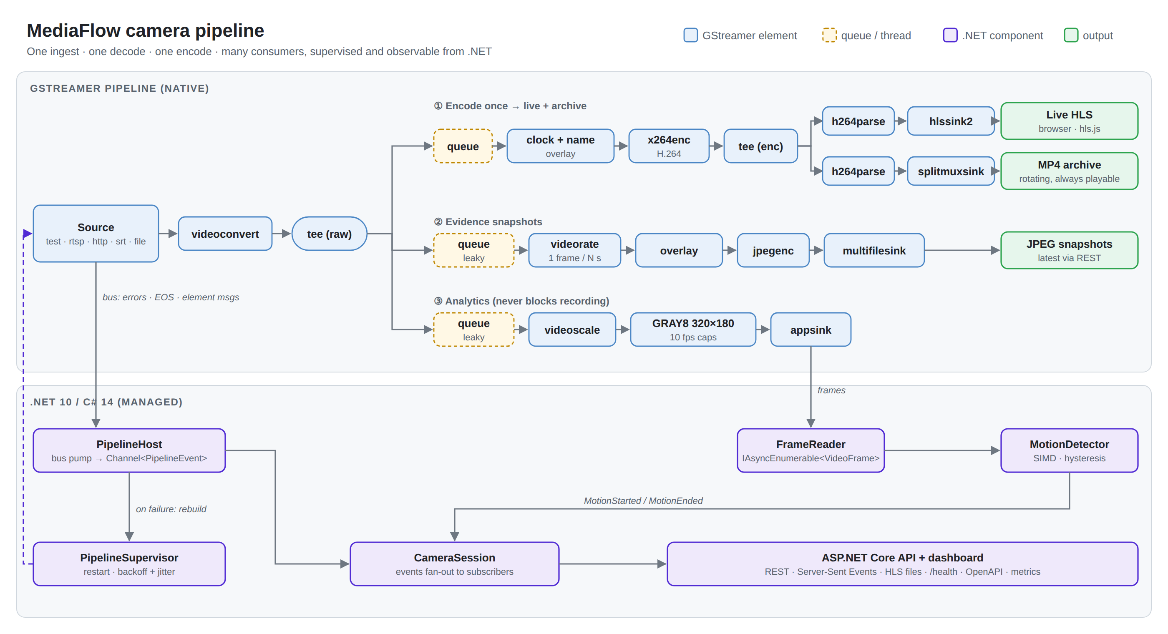
Architecture: native GStreamer branches (top) and the managed .NET control plane (bottom).
The whole graph is generated by CameraPipeline.Build(options) using the typed builder from Part 1, with nested tees. Encoding is by far the most expensive step, so we encode once and fan out the compressed stream to both HLS and the archive.

Five lessons the pipeline taught me

1. One parser per output, after the tee
My first version put a single h264parse before the encoded tee. It failed immediately with not-negotiated. HLS muxes to MPEG-TS, which wants H.264 in byte-stream format; MP4 wants avc format. A shared parser cannot output both. Moving one h264parse into each branch lets each negotiate its own format.

2. Every tee branch needs a queue, and analytics queues must be leaky
A queue gives each branch its own streaming thread. Without it, one slow branch blocks all the others. The analytics and snapshot queues are leaky=downstream with a tiny size: analytics may fall behind, but the recording must never do so.

3. Never burn a clock into frames you analyse
Operators want a timestamp and camera name on recordings and snapshots. But if the overlay sits before the analytics branch, a ticking clock is "motion" in the corner of every frame. Overlays are therefore applied only on the recording and snapshot branches.

4. Stop with EOS, not with a kill
An MP4 file is only playable once the muxer has written its index (the moov atom), which happens when it receives End-Of-Stream. Kill the process and the last file is corrupt. PipelineHost.StopAsync injects EOS, waits for it to arrive at every sink, then tears down. The supervisor calls it on cancellation, and the ASP.NET Core server calls it from IHostedService.StopAsync, so docker stop or a Kubernetes rollout leaves playable files. splitmuxsink also finalises each segment at a keyframe it requests itself (send-keyframe-requests=true).

5. Know which element sent a message
hlssink2 uses a splitmuxsink internally, so "fragment closed" messages arrive for HLS segments too. Only the archive recorder reports a file location, and the session filters on it. Snapshot messages from multifilesink carry filename rather than location; small details like these only show up when you run the system.

Self-healing: the PipelineSupervisor
Cameras reboot, Wi-Fi drops, RTSP servers time out. The supervisor owns a factory that builds a fresh pipeline, and runs it in a loop:
- An error, or an unexpected EOS from a live source, triggers a rebuild.
- The wait between attempts grows exponentially (1 s, 2 s, 4 s … capped at 30 s) with ±20 % jitter, so 200 cameras do not reconnect in lock-step after a network blip.
- A run that stayed healthy for 30 s resets the backoff.
- An optional give-up policy moves the camera to Faulted, which shows up in health checks.
- For file sources, EOS means "done" and the supervisor stops cleanly.
$ mediaflow nvr --source rtsp://127.0.0.1:8554/offline
[17:28:22] Status BackingOff (retry in 1.0s: Could not change state to Playing: Failed to connect.
(/GstPipeline:pipeline0/GstURIDecodeBin:uridecodebin0/GstRTSPSrc:source))
[17:28:23] Status BackingOff (retry in 2.1s: ...)
[17:28:25] Status BackingOff (retry in 4.7s: ...)

CameraSession: one observable camera
CameraSession combines the pipeline recipe, the supervisor and the motion detector. Bus messages and motion transitions become CameraEvents (MotionStarted, MotionEnded, SegmentClosed, Snapshot, Status, Warning, Error) that are fanned out to any number of subscribers. Each subscriber has its own bounded channel, so one slow browser tab cannot block the others.

The web server
MediaFlow.Server is an ASP.NET Core minimal API around a CameraRegistry hosted service:
Endpoint | Purpose
GET / | Dashboard: HLS players, health badges, motion meter, live event log
GET/POST /api/cameras, DELETE /api/cameras/{id} | Add and remove cameras at runtime
GET /api/cameras/{id}/events | Live Server-Sent Events (native TypedResults.ServerSentEvents in .NET 10)
GET /api/cameras/{id}/snapshot | Latest JPEG
GET /hls/{id}/hls/index.m3u8 | Live HLS, served with correct MIME types and a no-cache playlist
GET /health | Healthy, Degraded (a camera is reconnecting) or Unhealthy (a camera gave up)
GET /openapi/v1.json | OpenAPI document

api.MapGet("/cameras/{id}/events",
Results<ServerSentEventsResult<CameraEvent>, NotFound> (string id, CancellationToken ct) =>
registry.Find(id) is { } camera
? TypedResults.ServerSentEvents(Stream(camera, registry.RecordingsPath, ct))
: TypedResults.NotFound());
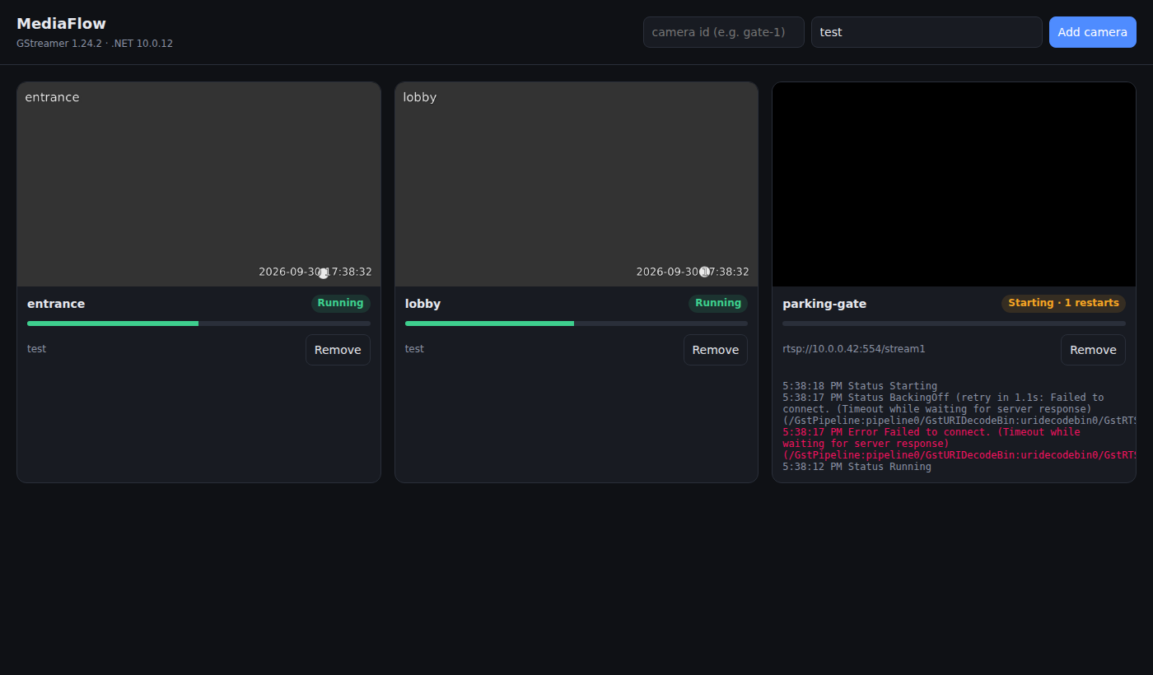
The dashboard: two healthy cameras with burned-in name and time, and an unreachable RTSP camera backing off.

Security: untrusted input meets a pipeline string
The API accepts a camera id and a source URI, and both end up in a pipeline description and in file paths. That combination deserves care:
- Camera ids must match ^[a-z0-9][a-z0-9-]{0,31}$, which rules out path traversal such as ../etc.
- Source URIs are allow-listed by scheme (rtsp, rtsps, http, https, srt, udp, or test). file:// is rejected, so a client cannot make the server read local files.
- Values are quoted by the builder, and the API never returns absolute server paths.
- A configurable camera limit protects the machine from resource exhaustion.

Observability
MediaFlowTelemetry publishes a Meter and an ActivitySource named "MediaFlow": frames processed and dropped, pipeline errors and restarts, motion events, and a histogram of per-frame analysis time. Any OpenTelemetry exporter (Prometheus, OTLP, Azure Monitor) can collect them with AddMeter("MediaFlow").

Tests, CI and Docker
The repository contains 24 tests. Unit tests cover the builder's quoting, SIMD-vs-scalar equality, motion hysteresis and backoff maths. Integration tests run real GStreamer pipelines: frames through appsink with exact timestamps, an appsrc→appsink round trip, error propagation, supervisor restarts, and a test that proves a gracefully stopped MP4 is playable. They skip automatically when GStreamer is not installed.
GitHub Actions installs GStreamer on Ubuntu 24.04, runs the tests and smoke-tests every CLI scenario, including a 12-second NVR run that must produce an HLS playlist and MP4 segments. A multi-stage Dockerfile builds on the .NET 10 SDK image and runs on the ASP.NET image with the GStreamer plugin sets installed.
docker build -f docker/Dockerfile -t mediaflow .
docker run --rm -p 8080:8080 -v "$PWD/recordings:/app/recordings" mediaflow

Taking it further
Goal | Change
Hardware encoding | Swap x264enc for nvh264enc (NVIDIA), vah264enc (Intel/AMD), qsvh264enc, or mfh264enc/d3d11h264enc on Windows. The pipeline shape stays the same.
Object detection | Feed VideoFrames to ONNX Runtime (YOLO), or run inference inside the pipeline with DeepStream elements.
Sub-second latency | Add a webrtcbin branch next to HLS.
Internet contribution | Use srtsink/srtsrc with encryption.
Scale out | Each CameraSession is independent: shard cameras across pods and keep the API contract.

Closing thoughts
The 2024 article ended with "you can now explore further features of GStreamer". This series is that exploration: the same few calls (Init, ParseLaunch, SetState, the bus) grow into a system that records, streams, analyses and heals itself, written in modern, testable C#. The full source is on GitHub: https://github.com/omairkhan/gstreamer-dotnet.

Appendix: LinkedIn announcement posts
Copy and paste as-is. Attach the dashboard screenshot (docs/dashboard.png in the repository) as the image. Publish once the repository is public, so the link works.

English
In 2024 I wrote "Bridging the Gap: GStreamer Integration for .NET Core 8 on Windows". It covered installing GStreamer, setting PATH, and playing a video with playbin in about 10 lines of C#.
Many of you asked: "Nice. But how do I build something real with it?"
So I wrote the sequel, and this time it's code. 👇
🎬 MediaFlow: GStreamer × .NET 10 / C# 14, from playbin to production
🔹 Level 0: the 2024 program, ported to .NET 10 with maintained, cross-platform GirCore bindings
🔹 Level 1: pipeline basics, seeking, 2× and slow-motion playback, and building pipelines by hand with dynamic pads
🔹 Level 2: C# in the media path. Frames as IAsyncEnumerable, SIMD motion detection, and video generated from C#
🔹 Level 3: production. A self-healing 24/7 camera recorder (live HLS, MP4 archive, snapshots, motion events) and an ASP.NET Core server with REST, live events, health checks and Docker
Lessons you only learn by running it:
✅ Encode once and share the compressed stream.
✅ Use one h264parse per output. HLS and MP4 need different H.264 formats.
✅ Never burn a clock into frames you analyse, or every second counts as "motion".
✅ Stop with EOS, not a kill, or your last MP4 is unplayable.
✅ Live analytics may drop frames. Recording must never do so.
✅ Keep the first error. It names the root cause.
Includes a 3-part blog series and 24 tests that run real GStreamer pipelines in CI.
🔗 https://github.com/omairkhan/gstreamer-dotnet
📖 2024 article: https://www.mathema.de/mathema/news-know-how/bridging-the-gap-gstreamer-integration-for-net-core-8-on-windows
What would you build on top of it? 👇
#dotnet #csharp #GStreamer #VideoAnalytics #ComputerVision #aspnetcore #opensource

German (Deutsch)
2024 habe ich „Bridging the Gap: GStreamer Integration for .NET Core 8 on Windows“ geschrieben: GStreamer installieren, PATH setzen und mit playbin in rund 10 Zeilen C# ein Video abspielen.
Die häufigste Frage danach: „Schön, aber wie baue ich damit etwas Echtes?“
Hier ist die Fortsetzung, diesmal als Code. 👇
🎬 MediaFlow: GStreamer × .NET 10 / C# 14, von playbin bis Produktion
🔹 Level 0: das Programm von 2024, portiert auf .NET 10 mit gepflegten, plattformübergreifenden GirCore-Bindings
🔹 Level 1: Pipeline-Grundlagen, Seeking, 2×- und Zeitlupen-Wiedergabe, Pipelines von Hand mit dynamischen Pads
🔹 Level 2: C# im Medienpfad. Frames als IAsyncEnumerable, SIMD-Bewegungserkennung und in C# erzeugtes Video
🔹 Level 3: Produktion. Ein selbstheilender 24/7-Kamerarekorder (Live-HLS, MP4-Archiv, Snapshots, Bewegungsereignisse) und ein ASP.NET-Core-Server mit REST, Live-Events, Health Checks und Docker
Erkenntnisse, die man nur im Betrieb gewinnt:
✅ Einmal encodieren, den komprimierten Stream teilen.
✅ Ein h264parse pro Ausgang. HLS und MP4 brauchen unterschiedliche H.264-Formate.
✅ Niemals eine Uhrzeit in analysierte Frames einblenden, sonst ist jede Sekunde „Bewegung“.
✅ Mit EOS stoppen, nicht abschießen, sonst ist die letzte MP4 unbrauchbar.
✅ Live-Analyse darf Frames verwerfen, die Aufzeichnung niemals.
✅ Den ersten Fehler behalten. Er nennt die Ursache.
Inklusive einer dreiteiligen Blog-Serie und 24 Tests, die in der CI echte GStreamer-Pipelines ausführen.
🔗 https://github.com/omairkhan/gstreamer-dotnet
📖 Artikel von 2024: https://www.mathema.de/mathema/news-know-how/bridging-the-gap-gstreamer-integration-for-net-core-8-on-windows
Was würdet ihr darauf aufbauen? 👇
#dotnet #csharp #GStreamer #Videoanalyse #ComputerVision #aspnetcore #opensource

