RPA Week 2 Assignment
Invoice Processing Automation Using UiPath
Comprehensive RPA Project Plan — Website Screenshots

Live Website:
https://omais-eng.github.io/rpa/assignment2/index.html
GitHub Repository:
https://github.com/omais-eng/rpa

Screenshot 1 — Hero & Project Overview

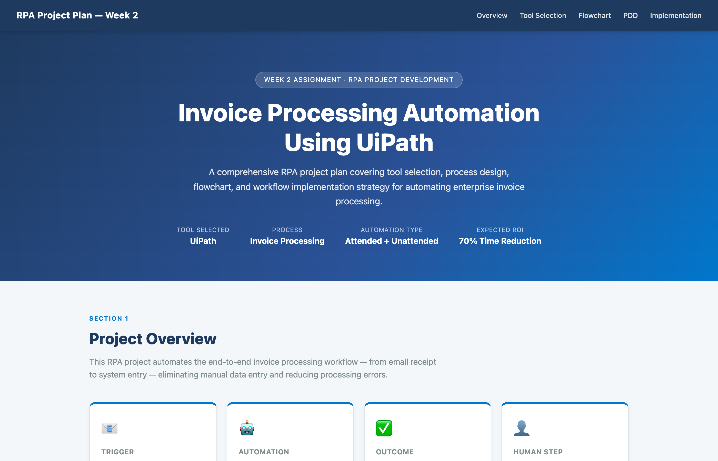

The top of the website showing the project title, tool selected (UiPath), process name, automation type, and ROI target. The project overview section below shows the four key components: trigger, automation, outcome, and human intervention step.

Screenshot 2 — RPA Tool Selection

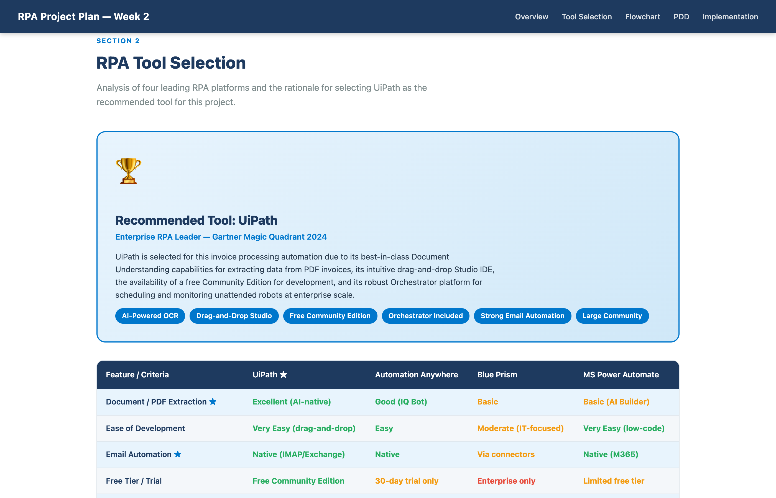

The UiPath tool selection section highlighting why UiPath was chosen over alternatives. The winner card shows the rationale including AI-powered OCR, drag-and-drop Studio, free Community Edition, and enterprise Orchestrator. Key feature tags are displayed.

Screenshot 3 — Tool Comparison Matrix

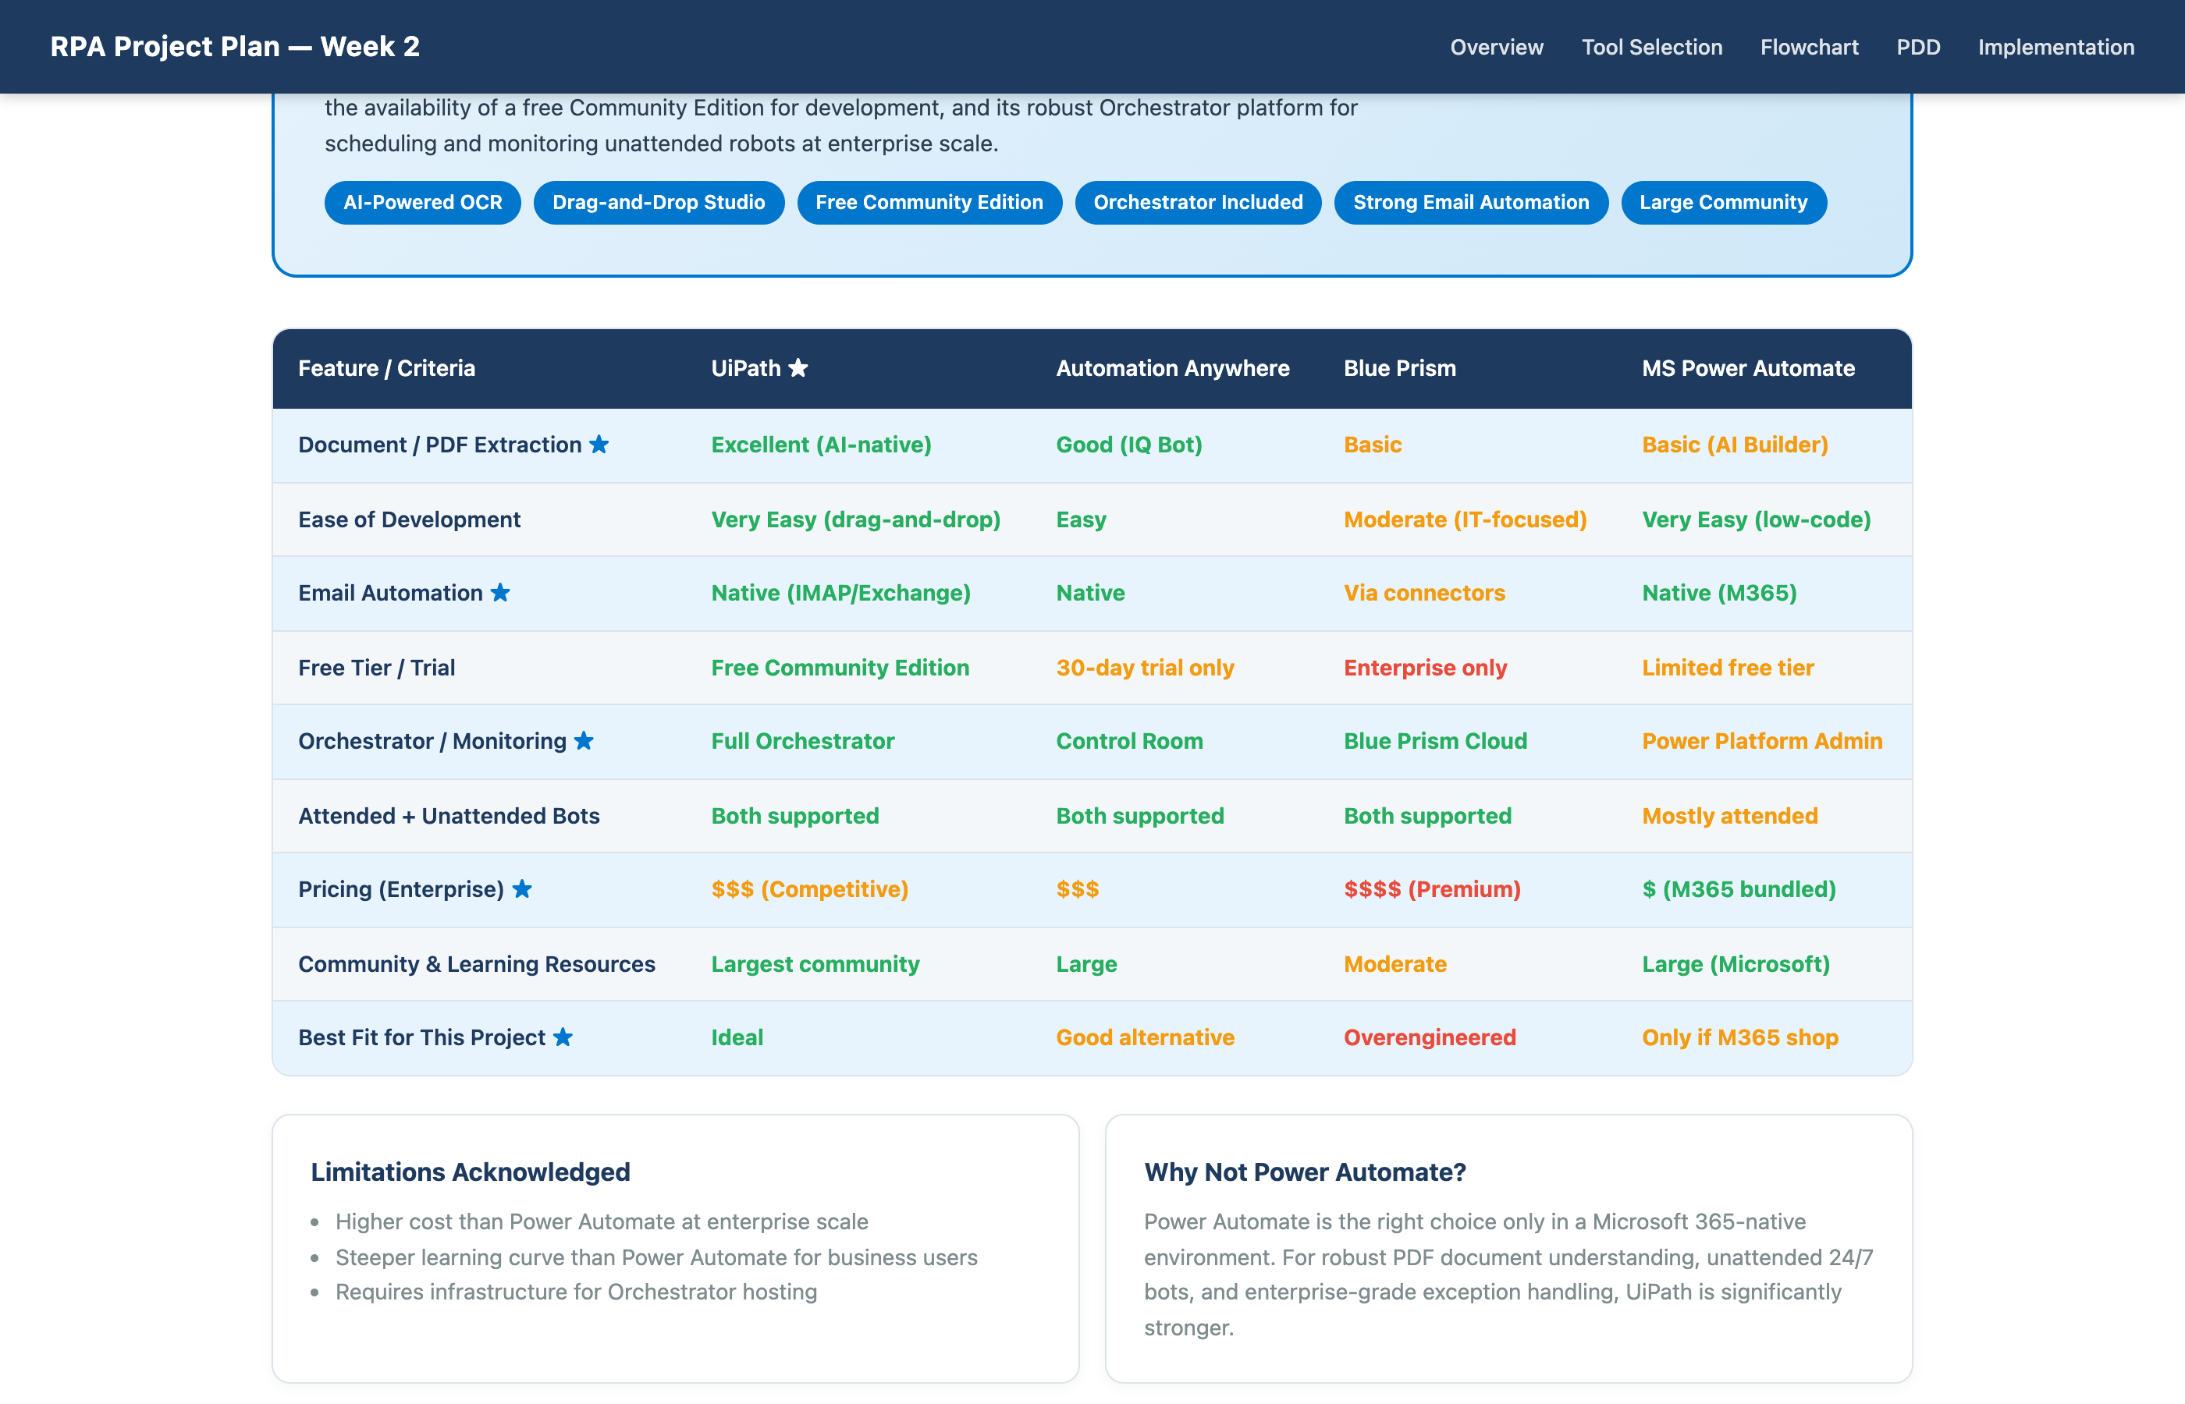

A detailed feature-by-feature comparison table across all four RPA platforms: UiPath, Automation Anywhere, Blue Prism, and Microsoft Power Automate. Nine criteria evaluated including document extraction, ease of development, email automation, pricing, and project fit.

Screenshot 4 — Process Flowchart (Mermaid.js)

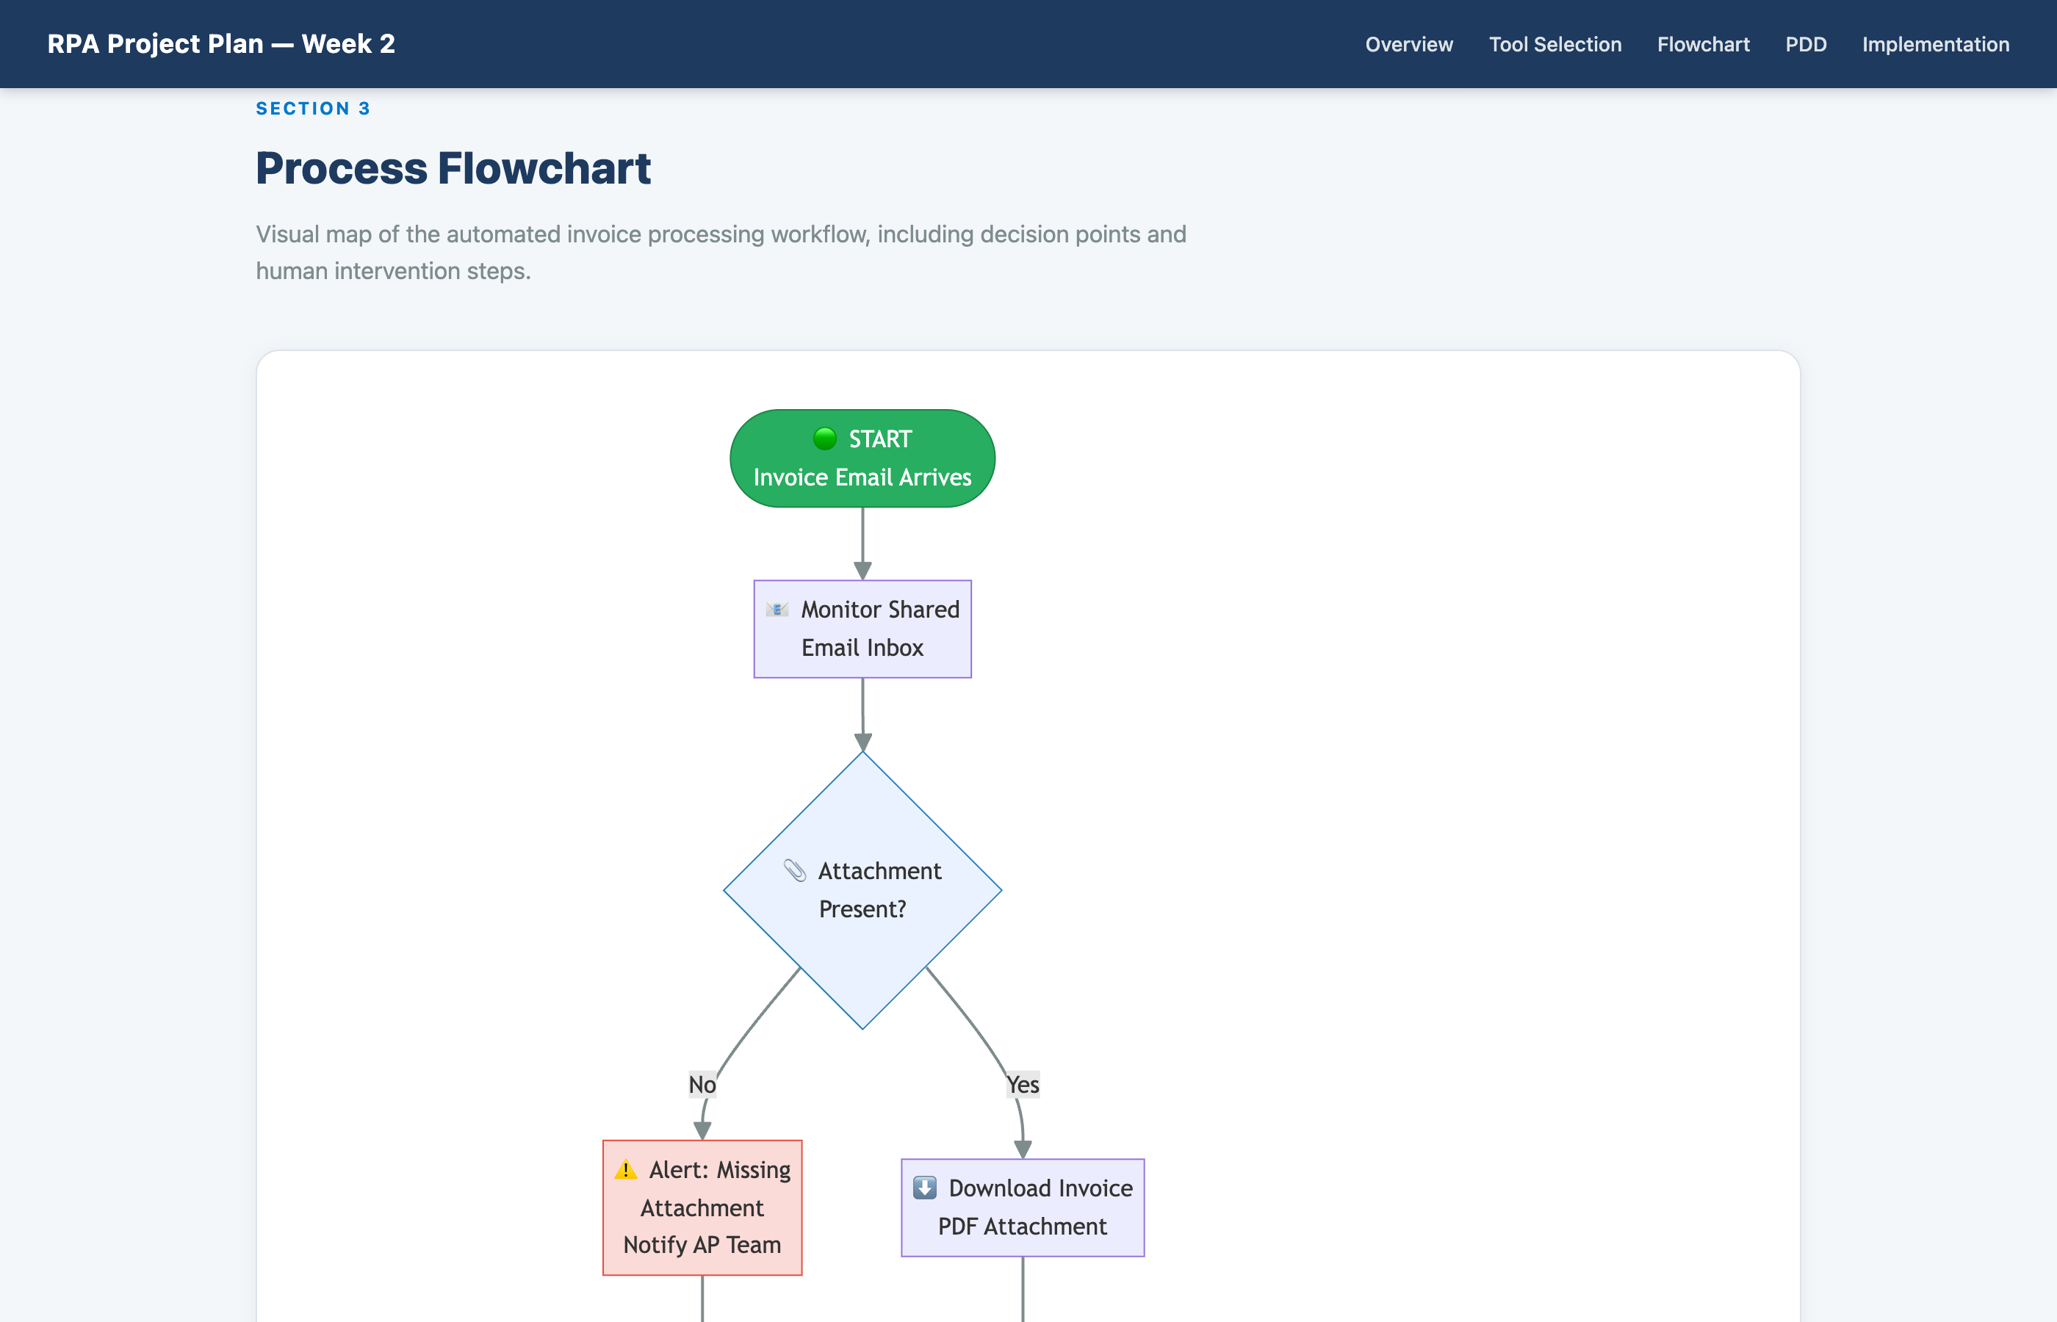

An interactive process flowchart built with Mermaid.js showing the complete invoice automation workflow. Color-coded with blue diamonds for decision points, red paths for exceptions, yellow for human intervention (manager approval), and green for automated actions.

Screenshot 5 — Process Design Document (Part 1)

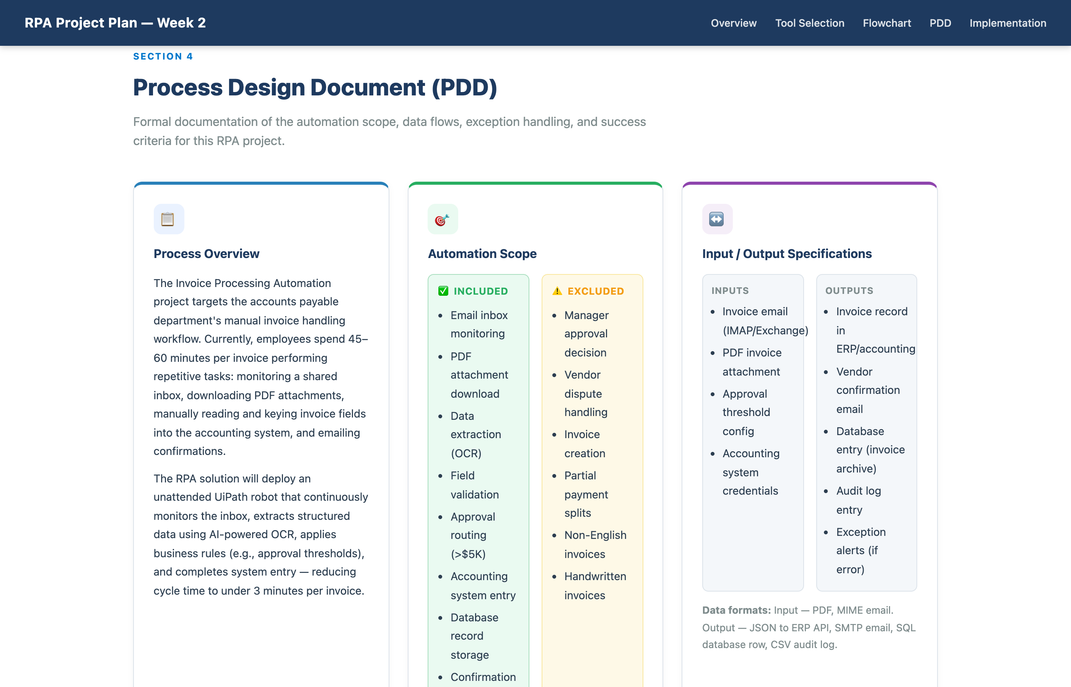

The top portion of the Process Design Document including the Process Overview (current state, 45–60 min manual cycle), Automation Scope with included/excluded items, and Input/Output Specifications detailing data formats for inputs (PDF, email) and outputs (ERP, database, email).

Screenshot 6 — Process Design Document (Part 2)

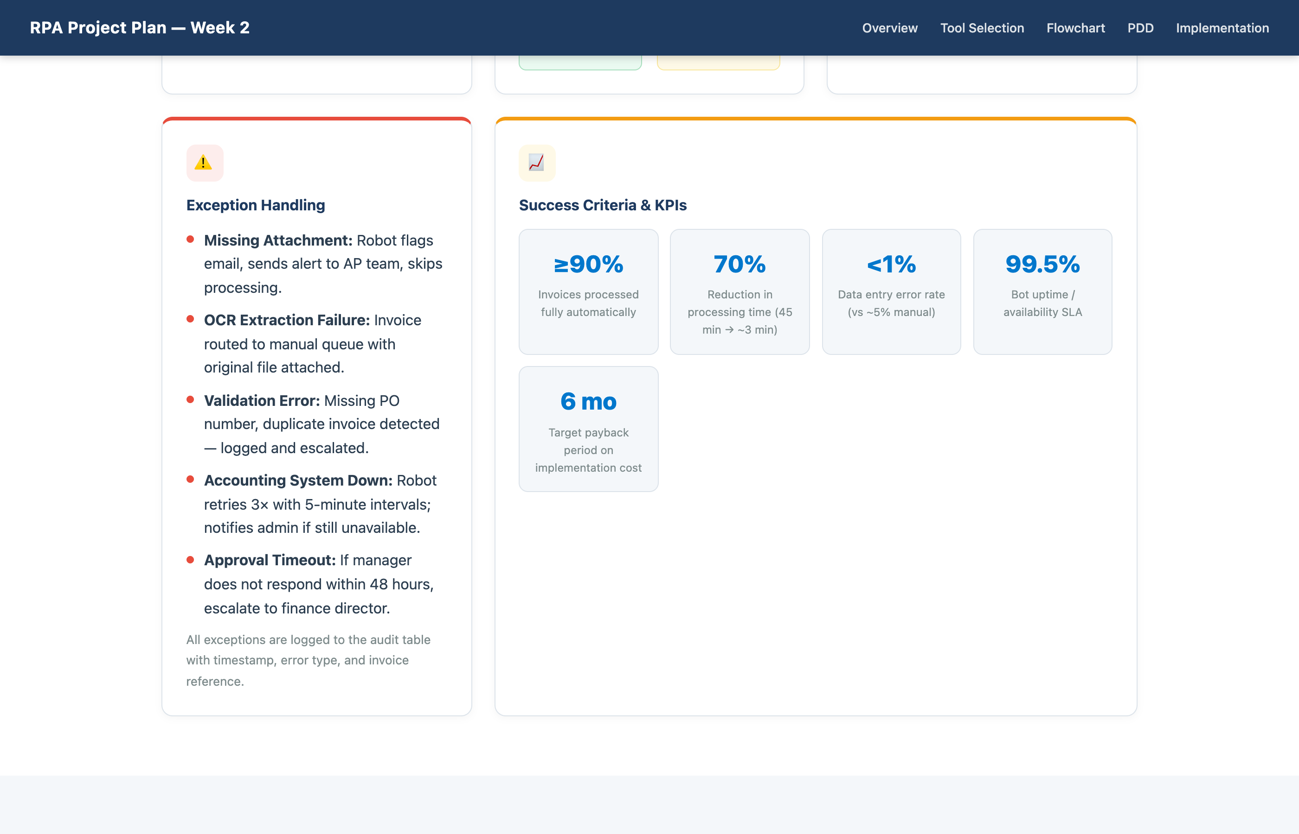

The bottom portion of the PDD showing Exception Handling (5 scenarios: missing attachment, OCR failure, validation error, system downtime, approval timeout) and the Success Criteria KPI dashboard with 5 measurable targets including 90% automation rate and 70% time reduction.

Screenshot 7 — Workflow Implementation Strategy

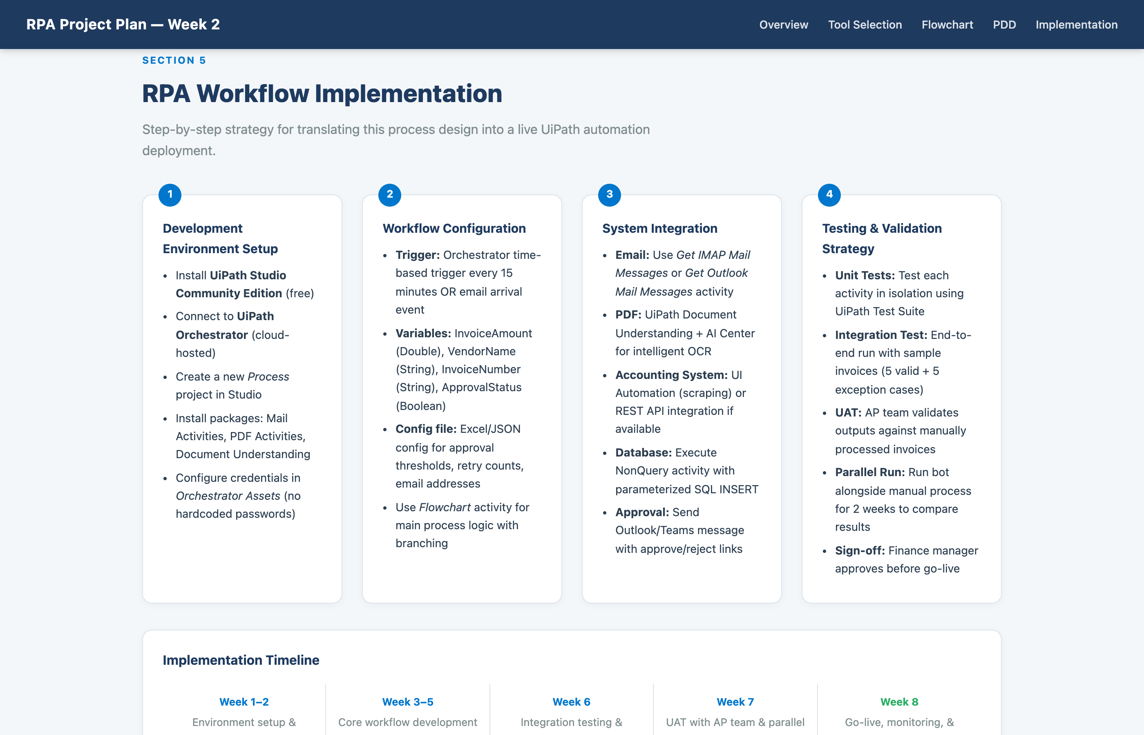

The four-pillar implementation strategy: (1) Dev environment setup using UiPath Studio and Orchestrator, (2) Workflow configuration with triggers and variables, (3) System integrations covering email, PDF, accounting system, and database, (4) Four-phase testing approach.

Screenshot 8 — Implementation Timeline & Footer

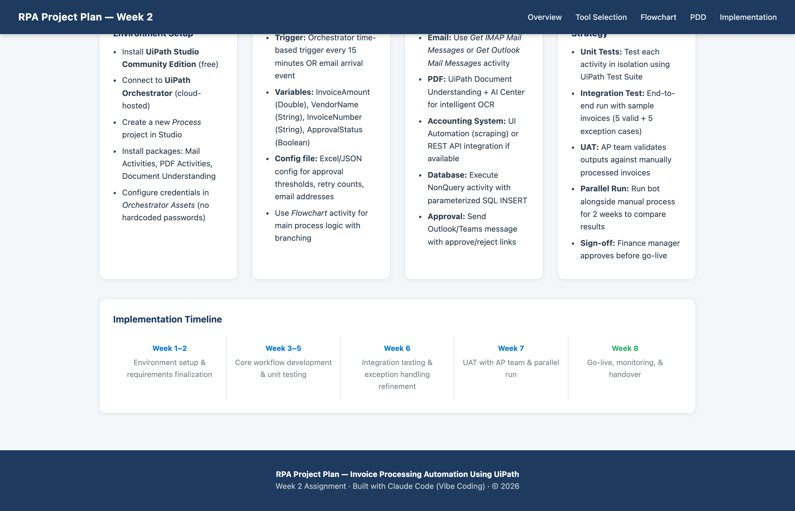

The 8-week implementation roadmap: Weeks 1–2 setup, Weeks 3–5 development, Week 6 integration testing, Week 7 UAT and parallel run, Week 8 go-live. The footer shows the live website URL and GitHub repository link.

Assignment Submission Summary

Component | Details
Website (Live) | https://omais-eng.github.io/rpa/assignment2/index.html
GitHub Repository | https://github.com/omais-eng/rpa
Tool Selected | UiPath — Enterprise RPA Leader
Process Automated | Invoice Processing (end-to-end)
Flowchart | Mermaid.js interactive diagram with decision points
PDD Sections | Overview, Scope, I/O, Exception Handling, Success KPIs
Implementation Plan | 8-week roadmap with testing strategy
Screenshots | 8 full-section screenshots included in this document
PPT File | RPA_Week2_Assignment.pptx with speaker notes

