Signal source: Quartz Board (Data Acquisition System)

DAQ-32-BNC-FR4
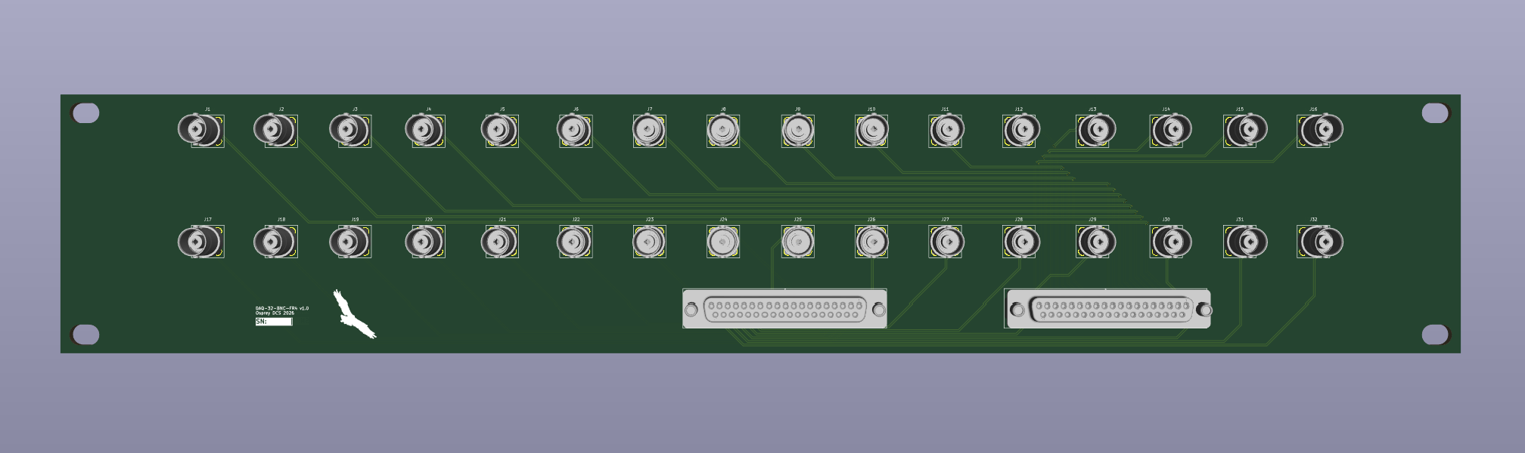
- PCB is the panel (thickness: 3.2mm)
- Local (meant for short ribbon cable: 3M 8237-6000 connectors)
  - D connectors come out the front
  - Would be rack mounted directly above the Quartz chassis
  - No shield grounding (differential pairs)
- D connectors lined up with the Quartz Chassis

