Signal source: Quartz Board (Data Acquisition System)

DAQ-32-BNC
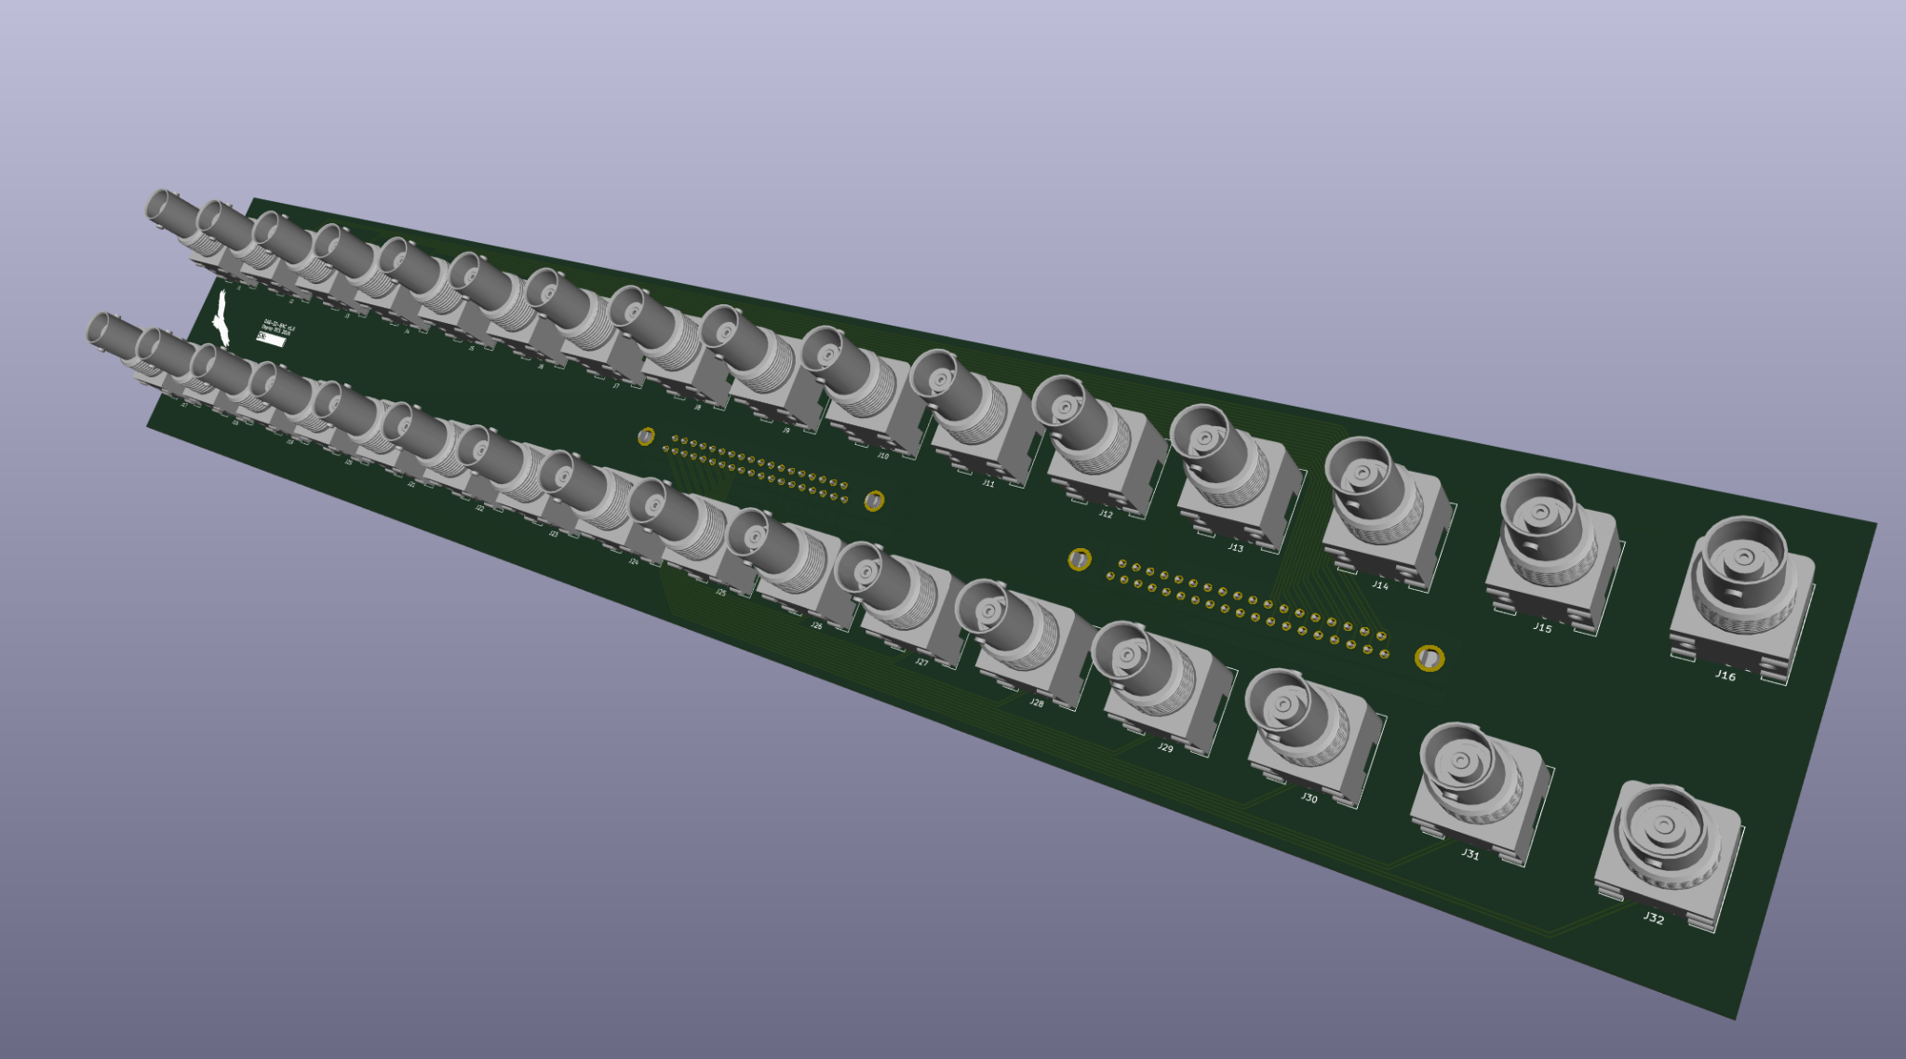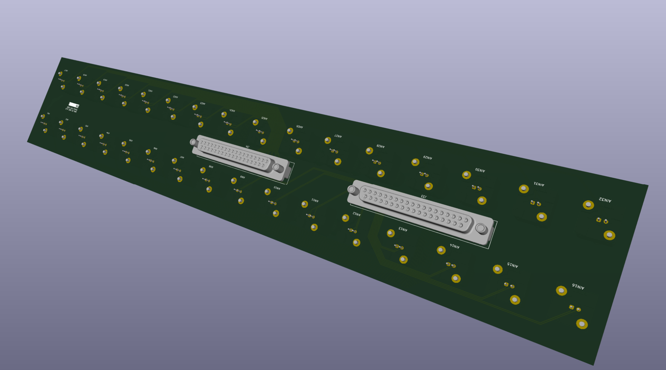
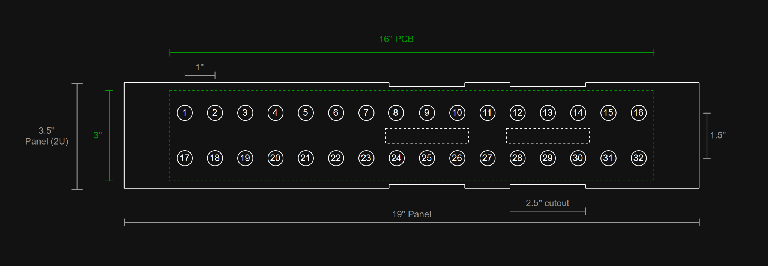
- 1 PCB mounted behind a 2U panel
- Local (meant for short ribbon cable: 3M 8237-6000 connectors)
  - Space for ribbon cable cutouts on either top or bottom of the panel so it can be rack mounted directly above or below the Quartz chassis
  - No shield grounding (differential pairs)
- D connectors lined up with the Quartz Chassis
- BNCs provide mounting
