Contact

**Address:**

Can’t tell ☹ sorry ☹

**Phone:**

Won’t tell ;(

**Email:**

[omamamehmood100@gmail.com](mailto:omamamehmood100@gmail.com)

**LinkedIn:**

linkedin.com/dreambigoooo

Languages

English

Urdu

Binary (Disclaimer- Not Fluent)

Hobbies

* Writing
* Sketching
* Photography
* Design
* Laughing at my own bad jokes

Omama Mehmood

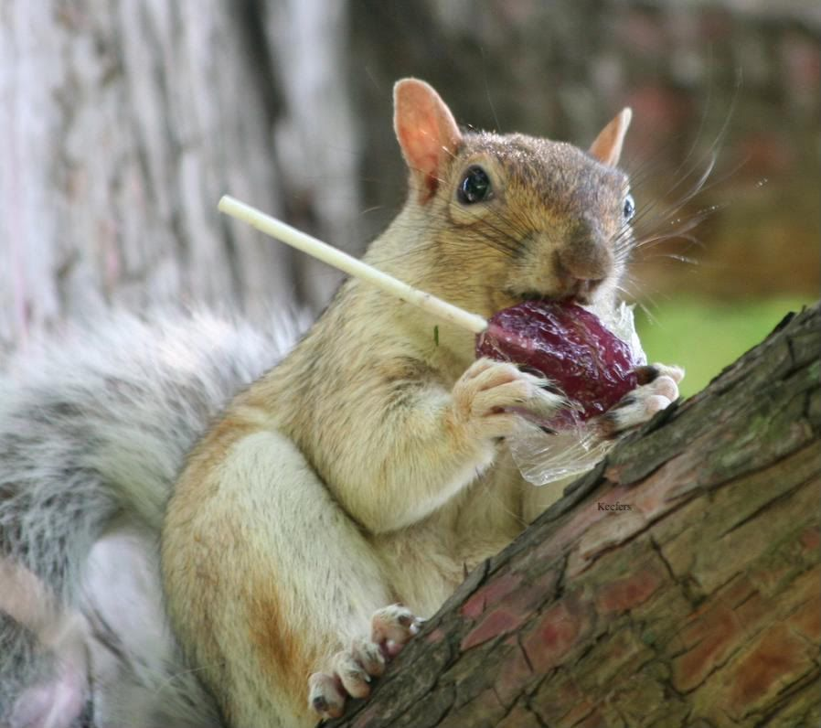

Summary

Currently a nothing specializing in absolutely nothing. Not experienced with any stages of the development cycle for dynamic web projects. Less-than-moderately-versed in around two programming languages namely VS and JavaScript with a pending HTML5 assignment so hopefully, soon HTML5 too. No background in project management and customer relations.

Skill Highlights

|  |  |
| --- | --- |
| * Strong decision maker * Complex problem solver | * Innovative (subjective - i can come up with some killer jokes) * Service-focused |

Experience

**Web Developer** - 09/2015 to 05/2019

* Cooperate with designers to create clean interfaces and simple, intuitive interactions and experiences.
* Develop project concepts and maintain optimal workflow.
* Work with senior developer to manage large, complex design projects for corporate clients.
* Complete detailed programming and development tasks for front end public and internal websites as well as challenging back-end server code.
* Carry out quality assurance tests to discover errors and optimize usability.
* **Just kidding hehe.**

Education

O Levels: **Not Public Info** - 2018

A Levels:  **Also Not Public Info** – 2020

Bachelors in Computer Science: **IBA, Karachi, Pakistan.** – Most probably 2024.

Certifications

Wish I had any.