Adaptive Educational Interfaces:
A Survey of Student Modeling,
Generative Systems, and Control Mechanisms
Pratik Rajendra Patil, Abhishek Ganesh Tirpude, Omanand Prashant Swami, Sanjana Shashikant Chavan, K. V. Deshpande
Dept. of Computer Science and Business Systems, JSPM’s Rajarshi Shahu College of Engineering, Pune, India
{prpatil_csbs, agtirpude_csbs, opswami_csbs, sschavan_csbs, kvdeshpande_comp}@jspmrscoe.edu.in

Abstract—Despite decades of development in intelligent tutoring systems (ITSs) that use mathematically rigorous methods for estimating the latent knowledge states of learners, personalized education still proves a challenging problem. These solutions provide an excellent pedagogical alignment but are inherently limited by their static interface paradigm. Recently, with the advent of foundation models, the community began exploring a new approach called Generative User Interfaces (GenUI). In contrast to traditional systems, GenUI allows the real-time creation of interactive learning environments. However, this feature comes at a significant structural cost. Namely, the generation process itself is detached from cognitive state estimation. Consequently, today’s tools tend to create environments with the same structural complexity irrespective of the learners' proficiency level, causing cognitive overload and failing to personalize. To study this problem systematically, we introduce a three-dimensional taxonomy comprising Cognitive Modeling, Interface Paradigm, and Control Mechanisms. By comparing the four most prevalent architectural patterns, we discover a trade-off between the pedagogical trustworthiness of GenUI and its expressive potential. We demonstrate how true personalization requires the existence of a common control parameter and a formal definition of cognitive complexity. To mitigate these issues, we suggest a novel approach based on closed-loop control theory applied to the probability distributions of student models.
Keywords—Adaptive Educational Interfaces, Intelligent Tutoring Systems, Generative User Interfaces, Bayesian Knowledge Tracing, Cognitive Modeling, Control-Theoretic AI
I. INTRODUCTION
The goal of adaptive education is to match instructional environments to the latent cognitive state of a learner [1]. Traditional approaches to this problem include intelligent tutoring systems (ITS), which utilize mathematically rigorous methods such as Bayesian Knowledge Tracing to achieve accurate estimation of the student’s knowledge [4]. Despite their strengths, current ITSs are limited by the inflexibility of their interface design, which usually includes fixed designs that do not allow adaptation [3].
Recent developments in foundation models enable a paradigmatic change towards Generative User Interfaces (GenUI). Under this approach, learning environments are generated dynamically during runtime. This new trend transforms education into an activity that focuses on generating rather than selecting content [2], [3]. Nevertheless, this added level of flexibility poses a new architectural problem: separating the process of interface generation from the task of assessing the cognitive state of the user.
Contemporary approaches to interface generation often focus on maximizing the expressive capacity of generated content, but a gap exists in adequately representing learner knowledge and mapping it to the environment [14], [15]. This can lead to learning spaces of similar complexity for novice learners and experts, potentially increasing the cognitive load on the user [14].
This paper presents a systematic review of recent efforts in solving the problem of integrating cognitive modeling with the architecture of adaptive interfaces. Our contributions include:
1) A three-dimensional taxonomy of contemporary systems based on Cognitive Modeling, Interface Paradigms, and Control Mechanisms.
2) A comparative analysis of four primary architecture paradigms of GenUI, which reveals a structural dilemma between pedagogical efficiency and expressive capacity.
3) Identification of major research gaps that necessitate moving towards closed-loop control approaches to cognitive modeling and interface generation.
II. BACKGROUND
In order to understand the categorization better, it is imperative to introduce the fundamental processes on which state estimation and interface synthesis are based.
Explicit Learner Modeling: In techniques such as Bayesian Knowledge Tracing (BKT) and Deep Knowledge Tracing (DKT), the student's domain knowledge is represented using a mathematical model wherein latent probabilistic skill distribution is dynamically computed [4], [11]; the posterior probability of mastery P(L_n) for BKT changes based on interactions and results in a deterministic value [5], which classical ITS uses to navigate students through predefined static content [4].
Generative User Interfaces (GenUI): Whereas conventional user interfaces involve rendering templates in HTML, GenUI involves generating executable code such as HTML, CSS, and JavaScript in real time from a generative foundation model. Unlike conventional adaptive interfaces that rely on predefined structural rules to show or hide existing templates, GenUI allows substantially greater structural variation than template-based interface selection.
III. METHODOLOGY
This section provides a description of the Systematic Literature Review (SLR) approach used to select and evaluate the works reviewed in this paper.
A. Search Strategy
Searches across IEEE Xplore, ACM Digital Library, Springer Link, Google Scholar, and arXiv utilized keywords including "generative user interface," "Bayesian Knowledge Tracing," and "adaptive learning," followed by forward and backward reference tracing.
B. Inclusion and Exclusion Criteria
Articles were selected if they (i) provided an architectural framework, a system, or a methodology for adaptive instruction or generative user interfaces, (ii) were published in a peer-reviewed journal or were written as a technical report from an established research lab, and (iii) were written between 1994 and 2026. Works establishing the foundations of knowledge tracing were selected regardless of age. Articles focusing exclusively on recommending content with no mention of an interface tailored to learners were excluded, and papers whose conclusions were made obsolete by another cited work were excluded as well. One article, MAIC-UI [3], was included as a special case. While MAIC-UI primarily concerns itself with content authoring, it explicitly shows how an LLM can synthesize HTML for runtime educational interfaces—exactly the kind of interface construction described in this survey.
C. Synthesis Approach
Each work was annotated according to the three axes discussed in Section IV: cognitive modeling, interface paradigm, and generation control. Patterns have been identified as groups of articles sharing the same values for at least one axis, and the limitations were compiled as limitations discussed by authors in the cited works and their critiques. This analysis is purely qualitative and does not include any meta-analysis.
D. Scope and Threats to Validity
The focus of this survey is on literature from AI and educational technology fields. Related works, including, e.g., HCI research on generative design tools, the cognitive psychology of complexity, and control theory in education, may be cited but were not comprehensively searched. The fact that we are using search engines that prioritize some languages over others, as well as the personal biases of the authors, creates a significant bias toward English-language and technical literature.
IV. TAXONOMY OF ADAPTIVE EDUCATIONAL INTERFACES
A. Overview
Generation through neural networks has brought about novel design principles within the field of education technology [2], [3]. In existing research, evaluation approaches tend to focus only on one component, favoring conversational ability or predictive capability without considering their interdependencies [14], [6]. To describe the present situation effectively, a categorization approach must be undertaken. In this regard, we propose a model consisting of three axes: Axis 1 focuses on how latent knowledge is managed via the interface, Axis 2 considers how the virtual space is represented, and Axis 3 restricts the algorithmic output for pedagogical safety.

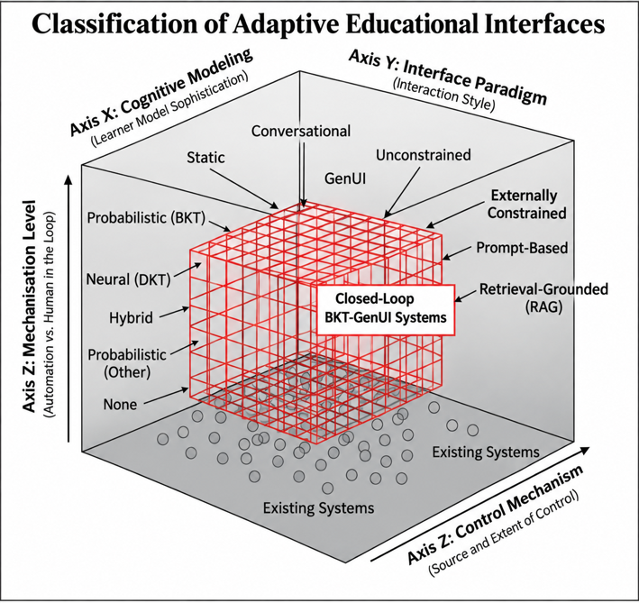

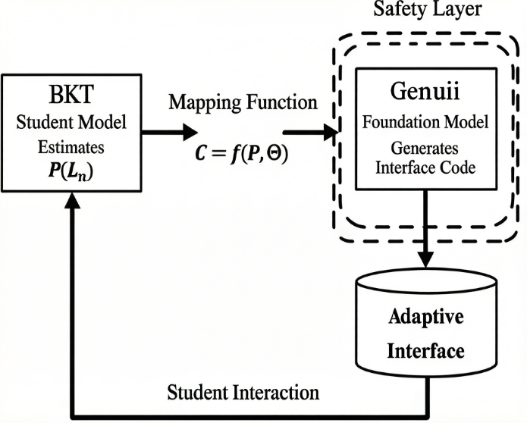
Fig. 1. Classification of adaptive educational interfaces and the closed-loop BKT-GenUI control architecture. The highlighted region represents the future research space for Closed-Loop BKT-GenUI Systems. (Source: Authors.)

B. Axis 1: Cognitive Student Modeling
This axis delineates the computational means that maintain a persistent model of the student’s cognitive state.
None (No Explicit Student Model): The system records no domain mastery, and it generates answers purely as a function of context.
Probabilistic: Mastery is probabilistically inferred, estimating the values of latent state variables over a sequence of interactions.
Neural: Deep learning approaches interpret interaction history to predict future performance of the student. Such models have high prediction accuracy but are not transparent because no cognitive parameters are available [7].
Hybrid (Neuro-Symbolic): Neural pattern recognition technology is coupled with symbolic logic to generate a human-interpretable, mathematically well-bounded cognitive model [12].
C. Axis 2: Interface Paradigm
This axis defines the structure of the medium providing an educational intervention.
Static / Pre-authored: Fixed components retrieved from the database.
Conversational: Dialogue-based interactions lack graphical manipulative elements.
Generative UI (GenUI): Dynamic interface generated on the fly, whereby the architecture produces executable code necessary for rendering manipulative interface tools.
D. Axis 3: Generation Control Mechanism
This axis classifies the constraints imposed on the generative process. Control mechanisms vary greatly depending on whether the constraints are implicit or explicit.
Unconstrained: No external validation layers affect the system's output.
Prompt-Based: Involves attempts to steer the generation process using a natural language prompt before inference.
Retrieval-Grounded (RAG): External verified documents are introduced to the context window, imposing strict factual boundaries [10], [12].
Externally Constrained (Symbolic/Rule-Based): Neural generation is subjected to external algorithmic restrictions, such as syntax validators or probability scalars limiting structural complexity [9].
E. Cross-Axis Interaction
The interactions between these three axes define efficacy and safety. High interface flexibility (GenUI) in combination with no external boundaries (Unconstrained) inherently brings epistemological risks. From a practical perspective, an architecture capable of predicting the learner's mathematical knowledge but unable to generate a dynamic interface faces as much of a bottleneck as an interface-generating framework operating blindly without tracking the learner's cognition. Based on the reviewed literature, we have yet to see an architecture that successfully merges explicit cognitive modeling, dynamic interface generation, and external safety constraints into a single closed-loop framework.
V. LITERATURE SYNTHESIS AND PATTERN ANALYSIS
A. Systems with Explicit Cognitive Modeling
The research efforts of the last few decades have been devoted to developing a mathematical representation of the latent student knowledge state. Classic ITS architectures use Bayesian Knowledge Tracing (BKT) to provide a convenient way to track probabilities for the student knowledge state [4], [5]. In modern research on learning analytics, the same approach has been used for the design of teacher-oriented tools, where machine learning algorithms allow visualization of student knowledge through a graphic analysis dashboard [8], [14]. Another approach called Deep Knowledge Tracing (DKT) attempts to replicate the same goal using neural pattern analysis of student behaviors [7].
Looking beyond traditional BKT, researchers often model learner progress using Item Response Theory (IRT) to estimate latent abilities, or Elo rating systems to continuously match a student's skill against task difficulty. Furthermore, Deep Knowledge Tracing (DKT) introduced sequence-based models utilizing recurrent architectures. More recently, transformer-based approaches, such as Self-Attentive Knowledge Tracing (SAKT), leverage self-attention to capture long-term interaction dependencies [16], while generally providing less direct interpretability than probabilistic approaches such as BKT. These differences matter for assessment, not only for modeling: IRT and Elo yield continuous, comparable ability scores rather than BKT's binary mastered-or-not read, while DKT and SAKT trade away some of that interpretability for stronger predictive accuracy over long interaction histories. A closed-loop architecture such as the one we outline in Section VIII is not tied to any single one of these assessment methods; what changes with the choice is the resolution and reliability of the signal the controller receives, not the mechanism by which it regulates interface complexity.
Limitation: Although all these models offer an efficient and mathematically precise way to model student cognition, they fail to transcend the static boundaries of their user interfaces. The problem stems not from the underlying model, but rather from a historical disjunction between knowledge modeling and interface development.
B. Systems with Generative Interfaces
Generative User Interfaces have introduced a different approach to ITSs, shifting the focus toward dynamically generated learning environments [2], [3]. Rather than using pre-existing material to present information to the learner, the engine compiles the executable code that creates the virtual environment.
Recent benchmarks have begun to quantify the strength of this paradigm. Leviathan et al. report an ELO score of 1736.2 for LLM-generated interfaces and a preference rate of 82.8% over standard markdown output, with the gap widening to 90.5% on information-seeking tasks [2]. The authors describe this generative behavior as an emergent capability that scales sharply with backbone model strength [2].
Limitation: Although highly adaptable, such interfaces fail to account for the intricacies associated with cognitive modeling. On the face of it, this looks like a rational solution. However, since there is no way to control the degree of difficulty involved, it creates more problems. These systems are neutral with regard to learning and generate equally complex environments regardless of the expertise level of the learners [2].
C. Conversational Educational Systems
Among all neural language-based solutions in education, conversational agents are the most widely used technology. The baseline conversational agents have been found to effectively improve engagement in the initial stage [14]. Yet, there are several major epistemological limitations to the application of such systems mainly due to the constant production of unsupported knowledge [6].
Limitation: Such agents do not incorporate any latent-state representation of the user. They require contextual information, which rapidly degrades with increasing turns in a conversation. Furthermore, they cannot generate executable and spatial manipulables necessary for higher-order procedures.
D. Retrieval and Externally Constrained Systems
In order to prevent generation failures, more recent works concentrate on external bounding of neural outputs [9]. Models based on Retrieval-Augmented Generation (RAG) rely on grounding their outputs by verified curriculum documents, thus limiting domain errors [10], [12]. More recent pedagogic implementations of the approach aim at explicitly identifying learning goals in order to ensure alignment of the generated content with the curriculum [13].
E. Reinforcement Learning (RL) Educational Systems
Reinforcement learning offers a different route to adaptivity, framing the tutoring process as a Markov Decision Process (MDP) in which an agent learns which pedagogical action to take next. Training such policies well typically calls for large volumes of interaction data or simulated learners, since long-horizon credit assignment is hard to learn from a handful of real sessions. Where our proposed architecture differs is in what gets adapted: rather than optimizing a sequence of instructional decisions, it targets the structure of the interface itself, adjusting it in real time as the learner's state changes.
Limitation: While RL models can optimize long-term curriculum policies, they do not necessarily treat the actual structural complexity of the interface as a directly controllable variable.
VI. COMPARATIVE ANALYSIS OF ADAPTIVE FRAMEWORKS
To avoid isolated evaluation, this section compares the four major architectural systems. The following table provides an overview.
TABLE I
ARCHITECTURAL COMPARISON OF ADAPTIVE EDUCATIONAL INTERFACE PATTERNS
Architecture | Cognitive Model | Interface | Control | Key Strength | Critical Failure
Rigid ITS | Probabilistic / Neural | Static | Externally constrained | Pedagogical safety | No runtime synthesis
Blind Generator (GenUI) | Agnostic | Generative | Prompt-based | High expressiveness | Cognitive mismatch
Stateless Chatterbox | None | Conversational | Unconstrained / Prompt | Natural accessibility | Context fidelity loss
Safe Knowledge Oracle | None | Conversational | Retrieval-grounded | Factual accuracy | Pedagogical ignorance
A comparative summary of these distinct adaptive frameworks further clarifies the positioning of our proposed closed-loop architecture against existing approaches.
TABLE II
COMPARISON OF ADAPTIVE TUTORING APPROACHES
Approach | Adaptation | Student Model | Interface Generation | Main Limitation
Conventional Adaptive UI | Rule/template | Explicit rules/BKT | Predefined | Limited structural variation
Transformer KT | Learner sequence | Transformer/SAKT | Usually predefined | Lower interpretability
RL Tutoring | Long-term policy | RL/MDP | Usually predefined | Data/policy complexity
GenUI | Real-time structure | LLM + learner state | Runtime generation | Control/safety challenge
Proposed Architecture | Closed-loop | Probabilistic state + GenUI | Controlled runtime generation | Requires empirical validation

A. The Zero-Sum Trade-off: Adaptability vs. Control
Current educational interfaces face a structural dilemma between the system's control and user adaptability [3]. Without a common control variable tying student modeling and interface generation together, the divide remains. However, while such a trade-off is perceived as unavoidable, this is not the case. There does not appear to be any reason why the trade-off arises not from model limitations but rather from architectural decoupling of independent components.
B. The Illusion of Personalization in Stateless Generation
Stateless generation struggles to regulate cognitive complexity appropriately for different users. An examination of actual generation demonstrates that LLM-based agents struggle to simulate diverse cognitive levels, often generating overly advanced responses that do not reflect individual user imperfections [2]. Therefore, the appearance of personalization based on prompt variation is an illusion [14].
C. The Insufficiency of Retrieval for Pedagogical Alignment
Current architectural changes towards Retrieval-Augmented Generation (RAG) models have successfully addressed factual inaccuracies by anchoring neural predictions against verified corpus material [10], [7]. While RAG improves epistemological consistency, pedagogical alignment remains an afterthought. The retrieval process can produce an answer to the student's query that is completely accurate, but if the explanation provided relies on syntactic complexity and abstraction in the field that goes beyond the student's current level of probabilistic mastery, the learning intervention will fail. In other words, factual accuracy alone is a necessary but insufficient condition for adaptive learning. In the absence of a cognitive control parameter, RAG only serves to retrieve accurate yet pedagogically unaligned information.
D. The Absence of Closed-Loop Generative Feedback
One common issue shared by all current generative educational systems concerns the lack of a closed-loop system. As defined in classical control theory, a closed-loop control system continually evaluates the state of the system itself to adjust future outputs accordingly. GenUI models, on the other hand, are open-loop systems since they receive an input prompt, produce a digital environment, and cease generating. No feedback loop exists that would allow for the continuous measurement of the student's cognitive mastery and adjustment of the structural complexity of the upcoming generation. Adaptive GenUI would require a closed-loop approach, where the probabilistic mathematical model of the student, such as Bayesian Knowledge Tracing, controls the output generation process.
VII. OPEN CHALLENGES IN ADAPTIVE GENERATION
A. The Lack of a Shared Control Variable
What stands in the way of closed-loop adaptivity is the lack of a common language for the cognitive model and the generator. Classic Intelligent Tutoring Systems have employed probability scalars, such as those in Bayesian Knowledge Tracing, to represent the student’s current level of understanding. At the same time, natural-language prompting and vector embedding form the input variables to the GenUI framework. There is currently no unified control variable to translate the state represented by a probabilistic distribution into a concrete constraint on the structural complexity of the generation process. Until the field can create a standard metric, a common mathematical pathway from knowledge state to interface complexity, pedagogical control over foundation models remains elusive.
B. The Evaluation Mismatch: Accuracy vs. Learning
Generative education models are still overwhelmingly assessed via NLP benchmarks, such as BLEU, ROUGE, and others. While these metrics serve well to measure fluency and epistemic safety, they are not appropriate measures of pedagogical effectiveness; a model might receive excellent scores for its accuracy but fall short in improving the latent knowledge state of the student. The current incentive mismatch results in the proliferation of models that can produce fluent and accurate language but cannot provide any meaningful learning experience. Thus, it is necessary to change evaluation methods and transition from NLP-centric metrics to more meaningful ones.
C. The Cognitive Complexity Measurement Gap
It is crucial to have a way of quantifying the structural complexity of the interface to implement a closed-loop system. There is currently a measurement gap in determining the cognitive load within a dynamically generated scenario. While Natural Language Processing already possesses formal metrics for measuring syntactic complexity, formal definitions for concepts such as Interface Complexity, including interaction density and visual abstraction, are still nascent or lack widespread consensus. Without a quantifiable definition of Interface Complexity, it is not possible to align the generated output with the modeled capability of the learner.
D. The Reliability vs. Adaptability Conflict
The implementation of foundational models in education brings to light a conflict between the system's reliability and its adaptability to the environment. Static ITS structures provide highly reliable educational environments at the expense of limited adaptability beyond their predefined limits. On the other hand, unconstrained GenUI-based systems offer high adaptability and can react to various user requests but present a number of reliability problems such as undefined modes of malfunction, execution bugs, and epistemological flaws. To address the issue described above, it is necessary to transition from this dichotomy to a hybrid approach enforcing symbolic safety constraints on the neural generator.
E. The Evaluation Benchmark Gap
Benchmarking tools that have been developed exclusively for the evaluation of generative interfaces are few and far between. The benchmark proposed by Leviathan et al., known as PAGEN, contrasts the generated user interfaces with reference websites created by an expert and measures the level of preference based on ELO scores [2]. Nevertheless, this benchmark is generic and does not account for any information about the learner’s status, hence making it impossible to evaluate the alignment capability of any pedagogic GenUI interface.
VIII. FUTURE DIRECTIONS
To address the issues arising from the application of current-generation educational technologies, it is essential to shift the field from open-loop generation to constrained state-based synthesis. The following are some important future directions that need to be pursued.
A. Control-Theoretic Architectures
A primary step to address the existing shortcomings of generation-based education technologies is to use the principles of control theory. Future research should design such architectures in which the Bayesian Knowledge Tracing probabilistic cognitive model serves as the controller, while the generative foundation model acts as the plant. In these proposed frameworks, the student's actions act as continuous feedback, allowing adjustments to generation parameters and imposing mathematical constraints on the engine during each user interface synthesis process.
The learner mastery probability may be represented as P(L_n), where n denotes the interaction step. Let P* represent the desired mastery threshold. The learning error may therefore be expressed as:
e_n = P* - P(L_n) (1)
The corresponding interface constraint vector may then be formulated as:
C_n = f(e_n, P(L_n), Θ) (2)
C_n can be thought of as a practical budget of complexity in visuals, depth of interface, and interaction density. In case a user is inexperienced, low C_n values could confine the generator to only generating simplistic interactive components and shallow DOM trees. As the level of expertise grows, such a budget expands naturally and allows creating complex and exploratory interfaces. We present this mapping methodology as an abstract approach towards designing such closed-loop systems, not as a mathematical theorem.
B. Mapping Functions for Generative Constraints
To develop such an architecture described above, it is essential to create the mapping algorithms that enable the conversion of latent probabilities into generative constraints. Future research should focus on mapping a single probability P(L_n) to a multidimensional vector representing the maximal cognitive load of the user interface.
C. Quantifiable Cognitive Complexity Metrics
The next research priority involves creating quantifiable metrics associated with the concept of interface complexity. For any generation algorithm, researchers require quantifiable parameters that define the level of interaction density, hierarchical abstraction, and multi-step reasoning within a dynamically synthesized context. The creation of these metrics will enable an educational system to objectively assess whether the generated user interface matches the cognitive capacity of the student, thereby solving the measurement problem and providing precise control variables.
D. Hybrid Safety Mechanisms
Overcoming the tension between the adaptability offered by the new technology on the one hand, and the necessary safety protocols on the other calls for the development of hybrid safety frameworks. Specifically, future work should focus on integrating the safe but somewhat inflexible safety bounds of classical ITS frameworks with the expressive potential of modern neural generators. This entails exploring the implementation of symbolic fallback mechanisms as well as run-time validations that run formal checks to guarantee that the generator respects our predefined epistemological constraints. By mathematically checking that the generated interface meets all required pedagogical or epistemological conditions prior to its rendering to a student, hybrid systems will become possible.
E. Proof-of-Concept: EduForge
To demonstrate the technical feasibility of the suggested architecture, we developed the EduForge open-source prototype, which integrates a FastAPI-based Bayesian Knowledge Tracing (BKT) backend with a generative interface layer. This system uses a scaffold map to convert BKT probabilities into actual interface constraints through the use of typed Zod schemas, thereby constraining the generated output against structurally invalid interface specifications. Currently, the EduForge is mainly aimed at demonstrating that the architecture itself is technically feasible. Formal user studies with quantitative learning metrics will be conducted as part of future research.
F. Limitations
This survey primarily focuses on conceptual and architectural analysis of adaptive educational systems rather than experimental validation. Additionally, several discussed GenUI architectures remain emerging technologies with limited large-scale empirical evaluation. The proposed control-theoretic direction therefore requires future experimental verification using real-world educational environments.
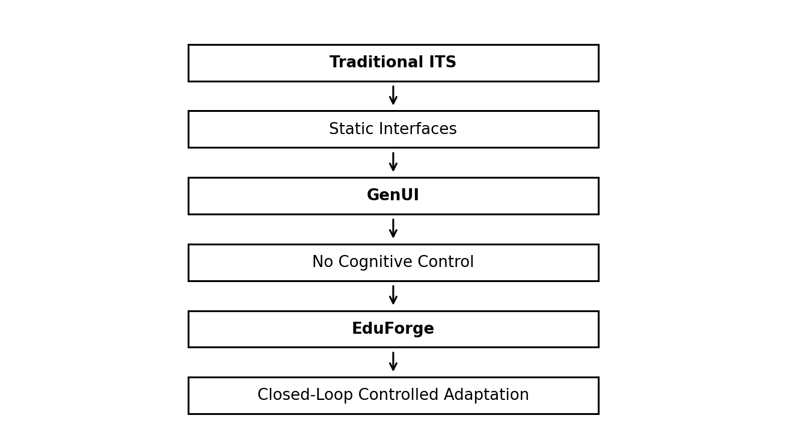
Fig. 2. Research gap flow from traditional ITS and GenUI limitations toward closed-loop controlled adaptation. (Source: Authors.)
IX. CONCLUSION
This survey traced the gap between the cognitive rigour of classical ITSs and the expressive flexibility of modern GenUI, and argued that closing it requires a closed-loop architecture in which a probabilistic learner model constrains the generation process. Retrieval-augmented approaches improve factual grounding but leave pedagogical alignment unaddressed. EduForge [15] demonstrates that the proposed BKT–GenUI loop is buildable with current tools; formal evaluation with real learners remains the immediate next step. The convergence of probabilistic learner modelling and constrained generative systems may define the next generation of truly adaptive educational technologies.
REFERENCES
[1] K. VanLehn, “The behavior of tutoring systems,” Int. J. Artif. Intell. Educ., vol. 16, no. 3, pp. 227–265, 2006.
[2] Y. Leviathan et al., “Generative UI: LLMs are Effective UI Generators,” arXiv preprint arXiv:2604.09577, Feb. 2026, doi: 10.48550/arXiv.2604.09577.
[3] S. Tu et al., “MAIC-UI: Making Interactive Courseware with Generative UI,” arXiv preprint arXiv:2604.25806, Apr. 2026, doi: 10.48550/arXiv.2604.25806.
[4] A. T. Corbett and J. R. Anderson, “Knowledge tracing: Modeling the acquisition of procedural knowledge,” User Model. User-Adapt. Interact., vol. 4, no. 4, pp. 253–278, 1994, doi: 10.1007/BF01099821.
[5] M. V. Yudelson, K. R. Koedinger, and G. J. Gordon, “Individualized Bayesian knowledge tracing models,” in Proc. 16th Int. Conf. Artif. Intell. Educ. (AIED), Springer, 2013, pp. 171–180, doi: 10.1007/978-3-642-39112-5_18.
[6] E. Kasneci et al., “ChatGPT for good? On opportunities and challenges of large language models for education,” Learn. Individ. Differ., vol. 103, p. 102274, Apr. 2023, doi: 10.1016/j.lindif.2023.102274.
[7] C. Piech et al., “Deep knowledge tracing,” in Adv. Neural Inf. Process. Syst. (NeurIPS), vol. 28, pp. 505–513, Dec. 2015, doi: 10.48550/arXiv.1506.05908.
[8] K. V. Deshpande et al., “Learning analytics powered teacher-facing dashboard to visualise, analyse students’ academic performance and give key DL (deep learning) supported key recommendations for performance improvement,” in 2023 Int. Conf. Adv. Technol. (ICONAT), IEEE, 2023, pp. 1–8, doi: 10.1109/ICONAT57137.2023.10080832.
[9] G. Poesia et al., “Synchromesh: Reliable code generation from pre-trained language models,” in Proc. Int. Conf. Learn. Represent. (ICLR), 2022, doi: 10.48550/arXiv.2201.11227.
[10] Y. Gao et al., “Retrieval-augmented generation for large language models: A survey,” arXiv preprint arXiv:2312.10997, Dec. 2023, doi: 10.48550/arXiv.2312.10997.
[11] Y. Cao, P. Jiang, and H. Xia, “Generative and Malleable User Interfaces with Generative and Evolving Task-Driven Data Model,” in Proc. CHI Conf. Hum. Factors Comput. Syst. (CHI ’25), Apr. 2025, Art. no. 686, doi: 10.1145/3706598.3713285.
[12] P. Lewis et al., “Retrieval-augmented generation for knowledge-intensive NLP tasks,” in Adv. Neural Inf. Process. Syst. (NeurIPS), vol. 33, pp. 9459–9474, 2020, doi: 10.48550/arXiv.2005.11401.
[13] S. Moore et al., “Empowering education with LLMs - The next-gen interface and content generation,” in Proc. Int. Conf. Artif. Intell. Educ. (AIED), Springer, 2023, pp. 32–37, doi: 10.1007/978-3-031-36336-8_4.
[14] K. V. Deshpande et al., “LTA (Learn to Analyse)—A teacher-centric analytical dashboard for illustrating students’ academic progress, backed by machine learning for informed performance enhancement recommendations,” in 2024 3rd Int. Conf. Innov. Techn
[15] O. P. Swami et al., “EduForge: AI-Powered Adaptive Learning Platform with BKT-Constrained Generative UI,” GitHub repository, 2025. [Online]. Available: https://github.com/omanandswami2005/EduForge-GenUI(Prototype Implementation).
[16] S. Pandey and G. Karypis, “A Self-Attentive Model for Knowledge Tracing,” in Proc. 12th Int. Conf. Educational Data Mining (EDM), 2019, pp. 384–389.

