Learner-State-Aware Generative User Interfaces: A Closed-Loop Control Architecture for Adaptive Learning Environments

Omanand Prashant Swami, Sanjana Shashikant Chavan, K. V. Deshpande, Pratik Rajendra Patil, Abhishek Ganesh Tirpude
Department of Computer Science and Business Systems, JSPM's Rajarshi Shahu College of Engineering, Pune, India
{opswami_csbs, sschavan_csbs, kvdeshpande_comp, prpatil_csbs, agtirpude_csbs}@jspmrscoe.edu.in

Abstract— Intelligent tutoring systems estimate what a learner knows but present a fixed interface, while generative user interfaces (GenUI) synthesize interfaces at runtime without any model of the learner. We propose a closed-loop architecture that couples the two. Bayesian Knowledge Tracing estimates mastery; a PID governor turns the mastery deficit into a structural complexity budget; a rule-based policy selects scaffolding; a planner fixes the layout closest to the budget; and a foundation model writes its content as a JSON component tree, with a fallback when schema or budget checks fail. We evaluate the architecture in silico on 1,000 synthetic learners from three archetypes, replayed through four arms. The closed loop keeps the rendered interface within 0.012 of the governor’s budget on average, against 0.131 for unconstrained GenUI and 0.123 for a rule-based baseline, with 3.5 times less jitter than unconstrained GenUI, which matches latent mastery slightly better but skips levels three times as often. Standard BKT saturates after long success runs, so a later streak of errors leaves the interface unchanged; a CUSUM lapse detector cuts overload in a forgetting cohort by 25%. In 300 single calls to the real model with the planner (not full learner sessions), 98.7% of raw outputs were within budget before any fallback, against 92% when the model also chose the layout. All claims concern algorithmic behavior; no learning gains are claimed.
Keywords— Generative user interfaces, Bayesian knowledge tracing, PID control, cognitive load, adaptive learning, simulation

- Introduction
Intelligent tutoring systems (ITS) have long modeled learners precisely. Knowledge tracing maintains a probability that a learner has mastered each knowledge component [1], and tutors built on it have been deployed at scale in mathematics [2], [3]. Their interface, however, is authored in advance: the learner model selects the next problem, not its presentation.
Generative user interfaces take the opposite position. A foundation model produces a task-specific interface for each request [4], including interactive courseware [5]. These systems are open loop: the model does not observe the learner’s state, and nothing bounds how complex the generated interface becomes.
Cognitive load theory explains why this matters. The same material can help a novice and hinder an expert (the expertise reversal effect) [6], and guidance should fade as competence grows [7], [8]. An adaptive interface therefore needs a learner model and a mechanism that holds its complexity to that model without the abrupt changes that make adaptive interfaces hard to use [9], [10].
BKT, PID control, layout search and constrained generation are each established; our contribution is their integration: to our knowledge, the first system in which a BKT mastery estimate, through feedback control, sets a structural budget that a runtime-generated interface must meet:
1) A closed loop in which BKT mastery drives a PID governor whose complexity budget is met by a layout planner and a generative model, with schema validation and a fallback.
2) A computable structural complexity metric over a component tree for linear-equation tasks, built from features linked to cognitive load.
3) An in-silico benchmark of 1,000 synthetic learners across four arms and ablations, including an analysis of BKT saturation after success runs and two remedies, with sensitivity analyses.
- Related Work
- Learner modeling: Bayesian Knowledge Tracing (BKT) models each knowledge component as a two-state hidden Markov model with prior, learning, guess and slip parameters [1]. Extensions individualize parameters [11], add forgetting [12] or contextualize guess and slip [13]; its fixed points are analyzed in [14]. Extended BKT stays competitive with logistic and deep models [12], [15]; its state is a probability that can serve directly as a control variable with interpretable parameters.
- Adaptive and generative interfaces: Model-based interface generation [16] adapts presentation to users, but adaptation has costs: unpredictable changes reduce usability [9], [10]. Recent GenUI systems let a large language model produce the interface itself [4], [5]. To our knowledge, none of these systems bounds the generated interface by a learner model: SUPPLE models devices and motor abilities, not knowledge; fading and staircase rules [8], [17] adjust task difficulty, not interface structure (Table I).
TABLE I
Prior approaches against the three properties combined here
Approach | Knowledge model | Generated interface | Bounded by learner state
Tracing tutors [1], [2] | yes | no | no
Adaptive fading [8] | yes | no | fixed rule
Model-based UI [16] | no | yes | no
LLM-based GenUI [4], [5] | no | yes | no
This work | yes | yes | yes

- Cognitive load and scaffolding: Cognitive load theory [18] attributes intrinsic load to element interactivity [19]. Worked examples help algebra novices [20] and should fade into problem solving [7], [8], as concrete representations should fade into symbolic ones [21]. The balance model aids early understanding of linear equations but fails with negative quantities [22], and misconceptions about equality persist [23], [24].
- Control and constrained generation: PID control with anti-windup and derivative filtering is standard practice [25], [26]. Constrained decoding guarantees well-formed model output [27], though schema-constrained output is not perfectly reliable in practice [28].
- Architecture
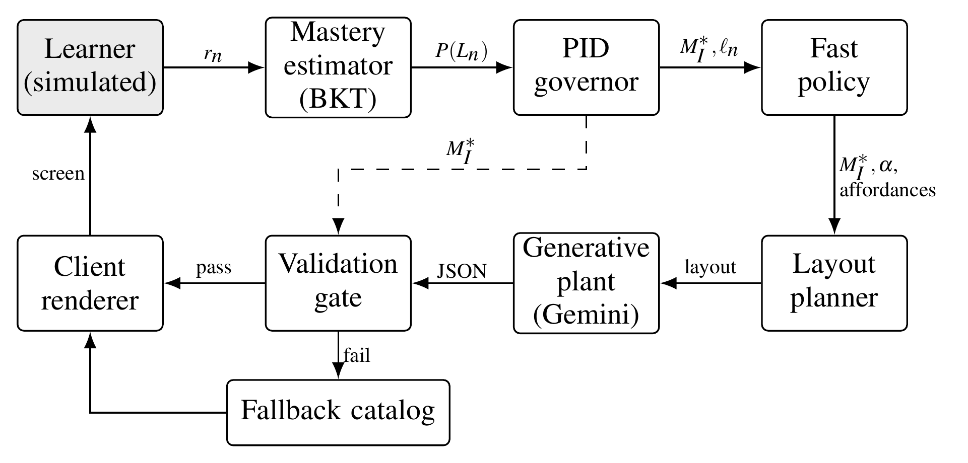
Fig. 1 The closed loop as deployed. The gate rechecks the budget (dashed); failing trees are replaced from the fallback catalog. The learner (shaded) is simulated here.
The loop has five stages (Fig. 1): a psychometric estimator, a complexity governor, a fast policy, a layout planner, and a generative plant whose output passes a validation gate before a deterministic client renders it.
- Mastery estimation
After response $r_{n}∈\{0,1\}$ the mastery estimate is updated by Bayes’ rule and the learning transition [1]. Writing $p=P(L_{n})$, $g=P(G)$, $s=P(S)$ and $\hat{p}=P(L_{n}∣r_{n})$,
$$\begin{aligned}P(L_{n}∣r_{n}=1)&=\frac{p(1−s)}{p(1−s)+(1−p)g}, (1) \\ P(L_{n}∣r_{n}=0)&=\frac{ps}{ps+(1−p)(1−g)}, (2) \\ P(L_{n+1})&=\hat{p} (1−P(F))+(1−\hat{p}) P(T), (3)\end{aligned}$$
where $P(F)=0$ gives standard BKT and $P(F)>0$ adds forgetting [12]. Default parameters are $P(L_{0})=0.15$, $P(T)=0.12$, $P(G)=0.20$, $P(S)=0.08$. They are design values, not fitted (sensitivity in Section V-C); they satisfy the bounds $P(G)<0.3$, $P(S)<0.1$ [1] and the non-degeneracy conditions $P(G)+P(S)<1$, $P(T)<1−P(S)/(1−P(G))$ [14].
- Complexity governor
The setpoint is the conventional mastery threshold $P^{*}=0.95$ [1], [29]. The tracking error is normalized on each side of the setpoint so that deficit and surplus have equal authority:
$$e_{n}=\left\{\begin{matrix}(P^{*}−P(L_{n}))/P^{*} & P(L_{n})≤P^{*} \\ (P^{*}−P(L_{n}))/(1−P^{*}) & P(L_{n})>P^{*}\end{matrix}\right. (4)$$
so that $e_{n}∈[−1,1]$. The control effort is
$$u_{n}=K_{p}e_{n}+K_{i}S_{n}+K_{d}D_{n}, (5)$$
with the clamped integral $S_{n}=clamp(S_{n−1}+e_{n}, −S_{max}, S_{max})$ for anti-windup [26] and the first-order filtered derivative $D_{n}=γ(e_{n}−e_{n−1})+(1−γ)D_{n−1}$ [25]. An inverted logistic maps effort to the complexity budget,
$$M_{I}^{*}=(1+e^{ku_{n}})^{−1}, (6)$$
which is quantized into four levels $ℓ_{n}=min(4,1+⌊4M_{I}^{*}⌋)$. A hysteresis deadband $Δ_{h}$ commits a new budget only when it differs from the last committed budget by at least $Δ_{h}$. The governor steps once per response (unit sample time) from $S_{0}=D_{0}=0$ with $e_{−1}=e_{0}$, so the first step has no derivative kick, and its first budget is always committed.
- Gain selection: Classical tuning rules [30], [31] assume an identified plant, but here the interface does not alter simulated responses (Section IV). Instead, $K_{p}$, $K_{i}$, $K_{d}$, $γ$, $S_{max}$ and $Δ_{h}$ were selected by minimizing the cost $ITAE+J$ (Section IV) [32] on a separate 1,000-learner tuning cohort; all reported results use a disjoint test cohort. A random search of 200 uniform samples over $K_{p}∈[0.25,2.5]$, $K_{i}∈[0,0.4]$, $K_{d},γ∈[0,1]$ ($γ≥0.05$), $S_{max}∈[1,6]$, $Δ_{h}∈[0.02,0.15]$ selected $K_{p}=0.865$, $K_{i}=0.377$, $K_{d}=0.672$, $γ=0.398$, $S_{max}=1.253$ and $Δ_{h}=0.141$. The cost surface is flat: the selected point scores 0.104 on the tuning cohort against 0.110 for hand-set initial values, which rank 22nd of 201. The logistic slope is $k=ln19/(K_{p}+K_{i}S_{max})=2.202$, so that the effort range $±(K_{p}+K_{i}S_{max})$ maps to $[0.05,0.95]$.
- Fast policy
A fast policy maps $(P(L_{n}),M_{I}^{*},ℓ_{n},\text{recent errors})$ to discrete affordances: scaffolding mode (worked example, guided scaffold, open symbolic), whether to show the balance-scale manipulative, whether hints are enabled, and an instructional density limit. The policy is deterministic and rule-based in every reported result. An open-weight decision model [33], evaluated zero-shot, took 1.32 s per decision (median, CPU) and chose a worked example in all 200 test states, so it is not used.
- Layout planner, generative plant and validation gate
The planner turns the budget into a layout. The policy fixes the abstraction level $α$; the planner then enumerates every admissible layout with 1–8 interactive elements, 0–3 hint tiers and nesting depth 1–4 (at most 102 valid layouts) and picks the one whose $M_{I}$ is closest to $M_{I}^{*}$. It keeps a requested worked example when that stays within $ε$; ties go to fewer elements, then shallower nesting. The plant, Gemini 3.7 Flash served through Vertex AI, receives this layout with the policy decision and the equation and writes the content as a JSON component tree. In the original design (free mode) the plant also chose the layout; we measure both (Table III). Nodes are drawn from a closed set of six components (balance scale, worked step, operation pad, symbolic workspace, hint accordion, verification plane). The client renders these components directly and never executes generated code. Each emission is parsed against the schema; if parsing fails, or if $|M_{I}−M_{I}^{*}|>ε$ with $ε=0.05$, a precompiled fallback tree is rendered instead: the planner’s layout for the nearest of 41 budgets 1/40 apart, within $ε$ for every budget and policy decision (worst 0.049). A web client renders the trees for inspection (Fig. 2); the benchmark does not use it.
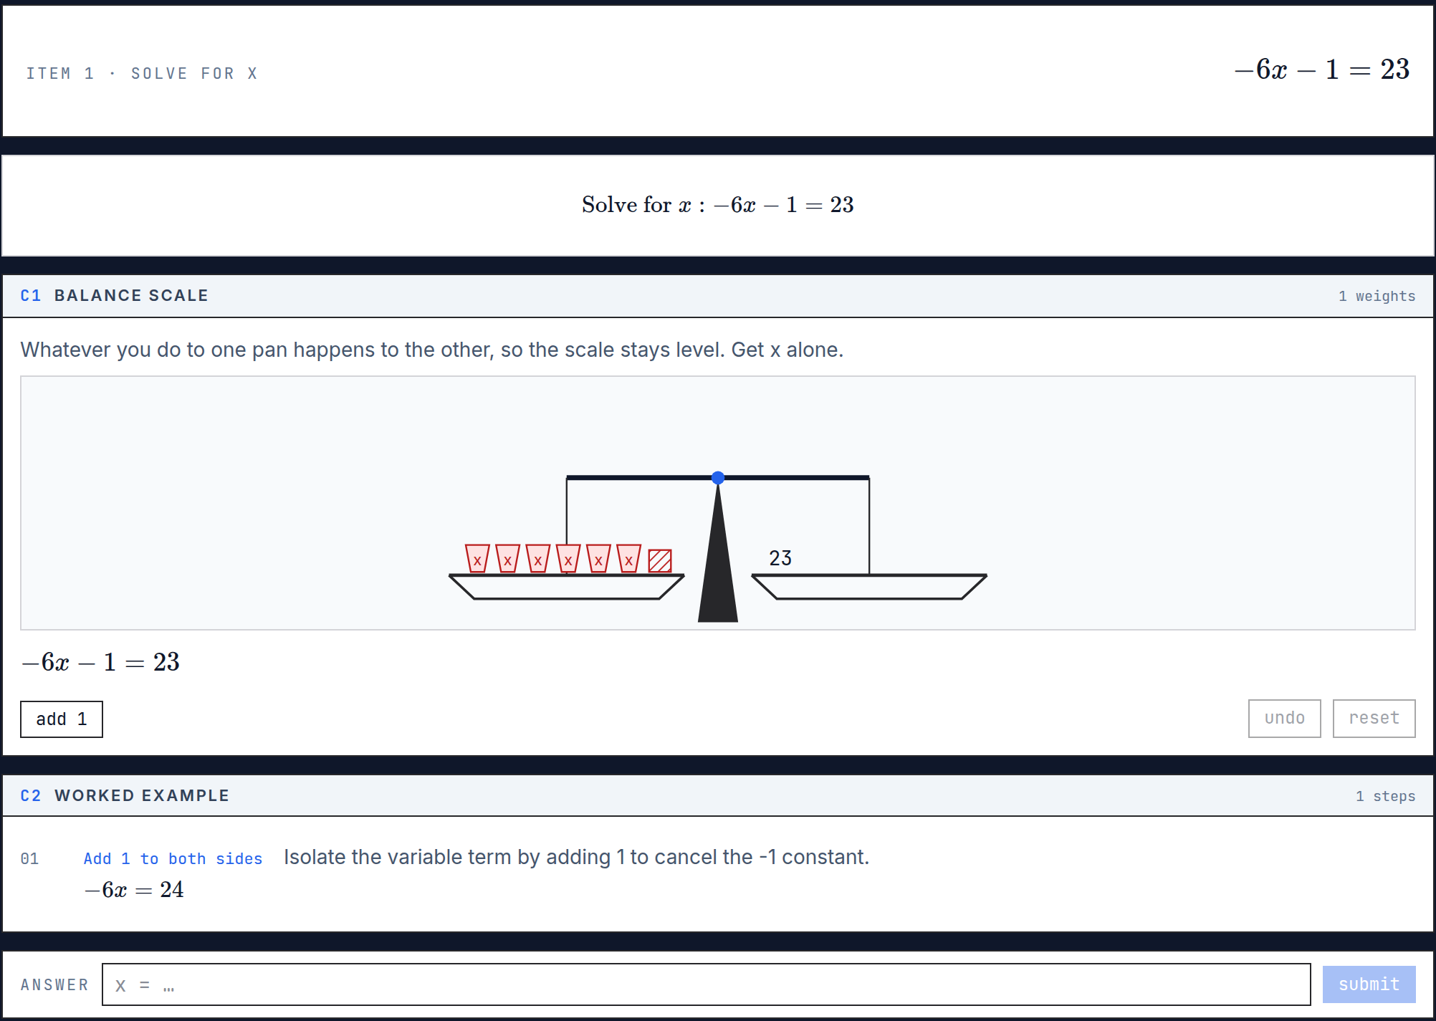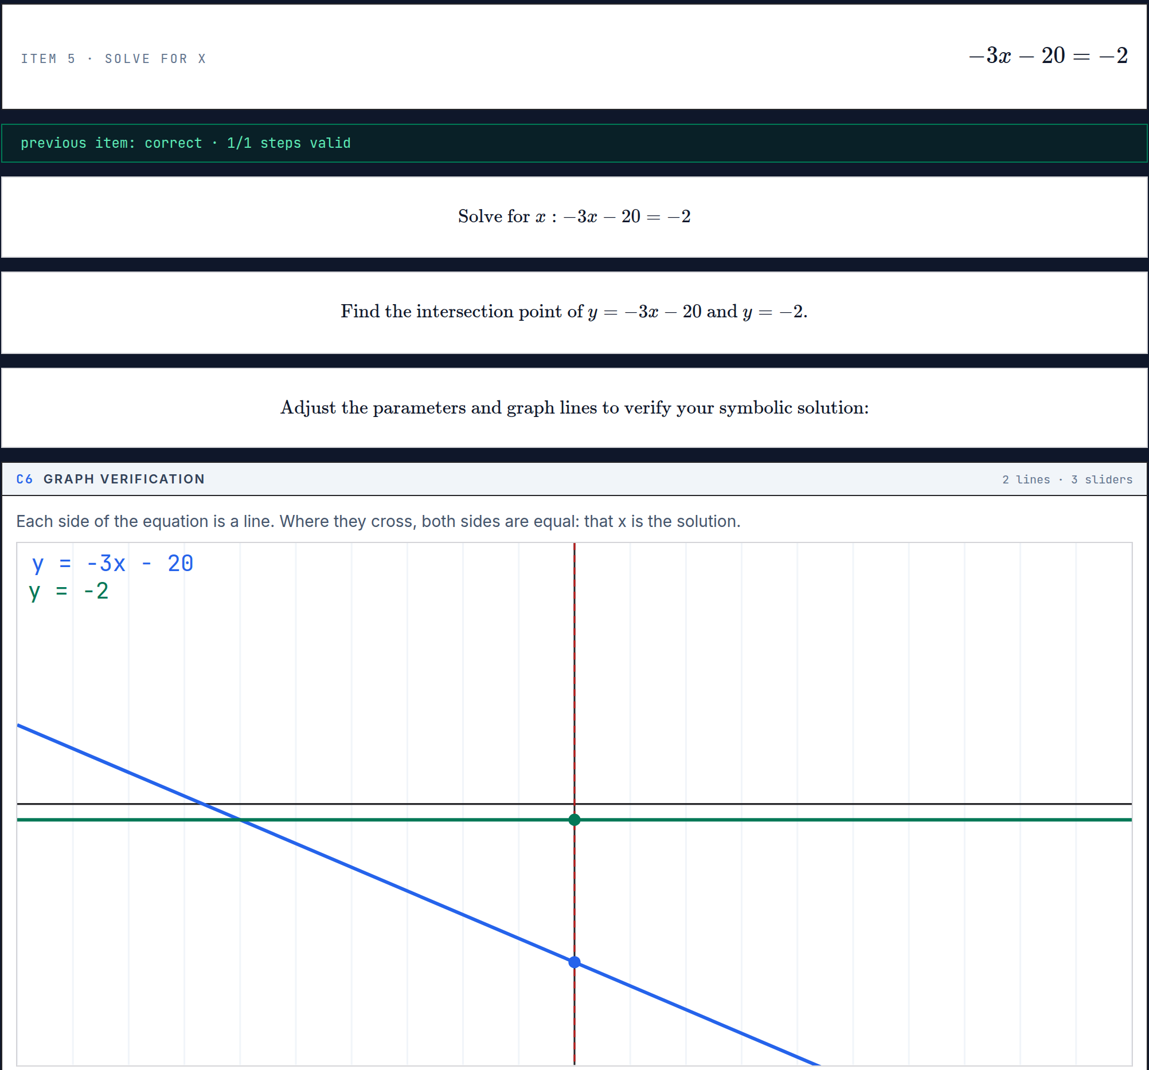
Fig. 2 Screens written by Gemini 3.7 Flash in guided mode; both passed the gate. Left: level 1, balance scale with a worked step ($M_{I}^{*}=0.091$, $M_{I}=0.111$). Right: level 4, graph verification ($M_{I}^{*}=0.903$, $M_{I}=0.905$).
- Structural complexity metric
For a tree with $ρ$ interactive elements, abstraction level $α$ and nesting depth $δ$,
$$M_{I}=w_{1}\frac{ρ−1}{7}+w_{2}\frac{α−1}{3}+w_{3}\frac{δ−1}{3}, (7)$$
with $ρ∈[1,8]$ and $α,δ∈[1,4]$. Each feature has a basis in prior work: element interactivity raises load [19] and display density is a classic complexity measure [34]; the abstraction ladder from balance scale to operation pad to symbolic workspace follows concreteness fading [21]; and deeper structures cost users more [35]. Placing the Cartesian plane at the top of the ladder is our design choice. With no data to fit weights, we use equal weights $w_{i}=1/3$, which are robust in that setting [36], and test sensitivity to the weights (Section V). Entropy measures such as XAOS [37] score rendered screens; $M_{I}$ scores the tree before rendering, as the gate requires.
- Method
- Synthetic learners
Simulated learners are an established way to test instructional designs before human studies [38], [39], and BKT-generated data have been used to evaluate mastery assessment [40]. Each learner is a two-state HMM whose parameters are drawn uniformly from archetype ranges (Table II). Novice and guesser ranges exceed the bounds of [1] by design but respect [14]. The cohort has 1,000 learners (300/400/300) with 40 items each. Responses are sampled once per learner and replayed unchanged through every arm (paired design). The interface therefore does not influence the simulated responses: the benchmark measures controller behavior, not learning.
TABLE II
Learner archetypes (uniform parameter ranges).
Archetype | $P(L_{0})$ | $P(T)$ | $P(G)$ | $P(S)$
Struggling novice | .02–.08 | .03–.07 | .10–.20 | .20–.30
Inconsistent guesser | .05–.20 | .10–.20 | .15–.40 | .08–.30
Fast master | .15–.30 | .30–.40 | .15–.25 | .01–.03

- Arms: All arms see the same responses and BKT estimate. (1) Static: a fixed level-2 interface. (2) Unconstrained GenUI: the plant sets its own complexity to the estimate plus Gaussian noise ($σ=0.15$); only the schema is checked. (3) Rule-based: step up after three consecutive correct responses and down after two consecutive errors, an up-down rule in the spirit of [17]. Arms 1 and 3 render catalog trees. (4) Closed loop: the full architecture. Ablations remove the derivative filter, remove anti-windup, and add a one-level slew limit.
- Plant model in the benchmark: The benchmark replaces the foundation model with a surrogate that compiles the planner’s layout and injects faults: with probability 0.15 it drifts off budget, and with probability 0.03 it emits malformed output (e.g., truncated JSON, unknown component). These rates were set before the real model was measured. The unconstrained arm uses the same surrogate without the budget check.
We measured the real model in free mode, which tests the model alone, and in guided mode, the deployed configuration with the planner. Each mode received 300 requests (JSON mode without a response schema, thinking level low, temperature 0.4, 30 s timeout) with budgets uniform on $[0.02,0.98]$, scored by the same gate (Table III).
TABLE III
Gemini 3.7 Flash, 300 calls per mode.
 | Free | Guided
Transport failures (HTTP error, timeout) | 6 | 4
Content-malformed, of completed calls | 3.4% | 0%
Off budget, of valid trees | 2.8% | 0%
Raw output within budget, of all calls | 92.0% | 98.7%
Median $|M_{I}−M_{I}^{*}|$ of valid trees | 0.012 | 0.007
Latency of completed calls, median / p95 | 7.7 / 18.6 s | 2.7 / 5.1 s

Free-mode failures lacked an interactive element (10/294) or missed the budget (8/284, mostly level 1); guided-mode failures were all in transport. The surrogate’s 3% malformed rate thus matches free mode, and its 15% drift rate is a stress setting. Compliance counts raw outputs over all calls; after the gate, every rendered tree met the budget.
- Metrics: Constraint error $ΔM=|M_{I}−M_{ref}^{*}|$ is measured against the budget the closed-loop governor commits for the same responses, so that all arms share one reference; “within $ε$” is the share of steps with $ΔM≤0.05$. Interface jitter is J=1N−1n​|MI(n)−MI(n−1)|, and a skip is a change of two or more levels between consecutive items. Jitter operationalizes the stability concern of [9]; the formula is ours. Recovery time is the number of items after a streak of five or more errors until the level returns to its pre-streak value. Fallback rate is the share of steps rendered from the fallback catalog. Because the simulator knows the learner’s latent state, we also report overload (level 3 or 4 shown while the skill is not known), underload (level 1 or 2 shown while it is known) and an ITAE-weighted mismatch n​(n+1)mn/n​(n+1) [32], where $m_{n}$ marks either case. These are level mismatches, not measured load.
- Results
All numbers come from one run on the test cohort (seed 20261003; tuning seed 20261004), with normal-approximation 95% CIs over 1,000 learners. The CIs reflect variation across learners in this run. Over ten independent test seeds the ranking of arms never changed and the closed loop’s $ΔM$ stayed within 0.0118–0.0122.
TABLE IV
Main results and ablations on the test cohort. $ΔM$ and “within $ε$” are measured against the closed-loop reference budget; every closed-loop variant meets its own budget at every step. Overload, underload and ITAE use the latent learner state and exist only in simulation. Fallback rates follow from the surrogate’s fault rates.
Arm | $ΔM$ (95% CI) | Within $ε$ | Jitter $J$ | Skips/run | Overload | Underload | ITAE | Fallback
Static | 0.426 (0.422–0.430) | 0.004 | 0.000 | 0.00 | 0.000 | 0.800 | 0.892 | –
Unconstrained GenUI | 0.131 (0.128–0.134) | 0.321 | 0.123 | 2.06 | 0.024 | 0.054 | 0.043 | 0.030
Rule-based | 0.123 (0.119–0.128) | 0.596 | 0.025 | 0.00 | 0.000 | 0.245 | 0.180 | –
Closed loop | 0.0122 (0.0119–0.0124) | 1.000 | 0.035 | 0.67 | 0.002 | 0.121 | 0.073 | 0.154
no derivative filter | 0.031 (0.030–0.033) | 0.811 | 0.044 | 1.19 | 0.002 | 0.124 | 0.076 | 0.156
no anti-windup | 0.107 (0.102–0.112) | 0.549 | 0.024 | 0.42 | 0.001 | 0.217 | 0.174 | 0.159
one-level slew limit | 0.025 (0.023–0.026) | 0.875 | 0.034 | 0.02 | 0.002 | 0.121 | 0.073 | 0.153

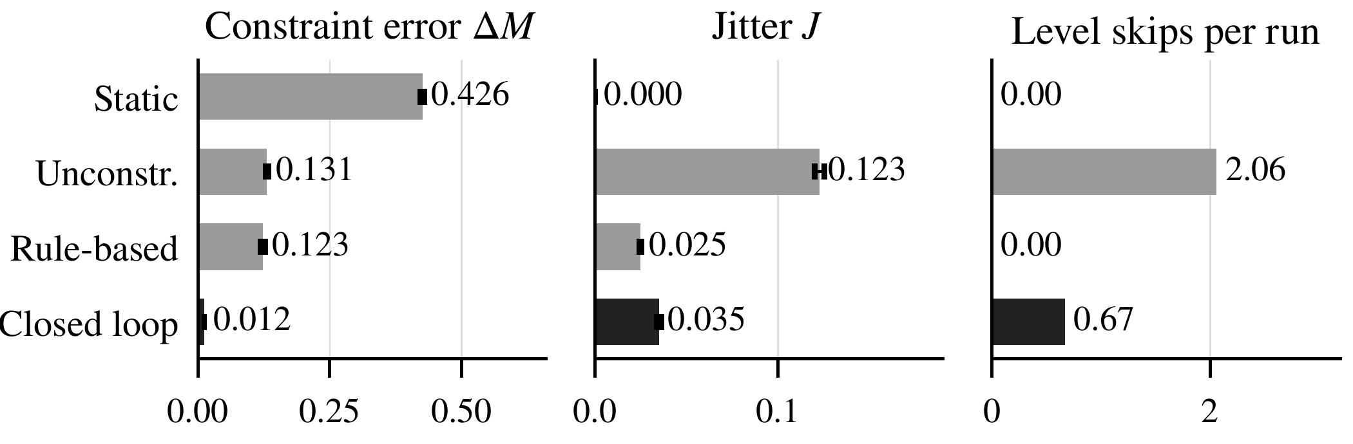
Fig. 3 Main comparison on the test cohort (means, 95% CIs); closed loop dark.
- Main comparison
The closed loop keeps the rendered interface within 0.012 of its budget on average (Table IV, Fig. 3), against 0.131 and 0.123 for unconstrained GenUI and the rule-based arm. Every rendered tree is within $ε$, partly by construction: the generator’s own output met the budget on 84.6% of steps, and the gate replaced the other 15.4% from the fallback catalog. The closed loop’s jitter (0.035) is 3.5 times lower than that of unconstrained GenUI (0.123), which also skips levels 2.06 times per run against 0.67. The rule-based arm is smoother still (0.025, no skips), because it moves one level at a time. Against the latent learner state, the picture is mixed. Unconstrained GenUI has the lowest ITAE mismatch (0.043 against 0.073) and the least underload (5.4% of steps against 12.1%), but shows an abstract interface to a learner who does not know the skill twelve times as often (2.4% against 0.2%). After streaks of five or more errors that lowered the level, the closed loop regained its pre-streak level in 34 of 51 cases (median 5 items), the rule-based arm in 9 of 19 (median 12).
- Ablations
Removing the derivative filter raises jitter from 0.035 to 0.044 and nearly doubles level skips (1.19 per run). Removing anti-windup lets the integral grow without bound: underload rises from 12.1% to 21.7%, only 84% of learners reach level 4 against 95%, and median recovery after an error streak grows from 5 to 14 items. A one-level slew limit removes nearly all skips (0.02 per run) and leaves the ground-truth measures unchanged.
- Sensitivity
Changing each controller parameter by $±50\%$ raised the cost ($ITAE+J$) from 0.108 to at most 0.118, except $1.5Δ_{h}$, which lowered it to 0.104 but more than doubled level skips. For the metric weights, the closed loop’s $ΔM$ stays between 0.007 and 0.017 under equal weights, the initial $0.40/0.35/0.25$ split and three single-feature-heavy splits ($0.6/0.2/0.2$). Dropping abstraction or depth roughly doubles it (0.023 and 0.022) while keeping more than 99% of steps within $ε$. Dropping element density breaks the loop: fallbacks rise to 84% and only 18% of screens are within $ε$. Changing each BKT parameter by $±50\%$ kept every step within $ε$, $ΔM$ between 0.010 and 0.017, jitter between 0.034 and 0.041 and fallbacks at 15–16%. The parameters mainly shift when the interface escalates: $P(T)$ and $P(G)$ move ITAE between 0.048 and 0.115, and skips rise to at most 1.20 per run.
- BKT saturation and lapse handling
Under correct responses the BKT estimate converges to a stable fixed point at one [14]. With the default parameters the estimate exceeds $1−{10}^{−6}$ after ten correct responses and five subsequent errors lower it only to about $0.98$; after 24 correct responses it equals $1.0$ in double precision and no further evidence can lower it. The interface then stays at its highest level through a streak of errors. We compare two remedies: forgetting, $P(F)>0$ [12], and a CUSUM detector [41] on the log-likelihood ratio between “not known” and the tracker’s prediction, which resets the estimate to 0.5 when the sum exceeds $h=6.5$. It accumulates only when a confident estimate is contradicted, so isolated slips are absorbed; unlike neural forgetting models, it needs no training data. Forgetting uses $P(F)=0.02$.
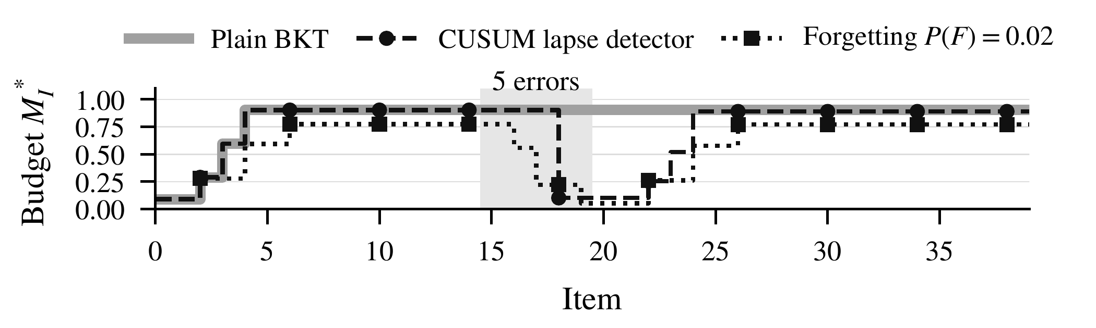
Fig. 4 Scripted probe: 15 correct responses, five errors, then correct again. With plain BKT the estimate is saturated and the budget never moves.
In a scripted probe with fifteen correct responses followed by five errors (Fig. 4), the plain closed loop never lowers the interface; the CUSUM variant drops a level 3 items after the streak begins and forgetting after 1. To test this at scale, a second cohort of 1,000 learners can forget the skill with probability 0.02–0.06 per item. There the plain closed loop shows an abstract interface to a learner who does not know the skill on 7.6% of steps. The CUSUM detector lowers this to 5.6% ($−25\%$) at the cost of higher jitter (0.052 against 0.042) and an almost unchanged ITAE mismatch (0.189 against 0.184). Forgetting lowers overload further, to 3.0%, but underloads on 25.3% of steps against 12.8%, raises ITAE to 0.273 and lets only 80% of learners reach level 4. Neither remedy dominates; weighting recent responses [42] is left for future work.
- Discussion and Limitations
The benchmark tests whether the controller does what it is designed to do; it does not test whether learners benefit. Because simulated responses do not depend on the interface, the loop is closed only through the mastery estimate, not through the learner. $M_{I}$ is a structural proxy that has not been validated against measured or perceived load, for which instruments exist [43]; the results show structural complexity regulation, not reduced cognitive load. BKT parameters are design values rather than fits to tutor data. Long error streaks may reflect misconceptions rather than slips [24]; the controller does not distinguish these. The real model was measured on single calls, not full trajectories. Its latency (median 7.7 s free, 2.7 s guided) calls for prefetching or caching. We tested one domain, linear equations.
- Conclusion
We coupled a learner model to a generative interface through a PID governor, a layout planner and a validation gate, and tested the loop in simulation. The governor’s budget is met at every step, with the gate replacing the 15.4% of generated trees that miss it, and the interface changes 3.5 times less than an unconstrained generator while rarely showing abstract screens to simulated learners who have not mastered the skill. Anti-windup and the derivative filter each matter, and a slew limit removes level skips. A CUSUM lapse detector restores BKT’s reaction after long success runs at a modest cost in jitter. In 300 single real calls, 98.7% of raw outputs met the budget with the planner and 92% without it. Next steps are full real-model trajectories, a learned fast policy and a study with learners. We claim structural budget regulation in simulation, not learning gains or reduced cognitive load.
Code and Data Availability
The engine, simulation harness, benchmark results and the sources of this manuscript are openly available at https://github.com/omanandswami2005/closed-loop-genui-research-implementation.
References
- A. T. Corbett and J. R. Anderson, “Knowledge tracing: Modeling the acquisition of procedural knowledge,” User Modeling and User-Adapted Interaction, vol. 4, no. 4, pp. 253–278, 1995. [Online]. Available: https://doi.org/10.1007/BF01099821
- S. Ritter, J. R. Anderson, K. R. Koedinger, and A. Corbett, “Cognitive Tutor: Applied research in mathematics education,” Psychonomic Bulletin & Review, vol. 14, no. 2, pp. 249–255, 2007. [Online]. Available: https://doi.org/10.3758/BF03194060
- K. VanLehn, “The relative effectiveness of human tutoring, intelligent tutoring systems, and other tutoring systems,” Educational Psychologist, vol. 46, no. 4, pp. 197–221, 2011. [Online]. Available: https://doi.org/10.1080/00461520.2011.611369
- Y. Leviathan, D. Valevski, M. Kalman, D. Lumen, E. Segalis, E. Molad, S. Pasternak, V. Natchu, V. Nygaard, V. Srinivasan, J. Manyika, and Y. Matias, “Generative UI: LLMs are effective UI generators,” arXiv:2604.09577, 2026. [Online]. Available: https://arxiv.org/abs/2604.09577
- S. Tu, Y. Li, K. Chen, S. Zhang, J. Yu, D. Zhang-Li, L. Hou, J. Li, Y. Zhang, H. Liu et al., “MAIC-UI: Making interactive courseware with generative UI,” arXiv:2604.25806, 2026.
- S. Kalyuga, P. Ayres, P. Chandler, and J. Sweller, “The expertise reversal effect,” Educational Psychologist, vol. 38, no. 1, pp. 23–31, 2003. [Online]. Available: https://doi.org/10.1207/S15326985EP3801_4
- A. Renkl and R. K. Atkinson, “Structuring the transition from example study to problem solving in cognitive skill acquisition: A cognitive load perspective,” Educational Psychologist, vol. 38, no. 1, pp. 15–22, 2003. [Online]. Available: https://doi.org/10.1207/S15326985EP3801_3
- R. J. C. M. Salden, V. Aleven, R. Schwonke, and A. Renkl, “The expertise reversal effect and worked examples in tutored problem solving,” Instructional Science, vol. 38, no. 3, pp. 289–307, 2010. [Online]. Available: https://doi.org/10.1007/s11251-009-9107-8
- K. Z. Gajos, K. Everitt, D. S. Tan, M. Czerwinski, and D. S. Weld, “Predictability and accuracy in adaptive user interfaces,” in Proceedings of the SIGCHI Conference on Human Factors in Computing Systems (CHI). ACM, 2008, pp. 1271–1274. [Online]. Available: https://doi.org/10.1145/1357054.1357252
- L. Findlater and J. McGrenere, “A comparison of static, adaptive, and adaptable menus,” in Proceedings of the SIGCHI Conference on Human Factors in Computing Systems (CHI). ACM, 2004, pp. 89–96. [Online]. Available: https://doi.org/10.1145/985692.985704
- Z. A. Pardos and N. T. Heffernan, “Modeling individualization in a Bayesian networks implementation of knowledge tracing,” in User Modeling, Adaptation, and Personalization (UMAP 2010), ser. Lecture Notes in Computer Science. Springer, 2010, pp. 255–266. [Online]. Available: https://doi.org/10.1007/978-3-642-13470-8_24
- M. Khajah, R. V. Lindsey, and M. C. Mozer, “How deep is knowledge tracing?” in Proceedings of the 9th International Conference on Educational Data Mining (EDM 2016), 2016. [Online]. Available: https://arxiv.org/abs/1604.02416
- R. S. J. d. Baker, A. T. Corbett, and V. Aleven, “More accurate student modeling through contextual estimation of slip and guess probabilities in Bayesian knowledge tracing,” in Intelligent Tutoring Systems (ITS 2008), ser. Lecture Notes in Computer Science. Springer, 2008, pp. 406–415. [Online]. Available: https://doi.org/10.1007/978-3-540-69132-7_44
- B. van de Sande, “Properties of the Bayesian knowledge tracing model,” Journal of Educational Data Mining, vol. 5, no. 2, pp. 1–10, 2013. [Online]. Available: https://jedm.educationaldatamining.org/index.php/JEDM/article/view/35
- R. Pelánek, “Bayesian knowledge tracing, logistic models, and beyond: An overview of learner modeling techniques,” User Modeling and User-Adapted Interaction, vol. 27, no. 3–5, pp. 313–350, 2017. [Online]. Available: https://doi.org/10.1007/s11257-017-9193-2
- K. Z. Gajos, D. S. Weld, and J. O. Wobbrock, “Automatically generating personalized user interfaces with Supple,” Artificial Intelligence, vol. 174, no. 12–13, pp. 910–950, 2010. [Online]. Available: https://doi.org/10.1016/j.artint.2010.05.005
- H. Levitt, “Transformed up-down methods in psychoacoustics,” The Journal of the Acoustical Society of America, vol. 49, no. 2B, pp. 467–477, 1971. [Online]. Available: https://doi.org/10.1121/1.1912375
- J. Sweller, “Cognitive load during problem solving: Effects on learning,” Cognitive Science, vol. 12, no. 2, pp. 257–285, 1988. [Online]. Available: https://doi.org/10.1207/s15516709cog1202_4
- ——, “Element interactivity and intrinsic, extraneous, and germane cognitive load,” Educational Psychology Review, vol. 22, no. 2, pp. 123–138, 2010. [Online]. Available: https://doi.org/10.1007/s10648-010-9128-5
- J. Sweller and G. A. Cooper, “The use of worked examples as a substitute for problem solving in learning algebra,” Cognition and Instruction, vol. 2, no. 1, pp. 59–89, 1985. [Online]. Available: https://doi.org/10.1207/s1532690xci0201_3
- E. R. Fyfe, N. M. McNeil, J. Y. Son, and R. L. Goldstone, “Concreteness fading in mathematics and science instruction: A systematic review,” Educational Psychology Review, vol. 26, no. 1, pp. 9–25, 2014. [Online]. Available: https://doi.org/10.1007/s10648-014-9249-3
- J. Vlassis, “The balance model: Hindrance or support for the solving of linear equations with one unknown,” Educational Studies in Mathematics, vol. 49, no. 3, pp. 341–359, 2002. [Online]. Available: https://doi.org/10.1023/A:1020229023965
- C. Kieran, “Concepts associated with the equality symbol,” Educational Studies in Mathematics, vol. 12, no. 3, pp. 317–326, 1981. [Online]. Available: https://doi.org/10.1007/BF00311062
- J. L. Booth, C. Barbieri, F. Eyer, and E. J. Paré-Blagoev, “Persistent and pernicious errors in algebraic problem solving,” The Journal of Problem Solving, vol. 7, no. 1, 2014. [Online]. Available: https://doi.org/10.7771/1932-6246.1161
- K. J. Åström and T. Hägglund, Advanced PID Control. Research Triangle Park, NC: ISA – The Instrumentation, Systems, and Automation Society, 2006.
- K. J. Åström and L. Rundqwist, “Integrator windup and how to avoid it,” in 1989 American Control Conference. IEEE, 1989, pp. 1693–1698. [Online]. Available: https://doi.org/10.23919/ACC.1989.4790464
- B. T. Willard and R. Louf, “Efficient guided generation for large language models,” arXiv:2307.09702, 2023. [Online]. Available: https://arxiv.org/abs/2307.09702
- S. Geng, H. Cooper, M. Moskal, S. Jenkins, J. Berman, N. Ranchin, R. West, E. Horvitz, and H. Nori, “JSONSchemaBench: A rigorous benchmark of structured outputs for language models,” arXiv:2501.10868, 2025. [Online]. Available: https://arxiv.org/abs/2501.10868
- J. Zhang, K. Vanacore, R. S. Baker, N. Ch, C. Mills, and O. Henkel, “How much mastery is enough mastery? The relationship between mastery in a lesson and the performance on the subsequent lesson,” in Proceedings of the 18th International Conference on Educational Data Mining (EDM 2025), 2025. [Online]. Available: https://doi.org/10.5281/zenodo.15870292
- J. G. Ziegler and N. B. Nichols, “Optimum settings for automatic controllers,” Transactions of the ASME, vol. 64, no. 8, pp. 759–765, 1942. [Online]. Available: https://doi.org/10.1115/1.4019264
- S. Skogestad, “Simple analytic rules for model reduction and PID controller tuning,” Journal of Process Control, vol. 13, no. 4, pp. 291–309, 2003. [Online]. Available: https://doi.org/10.1016/S0959-1524(02)00062-8
- D. Graham and R. C. Lathrop, “The synthesis of ‘optimum’ transient response: Criteria and standard forms,” Transactions of the American Institute of Electrical Engineers, Part II: Applications and Industry, vol. 72, no. 5, pp. 273–288, 1953. [Online]. Available: https://doi.org/10.1109/TAI.1953.6371346
- Convai Innovations, “Laya: Open-weight decision model,” Model card, https://huggingface.co/convaiinnovations/laya, 2026.
- T. S. Tullis, “The formatting of alphanumeric displays: A review and analysis,” Human Factors, vol. 25, no. 6, pp. 657–682, 1983. [Online]. Available: https://doi.org/10.1177/001872088302500604
- J. I. Kiger, “The depth/breadth trade-off in the design of menu-driven user interfaces,” International Journal of Man-Machine Studies, vol. 20, no. 2, pp. 201–213, 1984. [Online]. Available: https://doi.org/10.1016/S0020-7373(84)80018-8
- R. M. Dawes, “The robust beauty of improper linear models in decision making,” American Psychologist, vol. 34, no. 7, pp. 571–582, 1979. [Online]. Available: https://doi.org/10.1037/0003-066X.34.7.571
- C. Stickel, M. Ebner, and A. Holzinger, “The XAOS metric – understanding visual complexity as measure of usability,” in HCI in Work and Learning, Life and Leisure (USAB 2010), ser. Lecture Notes in Computer Science, vol. 6389. Springer, 2010, pp. 278–290. [Online]. Available: https://doi.org/10.1007/978-3-642-16607-5_18
- K. VanLehn, S. Ohlsson, and R. Nason, “Applications of simulated students: An exploration,” Journal of Artificial Intelligence in Education, vol. 5, no. 2, pp. 135–175, 1994.
- T. Käser and G. Alexandron, “Simulated learners in educational technology: A systematic literature review and a Turing-like test,” International Journal of Artificial Intelligence in Education, vol. 34, no. 2, pp. 545–585, 2024. [Online]. Available: https://doi.org/10.1007/s40593-023-00337-2
- S. E. Fancsali, T. Nixon, and S. Ritter, “Optimal and worst-case performance of mastery learning assessment with Bayesian knowledge tracing,” in Proceedings of the 6th International Conference on Educational Data Mining (EDM 2013), 2013.
- E. S. Page, “Continuous inspection schemes,” Biometrika, vol. 41, no. 1/2, pp. 100–115, 1954. [Online]. Available: https://doi.org/10.2307/2333009
- A. Galyardt and I. Goldin, “Move your lamp post: Recent data reflects learner knowledge better than older data,” Journal of Educational Data Mining, vol. 7, no. 2, pp. 83–108, 2015. [Online]. Available: https://doi.org/10.5281/zenodo.3554672
- J. Leppink, F. Paas, C. P. M. Van der Vleuten, T. Van Gog, and J. J. G. Van Merriënboer, “Development of an instrument for measuring different types of cognitive load,” Behavior Research Methods, vol. 45, no. 4, pp. 1058–1072, 2013. [Online]. Available: https://doi.org/10.3758/s13428-013-0334-1

