LED DESK LAMP
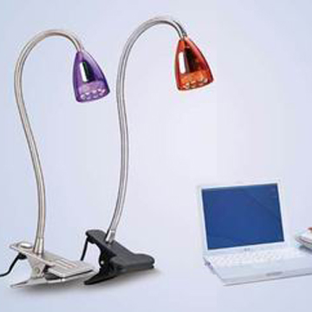
Product Name:KT606C
Product Infomation
Power Supply：100-240V- AC, 50-60Hz
Input Voltage: 12V-DC
Light Source：9pcs ￠5 LED
CTN: 31 x 36 x 39 CM
QTY: 12 pcs


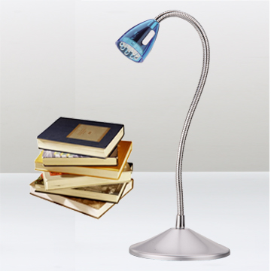

Product Name:KT606
Product Infomation
Power Supply：100-240V- AC, 50-60Hz
Input Voltage: 12V-DC
Light Source：9pcs ￠5 LED
CTN: 31 x 36 x 39 CM
QTY: 12 pcs



Product Name:KT610 3.0W
Product Infomation
Power Supply:100-240V ~AC,50/60Hz
Input Voltage:12V-DC 180mA
Light Source:36pcs Φ5LED
Power(W):3.0
Flux(lx):1100@0.4m
Color Temperature:3000K/6500K
CRI＞80
CTN:35x43x63.5CM
QTY:12pcs
Finish:Silver,Blue,Black,Red,Light Green/Blue/Pink




Product Name:KT612 3.0W
Product Infomation
Power supply: 100-240V~AC, 50/60Hz
Input Voltage: 12V-DC 180mA
Light Source: 36pcs Φ5 LED
Power(W) :3.0
Flux(lx):950@0.4m
Color Temperature : 3300K/ 6500K
CTN: 41x31x54.5 CM
Qty: 12PCS
Finish:Silver,Blue,Black,Red,Light Green/Blue/Pink




Product Name:KT625 5.0W
Product Infomation
Power Supply：100-240V- AC, 50-60Hz
Input Voltage: 5V-DC
Light Source：50pcs ￠5 LED
Power(W)： 5.0
Flux( lx): 1050 @ 0.4m
Color Temperature: 3300K/6500K
CRI: > 80.
CTN:44.5 x 45 x 53.5CM
QTY: 6 pcs
Color: Black,Green,Red,Yellow,Blue,Silver,Orange

Fluorescent desk lamp
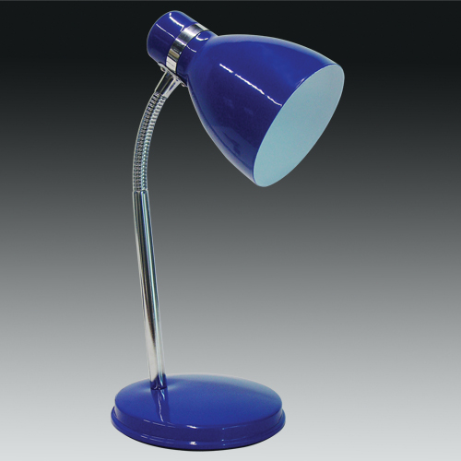

Product Name:KT 042 E14/E27 40W
Product Infomation
Optional Voltage:120/230V
Ctn(cm)62x47x27
Qty(pcs):12
G.w.(kg):14
N.W.(kg): 12



Product Name:KT068A 11W PL G23
Product Infomation
Input Voltage：100-240V- AC, 50-60Hz
Built-in Electronic Ballast
Black Metal Arms.
CTN:40.5 x 22 x 44 CM
QTY: 4 pcs
Finish: Sliver. Black. White



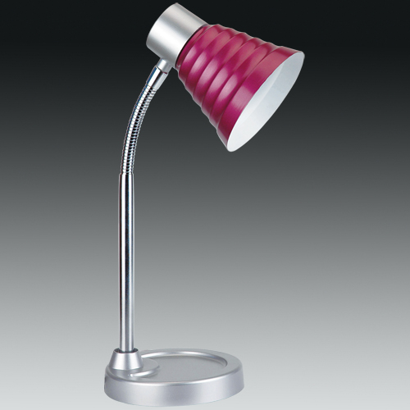

Product Name:KT 703 E14 40W
Product Infomation
Optional Voltage:120/230V
Ctn(cm)54x40x29
Qty(pcs):12
G.w.(kg):14
N.W.(kg): 12

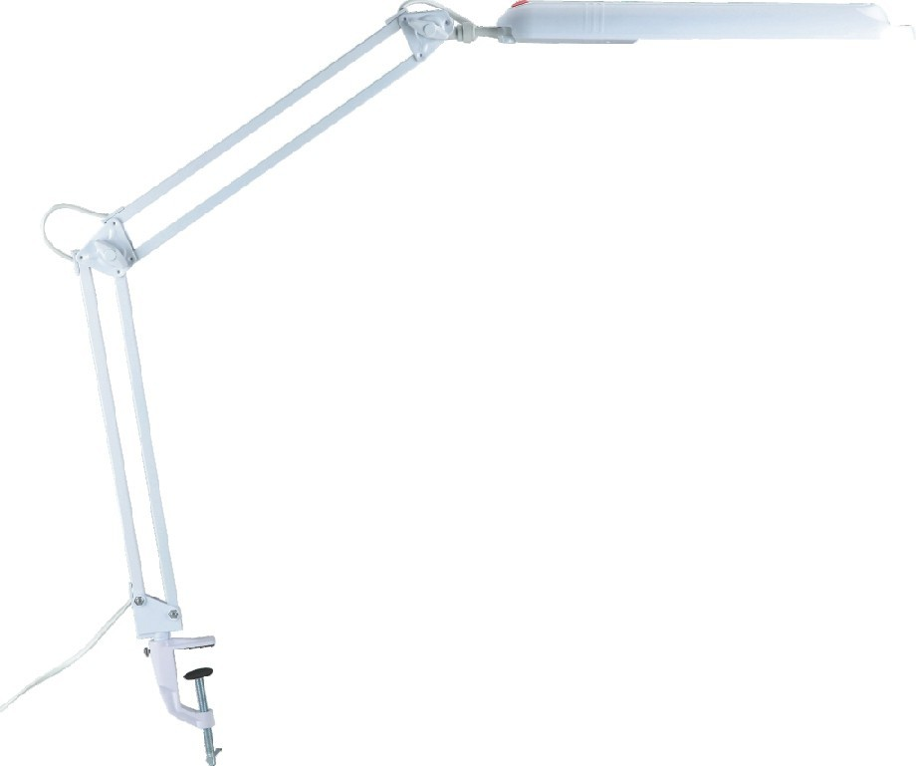

Product Name:KT068C 11W G23 PL
Product Infomation
Type： KT 068C 11W G23 PL
Input Voltage：100-240V- AC, 50-60Hz
Built-in Electronic Ballast
Black Metal Arms.Iron Clamp
G.W./N.W.:15.5/13.5 KGs
CTN:43 x 21 x 44CM QTY: 4 pcs
Finish: Sliver. Black. White


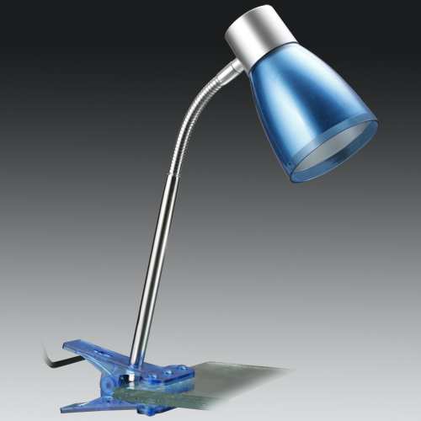

Product Name:KT 715C E14 40W
Product Infomation
Optional Voltage:120/230V
Ctn(cm)54x40x29
Qty(pcs):12
G.w.(kg):14
N.W.(kg): 12

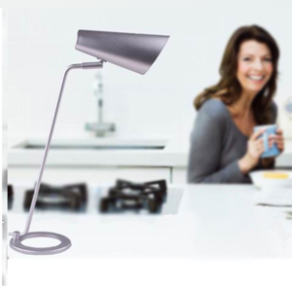

Product Name:KT015 E27 Max.3U 11W
Product Infomation
Input Voltage: 100-240V~AC, 50-60Hz
Metal Housing
On Line Switch
CTN: 60x33x58 CM
Qty: 6PCS
Finish: Black,White,Sliver
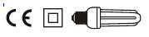

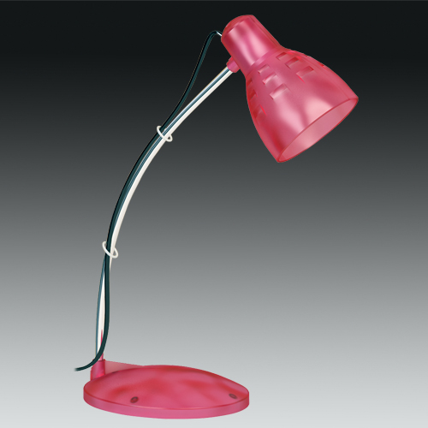

Product Name:KT 821 E14 40W
Product Infomation
Optional Voltage:120/230V
Ctn(cm)46x49.5x35
Qty(pcs):20
G.w.(kg):15.4
N.W.(kg): 13.4

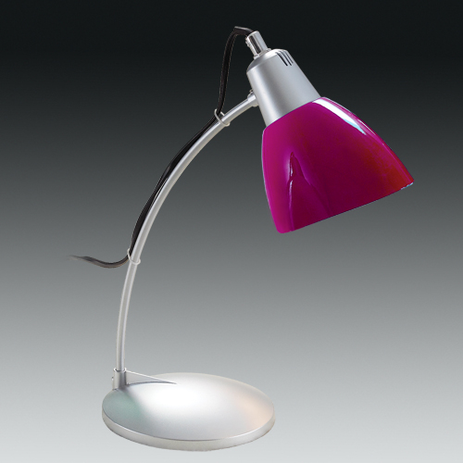

Product Name:KT 823 E14 40W
Product Infomation
Optional Voltage:120/230V
Ctn(cm)57x46x35
Qty(pcs):20
G.w.(kg):15.8
N.W.(kg): 13.8



Product Name:KT018 20W T4 G5
Product Infomation
Input Voltage： 100-240V -AC, 50-60Hz
Built-in Electronic Ballast.
Alum.Arms.
CTN:76 x 31.5 x 33CM
QTY:6 pcs
Finish: Black, Silver


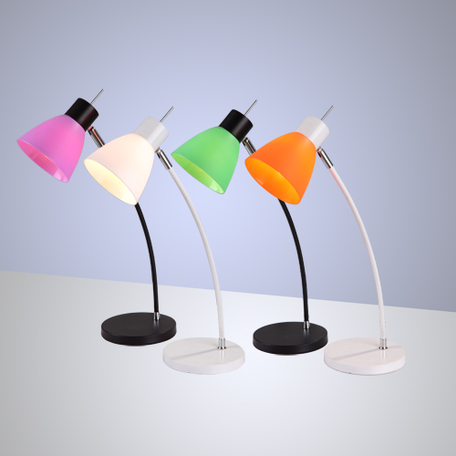

Product Name:KT -1006A
Product Infomation
KT -1006A E14 40W
Optional Voltage:120/230V
Ctn(cm) 50x50x45
Qty(pcs):6
G.w.(kg):9
N.W.(kg): 7.2

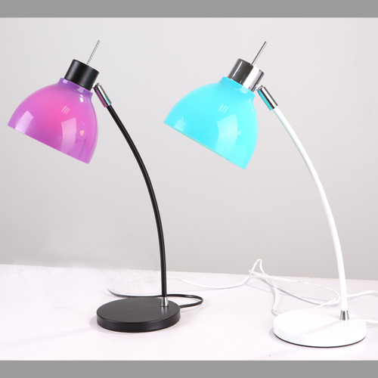

Product Name:KT -1006B
Product Infomation
KT -1006B E14 40W
Optional Voltage:120/230V
Ctn(cm) 50x50x45
Qty(pcs):6
G.w.(kg):9
N.W.(kg): 7.2

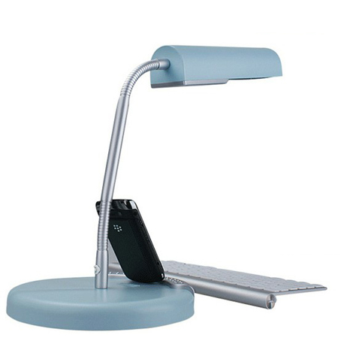

Product Name:KT 025 E27 Max.2U 13W
Product Infomation
Input Voltage: 100-240V~AC, 50-60Hz
On Line Switch
CTN: 30.5x72x48 CM
Qty: 12PCS
Finish : Light Pink, Light Blue.

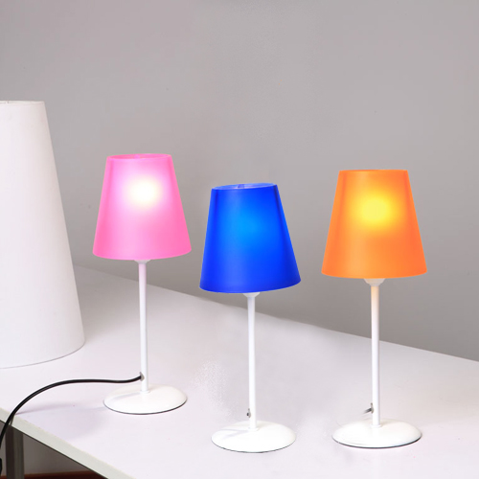

Product Name:KT-0033
Product Infomation
KT-0033 E14 40W
Optional Voltage:120/230V
Ctn(cm) 71.5x29.5x30.5
Qty(pcs):10
G.w.(kg):13
N.W.(kg): 11

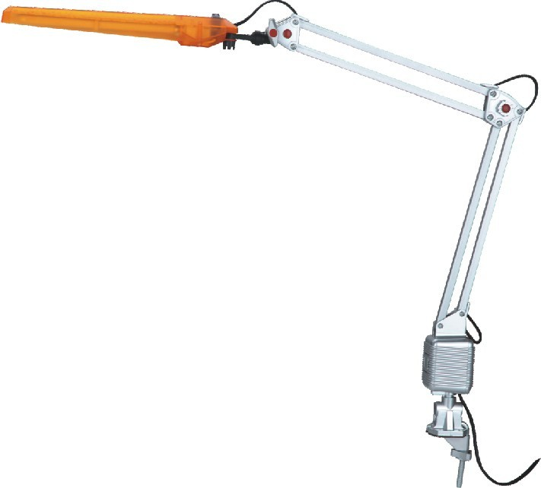

Product Name:KT016C 11W PL G23
Product Infomation
Input Voltage: 100-240V-AC, 50-60Hz
Built-in Electronic Ballast.
Alum. Arms.Plastic Clip.
CTN:42 x 38.5 x29 CM
QTY: 6 pcs


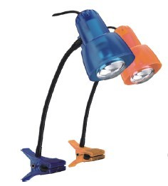

Product Name:KT034C E14 Max.60W
Product Infomation
Input Voltage：100-240V-AC, 50-60Hz
CTN: 32 x 32 x 46CM
QTY: 12 pcs
Color: black, green, red, yellow, blue,grey, orange


