Project - 1
Online Learning Management System
This project is a online learning management system. This project create from using pycharm. In this program I was used python programming language. Because this language is better understand and easy to project handling. And In this project I was used Django framework. To create easily project.

In this project I was create backend supporting part. And frontend I was use online downloaded template

In frontend I have use free online template. In that template HTML and CSS used for creating user interface and bootstrap use for responsive templates and as well as javascript for validation, etc.

Project Creating steps:
Day - 1 :
- First create a new project in pycharm as online learning ( online learning management system )
- In this project open pycharm terminal and install Django ( pip install Django )

- In terminal after installition create Django project.
terminal query Ex. django-admin startproject olms
After this query In project auto create project level folder as olms in this folder create 5 python files. And one manage.py file
Python files as below:
- __init__.py
- asgi.py
- settings.py
- urls.py
- wsgi.py
And manage.py file manage this project. In this project all changes all terminal queries fire under this file.

- After creating project using terminal change directory means jump online learning to olms.
ex. cd project-name
- In this django project create application
terminal query Ex. python manage.py startapp app
After this query In project auto create application level folder as app in this folder create 5 python files and 2 folders __pycache__ and migrations
Python files as below:
- __init__.py
- admin.py
- apps.py
- models.py
- views.py
__pycache__ and migrations this two folder explain after using in this project.
- Open online_learning/olms/olms/setting.py file open on pycharm and find INSTALLED_APPS section and register application to last number. As app-name (app)

- Then create views and url that file

- But views not write in app level file views.py. create new file views.py file in project level (olms )
Then write views in that file.
Ex. def Base(request):
return render(request,"app/base.html")

If you create view then write that view url
Ex. urlpatterns = [
path('admin/', admin.site.urls),
path('base/', views.Base,name="base"),
]

- After app registration run this olms using from using pycharm terminal server type this query on terminel
Ex. python manage.py runserver
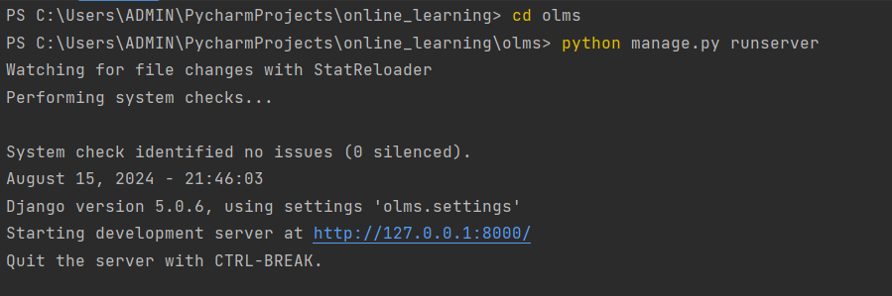

After fire query terminal will show this type output
In this output http://127.0.0.1:8000/ is project run server.
Copy this server link and open on any browser firefox, chrom, edge, etc. and they will show you

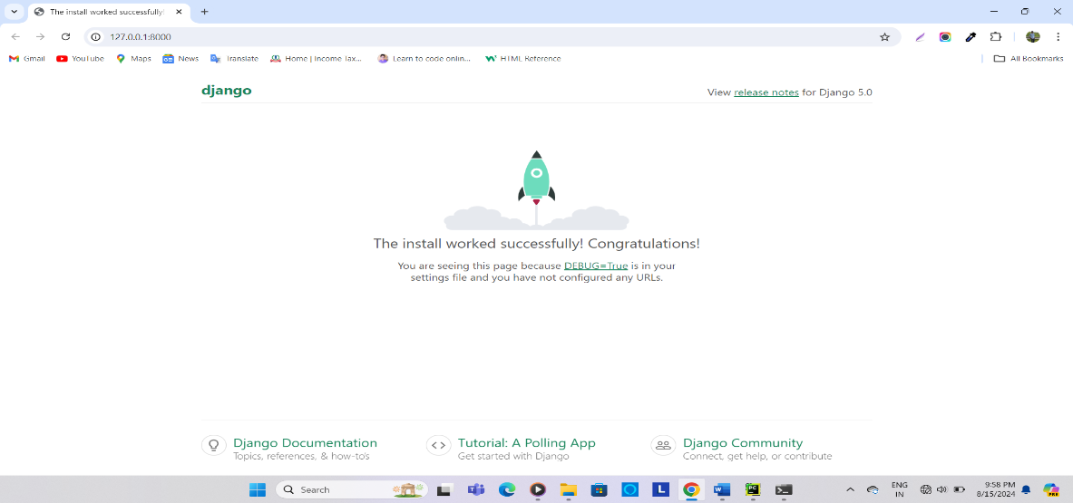

- Then in setting.py change database sqlite to mysql
But first create olms dababase in mysql database and then change setting below :

DATABASES = {
'default': {
'ENGINE': 'django.db.backends.mysql',
'NAME': 'olms',
'USER': 'root',
'PASSWORD': 'omkar@2848',
'HOST': 'localhost',
'PORT': '3306',
'OPTIONS': {
'init_command': "SET sql_mode='STRICT_TRANS_TABLES'"
}
}
}

- If change database then fire query on pycharm terminal for create super user
Ex. createsuperuser
Add username, useremail and userpassword

- Then create superuser fire query on termial makemigration for create django default table
python manage.py makemigrations

- After makemigrations fire migrate for save table on database
python manage.py migrate
and run browser at check user http://127.0.0.1:8000/admin/

- After project run successfully create template using setting.py, urls.py, views.py but before using
this files create new two folders as below:

- Templates: (templates)
- Template folder for a HTML files. Templates folder create on django project (olms) level
- And in this folder create another folder using app-name (app)
- Then in app-name folder create HTML files

- Static : (static)
- Static folder for a CSS, JS, images, etc files. Templates folder create on django project (olms) level
- In static folder create another three folder as below :
CSS :
For storing css files.
Js :
For storing js files.
Images :
For storing all images.
Etc :

- After creating folder link this folder in setting.py file.
First templates folder link:
In setting.py file import os and find BASE_DIR if you get base_dir then below this join template using os
Ex . TEMPLATE_DIR = os.path.join(BASE_DIR,"templates")

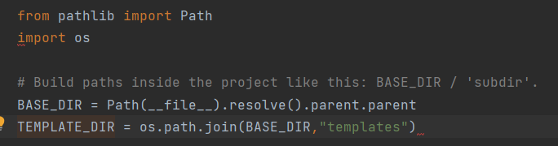

And then register to template sections in DIR list
Second static folder link :
Static folder register to the very last of setting.py file using below syntax :
STATICFILES_DIRS = [
BASE_DIR / "static"
]

- After applying this all setting, then create view in views.py using python function.
This fuction return request to html page
Ex. 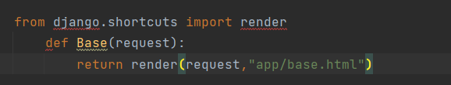

- After creating view create that view url, in urls.py. but first import all views in urls.py.
Using from . import views
In url create end-tag of that particular view
Ex. from django.contrib import admin
from django.urls import path
from . import views
urlpatterns = [
path('admin/', admin.site.urls),
path('base/', views.Base),
]
View

End-tag

- Then project then ready to create template.

- I was create first HTML file as base.html and css files for design base file.

- In online template search header code and paste on base.html file. header part created from using html, bootstrap, css and js.

In this header part I was show company logo and navigation bar, in this bar as below :
- Company courses
- Home menu
- Pages
- Blpog
- Shopping
- documentation
- Login
- Notifications
- Search
In all menus under creating sub-menus using dropdown menu
Dropdown menu from create using js and bootstrap for look better and easy to understand.

- In online template search header code and paste on base.html file. footer part created from using html, bootstrap, css and js.
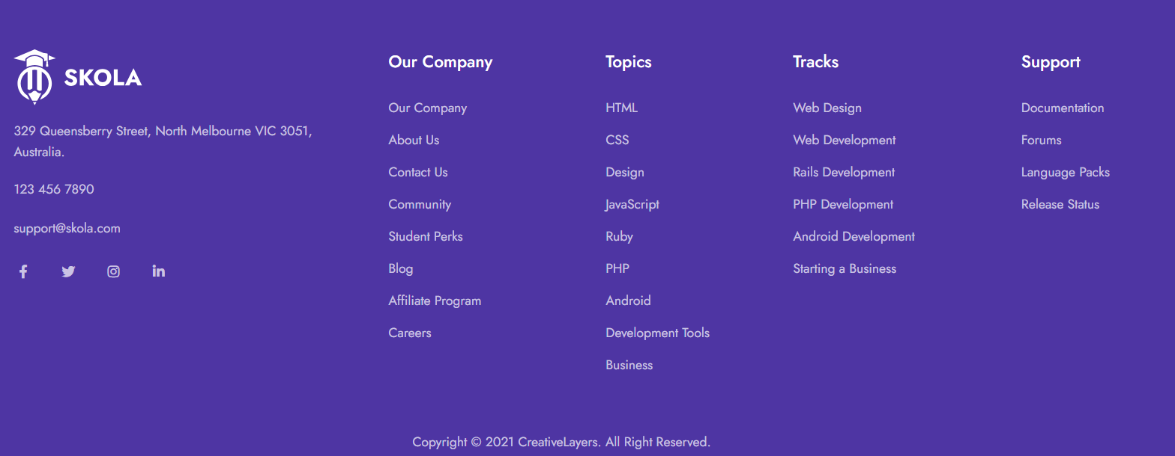

In that footer I will show :
- Company information
- Courses topic
- Coursws track
- Company support

- Then craeate new folder in template folder as components. In that add three html files as below:
- Header :
In that header file paste only header code.
- Footer :
In that footer file paste only footer code.
- Model :
In this model paste modes code from copy from search in online template .

- If after creating all files ( header, footer, model ) then remove all header, footer, model code from base file. And base.html body part using include method re-add this code.
Ex. {% include ‘components/main.html’ %}
{% include ‘components/header.html’ %}
{% include ‘components/footer.html’ %}

- Then run the server and check template work properly or not.
Day - 2:
- If your before steps work properly then add few pages ( home, about, contact, etc ).
But Except them login and register
For this pages add new folder in template folder as main. In that folder create all pages to recommended and use in base file like components file.

- In that pages first extends the base file. Ex. {% extends ‘app/base.html’ %}

After extending code use block content for add base file and that particular page.
But in block content first load static files(css, js, images)
Ex. {% block content %}
{ % load static %}
Particular page code (home, about, contact, etc )
{% endblock %}
In that online template search each page data and paste that file.
After creating pages in base file use only block content like
{% block content %}
(No single code, empty)
{% endblock %}
Upper code write after header and before footer in base file.
If you create all pages then write this pages views on project level views.py and url as like base file views and url

- For login and register page create registration folder in templates. In that folder create file login and register.
In that template search login and register page data and paste that file.

Create login and register page like upper pages.
    - Register views and url:
- This page view write on new python file as user_login at app level. And write in this file register file view.
def Register(request):
return render(request,"registration/register.html")

- But before write view import :
from django.shortcuts import render, redirect

- And write url as like upper pages. But first import user login page.
from app import user_login
path('register/', user_login.Register, name="register"),

    - Login views and url :
- After creating this no write any view and url. Because django auto create this page views and url means django use in-build function
- In setting.py/installed app/ 'django.contrib.auth'
- That function use in urls as :
path('accounts/', include('django.contrib.auth.urls')),

this use for only login page.
Day - 3:
- If you create register page then apply validationsa and store register data in database ( user )

- In components create new html file as msg.html for show already present name, email like img
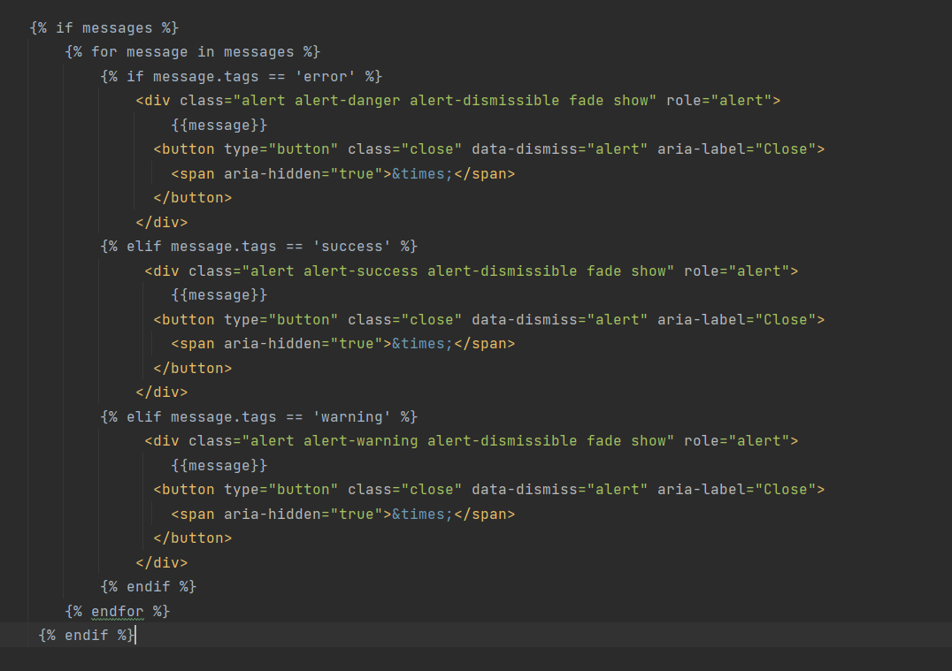

- First open register file and header file and search register form tag. In both file do the below change.
- In form tag use method=post and action={% include ‘register’ %}
If method=post then use csrf token to the form tag starting

- Register form required all input boxes give the name( username,email,password) for redirection.

- Then open register page views and write validation for registration and massage valid data or already present data. As Like below :
But first import from django.contrib.auth.models import User
from django.contrib import messages

from django.shortcuts import render,redirect
from django.contrib.auth.models import User
from django.contrib import messages
def Register(request):
if request.method =="POST":
username=request.POST.get('username')
email=request.POST.get('email')
password=request.POST.get('password')
# check email already present
if User.objects.filter(email=email).exists():
messages.warning(request,'email already exists')
return redirect('register')
# check user already present
if User.objects.filter(username=username).exists():
messages.warning(request,'username already exists')
return redirect('register')
user=User(email=email, username=username)
user.set_password(password)
user.save()
return redirect('login')
return render(request,"registration/register.html")

- After validation change menu in header part to your requirement.
Open header file and search navigation bar in that file. Then dselete this file and add below bootstrp responsive menus :

<ul class="navbar-nav ms-auto">

<li class="nav-item dropdown dropdown-full-width ">
<a class="nav-link px-xl-4 text-gigas" href="">
<span>Home</span>
</a>
</li>

<li class="nav-item dropdown dropdown-full-width">
<a class="nav-link text-gigas" href="">
About
</a>
</li>

<li class="nav-item dropdown dropdown-full-width">
<a class="nav-link text-gigas" href="">
Contact Us
</a>
</li>

<li class="nav-item dropdown dropdown-full-width">
<a class="nav-link text-gigas" href="">
My Courses
</a>
</li>

</ul>

If you change menu then remove chart option on navigation bar. ( delete cart code )
After changing menus then save file and check on browser.



Day - 4:
- If user register successfully in that website then they login without using username, they login
using email and password.

- In project level app create a new python file as EmailBackEnd.py. in that file write code for get email from admin/user model. And check email present or not in user model.
from django.contrib.auth import get_user_model
from django.contrib.auth.backends import ModelBackend
class EmailBackEnd(ModelBackend):
def authenticate(self, username=None, password=None, **kwargs):
UserModel = get_user_model()
try:
user = UserModel.objects.get(email=username)
except UserModel.DoesNotExist:
return None
else:
if user.check_password(password):
return user
return None

- Open login.html and model.html and search login form in both files. And implement the method =”post” and action=” ____” . change name username or email to email. email and password input box and pass the name for this box.

- Write view for login.first create Dologin function and Get all values in login page email and password used request.post .get method.
def Dologin(request):
if request.method == "POST":
email = request.POST.get('email')
password = request.POST.get('password')

- in this view authenticate that values using user user=EmailBackEnd.authenticate(request,username=email,password=password)

- in this view if value is correct then page redirect to the home page. But the value is incorrect then thae page redirect to the login page. And print massage 'Email and Password Are Invalid
if user!=None:
login(request,user)
return redirect('home')
else:
messages.error(request,'Email and Password Are Invalid !')
return redirect('login')

- After creating view create url for this view
path('dologin/', user_login.Dologin, name="dologin"),
that url use in login.html and model.html in both page login form tag. Method and Action
<form class="mb-5" method="post" action="{% url 'dologin' %}">

Day - 5:
- django have in-build password forgot function as password_reset.
Django create our own page. But that page is not attractive so create below pages.

- First install crispy form and bootstrap4 in django terminal as
pip install django-crispy-forms
pip install crispy-bootstrap4
after installing they mention in setting.py / installed apps before app install
INSTALLED_APPS = [
-----,
'crispy_forms',
'crispy_bootstrap4',
"app",
]

- In registration folder create forgot password file as below:
- password_reset_form.html

In this write code as :
{% extends 'base.html' %}
{% block content %}
{% load crispy_forms_tags %}
<!-- PAGE TITLE
================================================== -->
<header class="py-8 py-md-11" style="background-image: none;">
<div class="container text-center py-xl-2">
<h1 class="display-4 fw-semi-bold mb-0">Forgot Password</h1>
<nav aria-label="breadcrumb">
<ol class="breadcrumb breadcrumb-scroll justify-content-center">
<li class="breadcrumb-item">
<a class="text-gray-800" href="#">
Home
</a>
</li>
<li class="breadcrumb-item text-gray-800 active" aria-current="page">
Forgot Password
</li>
</ol>
</nav>
</div>
<!-- Img -->
<img class="d-none img-fluid" src="...html" alt="...">
</header>
<style>
.login_input{
}
</style>
<!-- LOGIN
================================================== -->
<div class="container mb-11">
<div class="row gx-0">
<div class="col-md-7 col-xl-4 mx-auto">
<!-- Login -->
<h3 class="mb-6">Log In to Your Skola Account!</h3>
{% include 'components/msg.html' %}
<!-- Form Login -->
<form method="post">
{% csrf_token %}
<!-- Email -->
<div class="form-group mb-5">
<label>{{field.label_tag}}</label>
<p>{{ form|crispy }}</p>
</div>
<!-- Submit -->
<button class="btn btn-block btn-primary" type="submit">
SEND CONFIRMATION LINK
</button>
</form>
</div>
</div>
</div>
{% endblock %}
This page for enter your email to get reset password link.

- password_reset_done.html
In this file write below code :
{% extends 'base.html' %}
{% block content %}
<br>
<br>
<div class="container mt-4">
<div class="col-sm-6">
<h2 class="display-4">Reset Password</h2>
<p>I have mailed you instruction for resetting your password</p>
<p>if you have didn't recive it verified you entered the correct email and / or check your spam folder</p>
</div>
</div>
<br>
<br>
{% endblock %}
In this page show message to email send on your own email.

- password_reset_confirm.html
In this file write below code :
{% extends 'base.html' %}
{% block content %}
{% load crispy_forms_tags %}
<!-- PAGE TITLE
================================================== -->
<header class="py-8 py-md-11" style="background-image: none;">
<div class="container text-center py-xl-2">
<h1 class="display-4 fw-semi-bold mb-0">Forgot Password</h1>
<nav aria-label="breadcrumb">
<ol class="breadcrumb breadcrumb-scroll justify-content-center">
<li class="breadcrumb-item">
<a class="text-gray-800" href="#">
Home
</a>
</li>
<li class="breadcrumb-item text-gray-800 active" aria-current="page">
Forgot Password
</li>
</ol>
</nav>
</div>
<!-- Img -->
<img class="d-none img-fluid" src="...html" alt="...">
</header>
<style>
.login_input{
}
</style>
<!-- LOGIN
================================================== -->
<div class="container mb-11">
<div class="row gx-0">
<div class="col-md-7 col-xl-4 mx-auto">
<!-- Login -->
<h3 class="mb-6">Log In to Your Skola Account!</h3>
{% include 'components/msg.html' %}
<!-- Form Login -->
<form method="post">
{% csrf_token %}
<div class="form-group mb-5">
<label>{{field.label_tag}}</label>
<p>{{ form|crispy }}</p>
</div>
<!-- Submit -->
<button class="btn btn-block btn-primary" type="submit">
SEND CONFIRMATION LINK
</button>
</form>
</div>
</div>
</div>
{% endblock %}
That page work Enter new password and comfirm password and submit this password.

- password_reset_complete.html
In this file write below code :
{% extends 'base.html' %}
{% block content %}
<br>
<br>
<div class="container">
<div class="col-sm-8">
<h2 class="display-4">Password has been Changed</h2>
<p>You May Go Ahead and login now </p>
<a href="{% url 'login' %}" class="btn btn-success" style="width:20%;">Login</a>
</div>
</div>
<br>
<br>
{% endblock %}

In that page show password reset successfully and login it.

- After creating pages pass url for forgot password in login page and model.
As href=”{% url ‘password_reset’ %}”

- Refresh the page and try it.

Day - 6:
- In this template change the feature courses and trending categories. This chages is dynamic changes from admin To page. values python, jave, html, js, react

- In django create one model in model.py as Categories, in this categories add fields as below :
class Categories(models.Model):
icon = models.CharField(max_length=50)
name = models.CharField(max_length=50)
def __str__(self):
return self.name
and after using this model as foreign key that return value is name.

- Then next register this model in admin .py as below :
from django.contrib import admin
from . import models
admin.site.register(models.Categories)

- Then in django terminal stop the server and fire below qurery :
- python manage.py makemigrations
- python manage.py migrate
and then run the server

- then open admin page on browser and in this categories table add font awesome icon and name.

- Then create view in views.py. but at first import from app.models import *
- write view for home function as below :
def Home(request):
category = Categories.objects.all().order_by('id')[0:5]
data = {
"category": category
}
return render(request, "main/home.html", data)

- After creating view open home file and search feature courses and trending categories. And write code in using for loop as below : for feature course
<section class="pt-5 pb-9 py-md-11 bg-white">
<div class="container container-wd">
<div class="row align-items-end mb-7">
<div class="col-xl mb-5 mb-xl-0">
<h1 class="mb-1">Featured Courses</h1>
<p class="font-size-lg text-capitalize mb-0">Discover your perfect program in our courses.</p>
</div>
<div class="col-xl-auto">
<!-- Nav -->
<div class="nav justify-content-lg-start justify-content-xl-center justify-content-center tab-nav-1" id="pills-tab" role="tablist">
<a class="btn-sm btn-pill me-1 mb-1 text-dark fw-medium px-6 active" id="pills-all-tab" data-bs-toggle="tab" href="#pills-all" role="tab" aria-controls="pills-all" aria-selected="true">
All Categories
</a>
{% for i in category %}
<a class="btn-sm btn-pill me-1 mb-1 text-dark fw-medium px-6" id="pills-art-tab" data-bs-toggle="tab" href="#pills-art" role="tab" aria-controls="pills-art" aria-selected="false">
{{ i.name }}
</a>
{% endfor %}
</div>
</div>
</div>
- For trending categories :

<section class="py-5 py-md-8 bg-white">
<div class="container container-wd">
<div class="row align-items-end mb-md-7 mb-4">
<div class="col-md mb-4 mb-md-0">
<h1 class="mb-1">Trending Categories</h1>
<p class="font-size-lg mb-0 text-capitalize">Cum doctus civibus efficiantur in imperdiet deterruisset.</p>
</div>
<div class="col-md-auto">
<a href="course-list-v6.html" class="d-flex align-items-center fw-medium">
Browse All
<div class="ms-2 d-flex">
<!-- Icon -->
<svg width="10" height="10" viewBox="0 0 10 10" fill="none" xmlns="http://www.w3.org/2000/svg">
<path d="M7.7779 4.6098L3.32777 0.159755C3.22485 0.0567475 3.08745 0 2.94095 0C2.79445 0 2.65705 0.0567475 2.55412 0.159755L2.2264 0.487394C2.01315 0.700889 2.01315 1.04788 2.2264 1.26105L5.96328 4.99793L2.22225 8.73895C2.11933 8.84196 2.0625 8.97928 2.0625 9.1257C2.0625 9.27228 2.11933 9.4096 2.22225 9.51269L2.54998 9.84025C2.65298 9.94325 2.7903 10 2.9368 10C3.0833 10 3.2207 9.94325 3.32363 9.84025L7.7779 5.38614C7.88107 5.2828 7.93774 5.14484 7.93741 4.99817C7.93774 4.85094 7.88107 4.71305 7.7779 4.6098Z" fill="currentColor"/>
</svg>

</div>
</a>
</div>
</div>

<div class="row row-cols-2 row-cols-md-3 row-cols-xl-5 row-cols-wd-6">
<div class="col mb-md-6 mb-4 px-2 px-md-4">
<!-- Card -->
<a href="course-list-v6.html" class="card bg-lavender hover-gradient-1 rounded-lg p-md-5 p-3 h-210p text-center lift">
<!-- Image -->
<div class="mt-7 text-gigas display-4">
<i class="fas fa-bezier-curve"></i>

<!-- Footer -->
<div class="card-footer px-0 pb-0 pt-4">
<h5 class="mb-0 line-clamp-2 text-gigas">Design</h5>
</div>
</div>
</a>
</div>

{% for i in category %}
<div class="col d-xl-none d-wd-block mb-md-6 mb-4 px-2 px-md-4">
<!-- Card -->
<a href="course-list-v6.html" class="card bg-lavender hover-gradient-1 rounded-lg p-md-5 p-3 h-210p text-center lift">
<!-- Image -->
<div class="mt-7 text-gigas display-4">
<i class="{{ i.icon }}"></i>

<!-- Footer -->
<div class="card-footer px-0 pb-0 pt-4">
<h5 class="mb-0 line-clamp-2 text-gigas">{{ i.name }}</h5>
</div>
</div>
</a>
</div>
{% endfor %}
</div>
</div>
</section>

- And see changes on home page.
Day - 7:
- After changing trending categories then change featured courses. Then create new two models as Athor and Course like :

- Author :
class Author(models.Model):
author_profile=models.ImageField(upload_to='media/author')
author_name=models.CharField(max_length=100)
about_author=models.CharField(max_length=200)
def __str__(self):
return self.author_name

and register this model in admin like :
class AuthorAdmin(admin.ModelAdmin):
list_display=['id','author_name']
admin.site.register(models.Author,AuthorAdmin)

- Course :
class Course(models.Model):
STATUS = (("PUBLISH", "PUBLISH"), ("DRAFT", "DRAFT"),)
featured_image = models.ImageField(upload_to="media/featured_img")
featured_video = models.CharField(max_length=300)
title = models.CharField(max_length=100)
created_at = models.DateField(auto_now_add=True)
author = models.ForeignKey(Author, on_delete=models.CASCADE)
category = models.ForeignKey(Categories, on_delete=models.CASCADE)
description = models.TextField()
price = models.FloatField()
discount = models.FloatField()
# slug = models.SlugField(default='', max_length=100, null=True)
status = models.CharField(choices=STATUS, max_length=100)

def __str__(self):
return self.title

and register this model in admin like :
class CourseAdmin(admin.ModelAdmin):
list_display = ['id', 'title']
admin.site.register(models.Course,CourseAdmin)

- And then use this two models in home page for add course dyanyamically on home page.write view like :
def Home(request):
category = Categories.objects.all().order_by('id')[0:5]
course= Course.objects.filter(status='PUBLISH').order_by('-id')
data = {
"category": category,
"course": course
}
return render(request, "main/home.html", data)

- For this two models create view to show data on that particular page to need this data on to the dyanamic. Write view like :
def Home(request):
category = Categories.objects.all().order_by('id')[0:5]
course= Course.objects.filter(status='PUBLISH').order_by('-id')
data = {
"category": category,
"course": course
}
return render(request, "main/home.html", data)

categogy = category = Categories.objects.all() means, all column value in this category keyword (name,icon)
write this name, icon like {{i.name}} {{i.icon.url}}

- If you create model then change logic in home.html featured curses. If you add course in admin then they dyanamically show in home page. Using for loop display course category wise but all courses display in all categories.
Like :
{% for i in category %}
{{ i.column_name}}
{% endfor %}

Day - 8:

