Arrays
____________________________________________________________________________
Q. what is array?
___________________________________________________________________
Array is collection of similar type of data or it is collection of multiple values of same data.
If we use array then we can store multiple values of same type in single variable.
If we want to use array in programming we have identity [ ] – subscript

Syntax: data type variablename[size];
Example: int a[5];
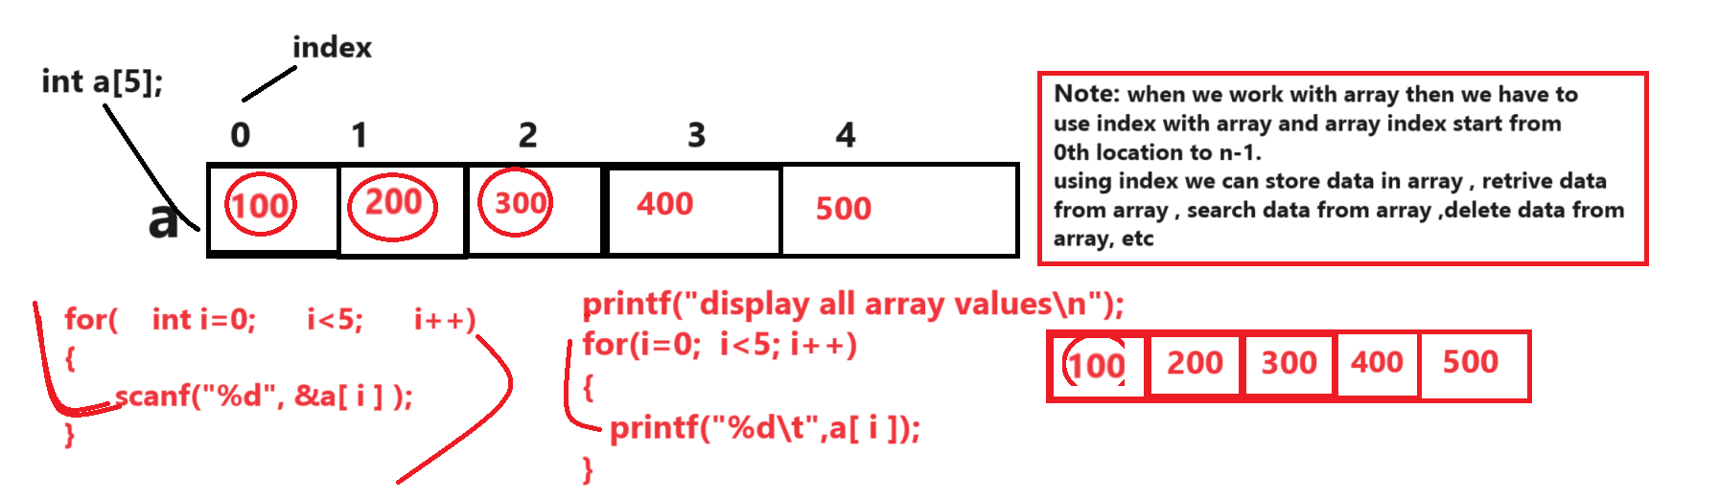

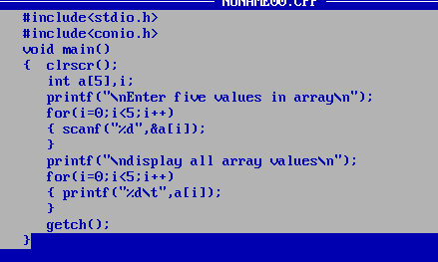

Example: WAP to input five values in array and calculate its sum
Input: 10 20 30 40 50
Output: sum of all value is 150
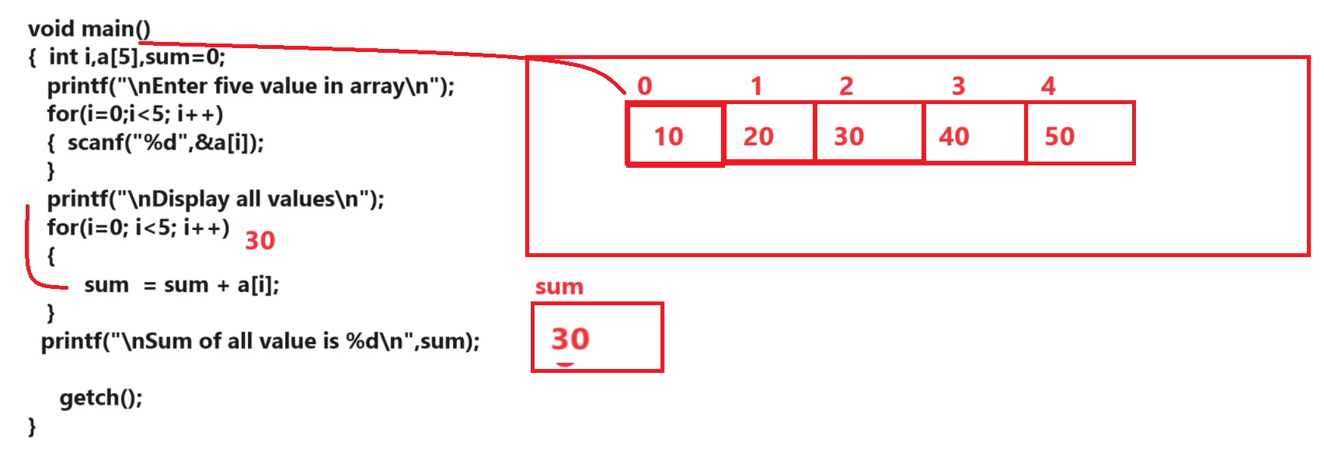

Example: WAP to input five values in array and find the max value from array.
Input: 5 6 8 2 4
Output: Max value is 8
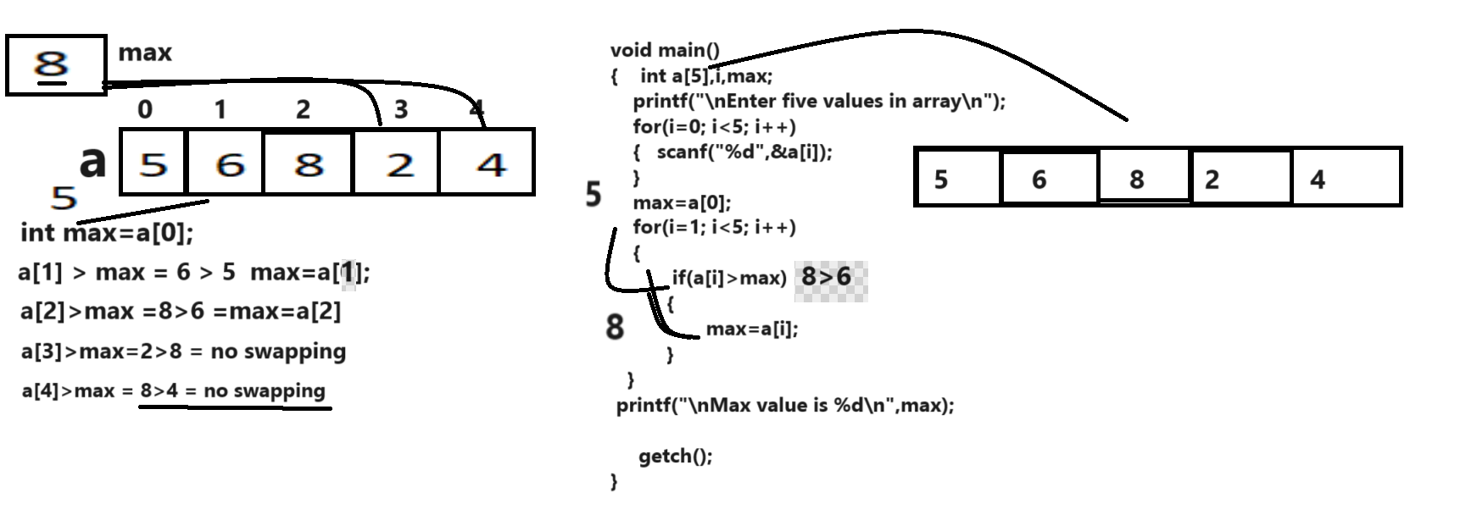

Example: WAP to input the five values in array and search element in array.
Input: 10 20 30 40 50
Input value for search
30
Output: value found
Input value for search
500
Output: value not found

