Example: WAP to create function name as Table with single parameter and input number from keyboard and print its table.
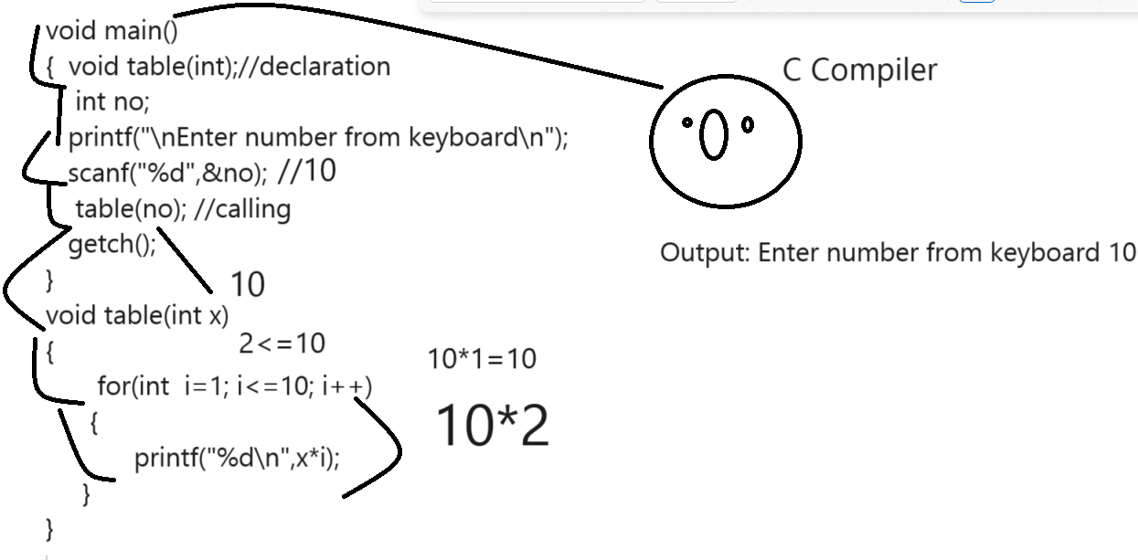
Example: WAP to create function name as void power(int,int) input two values consider first as base and second as index and calculate its power.
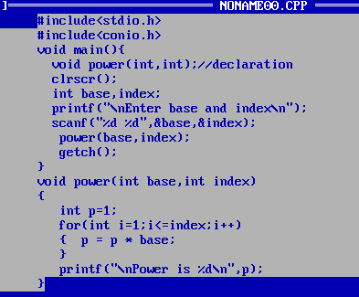
How to return value from a function
______________________________________________________________________
If we want to return value from function then your function return type should not be void
You must be use data type as return type which kind of value we want to return.
Important points when we return value from function
___________________________________________________________________________________
a) Function return type should not void
b) Must be use data type with function which kind of value we want to return
c) Function always return value at calling point so we need to use variable at
Left side of function calling as per the return data type of function
Example: we want to function name as getSquare(int) and this function return square at function calling point
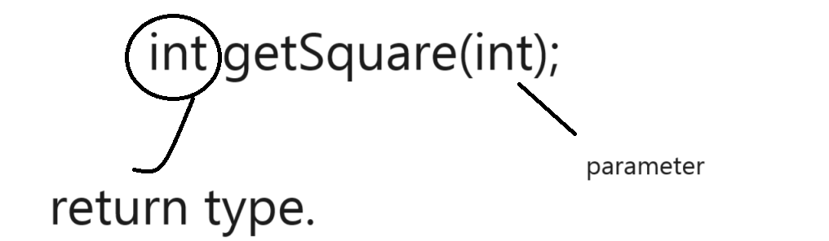
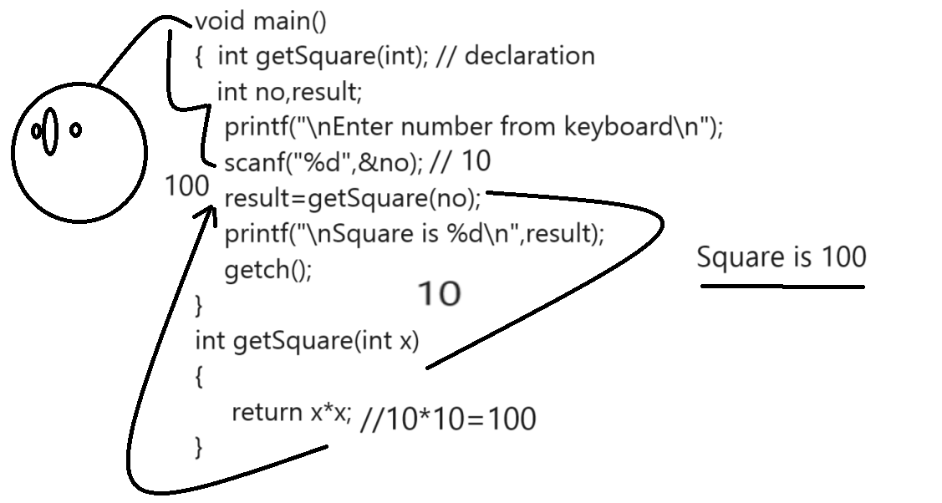

Example: WAP to design function name as int isPerfect(int): this function accept number as parameter and check number is perfect or not if number is perfect return 1 if not return 0
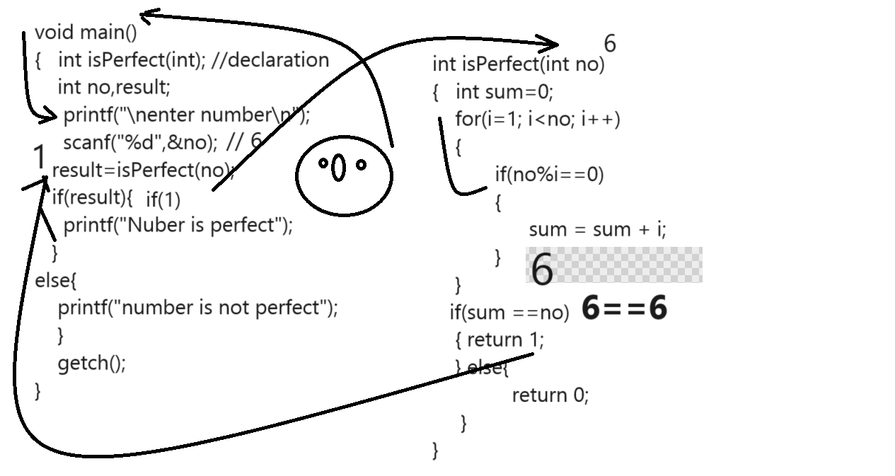

How to pass array as parameter to function?
___________________________________________________________________________
If we want to pass array as parameter to function we need to pass base address of array to function
Definition means using base we can access array in function.
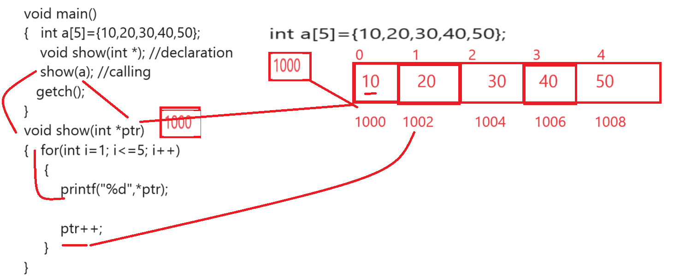
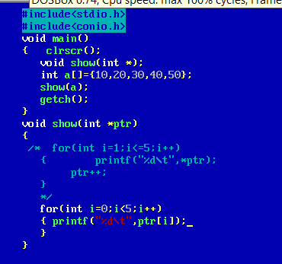

Example: WAP to create function name as int getMax(int a[]): this function can accept integer array as parameter and find the max value from array and return it.

Example: WAP to create function name as int getSecondHigesht(int []): this function accept array as parameter and find second highest value.

Example: WAP to create function name as int [] getMerge(int a[],int b[]): this function can accept two array as parameter and merge them return third array as result

Example: WAP to create function name as int [] getSortedArray(int []): this function accept array as parameter and sort them and return sorted array

How to return array from function
_______________________________________________________________________________
If we want to return array from function we need to return base address of array from function
Just we need to give pointer as return type with its data type and need to use pointer variable
at function calling for hold address return by function definition.

Example: Write a program to create function name as
int * changeArray(int a[]) : you have add 10 in every value by using pointer and return its base
address.

Function Recursion
_________________________________________________________________________
Function recursion means function calls itself again and again called as function recursion.
Means when we call function from its own definition called as recursion.

Syntax:
return type functionname(datatype variablename)
{
if(condition)
{ write logic
functionname(arguments) //recursive call
}
}
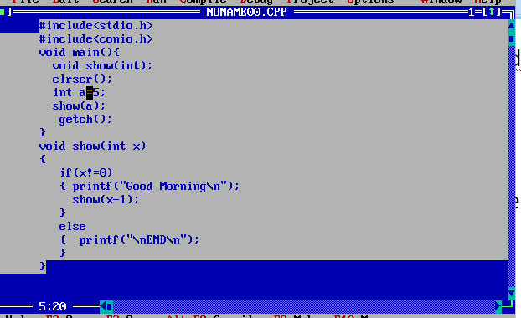

Example: WAP to create function name as
void table(int): this function can accept number as parameter and print its table using
recursion.
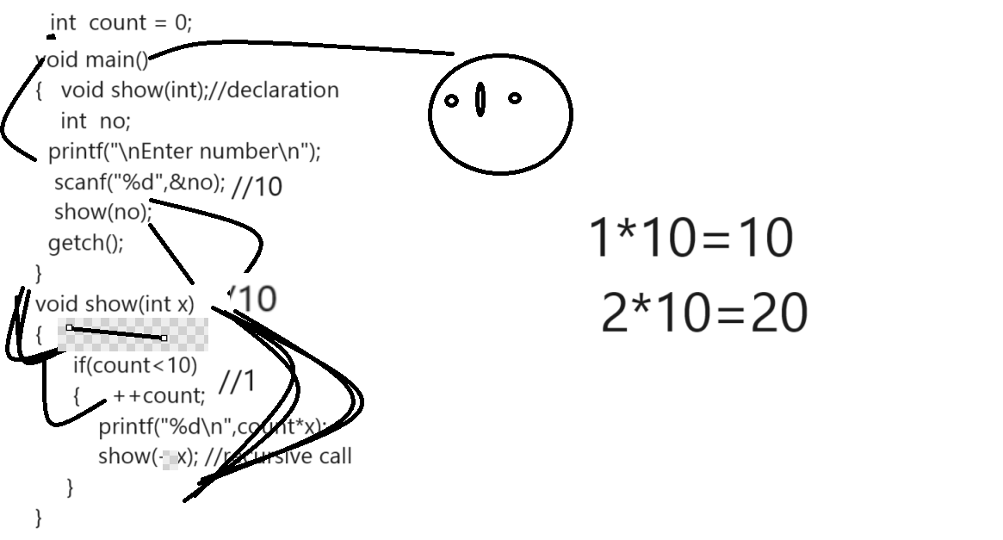
Example: WAP to create function name as void power(int base,int index): this function
can accept two values as parameter and calculate its power without using loop or can calculate
using recursion.

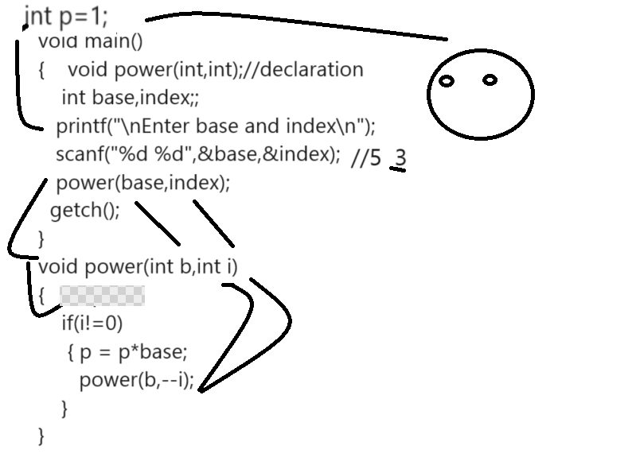

Call by Value and call by Reference
_________________________________________________________________
Call by value means we call function by passing simple arguments and call by reference
Means we call function by passing address of variable.
If we think about call by value when we pass duplicated copies of variable from calling to definition
Means if we perform any operation in function definition it will never reflect on function calling
If we think about call by reference if we perform any change in function definition it will reflect on function calling point.

Example: WAP to create function name as void swap(int,int) this function accept two parameters as
Input and perform swapping on it.

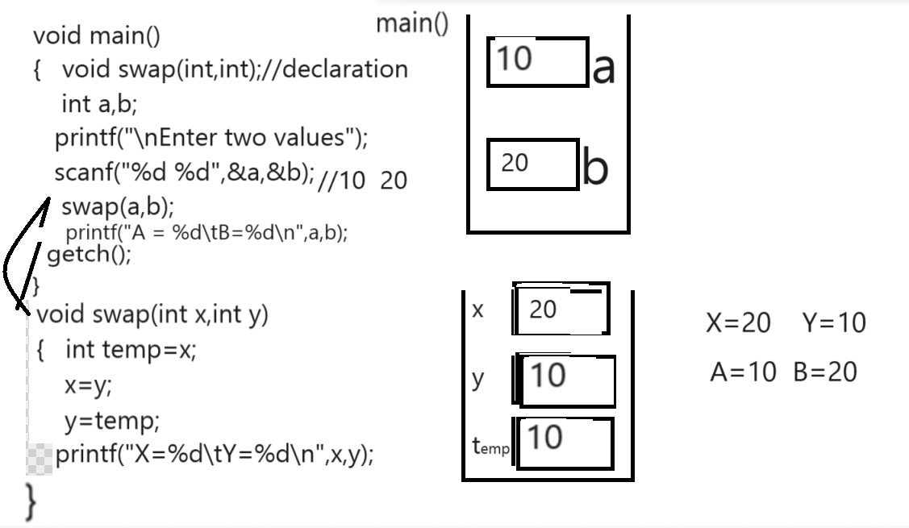

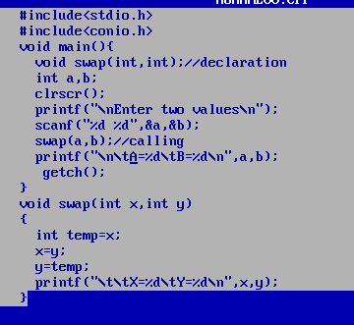

Swapping Example using Call by reference
___________________________________________________________________
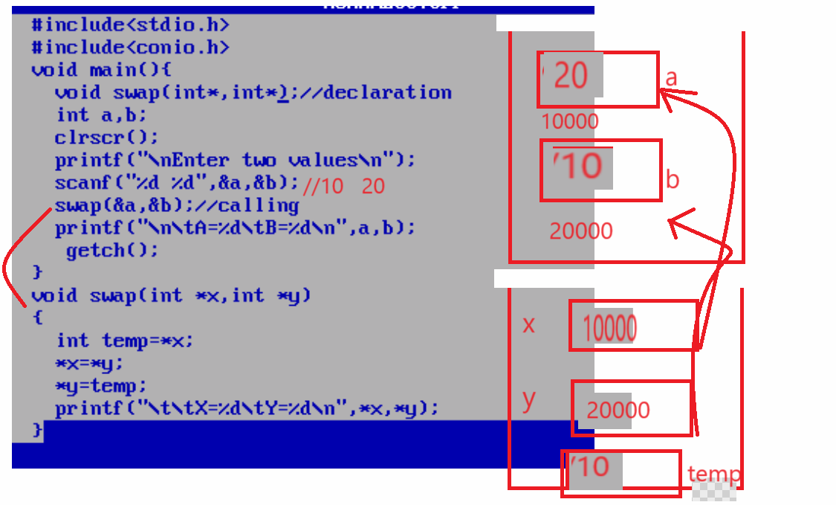

Local variable and global variable concept
__________________________________________________________________________
Local variable means if we declare variable within function called as local variable and if we declare variable before main or outside of function called as global variable

If we want to work with local variable we have some important steps.
1. Local variable cannot access outside of his block or function
2. Local variable use default value as garbage value.

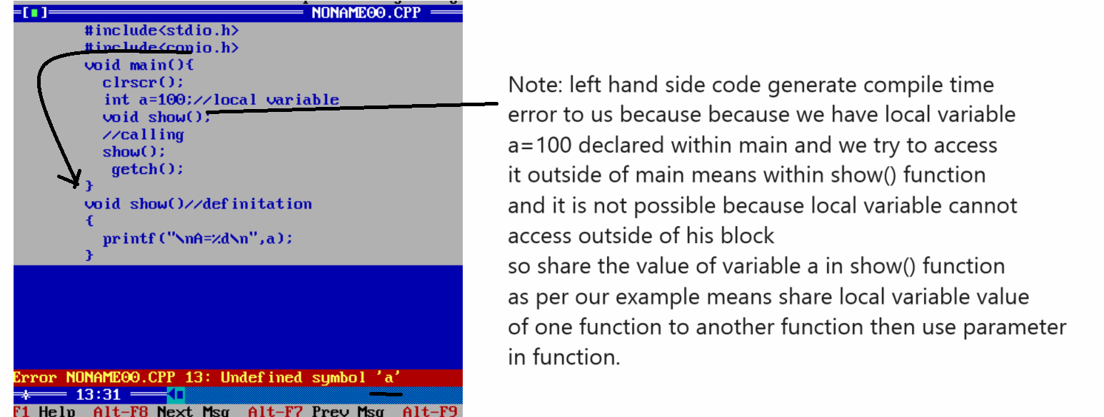
Parameter passing show in following code.
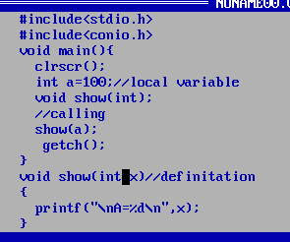

Global variable: if we declare variable before main called as global variable in c and global variable can access in all programs or can access in all functions of program.
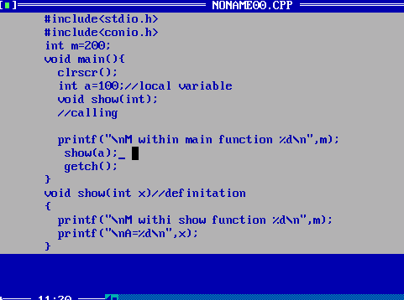

Example: what will be output of given code?
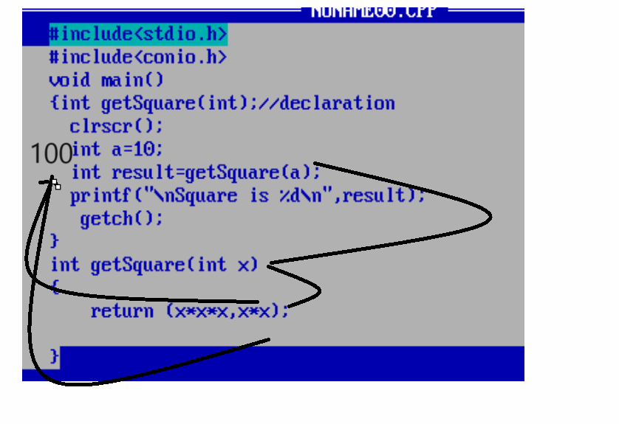
Output: Square is 100

