Pointers
_____________________________________________________________________________
Q. what is pointer?
___________________________________________________________________________
Pointer is a derived data type and which is used for allocate memory dynamically at program run time.

Q. what is derived data type?
________________________________________________________________________
Derived data type means those data type acquire the properties from another data type for complete its meaning called as derived data type

Q. what is dynamic memory allocation?
______________________________________________________________________________
To decide how much memory required at program run time called as dynamic memory allocation.

How you can use pointer practically?
______________________________________________________________________
If we want to use pointer practically we have syntax
Syntax: datatype *variablename;
(*) – denote pointer.
Example: int *ptr;//

How Pointer allocate memory dynamically?
___________________________________________________________________________
Pointer can allocate memory dynamically by storing address of another variable or another memory.
What is memory address?
Memory address is unique integer number provided by ram to every memory block.

Can we see the memory address?
______________________________________________________________________________
Yes we can see or access the memory address of variable and for that we have & operator.
Example:
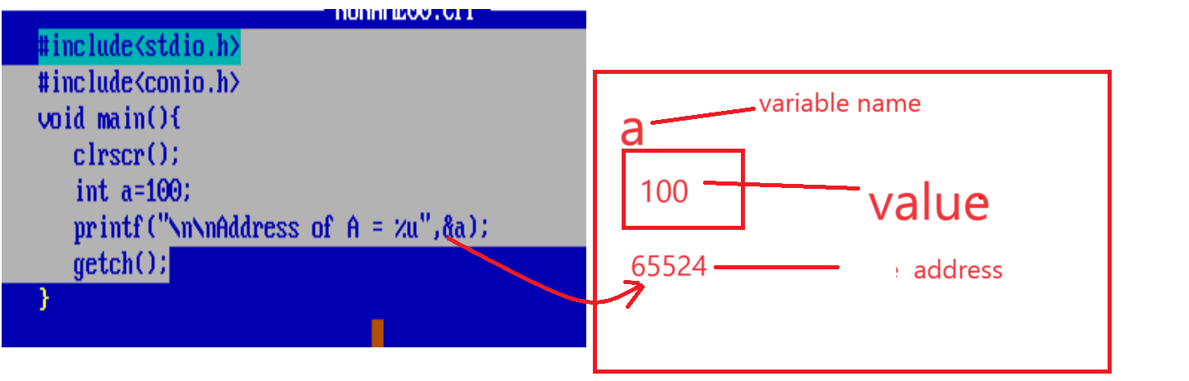
Output:
Address of A = 65524

How to store address of another variable in pointer?
____________________________________________________
If we want to store address of another variable in pointer we have following syntax
Syntax: pointervariable =&normalvariable;

important points of pointer
1. Pointer always use address of another memory and pointer has its own different address
2. Pointer can use the values of memory or variable whose address stored in it Just we need to use * with pointer at the time of use
Note: * known as value at address operator or dereferencing technique.
3. when we increase the pointer without * operator using ++ or decrease the pointer using -- then pointer can shift on next block or may be shift on previous block and block is size is dependent on data type of pointer.
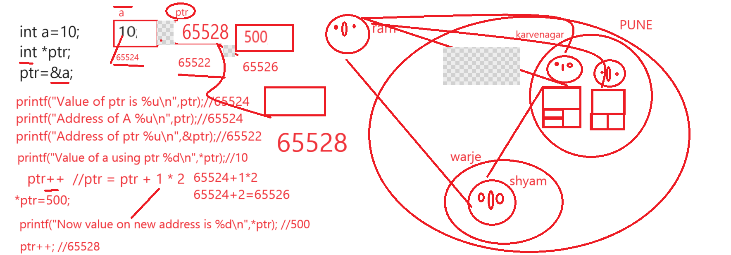

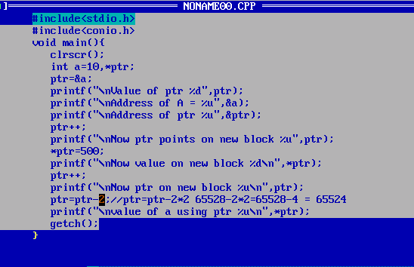

Example: for runtime memory allocation
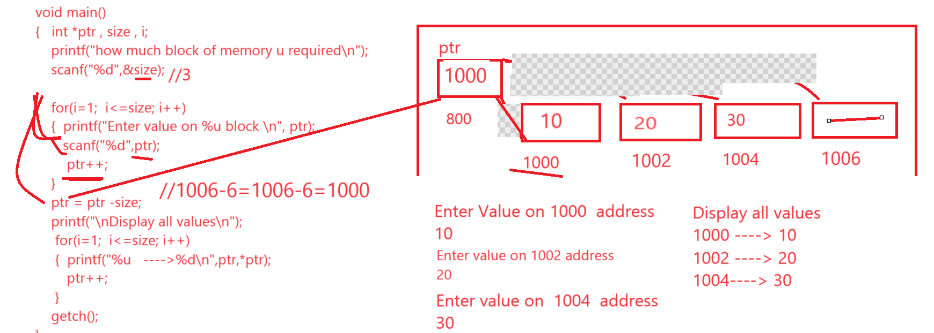

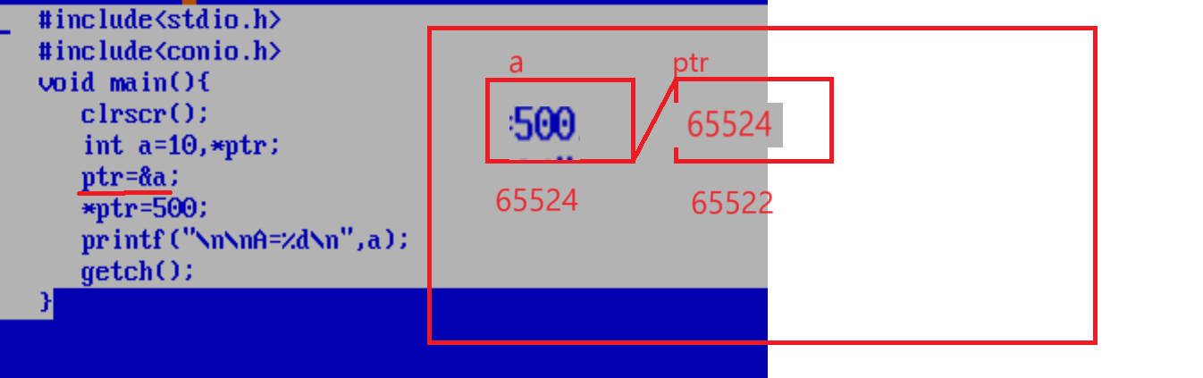
Output: A = 500
Application of pointer and Types of pointer

Application of Pointer
____________________________________________________________
1. Access Array or work with array
2. Work with String
3. Work with function
4. Work with Structure

Types of Pointer
____________________________________________________________
1. void pointer or generic pointer
2. Dangling of pointer
3. null pointer
4. Far pointer
5. Huge pointer
6. near pointer

How to access array by using pointer?
_______________________________________________________________________
If we want to access array by using pointer we have to store base address of array in pointer variable.

Q. What is base address?
___________________________________________________________
Base address means 0th location address called as base address.

Q. How to get base address of array?
_________________________________________________________________________
If we want to access base address of array we have following syntax

Syntax1: Use array without subscript
arrayname
Example:
int a[5];-array
printf(“%u”,a); //base address
or
Syntax2: use & operator with array 0th location
&arrayname[0];
Example: int a[5]={10,20,30,40,50};
&a[0] – base address
Example:
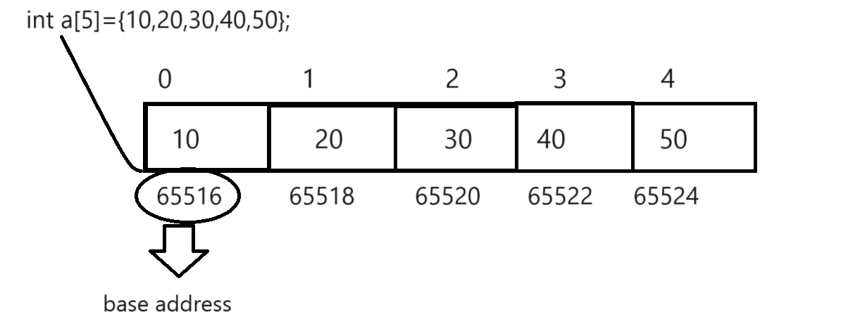
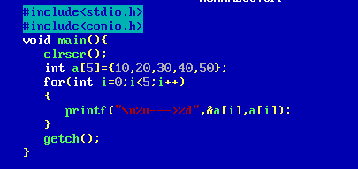
Output:
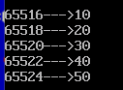

Example: Access array by using pointer.
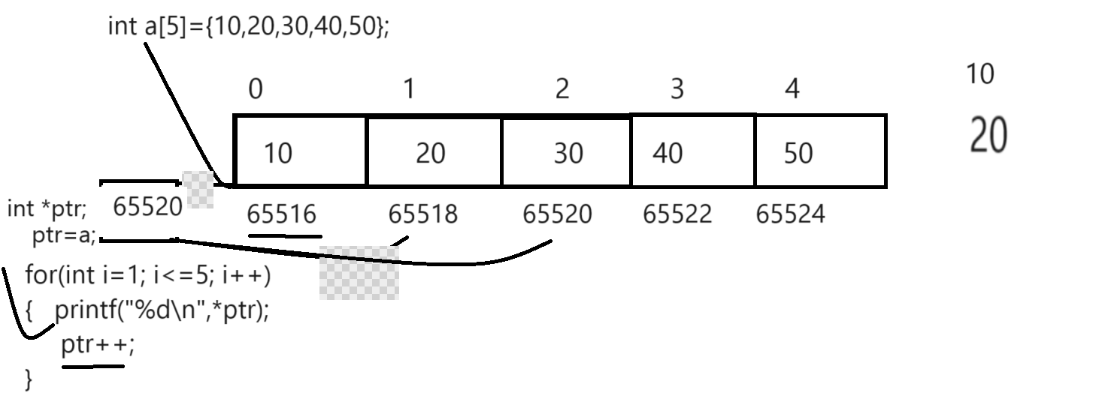
Example:
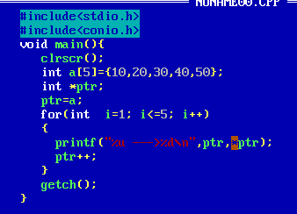

Q. what is meaning of a[i]?
the meaning of array[i] is base address+index*size
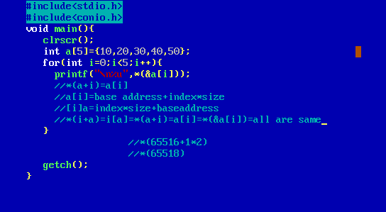

Q. why array index start from 0th location?
_________________________________________________________
because we want to fetch value of base address because when we fetch data from array then we have equation is base address+index*size so if we start array index from 1 then possibility is baseaddress+index*size shift direct on second address because in equation we have two operators + and * so multiplication executed before + so first 1*size get executed then added in base address so we get next address location means indirectly we get second value of array not first so for first value we need to perform multiplication first and need to get base address first time so we start from 0th means
baseaddress+0*size so first multiplication get executed so 0*size return 0 and if we add 0 in base address then we get base address first time so we get first so this is major reason address index start from 0th location

Q. Can we modify the base address of array?
No we cannot modify or change base address of array and if we try to modify the base address of array then we get compile time error.
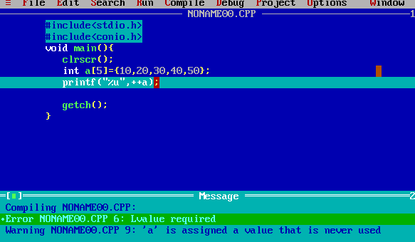

Q. what will be output of given code?
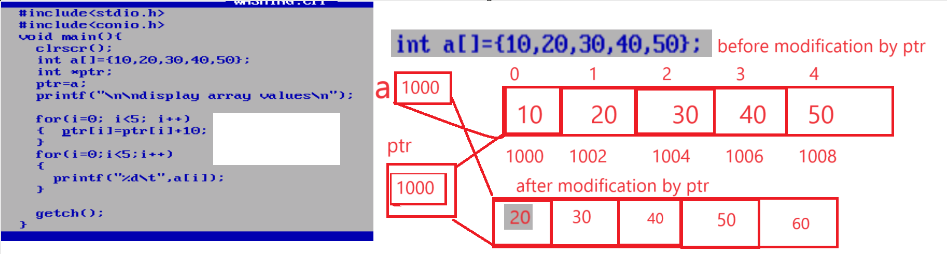
Q. what will be output of given code?
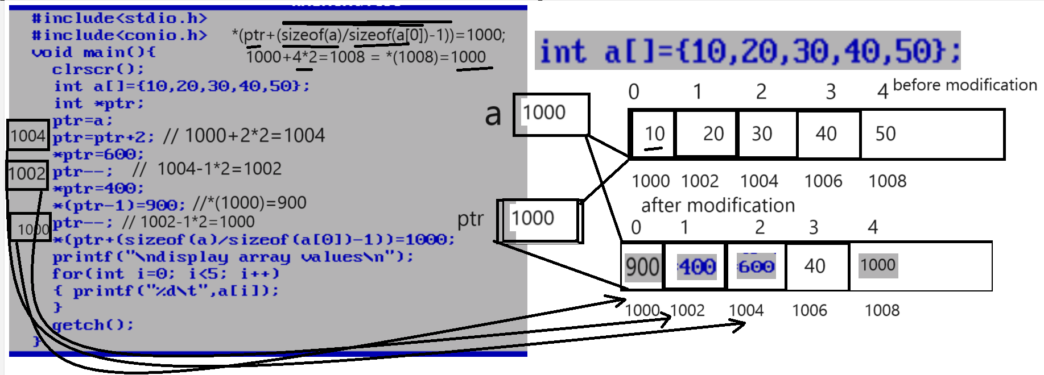

Q. what will be output of given code?
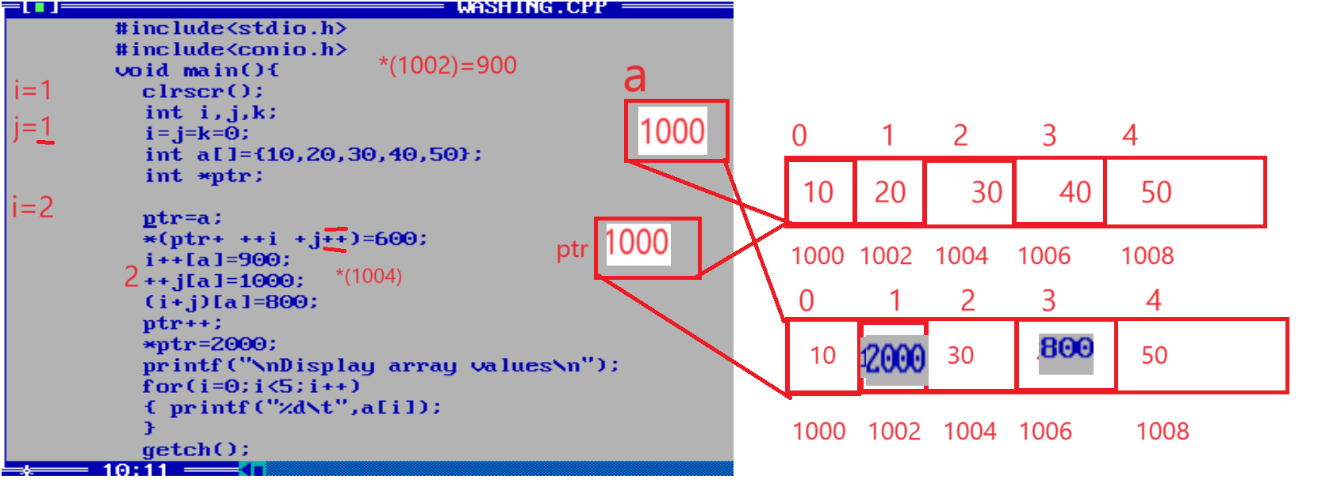

Q. what will be output of given code?
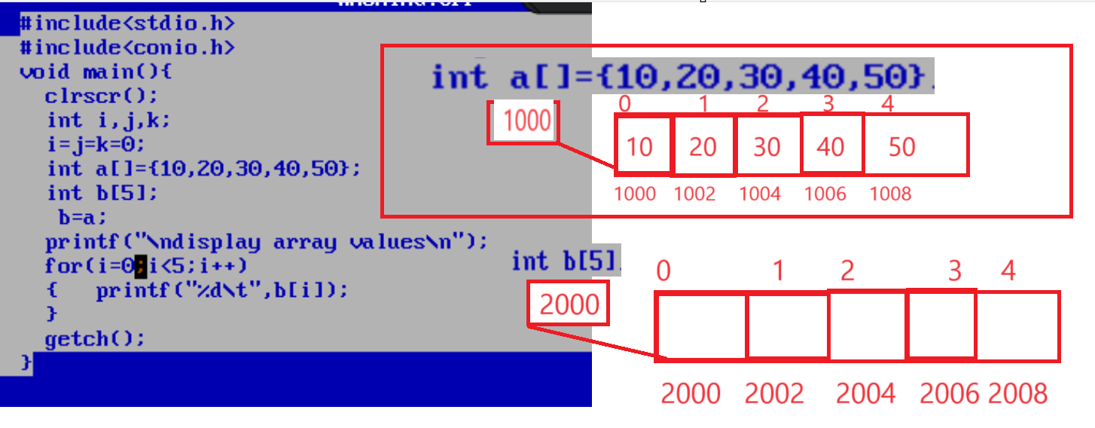
Note: above code generate compile time error to us because we use the statement b=a;
if we think about above code we have two arrays int a[]={10,20,30,40,50}; and int b[5] means
we have two different arrays in memory so the a has base address 1000 in our diagram and b has base address 2000 in our diagram and we cannot modify the base address of array and we use the statement
b=a means we try to modify the base address of array b means we try to initialize base address to b and it is not possible so we get compile time so if we want to copy the data between array to array we can copy member by member using loop shown in following code.
