Ball-by-Ball cricket event classification using temporal string kernels.

GUIDED BY
Prof. J Dinesh Babu

SUBMITTED BY
Harshit Joshi : MT2016059
Nitesh Kataria : MT2016097
Omang Poddar:MT2016099
Palak Langer:MT2016100



MAY 2017

TABLE OF CONTENTS

Abstract…………………………….…………………………………………………………….2

Chapter 1: Introduction……………………………………………………………………….....3

1.1 Problem Statemet
1.2 Motivation for solving this problem

Chapter 2: Literature Review…………………………………………………………………….4

2.1 Summary of related papers or readings that exist
2.1.1 Temporal Classification of Events in Cricket Videos
2.1.2 Fine-Grain Annotation of Cricket Videos

Chapter 3: Implementation of Cricket Event Classification System.......................................…..21

3.1 Dataset
3.2 Feature Engineering
3.2.1 Randomized PCA
3.2.2 VboW
3.2.3 Visual Features
3.3 Modelling(Building our model)
3.3.1 Shot Categorization
3.3.2 Event Categorization

Chapter 4: Current Results..............................................................................................................

Chapter 4: Future work……...........................……………………………...................................13

Appendix : Tools used (H/W & S/W)……………………………………………………….14

References

ABSTRACT
________________________________________________________________________________

.
.
.
.
.
.
.
.
.
.

CHAPTER 1
INTRODUCTION
________________________________________________________________________________

1.1 Problem Statement
In the sport of cricket, each ball can have different outcomes, and we define our classification task as the prediction of this outcome, given a sequence of frames representing the video for that ball. Further we would like to extend our project for generating context-rich commentary with the output. The input to our algorithm is a video clip of a single ball being played out in Cricket

1.2 Motivation for solving this problem
Video search today uses the metadata surrounding the video, ignoring its semantic content. Over the years, a lot of research has gone into indexing and browsing of sports video content. Cricket, being the most popular sport in our country, is our selected sport. In our project, we try for classification of events in cricket videos and thus, summarize its visual content.
As we all know the popularity of the game the usefulness of the work can be many. From automatically describing a given cricket video to integrating with a module that generates text-based commentary on the basis of outcome produced by our project.
From learning point of view, apart from inculcating the ethics of working in a team and generate quality reports, we surely are on the way to enhance our technical knowledge in the domain. Starting from feature engineering on videos to applying various classification methods, improving upon them, are some tasks to mention. Further, if time permits, we would like to take this one step ahead and try to work on generating text-based commentary which would definitely add to our skills.

CHAPTER 2
LITERATURE REVIEW _____________________________________________________________

2.1 Summary of related papers or readings that exist
2.1.1 Temporal Classification of Events in Cricket Videos:
In our work , Visual features are extracted from individual frames and a multi-layer perceptron (MLP) is trained to classify them into a category such as pitch, ground, etc. A novel temporal classifier based on sequential pattern mining and support vector machine (SVM) is then used to identify the events in the match. A shot is a low-level content representation unit .It consists of a group of consecutive frames having similar visual content. The given cricket video is first segmented into the number of shots and visual features are extracted from the frames in the individual shots. A MLP is then used to classify each shot into one of the following categories: GROUND,PITCH,BOUNDARY, PLAYER and CROWD.

2.1.2 Fine-Grain Annotation of Cricket Videos:
In this Each shot is represented with the classical Bag of Visual Words (BoW) approach . SIFT features are first computed for each frame independently, which are then clustered using the K-means clustering algorithm to build a visual vocabulary (where each cluster center corresponds to a visual word). Each frame is then represented by the normalized count of number of SIFT features assigned to each cluster (BoW histograms). The shot is represented by the average BoW histogram over all frames present in the shot. The shots are then classified into one of these classes: {Bowler Runup, Batsman Stroke, Player Close-Up, Umpire, Ground, Crowd, Animations, Miscellaneous}. The classification is performed using a multiclass Kernel-SVM. The individual shot classification results could be further refined by taking into account the temporal neighborhood information. Given the strong structure of a Cricket match, the visuals do not change arbitrarily, but are predictable according to the sequence of events in the scenes. Such a /sequence could be modelled as a Linear Chain Conditional Random Field (LC-CRF).

CHAPTER 3
IMPLEMENTATION OF SYSTEM
________________________________________________________________________________

3.1 Dataset
Our dataset is collected from the YouTube channel for the Indian Premier League(IPL) tournament. The format for this tournament is 20-overs per side, which results in about 120 scenes or events for each team. The dataset consists of four matches, amounting to about 16 hours of footage. Currently we have segmented one full match manually at the scene and shot level . We plan to extend the segmention task to four matches, two of which will be used for training and the other two for testing.
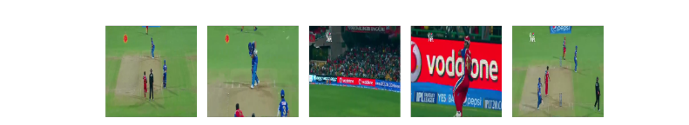
Figure 1. A sample video in our dataset

Our Final Dataset consists of segmented videos of cricketing events namely Four , Six , Wicket and Run .

3.2 Feature Engineering

3.2.1 Randomized PCA
Motivation for PCA - It is simple and allows one to get the useful representation of the image in R^{n}.

First of all, the images were flattened . Then PCA was applied. The components were added to the list of extracted features.
Currently we have taken number of component as 15 , but we look to arrive at an optimal guess using Grid Search .

3.2.2 VBoW
Each shot frame is represented with the classical Bag of Visual Words (BoW) approach . SIFT features are first computed for each frame independently, which are then clustered using the K-means clustering algorithm to build a visual vocabulary (where each cluster center corresponds
to a visual word). Each frame is then represented by the normalized count of number of SIFT features assigned to each cluster (BoW histograms).
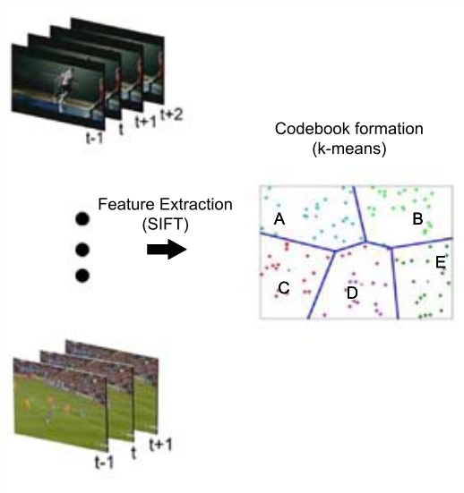

Figure 2: Visual CodeBook Generation .

3.2.3 Visual Features
Following are the visual features that are used for frame categorization.

1. Grass Pixel Ratio (GPR): A pixel is identified as a grass pixel if its hue component lies between
48 and 68 (determined experimentally). We first compute a histogram for the hue component of
the frame quantized into 256 bins. The GPR is the ratio of the pixel count in bins 48-68 to the
total number of pixels.

2. Pitch Pixel Ratio (PPR): We observed through experiments that the pixels having Blue
component between 150 and 175 , Green component between 160 and 190 and Red component
between 130 and 150 are generally pitch pixels. We compute PPR as the ratio of the pitch pixel
count to the total number of pixels.

3. Edge Pixel Ratio (EPR): The presence of crowd in a frame can be detected by performing canny
edge detection on the given image. We therefore calculate the ratio of the number of edge pixels
to the total number of pixels on a frame (EPR).

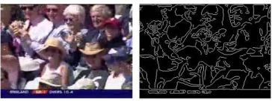

Fig . Canny edge detection on a frame containing the crowd.

The final set of features is the following:
- PCA
- VBoW
- GPR
- PPR
- EPR

3.3 Modeling (Buildind Our Model)
We have Modelled our problem into two subtasks :
i. Shot Categorization
ii. Event Categorization

3.3.1 Shot Frame Categorization :
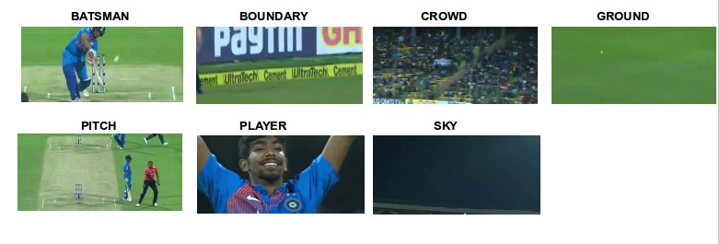
Figure 1. Visual shot categories.

A shot frame is a low-level content representation unit . It consists of a group of consecutive frames having similar visual content. The given cricket video is first segmented into a number of shots and visual features are extracted from the frames in the individual shots. A shot frame classifier is then used to classify each shot into one of the following categories(Fig. 1......):
1) GROUND 2) PITCH 3) BOUNDARY 4) CROWD
5) PLAYER 6) BATSMAN 7) SKY.
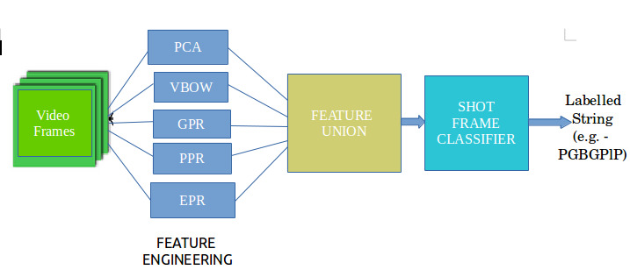
Fig. Shot Frame Classifier Pipeline

3.3.2 Event Categorization
In a cricket video, events of interest include run, six, four, etc.
The sequence of shots between two consecutive bowling shots corresponds to an event.
In our project, we consider four events for classification namely, FOUR, SIX, OUT and RUN.

Temporal Classification
The training corpus consists of tuples of the form <X, e>, where X is a shot sequence obtained by procesing video through shot frame classifier and e is the corresponding event.

There training process consists of the following three steps:
1. Sequence mining: First, frequent subsequences are mined from the set of shot sequences in
the corpus. Each frequent subsequence correspoonds to a feature for classification.
Here we have used Generalized Sequential Pattern (GSP) mining algorithm to mine frequent
subsequences in the training corpus.

2. Feature Extraction: Let {s ₁ , s ₂ , ..., , s _{n} } be the set of frequent subsequences mined from
the corpus. Let f _{i} be a binary feature corresponding to subsequence s _{i} . Given a sequence of
shots X, the feature value f _{i} (X) is 1 if the subsequence s _{i} matches with X and is 0 otherwise.

3. Supervised Learning: A support vector machine (linear kernel) is trained using the sequential
minimal optimization (SMO) algorithm to classify events based on the extracted binary
feature vectors. The working of the temporal classifier has been illustrated in Fig ......

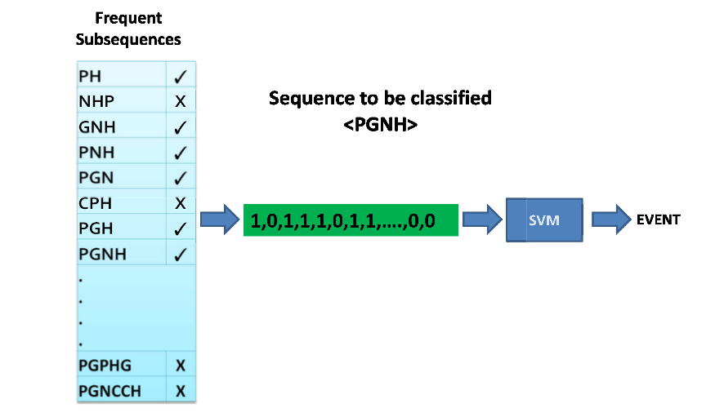
Figure 10. Temporal Classifier for Cricket Vid deo Events.

CHAPTER 4
CURRENT RESULTS
________________________________________________________________________________
Current Result

CHAPTER 5
FUTURE WORK
_____________________________________________________________

Future work
Future lines of work include following tasks -
1. Improving the accuracy of base shot frame classifier
2. Tuning the hyperparameters of the classifier.
3. Improving and extending the dataset.
4. Testing different sequence mining algorithms.
5. Increasing the overall accuracy of the project.
APPENDIX

Tools Used (Software and Hardware) :

REFERENCES
_____________________________________________________________

[1] N. Harikrishna Sanjeev Satheesh S. Dinesh Sriram K.S. Easwarakumar “Temporal
Classification of Events in Cricket Videos” IEEE 2011.
[2] Lamberto Ballan, Marco Bertini, Alberto Del Bimbo, Giuseppe Serra “Video event
classification using string kernels” Multimed Tools Appl (2010)
[3] Kalpit Dixit, Anusha Balakrishnan Stanford University “Deep Learning using CNNs for Ball-
by-Ball Outcome Classification in Sports”
[4] Rahul Anand Sharma, India Pramod Sankar K, C. V. Jawahar“Fine-Grain Annotation of Cricket
Videos” IEEE 2015.

