1. Strategic Positioning (Core Message)
❝ From Utility-Grade Automation to Mission-Critical Facilities ❞
Position Al-Ojaimi Automation as a “Utility-Grade Automation Integrator”
—not a typical BMS or system integrator.
“We design automation systems that run power grids.
We apply the same engineering discipline to factories, hospitals, and mega facilities.”
This immediately:
- Justifies higher CAPEX
- Signals zero-tolerance for downtime
- Differentiates you from BMS / low-cost integrators

2. Target High-Value Vertical Segments (Non-Utility)
2.1 Industrial & Process Facilities (Primary Target)

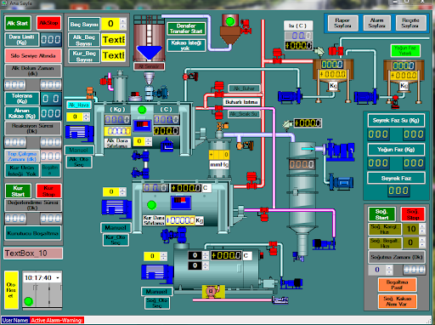
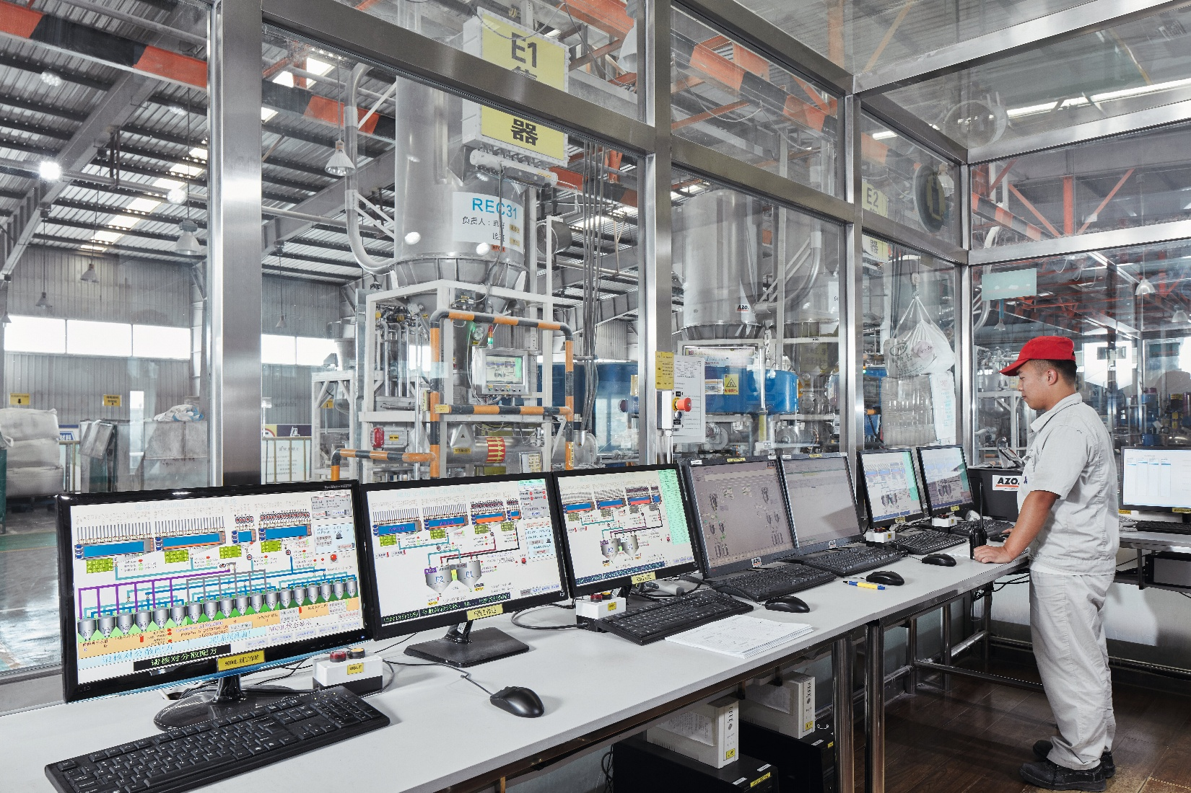
4
Examples
- Large manufacturing plants (cement, steel, FMCG, chemicals)
- Food & beverage factories (multi-line production)
- Industrial zones & clusters
Budget Range
- 7–30+ M SAR
Your Competitive Advantage
- SCADA-first mindset (not just PLC logic)
- Network segmentation, redundancy, virtualization
- OT cybersecurity awareness
- KPI-driven dashboards (OEE, energy, downtime)
Typical Offers
- Plant-wide SCADA & historian platform (Zenon / equivalent)
- Production monitoring & OEE optimization
- Energy optimization & power quality monitoring
- Predictive maintenance & alarm rationalization
- OT network design & hardening

2.2 Medical Campuses & Mega Hospitals
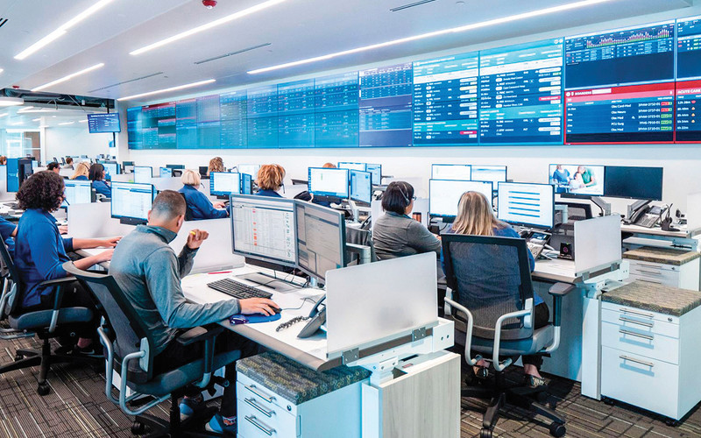

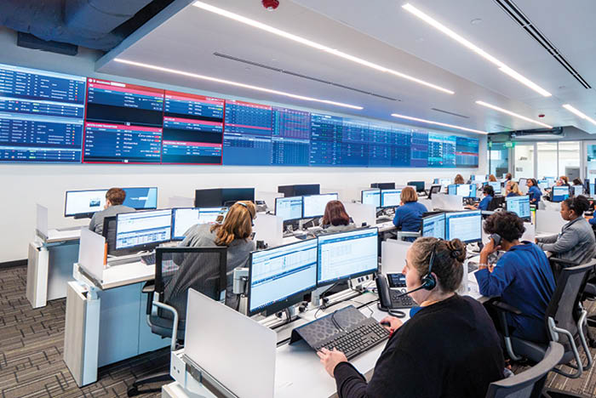
4
Examples
- Medical cities
- University hospitals
- Private healthcare holding groups
Budget Range
- 8–25 M SAR
Why You Fit Perfectly
- Hospitals = 24/7 mission-critical operations
- Similar risk profile to substations:
  - Zero downtime
  - Redundant power, HVAC, gases
  - Strict alarm management
High-Value Services
- Centralized hospital command & control center
- Power, HVAC, medical gas, UPS, generator monitoring
- Cyber-secure OT architecture
- Integration of disparate OEM systems into one SCADA
- Alarm prioritization & escalation workflows

2.3 Mega Buildings & Holding Facilities
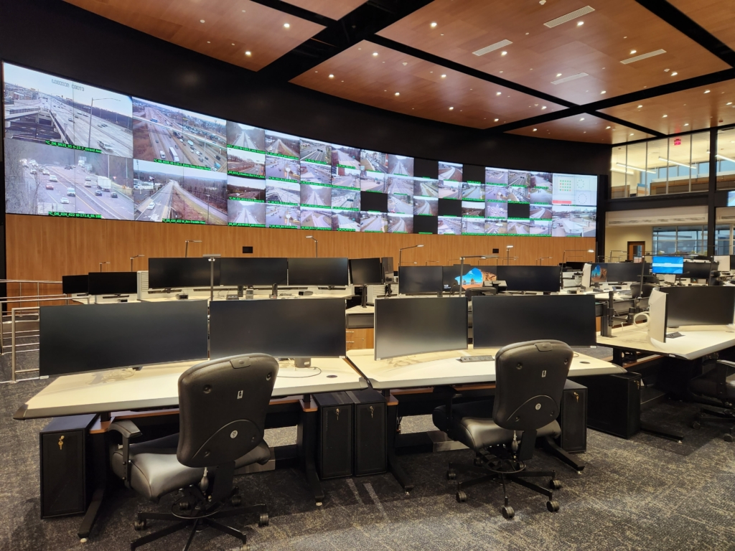


4
Examples
- Data centers
- Airports
- Financial HQs
- Mixed-use mega developments
Budget Range
- 10–50 M SAR
Your Differentiation
- You don’t sell BMS → you sell Facility Operations Intelligence
- You manage:
  - Power quality
  - Redundancy logic
  - Failover scenarios
  - Long-term scalability
Typical Scope
- Multi-system integration (BMS, EMS, PMS, security)
- Virtualized control rooms
- Energy optimization & peak shaving analytics
- Disaster recovery & failover design

3. Technology Stack Messaging (Reframed for Non-Utility)
Primary Platform (Flagship)
COPA-DATA zenon Software Platform
How to Market It
- Vendor-agnostic, open architecture
- Proven in grid-level critical infrastructure
- IEC-grade alarm & event handling
- Scales from single plant to multi-site enterprise
Supporting Capabilities (Silent Strengths)
- PLC / DCS multi-vendor integration
- Industrial networks (VLANs, redundancy, firewalls)
- Virtualization (VMware / Proxmox)
- Data historians & SQL reporting
- OT cybersecurity principles
- Custom middleware & gateways

4. High-Budget Offer Structure (Avoid Low-Value Projects)
Minimum Project Entry Point
“Projects below 5 M SAR are selectively evaluated.”
Package Positioning
Tier 1 – Mission-Critical Automation (7–12 M SAR)
- SCADA + core systems integration
- Network architecture & redundancy
- Commissioning & handover
Tier 2 – Operational Intelligence Platform (12–25 M SAR)
- Tier 1 +
- OEE / energy analytics
- Predictive maintenance
- Centralized command center
Tier 3 – Digital Operations Backbone (25 M+ SAR)
- Multi-site integration
- Enterprise dashboards
- DR / cyber resilience
- Long-term support contract

5. Marketing Content Strategy (Executive-Focused)
5.1 Core Marketing Assets
Asset | Purpose
1-Page Capability Statement | CEO / Board
Utility-Grade Automation Whitepaper | CTO / Engineering
Industry-Specific Case Narratives | Decision committees
LinkedIn Thought Leadership | Brand authority
Technical-Commercial Slide Deck | Sales meetings
Example Thought Leadership Topics
- “Why Utility-Grade SCADA Belongs in Hospitals”
- “From Substations to Smart Factories: Lessons in Zero-Downtime Design”
- “Why Most BMS Projects Fail at Scale”

6. Go-To-Market (How to Reach 7–10 M+ Projects)
Primary Channels
- Direct engagement with:
  - EPC contractors
  - PMC firms
  - Large consultants
- Invitation-only technical workshops
- Strategic vendor alliances (PLC, HVAC, medical OEMs)
Sales Approach
- No price competition
- Lead with risk, reliability, lifecycle cost
- Emphasize engineering governance & execution discipline

7. Key Message for Decision Makers
For Executives
“This is not an automation system.
It’s an operations continuity platform.”
For Engineers
“Open architecture, vendor-neutral, IEC-grade design.”
For Procurement
“Lower lifecycle cost, fewer vendors, reduced failure risk.”

