**Personal Website Project**

**Software Requirements Specification**

**1.1**

**19/09/2022**

**Product Name: OD (Frontend)**

**Prepared for**

WWW.OD.com

**1. Introduction**

This Portfolio project aims to provide a collection of my professional projects to employers. It will **help employers understand my background as a software engineer**, so include my most impressive projects and work experiences.

**1.1 Purpose**

*The Purpose of this document is to outline the requirements for the portfolio website to be developed. This document will be used by all stakeholders including developers and testers.*

**1.2 Scope**

*The scope of this project is limited to the testing of the features described in the succeeding sections of this document.*

*Non-functional testing like stress, performance is beyond scope of this project.*

*Automation testing is beyond scope.*

*Functional testing & external interfaces are in scope and need to be tested*

*The website will be only compatible with Chrome version 27 and above*

## 1.3 Technical Requirements

## OD requires certain technical requirements to be met for the store to operate properly. First, a web server must be created to make the OD Website publicly available on the web. Domain names and hosting services can easily be purchased for an affordable price. When selecting a hosting service, you should check to see that these server. Requirements are provided and installed on their web servers: These extensions must be enabled for OD to install properly on the web server.

## • PHP 8

## • jQuery

## • JavaScript

## • Database (MySQL suggested)

## • Web Server (Apache suggested)

## OD Frond-End:

1. **Home page**

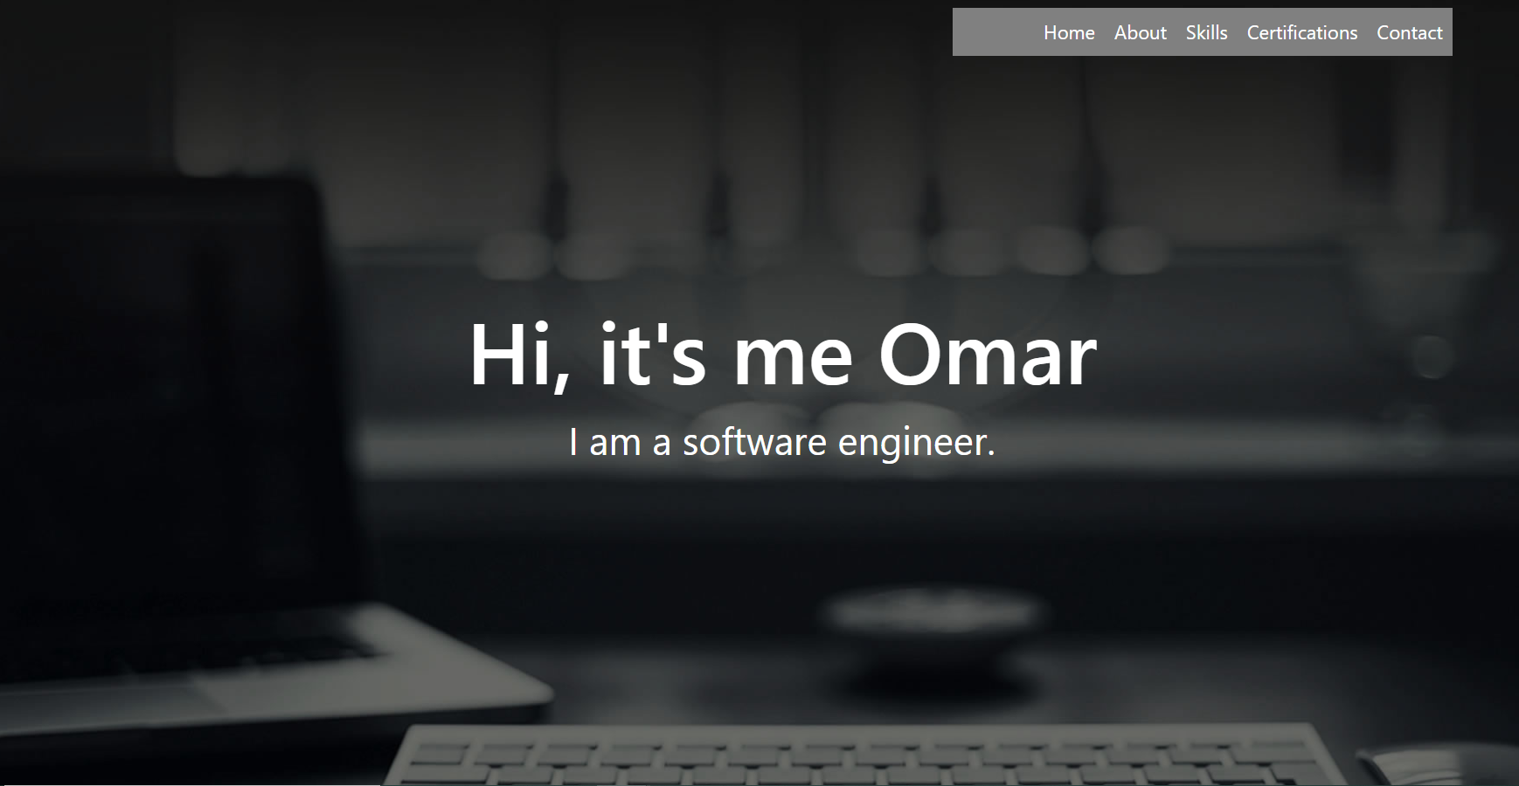

1. **About page:**

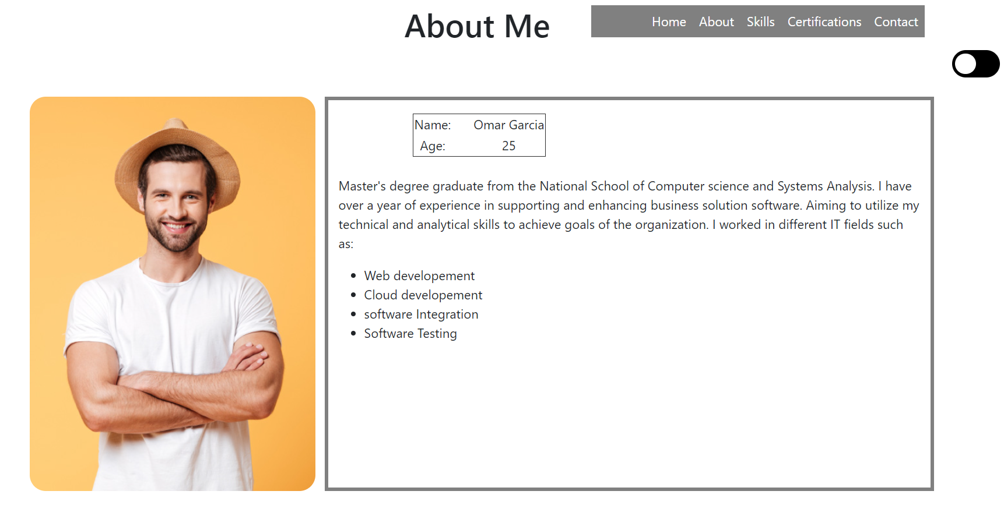

1. **Skills:**

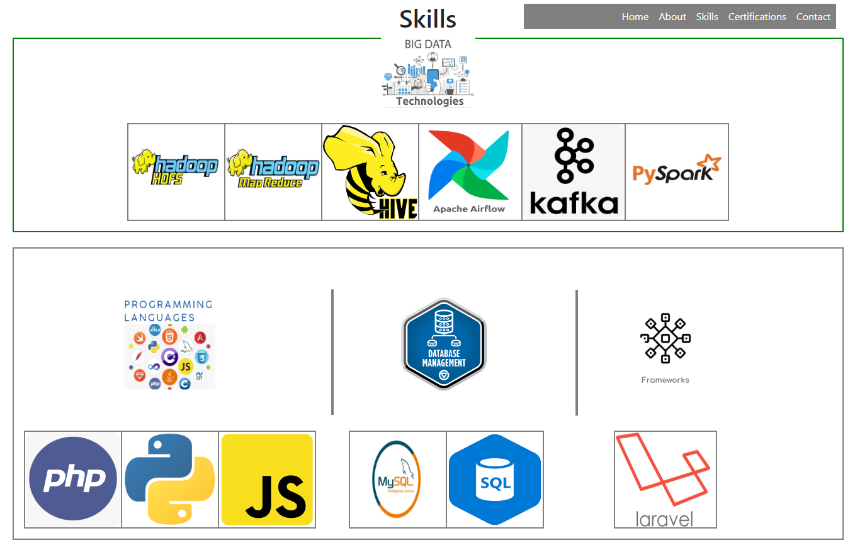

1. **Certification page:**

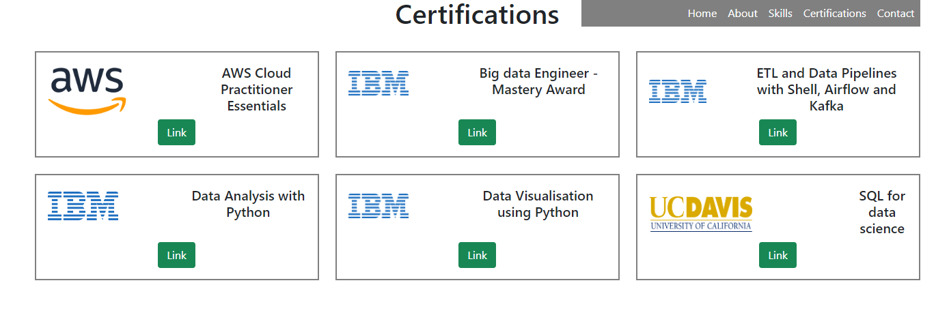

1. **Contact Page:**

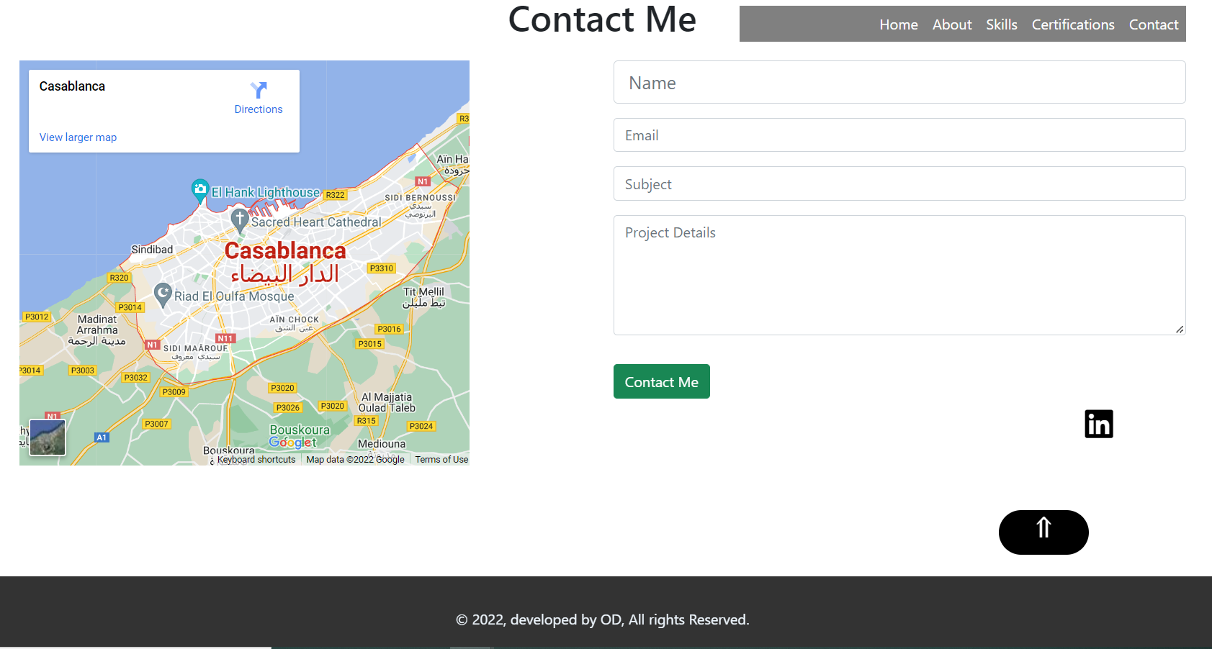

**T1** Name is required

**T2**  Name - Special character are not allowed

**T3** Name - Characters are not allowed

**T3**  Name - First character cannot have space

**T4**  Email : Email ID must not be blank

**T5**  Email : Email ID is not valid

**T6**  Email : First character cannot have space

**T7** Subject is required

**T8**  Subject - Special character are not allowed

**T9** Subject - Characters are not allowed

**T10**  Subject - First character cannot have space

**T7** Details is required

**T8**  Details - Special character are not allowed

**T9** Details - Characters are not allowed

**T10**  Details - First character cannot have space