Team 03

Authors: Omar Alomar, Sudeep Bishwakarma, Abednego Njike, Jared Herrera, Josh Thompson

**User Documentation**

**1.1 Introduction and Purpose**

The purpose of this website is to allow drivers, executives, and clients to login into their home page and see the assigned features respective of their role and position in the company. The name of the system is Dump Truck services/system.

**1.2 User Manual**

**1.2.1**

*Driver interface(Sudeep, Josh)*

Driver interface will login into the website using their given name and password. Once they login successfully, they will be able to see their dashboard. In the dashboard driver will be able clock in at the start of the work and clock out at the end of the shift. There is other two features’ logs where drivers will be able to see all the Logs details and in the work history feature drivers will be able to see hours worked, week worked and hourly rate and gross amount of money they are getting.

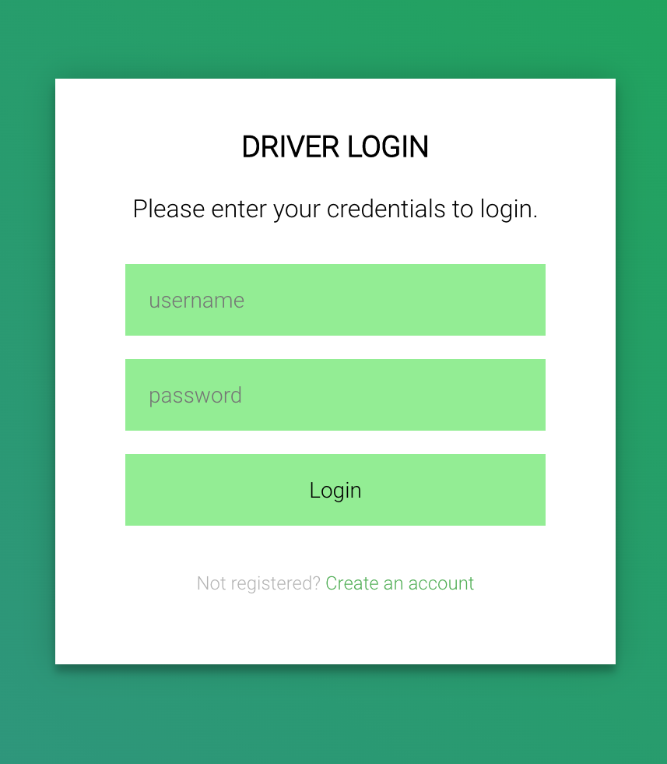

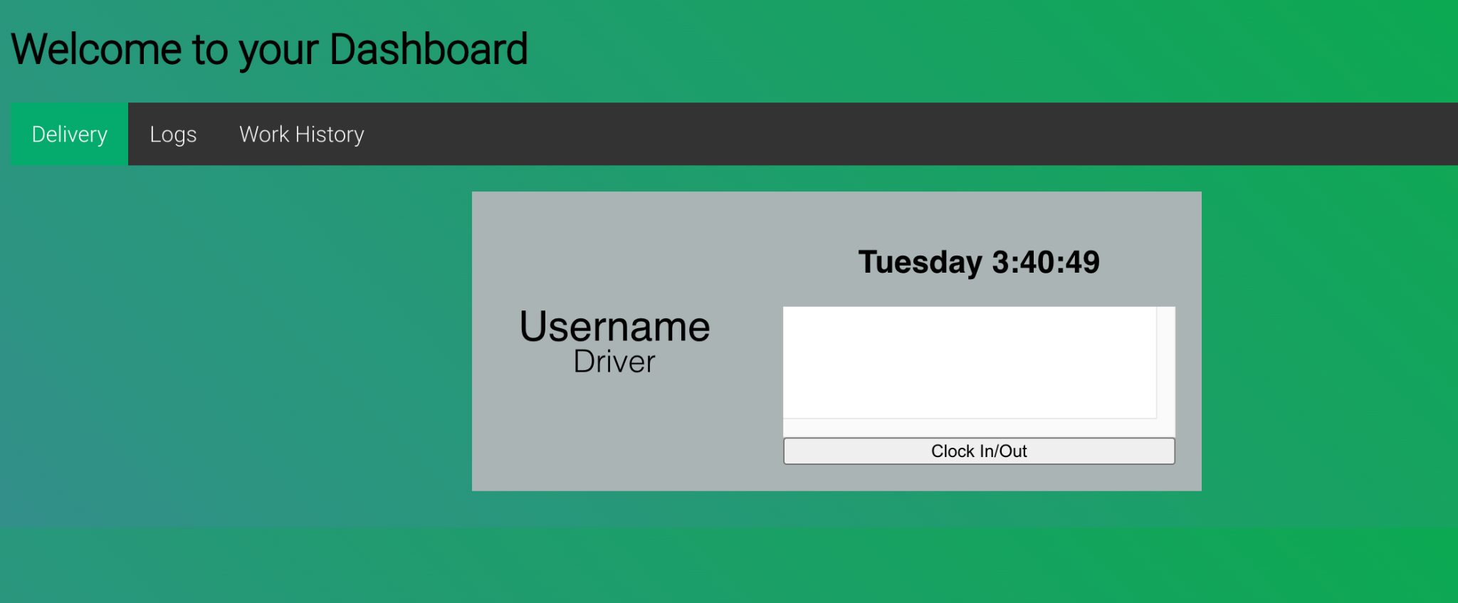

**1.2.2**

*Executive interface(Omar)*

The executive interface allows company executives to perform several business operations, such as managing orders, clients, and account information. When it is chosen from the main page, users are prompted to log in:

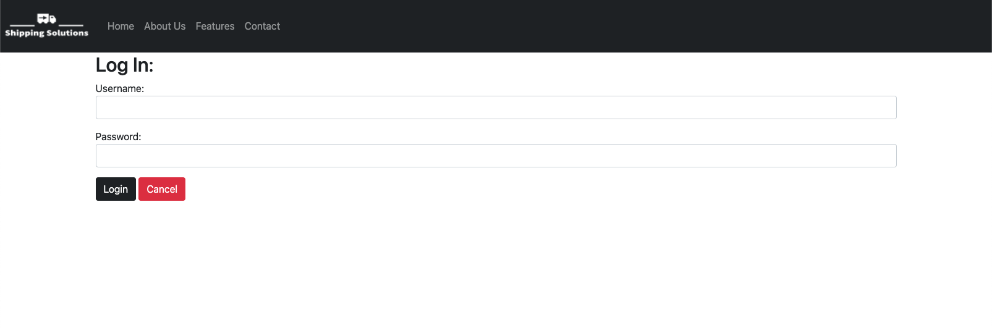

This login page uses php to validate the login info by comparing the username/password against the user SQL database. If the login info is not correct, the user cannot access the site:



Once the user logs in successfully, they are presenting with the order manager page:

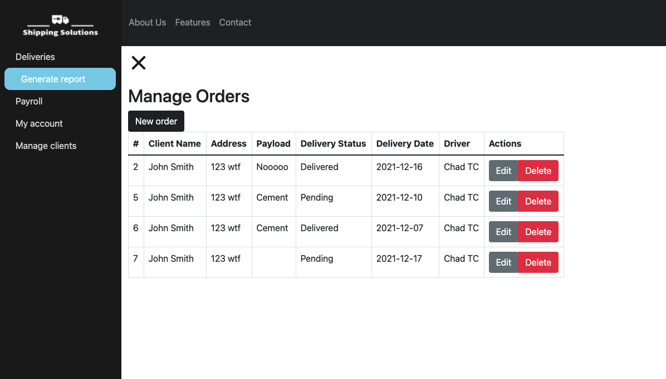

The executive interface is a single page application (SPA) with 5 views: delivery manager, report generator, payroll, account management, and client manager. The SPA is based on the collapsible animated side navigation bar, which I made with JS.

The order/delivery manager offers fully featured CRUD (create, read, update, delete) UI. The “new order” button allows executives to create a new order:

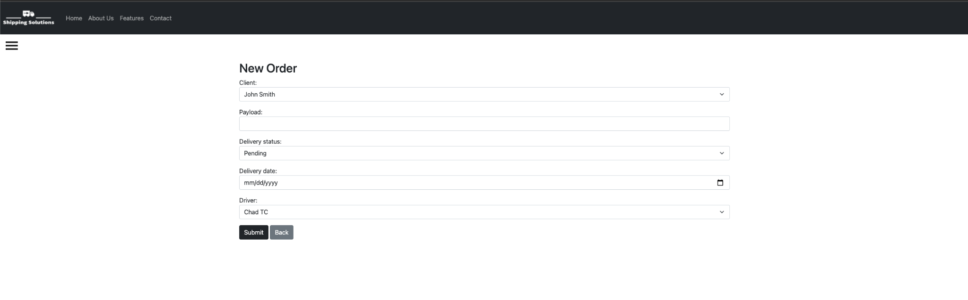

This view lets users choose from available clients through a drop down, as well as drivers. This is achieved through some php scripts and sql queries, which pull existing client and driver info from the database. You can input all other order information as well and insert into the database, which you can view in the delivery manager.

The “edit” button displayed next to each entry allows users to edit existing order records, and it prompts the users with an html form to do this on the same page:

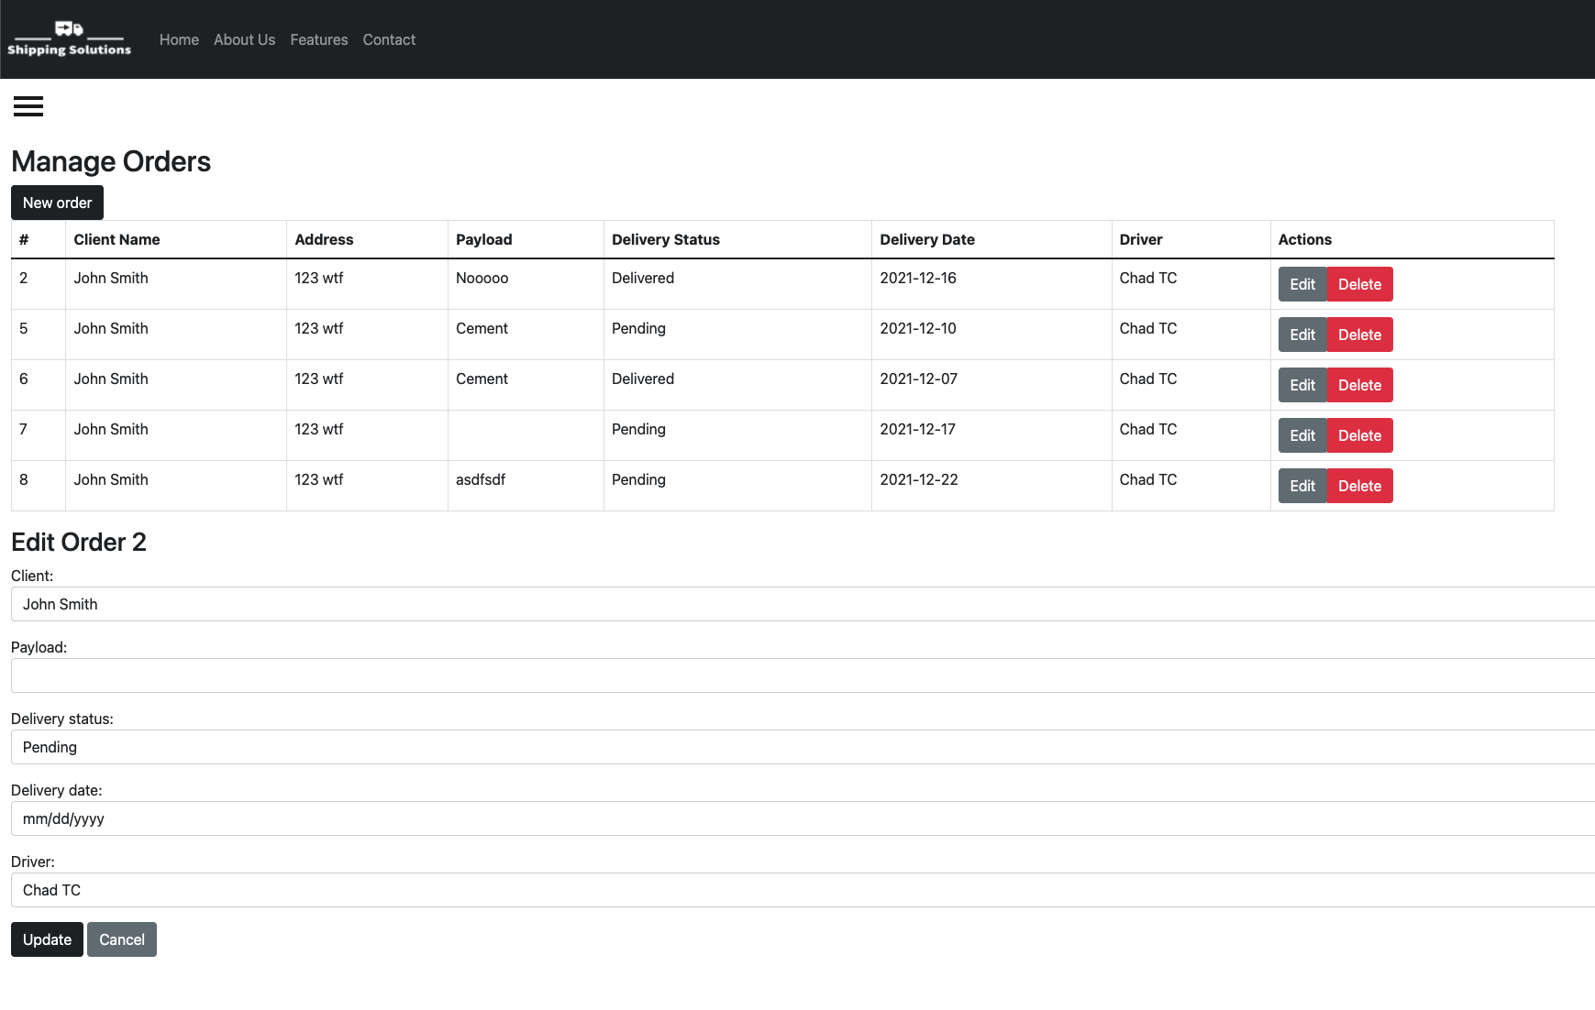

The delete button simply removes records.

The client manager view offers similar CRUD functionality for clients rather than orders:

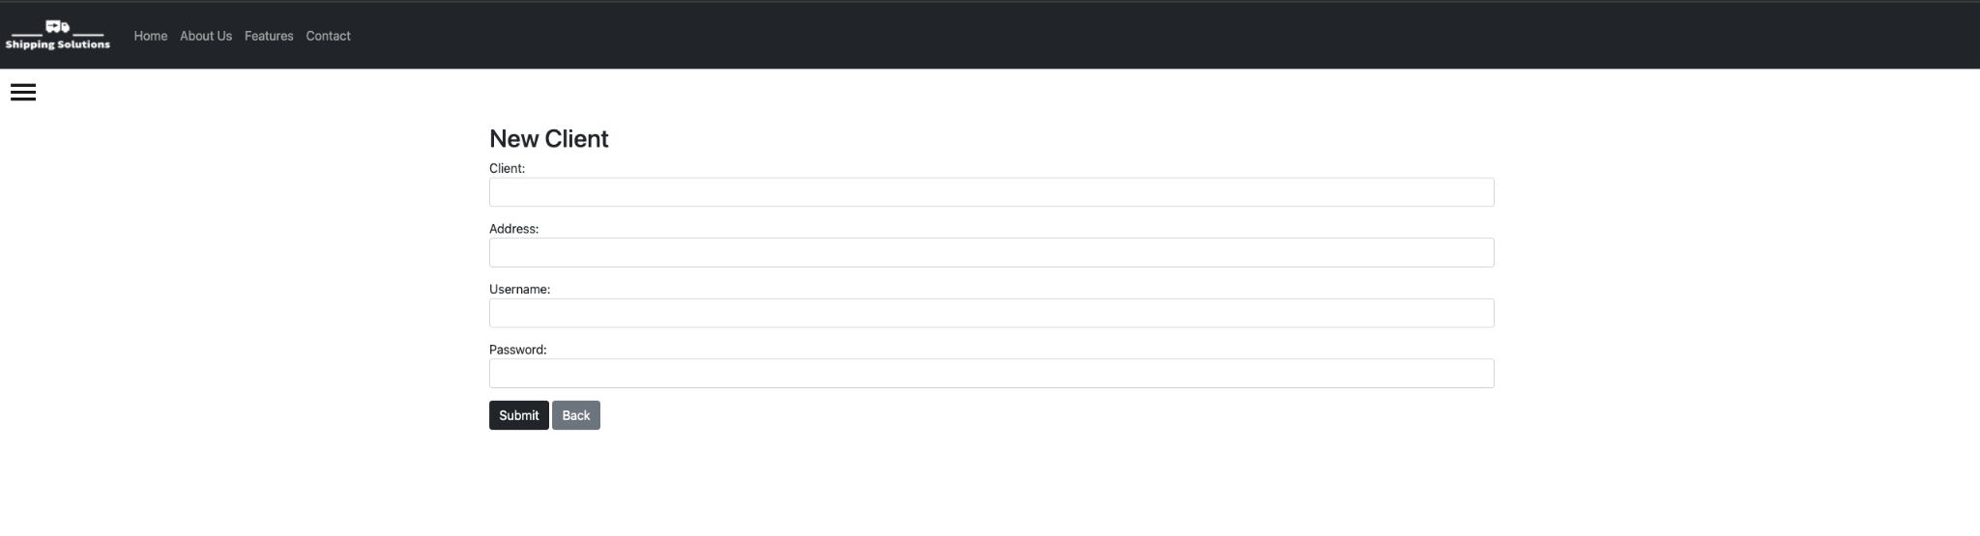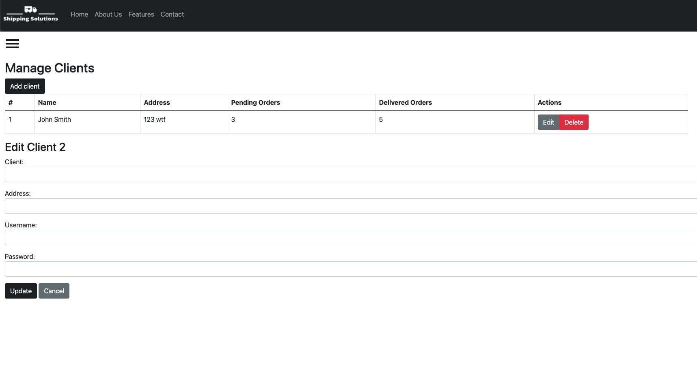

Account manager offers simple username/password changing options:

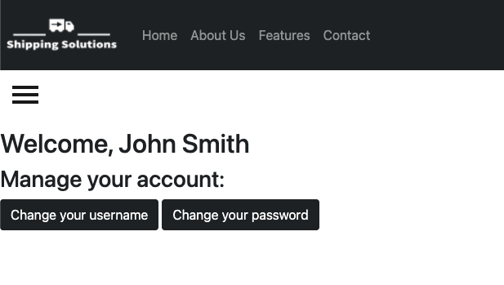

The application login system keeps track of and stores the current user information.

Report generator:

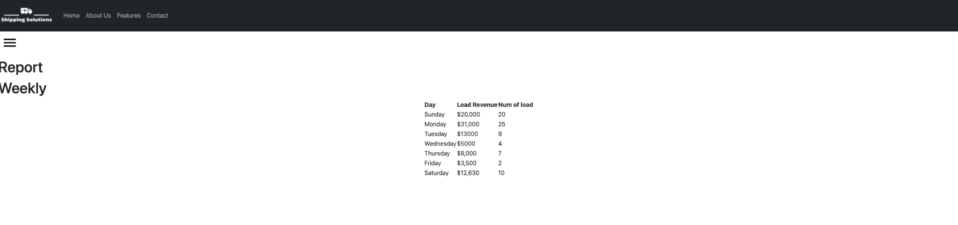

**1.2.3**

Client interface (Jared)

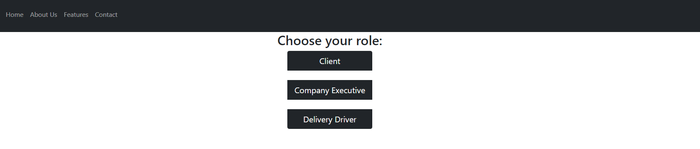

The Client Interface Holds the information and functions that the client should have access to. The Client interface has one page for each function which totals to three pages.

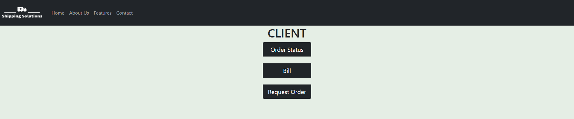

The First Page is the Order status page which allows Clients to see the order status of their order. The information will be the order address, Company Name, the load type, and the status.

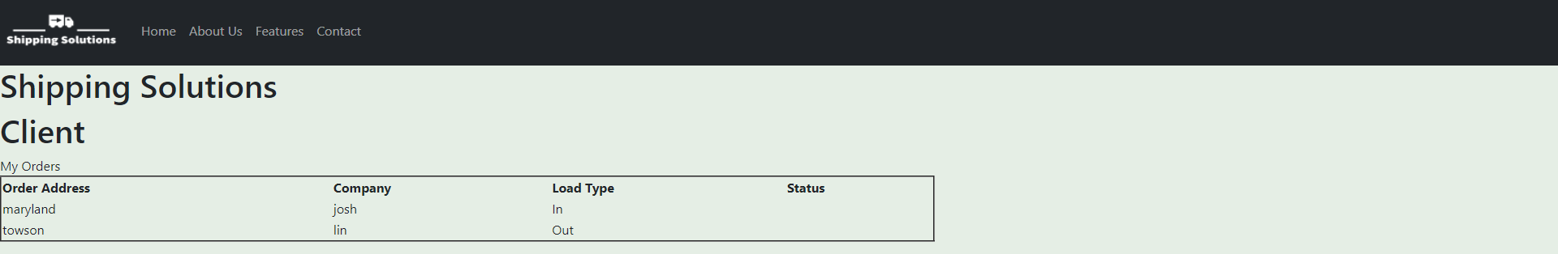

The Second page is the bill page which will show the client his/her orders and how much is due. The information in this page is the Order Address, AMount of Loads, Load Type , and the Amount Due.

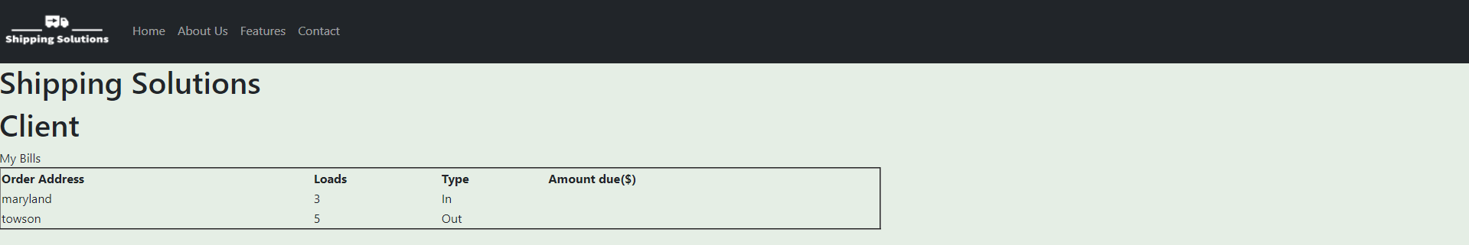

The third Page is the request order page. This page will prompt the client to insert a new order by asking for the company name , address, Delivery Date, Load type, and the number of Loads.

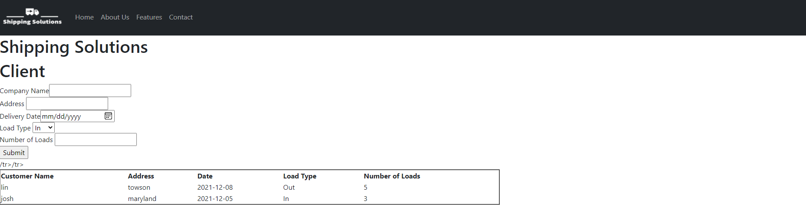

**2 System Overview**

**2.1 System Application**

The system is designed for driver, client and executive to go from paper based to using a website for more efficient use of logs.

**2.2 System Organization**

The operation will be heavily based on executive interface because executive will have powers to make all the changes that are required in driver or clients side interface.

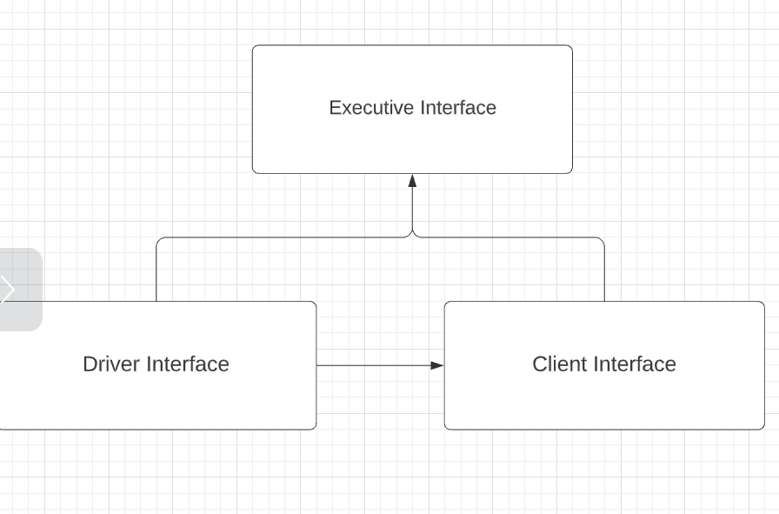

**3 Installation and setup**

**3.1 Setup**

Each interface will have their account setup already with the company. Drivers will have their own interface to choose from the given role. It is going to be the same for clients and executive interface. Each interface will click into their given role to access their dashboard.

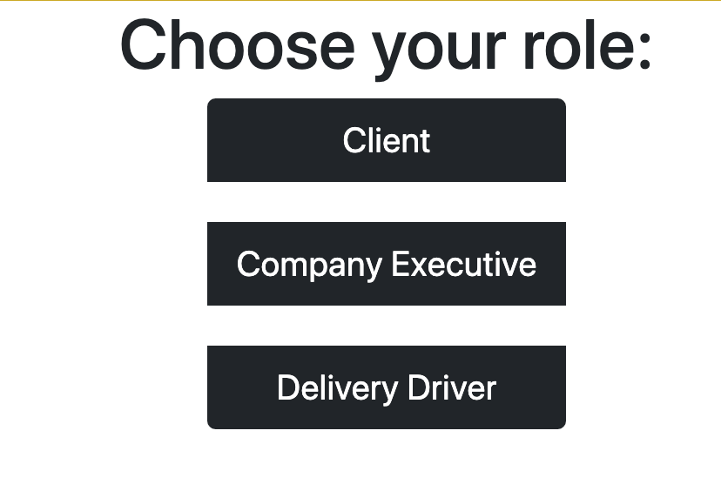

**3.2 Deployment**

For the Deployment of this project, because of various constraints factors such as time, team communication we were not able to deploy our project currently.