**CS213: OOP**

**Assignment 1 – Task 4**

عمر مصطفي سعد محمد – 20230267 – سكشن 29

omar16220061622006@gmail.com

بيشوي بشاي سعيد سلامه – 20230102 – سكشن 5

beshobeshay4@gmail.com

بندر عبدالسلام محمد يحيى – 20230774 – سكشن 11

bndrbdalslam97@gmail.com

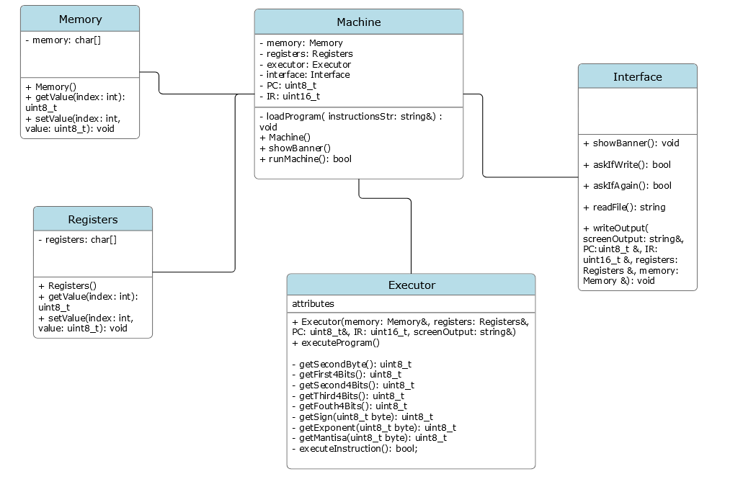Class Diagram

Work Table

|  |  |
| --- | --- |
| Name | Work |
| Omar Mostafa Saad - 20230267 | Machine, and Executor classes |
| Bshoy beshay saaied - 20230102 | Interface class |
| Bander abdelsalam yehia - 20230774 | Memory and Registers classes |