Title: Observation and Verification of transfer characteristics of CMOS inverter.

- Objectives:
- We can see the change of the output rate in the graph of voltage vs voltage and the voltage vs time .
- Layout design simulation using Micro wind.
- Here we use inverter to see the output result. Inverter is contain both pMOS and nMOS.
- To observe the deviation in results with default layout

- Aparatus:
  - Microwind software.
  - Windows/Linux Operating System

- Theory: Transfer characteristics of CMOS inverter:
It has 5 region , A,B,C,D,E . Transistor operating regions are given below in chart.

For Region A.0 ≤ V_{in} ≤ V_{tn}.NMOS is off , I_{dsn}= 0; where PMOS is in linear region.In this circuit I_{dsn} = -I_{dsp.} Therefore both current will be zero,since I_{dsn}= 0Now V_{dsp} = V_{DD}-V_{out} Or, 0 = V_{DD}-V_{out}; in linear region V_{dsp} ≈0.Therefore V_{out} = V_{DD}.In region B, the nMOS transistor starts to turn ON, pulling the output down. In region C, both transistors are in saturation. Notice that ideal transistors are only in region C for Vin = VDD /2 and that the slope of the transfer curve in this example is –8 in this region, corresponding to infinite gain. Real transistors have finite output resistances on account of channel length modulation, described in Section 2.4.2, and thus have finite slopes over a broader region over a broader region C. Other 2 resion D and E will be like this .

We can measure this change by the, Beta ratio
If β_{p} / β_{n} 1, switching point will move from V_{DD}/2.This is called skewed gateOther gates: collapse into equivalent inverter
βp=mobility of pMOS =constant=W/L
βn=mobility of nMOS =constant=W/L, Here w=width and L=Length
βp/ βn=constant , Which is depend on its transfer characteristics is changes.

- Procedure:
Table:
Inverter | pMOS |  | nMOS |  | βp/ βn
Inverter | Width | Length | Width | Length
1st | 50 | 1 | 5 | 1 | 0.1
2nd | 5 | 1 | 5 | 1 | 1
3rd | 5 | 1 | 50 | 1 | 10

Schematic Diagram: Stick Diagram:
V_{DD}
V_{ss}
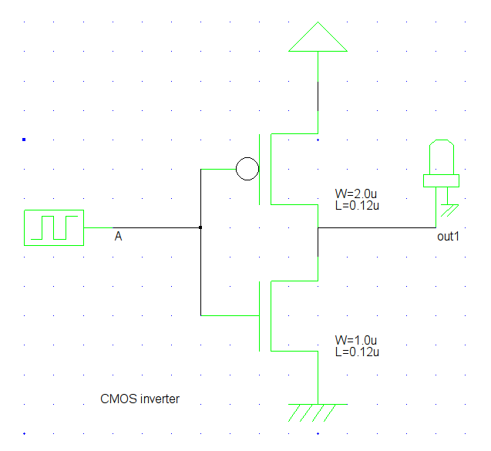Illustration 1: CMOS Inverter

Step by Step Procedure is as follows:

- First we start a new file in Microwind and take two metal lines at a distance of 85 lambda, each of which is 10 lamda wide. Both of them are the same metal.

- Then add a V_{DD} to the upper metal and a V_{SS} to the lower one. The figure will be as bellow.

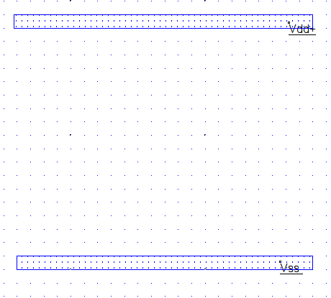Illustration 2: Figure: Two metal plates

Then generate one pMOS and one nMOS and connect them to the metal plates as show below. The pMOS and nMOS should be sized as shown in first row of the table
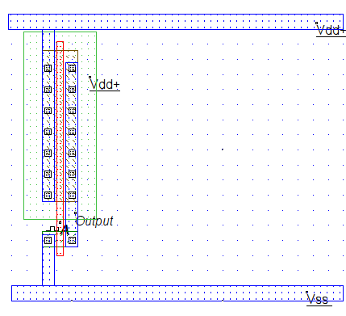Illustration 3: First pMOS and nMOS placed

- After the first pMOS and nMOS is placed we’ll generate two more pMOS and nMOS using the size mentioned in 2nd row of the table. And place them as follows
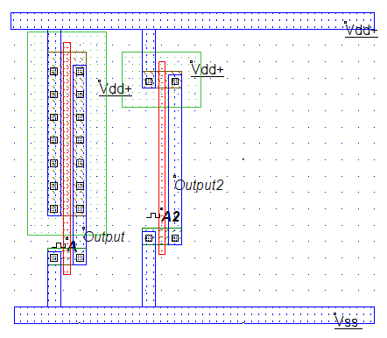Illustration 4: After placing 2nd couple of pMOS & nMOS

After 2nd couple of pMOS and nMOS is placed,we’ll generate one more couple of pMOS & nMOS using the dimension mentioned in 3rd row of the table, and place them inside the two metal plates as shown below
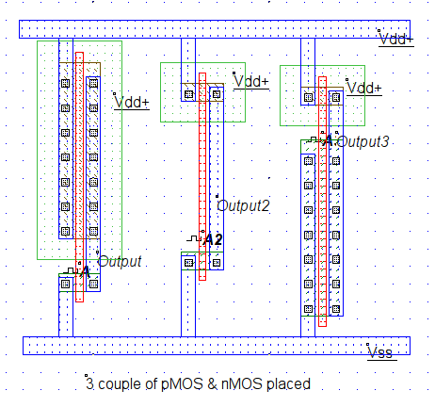Illustration 5: After placing all 3 MOS

Now we simulate the circuit to evaluate different characteristics of the Inverter Circuit
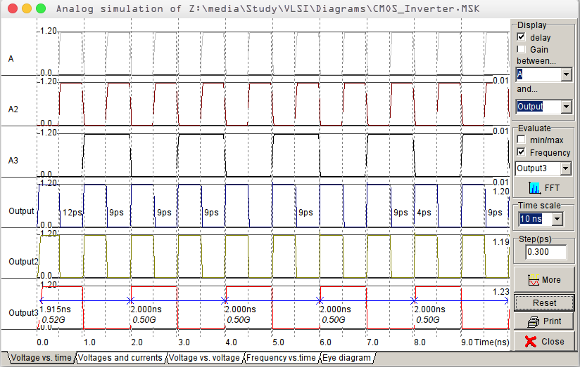Illustration 6: Voltage vs Time characteristics Curve of CMOS inverter

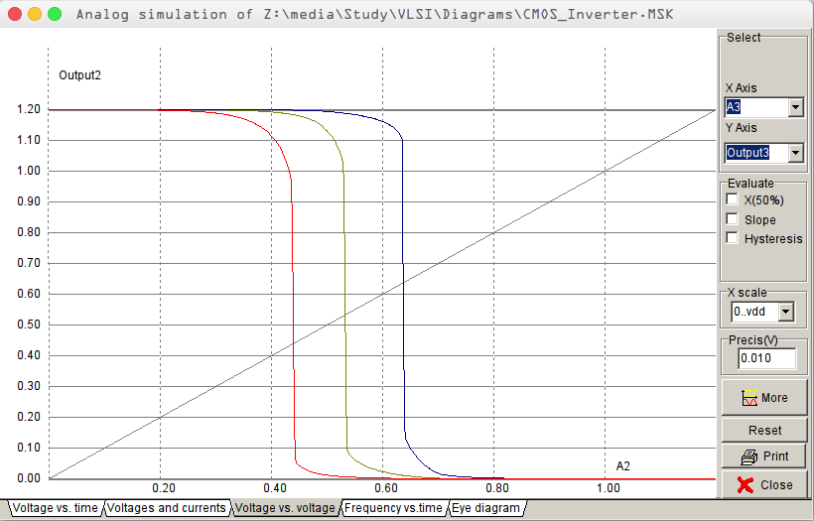Illustration 7: Input Voltage vs Output Voltage Characteristics

5) Conclusion:The CMOS INVERT gate is implemented using three pMOS and three nMOS with different ratio. The required waveforms were obtained, observed and noted down using Microwind. And we observe the change of output in the voltage vs time graph and the voltage vs voltage graph .

