**CSC 1101 – Problem Solving and Programming Laboratory**

**Lab 5 – Omar Faruk**

**25 points – Due September 22, end of lab**

**a)** Save this document with your name and the lab assignment number somewhere in the file name.

**b)** Type/paste your answers into the document.

**c)** Submit this document to the Canvas item where you downloaded this document.

Let, you go to a grocery shop to buy some grapes. You would like to buy three types of grapes from that grocery shop. The price of them are different. You would like to buy the following grapes and their prices are below:

|  |  |  |
| --- | --- | --- |
| Name of grapes type | Price per lb | Amount (lbs) |
| Barbara grapes | $4.00 | weight1 |
| Colombard grapes | $3.50 | weight2 |
| Cortese grapes | $3.00 | weight3 |

In this table, weight1, weight2, and weight3 are the weights of grapes. Now write a C++ console application to find out the total price of three items for the shopkeeper.

You need to do followings:

1. Declare three double variables (weight1, weight2, weight3) and assign the following values:

weight1=4.0;

weight2=3.5;

weight3= 2.5;

1. Declare a double variable total_price
2. Find the value of price in a single equation which consists the prices and weights of grapes.
3. Make header and body comments.
4. Use setw(), right and left alignment to print the output.
5. Declare constants COLMFT1 and COLMFT2 to be used in the setw() function calls.
6. Show all real numbers with two decimal places using fixed and setprecision().
7. Run the program three different times with different values for weights and prices.

**Sample Input/Output**

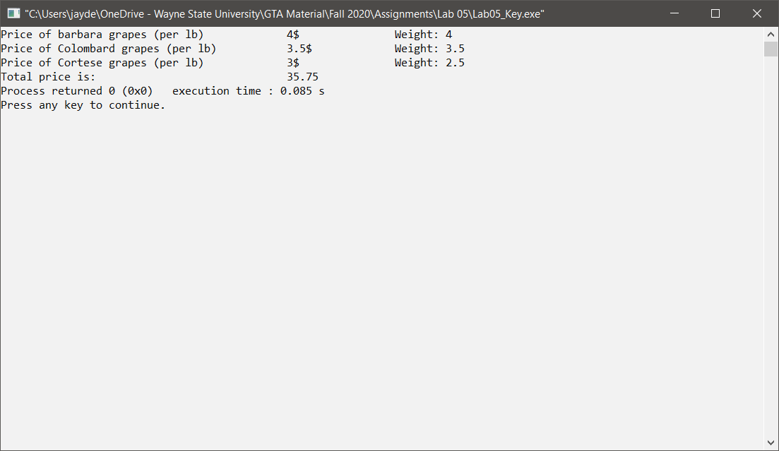

*[your program code here]\**

//==========================================================

//

// Title: Lab 05

// Course: CSC 1101

// Author: Lab 05

// Date: 09/22/20

// Description:

// Creating a calculator to clculate the total price

// based on fixed prices of graoes.

// Set variables, constants, and calculations with output in formatted output.

//

//==========================================================

#include <cstdlib> // For several general-purpose functions

#include <fstream> // For file handling

#include <iomanip> // For formatted output

#include <iostream> // For cin, cout, and system

#include <string> // For string data type

using namespace std; // So "std::cout" may be abbreviated to "cout"

int main()

{

//Declare Constants

const double barbaraGrapes = 4.00;

const double colombardGrapes = 3.50;

const double corteseGrapes = 3.00;

const int COLFMT1 = 35;

const int COLFMT2 = 14;

// Declare variables

double weight1 = 4.0;

double weight2 = 3.5;

double weight3 = 2.5;

double total_price;

//Calculations

total_price = ((weight1 * barbaraGrapes) + (weight2 * colombardGrapes) + (weight3 * corteseGrapes));

// Show application header

cout << "Welcome to my Grapes Price Calculator" << endl;

cout << "--------------------------" << endl << endl;

// Write to screen

cout << setw(COLFMT1) << left << "Price of Barbara grapes (per lb)";

cout << setw(COLFMT2) << right << "4$";

cout << setw(COLFMT1) << right << "Weight: 4.0" << endl;

cout << setw(COLFMT1) << left << "Price of Colombard grapes (per lb)";

cout << setw(COLFMT2) << right << "3.5$";

cout << setw(COLFMT1) << right << "Weight: 3.5" << endl;

cout << setw(COLFMT1) << left << "Price of Cortese grapes (per lb)";

cout << setw(COLFMT2) << right << "3$";

cout << setw(COLFMT1) << right << "Weight: 2.5" << endl;

cout << setw(COLFMT1) << left << "Total price is:";

cout << setw(COLFMT2) << right << total_price << endl;

// Show application close

cout << "\nEnd of my Application" << endl;

}

*[your program output here]\*\**

