1. (1 point) What’s gone wrong with this code? Why are the points not blue? ggplot(data = mpg) +

geom_point(

mapping = aes(x = displ, y = hwy, color = "blue") )

color argument has to be outside the aesthetic parenthesis so it is not considered as a legend of all units being labels as blue.

Correct graph:

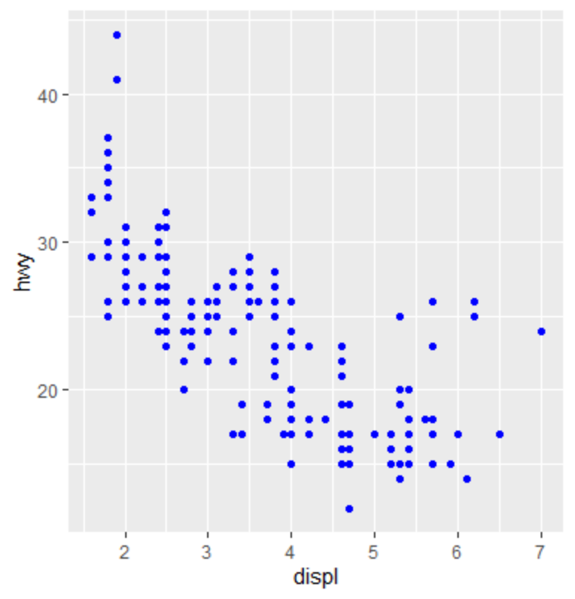

1. (1 point) Which variables in mpg are categorical? Which variables are continuous? Map a continuous variable to color, size, transparency, and shape. How do these aesthetics behave differently for categorical versus continuous variables?

The manufacturer, model, drv, trans, fl, and class are categorical variables.

The displ, year, cyl, cty, and hwy are continuous variables.

A continuous variable can not be mapped to a shape; however, for the rest of the aesthetics it can be graphed.

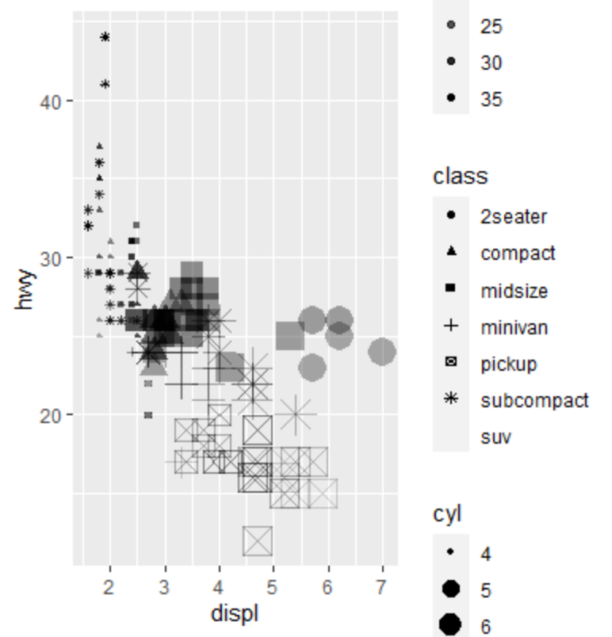

1. (1 point) What happens if you map the same variable to multiple aesthetics?

The points on the graph get removed depending on which variable and the graph could have different points.

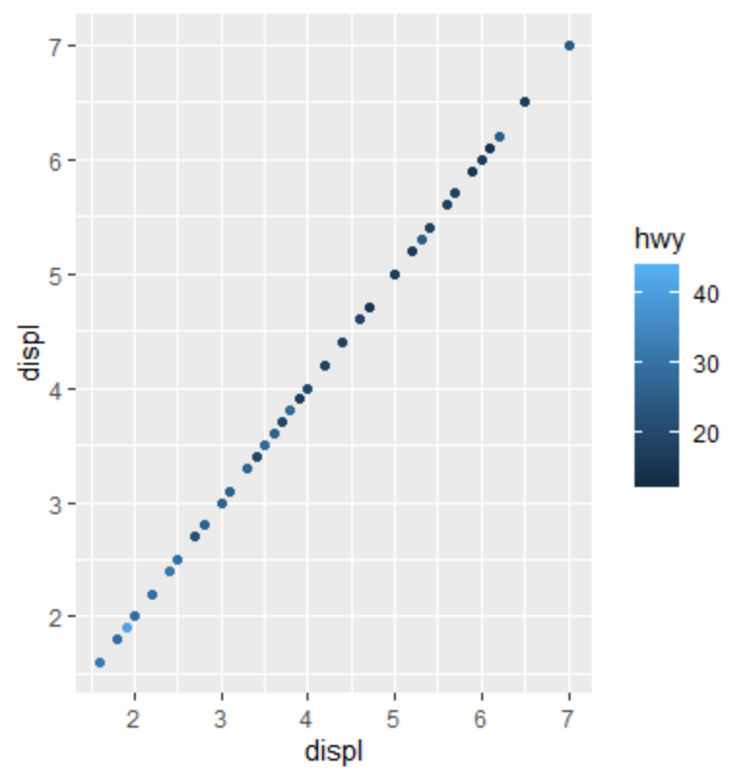

1. (1 point) What does the stroke aesthetic do? (Hint: just google it.)

Stroke aesthetic changes the size of the border for shapes 21-25.

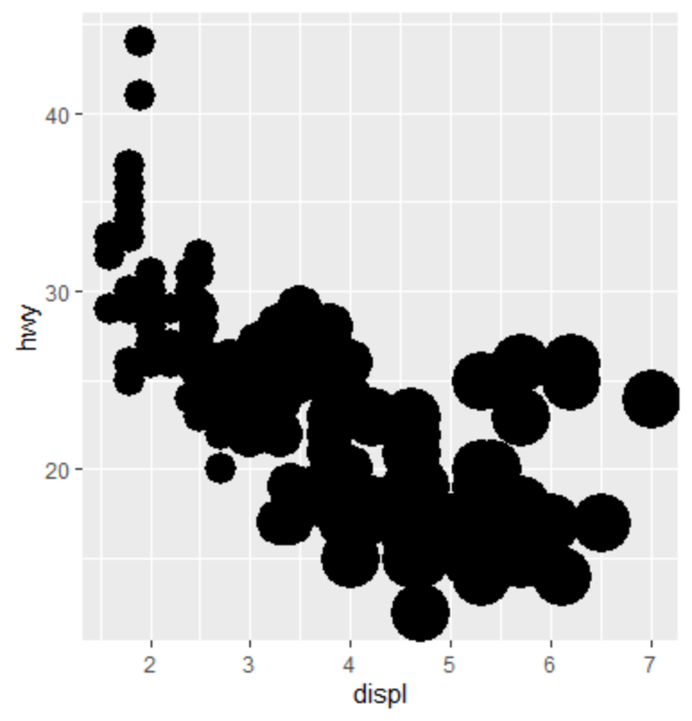

1. (1 point) What happens if you map an aesthetic to something other than a variable name, like aes(color = displ < 5)?

It show’s where the displ points are indeed true that it is less than 5 and false when it is greater than 5.

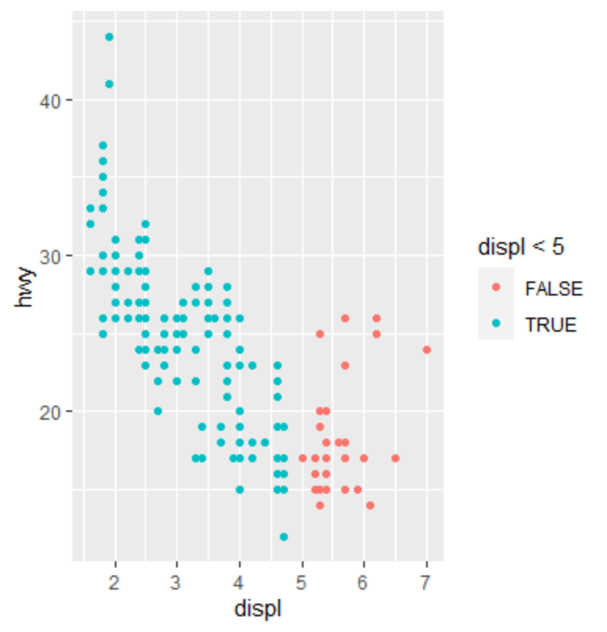

1. (1 point) What happens if you facet on a continuous variable?

Depending on the continuous variable numbers, it can create many graphs.

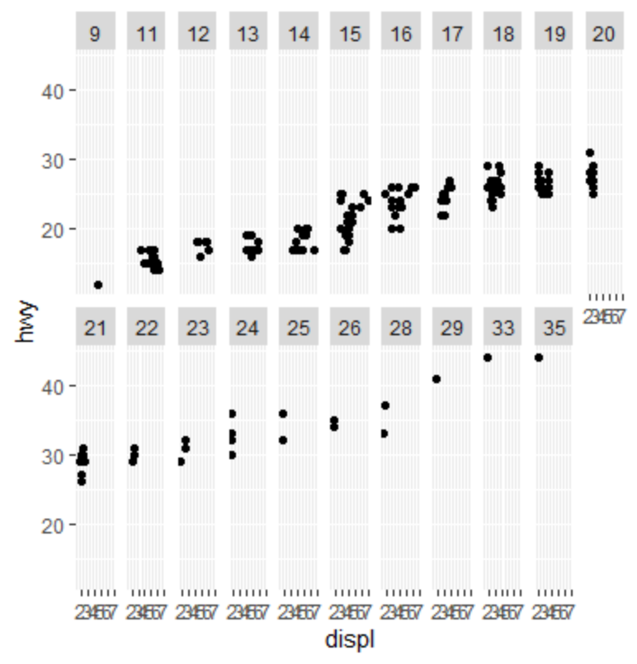

1. (1 point) What plots does the following code make? What does . do?

ggplot(data = mpg) +

geom_point(mapping = aes(x = displ, y = hwy)) +

facet_grid(drv ~ .) Facet drv by y axis

ggplot(data = mpg) +

geom_point(mapping = aes(x = displ, y = hwy)) +

facet_grid(. ~ cyl) Facet cyl by x axis

It ignores the dimensions when faceting.

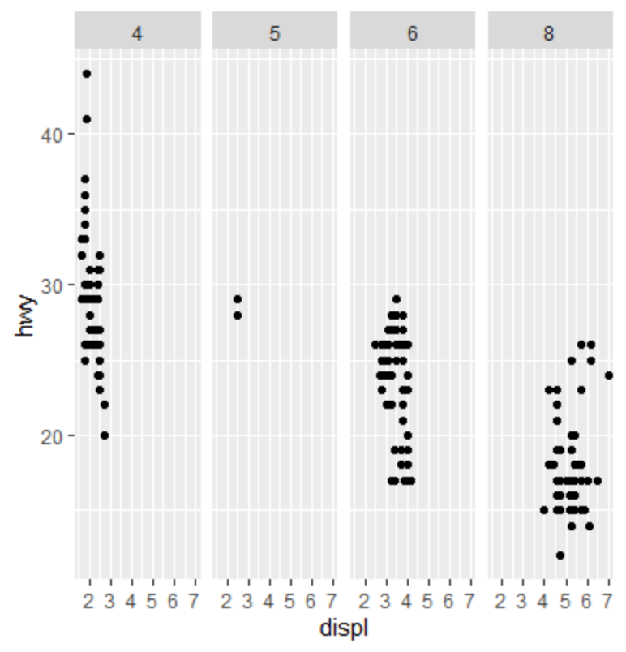 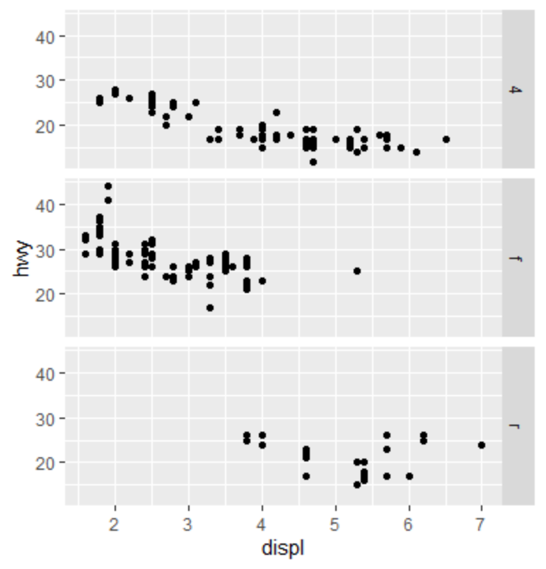

1. (1 point) What does show.legend = FALSE do? What happens if you remove it?

The legend box becomes hidden when set to false, if removed it is shown.

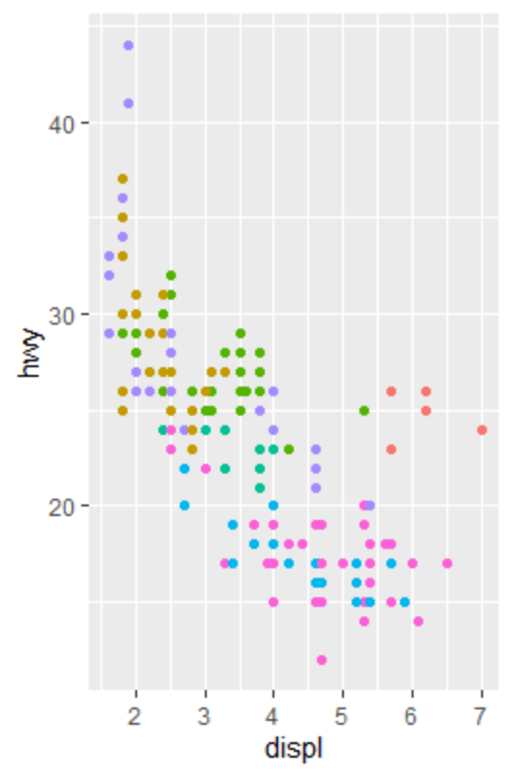

1. (1 point) Will these two graphs look different? Why/why not?

ggplot(data = mpg, mapping = aes(x = displ, y = hwy)) +

geom_point() +

geom_smooth()

ggplot() +

geom_point(

data = mpg,

mapping = aes(x = displ, y = hwy)

) +

geom_smooth(

data = mpg,

mapping = aes(x = displ, y = hwy)

)

They are the same as the aesthetics have same arguments for both plots.

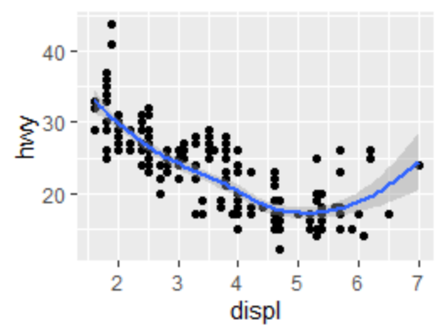

1. (1 point) What is the problem with this plot? How could you improve it?

ggplot(data = mpg, mapping = aes(x = cty, y = hwy)) +

geom_point()

It is mapping two continuous variables of the same type. We need to use the jitter for position.

ggplot(data = mpg, mapping = aes(x = cty, y = hwy)) +

geom_point(position="jitter")

