EECE 490 Project — 3-Week Roadmap
Nov 4, 2026 · @Jana

Project in one paragraph
We build a day-ahead forecast of electricity load and solar production for Azm School and use it to recommend which diesel generator to run each hour. The school runs on its own generators about 99% of the time. Its four units differ in size (observed peaks of roughly 160, 315, 415 and 415 kW), so picking the wrong one either overloads it or burns fuel at low efficiency. This is Path A (application system). Household 3 is a second site for checking that the method transfers; the Karoun 2016 regional file is a stretch goal only.
Path A requirement | Our answer
Real-world problem | Generator choice is made without a forecast, causing overloads or wasted diesel
Decision automated | Hourly generator recommendation for tomorrow, from forecast net load (load minus PV)
User / stakeholder | The school's facility or generator operator
How it is done today | Operator judgment and fixed habits (to confirm with the school in Week 1)
Why ML could help | Load depends on hour, weekday, temperature and season together; simple rules miss these interactions
Non-ML baseline | Same hour yesterday, same hour last week, and an average weekday profile
ML approach | Ridge regression, then XGBoost, plus a high-quantile (P90) model for safe sizing
Real-world constraint (to get approved) | Missing inputs: weather forecast or meter data unavailable on the day
Responsible ML (pick 3) | Explainability, robustness and distribution shift, human oversight
Production | FastAPI service in Docker, plus a Streamlit page for the operator
The schedule assumes work starts Thu Nov 5 and everything is due Wed Nov 25. Shift the weeks if your poster date or final deadline differs.
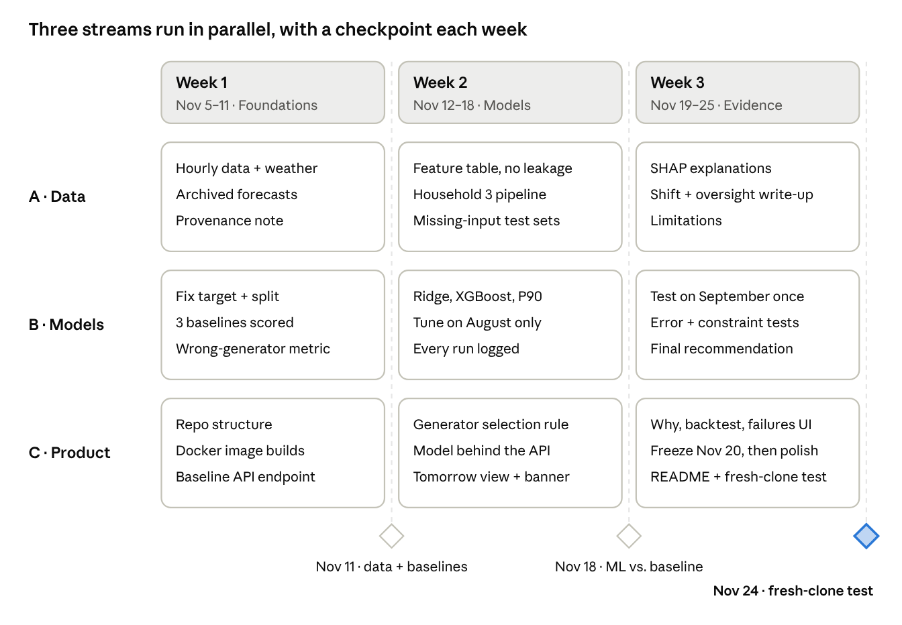
roadmap · 3 weeks × 3 streams, 3 gates
The three streams run side by side; nothing moves to the next week until that week's gate passes.

Team roles
Each teammate owns one stream, but the course requires that everyone can explain and defend all of it, so each Friday includes a 30-minute walkthrough where people present each other's work.
Teammate | Owns | Main outputs
A: Data | Cleaning, weather data, features, data provenance, Responsible ML write-up | One clean hourly dataset per site, feature pipeline, data documentation
B: Models | Baselines, ML models, evaluation, error analysis, constraint test | Results tables, experiment log, final trained models
C: Product | Repository structure, generator logic, API, Docker, interface, README | Running Dockerized API, Streamlit page, reproducible setup
Put names next to A, B and C. Record who did what in a shared contribution log from day 1, since the final submission must include it.

Week 1 (Nov 5–11): Data, baselines, problem framing
By the end of the week you should have a clean dataset, baseline scores, and a framed problem that's ready for the poster.
A: Data
- ☐ Get Azm School's coordinates, ask the data provider how the generators are chosen today, request a fresh export through November plus any data from before Apr 16, and ask in writing whether the data may be published in a public GitHub repo (if not: commit an anonymised sample and document how to request the full set)
- ☐ Resample Azm to hourly; keep load, production, each generator's power and status
- ☐ Look at Azm's 42 hourly jumps above 200 kW and confirm they are real (school opening, not meter errors)
- ☐ Fix the mixed date formats in the Household 3 files and resample to hourly
- ☐ Mark frozen readings as missing (Household 3: 41 rows stuck on one value for 3 hours or more)
- ☐ Check Household 3's power balance (grid + PV − battery vs. load); it agrees within 20% in about 70% of rows, so flag the rest
- ☐ Make sure lag features ("same hour last week") never reach across the Oct–Nov 2024 gap in Household 3
- ☐ Script every weather download (historical and archived forecasts) so one command re-fetches the exact data; download Open-Meteo historical weather for both sites and periods (temperature, humidity, radiation, cloud cover)
- ☐ Download archived weather forecasts (Single Runs or Previous Runs API) for the same periods
- ☐ Add calendar columns: hour, weekday, weekend, school holidays, Lebanese public holidays
- ☐ Write the data provenance note: source, period, units, known issues, every change made, and which files are excluded and why (Household 1 and 2 duplicates and recording change, Industrial 2 and 3 copies of Industrial 1, Industrial 2 July, Municipality)
B: Models
- ☐ Define the target exactly: hourly average load and PV (kW) for the next 24 hours, issued once at midnight
- ☐ Fix the chronological split now, before modeling: train Apr 16–Jul 31, validate August, test September (touch once, at the end)
- ☐ Implement the three baselines and score them on validation (MAE, RMSE, peak error)
- ☐ Define a use-linked metric: hours where the forecast would pick an undersized generator (overload risk) vs. oversized (wasted fuel)
C: Product
- ☐ Create the GitHub repo with separate folders for data processing, features, models, evaluation, API and app
- ☐ Set up the environment file and a first Dockerfile that builds
- ☐ Write a FastAPI /forecast endpoint that returns the baseline forecast (a placeholder for the model)
- ☐ Extract each generator's rated or observed maximum output from the data and draft the selection rule
- ☐ Start the contribution log
Everyone
- ☐ Confirm the poster session date; draft the poster (problem and user, baseline, ML approach, metrics, constraint, deployment plan) and print the final version 2 days before the session
- ☐ Submit the real-world constraint (missing inputs) for approval
Gate (Nov 11): hourly dataset with weather is done, baseline scores exist, and the Docker image builds. If archived forecasts can't be found for the site, use Previous Runs and say so in the limitations.

Week 2 (Nov 12–18): ML models and a working system
By the end of this week, models trained only on the validation split are served through the API and visible in the interface.
A: Data
- ☐ Build the feature table: lagged load (24 h and 168 h back), calendar, and forecast weather only (never observed future weather; this is the leakage control)
- ☐ Run a leakage check: confirm no feature uses information after the forecast issue time
- ☐ Replicate the pipeline for Household 3
- ☐ Create the missing-input test sets: weather forecast missing, last 6 hours of meter data missing, both missing
B: Models
- ☐ Train Ridge and XGBoost for load, and separately for PV; tune on August only
- ☐ Train a P90 quantile model for load (sizing the generator on the median forecast risks overload)
- ☐ Run rolling-origin backtests inside the training period to see how stable the errors are
- ☐ Log every run (parameters, split, scores) to a results CSV or MLflow
- ☐ Note that September load is higher than anything in training (weekday mornings average about 500 kW vs. under 400 kW before), and that tree models cannot predict above what they have seen. Decide whether to model the change from last week instead of the level
C: Product
- ☐ Turn the forecast into a recommendation: the smallest generator whose capacity covers P90 net load plus a safety margin
- ☐ Connect the API to the trained model, with a fallback to the baseline when inputs are missing
- ☐ Build the Tomorrow view and Trust banner (see UI specification)
- ☐ Make one command (docker compose up) start the API and the page
Gate (Nov 18): each model is compared with the best baseline on validation. If XGBoost doesn't beat Ridge or the baseline clearly, keep the simpler model and say why. The course rewards that.
Optional, for originality (only if the Nov 11 gate passed on time): Teammate B or A pretrains a load model on education buildings from the Building Data Genome Project 2 (open, hourly, 2016–2017), fine-tunes it on Azm, and compares it with training on Azm alone. About 3–4 days for one person; report the result either way. It directly tests the "limited data" problem.

Week 3 (Nov 19–25): Evidence, analysis, submission
The test set is opened once, results are explained honestly, and the repo can be reproduced by a stranger. Features freeze on Nov 20; after that, only polish, documentation and rehearsal.
A: Data
- ☐ Explainability: SHAP or feature importance for the final load model, with which inputs drive peak hours
- ☐ Robustness and distribution shift: write up the September jump and how the model handled it
- ☐ Human oversight: the operator keeps the final say; state what an under-forecast costs (an overloaded generator) vs. an over-forecast (wasted fuel)
- ☐ Limitations: a single school, about 5.5 months of data, served load rather than true demand, unexplained PV readings
B: Models
- ☐ Run the final models once on September and fill the results table: baselines vs. Ridge vs. XGBoost vs. P90
- ☐ Error analysis: errors by hour, weekday vs. weekend, hot vs. mild days, holidays; pick 3 worst days and explain them
- ☐ Constraint evaluation: accuracy and generator mistakes with each missing-input set, with and without the fallback
- ☐ Transfer check on Household 3: same pipeline, report where it works and where it doesn't
- ☐ Write the final recommendation: is ML worth it over the baseline here, and when should it not be used?
C: Product
- ☐ Build the Why panel, Backtest page and Failure gallery by Nov 20 (feature freeze), then polish only; freeze the model files and pin package versions
- ☐ README: install, project structure, how to reproduce each results table, how to call the API, how to get the data (or the sample) and re-run the weather download
- ☐ Fresh-clone test: a teammate who didn't write the code runs it from scratch on another laptop
- ☐ Finish the contribution log
Everyone
- ☐ Build the 5-minute presentation; rehearse twice with Q&A where each person answers questions on another person's part; prepare short answers to likely questions (why no graph model: the sites share no meaningful relationship structure, and the guidelines prefer no graph over an unneeded one; why this model; why September as the test month)
Gate (Nov 24): the fresh-clone test passes and every number in the slides comes from a logged run. Nov 25 is buffer, not work time.

UI specification
The interface exists to show the evidence, not to replace it: every screen is built on a logged result or a live model output. Teammate C builds it with Streamlit and Plotly, using a custom theme.
Screen | What it shows | Built from | Week
Tomorrow view | 24-hour load forecast with a shaded P90 band; under it an hour-by-hour strip of the generator to run, colour-coded by unit | API forecast + generator rule | 2
Trust banner | Green "full inputs" or amber "weather missing, using fallback" above the forecast | API input check | 2
Why panel | The top 3 drivers behind tomorrow's peak (e.g. hot day, weekday, 9 AM) | SHAP values from Teammate A | 3
Backtest page | Pick any past day: forecast vs. actual, baseline beside the model, generator picked vs. generator needed | Logged backtest results from Teammate B | 3
Failure gallery | The 3 worst forecast days, each with a one-line explanation | Error analysis from Teammate B | 3
Feature freeze: Nov 20. After that date nothing new is added. Teammate C only polishes the interface and README; A and B only fix bugs and prepare the presentation.

Guideline checklist
Every requirement in the project announcement has an owner and a week.
Requirement (from the announcement) | Where it's covered | Owner | Week
Problem, decision, user, current practice | Project summary table; operator question | All | 1
Transparent data provenance and data visibility | Data provenance note; publication permission or anonymised sample | A | 1
Non-ML baseline | Yesterday, last week, weekday profile | B | 1
ML approach | Ridge, XGBoost, P90 quantile | B | 2
Train/validation/test split, leakage control | Fixed chronological split; forecast weather only; leakage check | B, A | 1–2
Metrics linked to the use case | MAE, peak error, wrong-generator hours | B | 1
Baseline vs. ML comparison | Final results table | B | 3
Error and failure analysis | Errors by condition, 3 worst days | B | 3
Why this model complexity | Gate in Week 2; final recommendation | B | 2–3
Real-world constraint, approved | Missing inputs, with fallback | All, B | 1, 3
Responsible ML (3 topics) | Explainability, distribution shift, human oversight | A | 3
Dockerized API | FastAPI in Docker | C | 1–2
Data / model / evaluation / serving separated | Repo folder structure | C | 1
Minimal interface | Streamlit app, 5 screens (UI specification) | C | 2
Reproducible experiments, README | Run log, scripted weather download, pinned versions, fresh-clone test | C, B | 3
Final models or checkpoints | Frozen model files in the repo | C | 3
Poster | Draft by Nov 11; final printed 2 days before the session | All | 1
5-minute presentation + Q&A | Two rehearsals | All | 3
Contribution record | Contribution log | C | 1–3

Risks and fallbacks
Risk | Fallback decision
The school can't say how generators are chosen today | Describe the observed pattern from the status columns as the current practice, and say it's inferred
No archived weather forecasts for the site | Use Previous Runs (fixed 24-hour lead); if neither works, use observed weather and label results as an upper bound
September is outside the range seen in training | Report it as a distribution-shift finding; try predicting the change from last week rather than the level
ML doesn't beat the baseline | Keep the simpler model and argue it with evidence, as the grading philosophy allows
PV readings stay unexplained | Mask night hours by sun position, forecast load first, and treat PV as secondary
Docker breaks late, or features keep being added in the last days | Docker is built in Week 1 and rebuilt after every change; nothing new is added after the Nov 20 feature freeze
The poster date is earlier than Nov 11 | Move the Everyone tasks from Week 1 forward; the poster needs framing, not results

