Cloud and Mobile Computing
Lecture 5 Lab Report
Local Serverless Computing and Event-Driven Image Processing Pipeline

Student Name | Omar Mohamed Hussein Said
Group | SE3
Lab | Lab 5 — Serverless Computing and Event-Driven Architectures
Date | 3 May 2026

1. Lab Overview
This lab implements a local serverless-style event-driven architecture using Docker, Redis Streams, Python (Flask), and Pillow — entirely on a local machine with no cloud services required. The pipeline simulates Function-as-a-Service (FaaS) concepts including event sources, routers, destinations, and cold-start behaviour.

2. Pipeline Architecture
Component | Implementation
Event Source | watcher.py — monitors /data/input for new images
Event Bus | Redis Streams running locally in a container
Event Router | event_router.py — reads events and forwards to functions
Function 1 | image-resizer — resizes image and saves to /data/output
Function 2 | notifier — logs a notification (demonstrates fan-out)

3. Deliverable Screenshots

3.1 Event Router Logs and Output Folder
The following screenshot shows the event router receiving the image.uploaded event, routing it to both functions, and the output folder with both resized images.

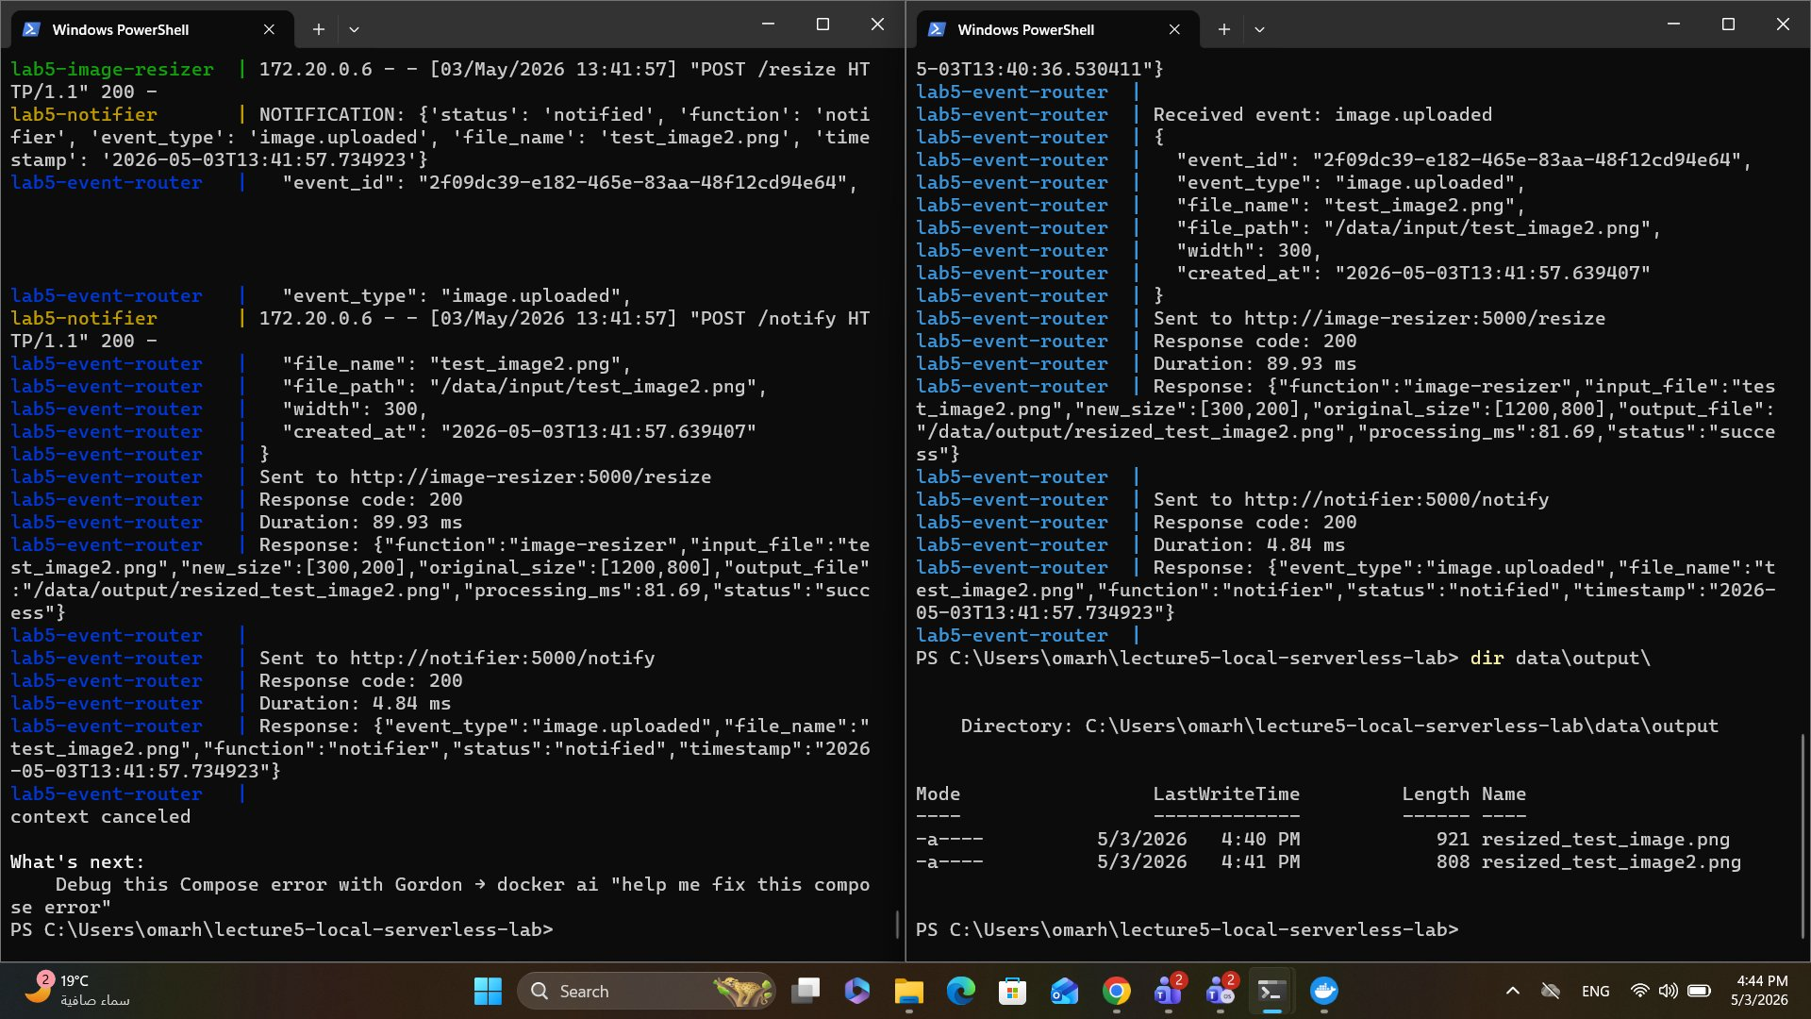
Figure 1: Event router logs showing full pipeline flow and output folder

3.2 Running Containers - docker compose ps
All five containers are running successfully: lab5-redis, lab5-event-source, lab5-event-router, lab5-image-resizer, and lab5-notifier.

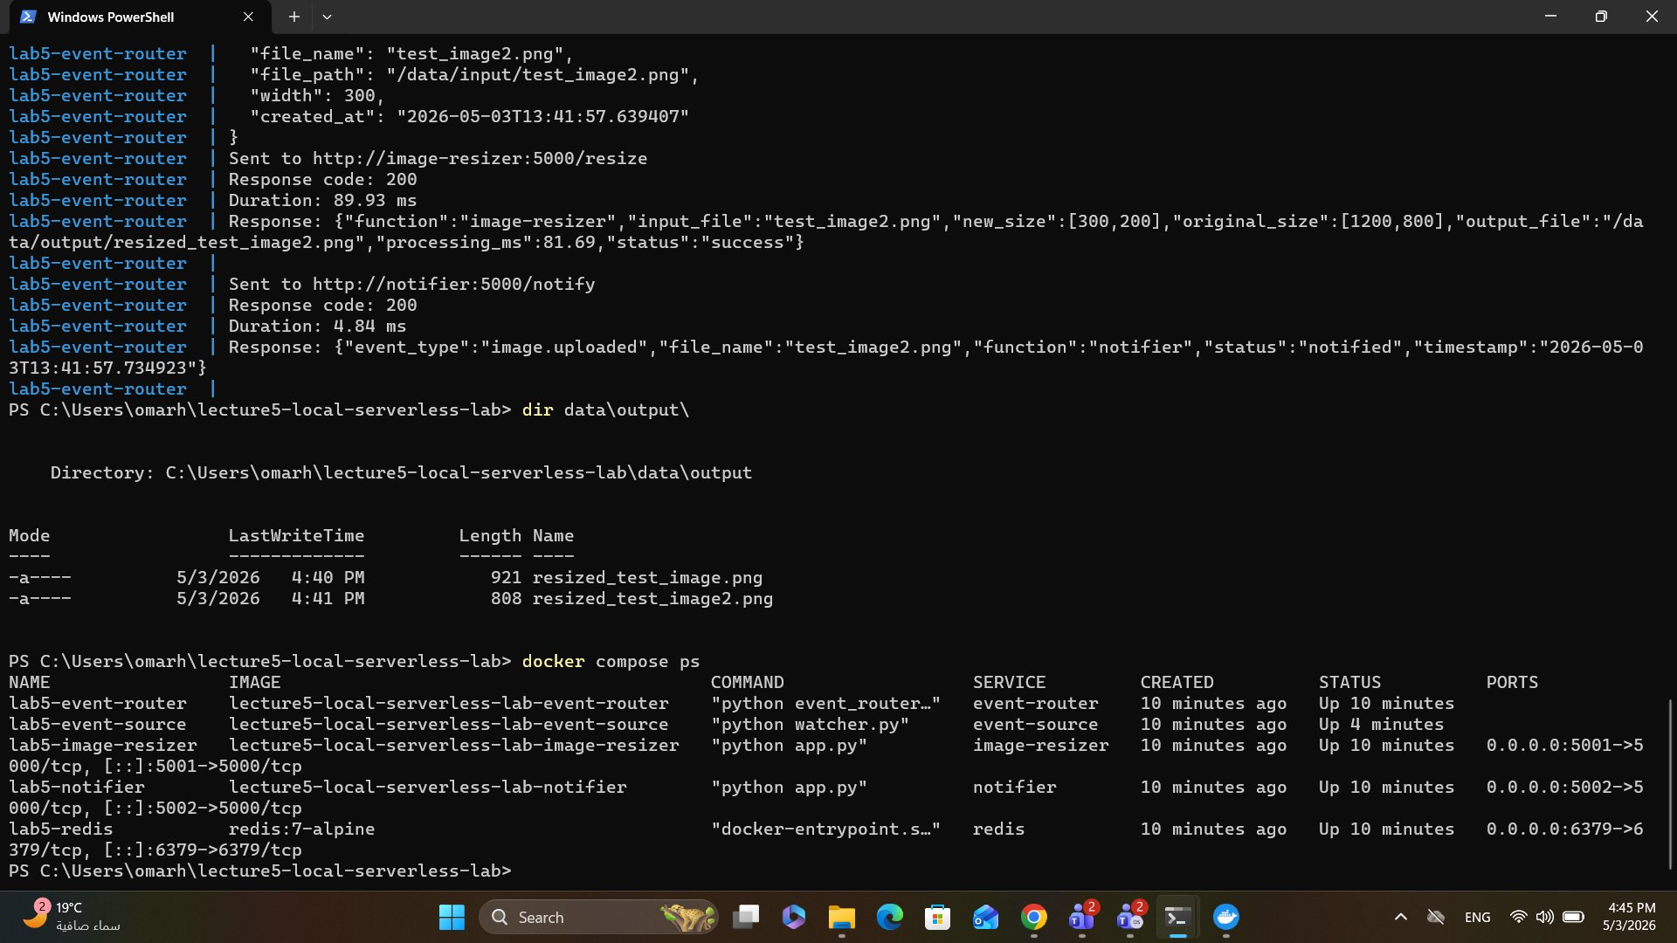
Figure 2: docker compose ps showing all 5 containers up and running

3.3 Cold Start Experiment
A warm request was sent first (85.09ms), then the image-resizer container was restarted and the same request was sent immediately after (89.92ms) to observe the cold start effect.

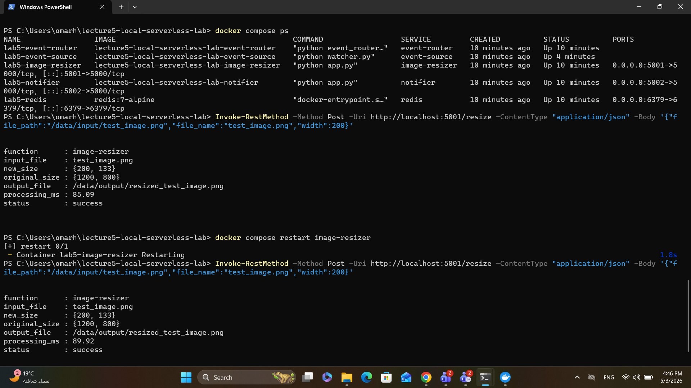
Figure 3: Cold start experiment - warm request (85.09ms) vs post-restart request (89.92ms)

4. Cold Start Measurement Table
Measurement | Value
Warm request time | 85.09 ms
First request after restart | 89.92 ms
Difference | 4.83 ms
Reason / Explanation | After restarting, the container reinitializes Flask and loads Python libraries before handling the first request, causing a slight delay compared to a warm container.

5. Reflection Questions

Q1: What is the event source in this lab?
The event source is watcher.py, a Python script running inside the event-source container. It continuously monitors the /data/input folder and publishes an image.uploaded event to the Redis Stream whenever a new PNG or JPG image appears.

Q2: What is the event router?
The event router is event_router.py. It reads events from the Redis Stream and forwards each event to the correct function endpoints based on the event type. For image.uploaded events, it routes to both the image-resizer and the notifier.

Q3: What are the event destinations?
The event destinations are: (1) the image-resizer function at /resize, which processes and saves the resized image, and (2) the notifier function at /notify, which logs a notification message. This demonstrates event fan-out — one event triggers multiple destinations.

Q4: Why is this pipeline loosely coupled?
The pipeline is loosely coupled because each component communicates through Redis Streams and HTTP endpoints rather than calling each other directly. The event source does not know about the functions, and the functions do not know about each other. Any component can be replaced, updated, or scaled independently without affecting the others.

Q5: What happened after restarting the image-resizer container?
The first request after the restart took 89.92ms compared to 85.09ms for the warm request. The container needed to reinitialize the Flask application and load the Python runtime before it could handle the request, which added a small delay.

Q6: How is this similar to serverless cold start?
In real serverless platforms such as AWS Lambda, a cold start occurs when a function has not been used recently and the platform must initialize a new execution environment — loading the runtime, the code, and any dependencies. This local experiment simulates the same idea: restarting the container forces reinitialization, causing the first request to be slower than subsequent warm requests.

Q7: What is missing compared to real cloud serverless platforms?
Real serverless platforms include: true ephemeral execution (functions terminate after each invocation), automatic scaling, microVM sandboxing, pay-per-use billing, provisioned concurrency, managed networking, IAM-based access control, and built-in observability. The local Flask containers are long-running processes, not true ephemeral FaaS handlers.

Q8: How could this pipeline be extended?
The pipeline could be extended by adding new function destinations to the router. For example: an OCR function to extract text from images, an ML image classification function to tag content, an image moderation function to detect inappropriate content, or a thumbnail generator that produces multiple output sizes. Each new function would simply be a new route destination registered in the router.

